Data Technician

UA

Name:
Course Date:
Table of contents
Day 2: Task 1 3
Day 3: Task 1 3
Exercise 1: Loading and Exploring the Data 4
Exercise 2: Indexing and Slicing 4
Exercise 3: Data Manipulation 4
Exercise 4: Aggregation and Grouping 5
Exercise 5: Advanced Operations 5
Exercise 6: Exporting Data 6
Exercise 7: If finished early try visualising the results 6
Day 4: Task 1 7
Day 4: Task 2 8
Course Notes 8
Additional Information 9

Day 2: Task 1

It is a common software development interview question to create the below with a certain programming language. Create the below using Python syntax, test it and past the completed syntax and output below.

FizzBuzz:

Go through the integers from 1 to 100.
If a number is divisible by 3, print "fizz."
If a number is divisible by 5, print "buzz."
If a number is both divisible by 3 and by 5, print "fizzbuzz."
Otherwise, print just the number.

Paste your completed work to the right | for i in range(1, 101):  if i % 3 == 0 and i % 5 == 0:  print("fizzbuzz")  elif i % 3 == 0:  print("fizz")  elif i % 5 == 0:  print("buzz")  else:  print(i)  Eg:  1  2  fizz  4  buzz  fizz  7  8  fizz  buzz  11  fizz  13  14  fizzbuzz  16  17  fizz  19  buzz  fizz  22  23  fizz  buzz  26 … so on

Day 3: Task 1

Using the ‘student.csv’ which can be downloaded here, complete the below exercises as a group and paste your input and output. Although this is a group activity, everyone should have the below answered so it supports your portfolio:

Exercise 1: Loading and Exploring the Data
- Question: "Write the code to read a CSV file into a Pandas DataFrame."
- Question: "Write the code to display the first 5 rows of the DataFrame."
- Question: "Write the code to get the information about the DataFrame."
- Question: "Write the code to get summary statistics for the DataFrame."

- df= pd.read_csv(‘filename.csv’)
- Df.head()
- Df.info()
- Df.describe()

1. df = pd.read_csv('student.csv', index_col='id')
print("DataFrame loaded successfully.")

2. print("First 5 rows of the DataFrame:")
display(df.head())
3. print("Information about the DataFrame:")
df.info()
4. print("Summary statistics for the DataFrame:")
display(df.describe())

Exercise 2: Indexing and Slicing
- Question: "Write the code to select the 'name' column."
- Question: "Write the code to select the 'name' and 'mark' columns."
- Question: "Write the code to select the first 3 rows."
- Question: "Write the code to select all rows where the 'class' is 'Four'."

- Df[‘name’]
- Df[[‘name’, ‘mark’]
- Df[: 3] or df.head(3)
- Df[df[‘class’] == “Four”]

1. print("Selecting the 'name' column:")
display(df['name'].head())
2. print("Selecting 'name' and 'mark' columns:")
display(df[['name', 'mark']].head())
3. print("Selecting the first 3 rows:")
display(df.head(3))
4. print("Selecting students in 'class' 'Four':")
display(df[df['class'] == 'Four'].head())

Exercise 3: Data Manipulation
- Question: "Write the code to add a new column 'passed' that indicates whether the student passed (mark >= 60)."
- Question: "Write the code to rename the 'mark' column to 'score'."
- Question: "Write the code to drop the 'passed' column."

- Df[‘passed’] = df[‘mark’] >= 60
- Df.rename(columns=('mark’:’score’), inplace = True)
- Df.drop(columns=[’passed’], inplace = True)
# Create a fresh copy of the original DataFrame for these operations
df_manipulation_rerun = df.copy()

print("Original DataFrame copy for manipulation (rerun):")
display(df_manipulation_rerun.head())

1. # Add 'passed' column
df_manipulation['passed'] = df_manipulation['mark'] >= 60

print("DataFrame after adding 'passed' column:")
display(df_manipulation.head())

2. # Rename 'mark' column to 'score'
df_manipulation.rename(columns={'mark': 'score'}, inplace=True)

print("DataFrame after renaming 'mark' to 'score':")
display(df_manipulation.head())
3. # Drop the 'passed' column
df_manipulation_rerun.drop(columns=['passed'], inplace=True)
print("DataFrame after dropping 'passed' column:")
display(df_manipulation.head())

- # Drop the 'passed' column
df_manipulation.drop(columns=['passed'], inplace=True)
print("DataFrame after dropping 'passed' column:")
display(df_manipulation.head())

Exercise 4: Aggregation and Grouping
- Question: "Write the code to group the DataFrame by the 'class' column and calculate the mean 'mark' for each group."
- Question: "Write the code to count the number of students in each class."
- Question: "Write the code to calculate the average mark for each gender."

- Df.groupby(‘class’)[‘score’].mean()
- Df[‘class’].value_counts()
- Df.groupby(‘gender’)[‘score’].mean()

1. print("Mean mark by class:")
mean_mark_by_class = df.groupby('class')['mark'].mean()
display(mean_mark_by_class)
2. print("Number of students in each class:")
students_per_class = df['class'].value_counts()
display(students_per_class)
3. print("Average mark by gender:")
average_mark_by_gender = df.groupby('gender')['mark'].mean()
display(average_mark_by_gender)

Exercise 5: Advanced Operations
- Question: "Write the code to create a pivot table with 'class' as rows, 'gender' as columns, and 'mark' as values."
- Question: "Write the code to create a new column 'grade' where marks >= 85 are 'A', 70-84 are 'B', 60-69 are 'C', and below 60 are 'D'."
- Question: "Write the code to sort the DataFrame by 'mark' in descending order."

- Df.pivot_table(index=’class’, columns=’gender’, values=’score’, aggfunc=’mean’)
- Df[‘grade’]=pd.cut(df[‘score’], bins=[0, 59, 69, 84, 100], labels=['D’, ‘C’, ‘B’, ‘A’])
- Df.sort_values(by=['score’], ascending = False)

1. print("Pivot table of marks by class and gender:")
pivot_table = pd.pivot_table(df, values='mark', index='class', columns='gender', aggfunc='mean')
display(pivot_table)

2. import numpy as np

# Create a copy to add the new column without modifying the original df
df_graded = df.copy()

conditions = [
(df_graded['mark'] >= 85),
(df_graded['mark'] >= 70) & (df_graded['mark'] < 85),
(df_graded['mark'] >= 60) & (df_graded['mark'] < 70),
(df_graded['mark'] < 60)
]
choices = ['A', 'B', 'C', 'D']

df_graded['grade'] = np.select(conditions, choices, default='') # Changed default to an empty string

print("DataFrame with new 'grade' column:")
display(df_graded.head())

3. print("DataFrame sorted by 'mark' in descending order:")
display(df.sort_values(by='mark', ascending=False).head())

Exercise 6: Exporting Data
- Question: "Write the code to save the DataFrame with the new 'grade' column to a new CSV file."

From google.colab import files
Files.download(‘new_filename.csv’)

# Save the DataFrame with the 'grade' column to a new CSV file
df_graded.to_csv('students_graded.csv', index=False)

print("DataFrame 'df_graded' saved to 'students_graded.csv' successfully!")

Exercise 7: If finished early try visualising the results

Df.groupby(‘class’)[‘score’].mean().plot(kind=’bar’)

# Group by 'class' and calculate the mean of 'mark', then plot as a bar chart
df.groupby('class')['mark'].mean().plot(kind='bar', title='Mean Mark by Class')
plt.xlabel('Class')
plt.ylabel('Mean Mark')
plt.xticks(rotation=45)
plt.grid(axis='y', linestyle='--', alpha=0.7)
plt.show()

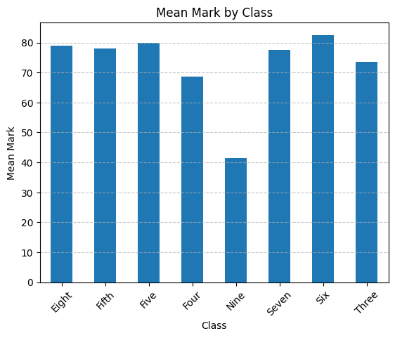

With line:
# Group by 'class' and calculate the mean of 'mark', then plot as a bar chart
df.groupby('class')['mark'].mean().plot(kind='line', title='Mean Mark by Class')
plt.xlabel('Class')
plt.ylabel('Mean Mark')
plt.xticks(rotation=45)
plt.grid(axis='y', linestyle='--', alpha=0.7)
plt.show()

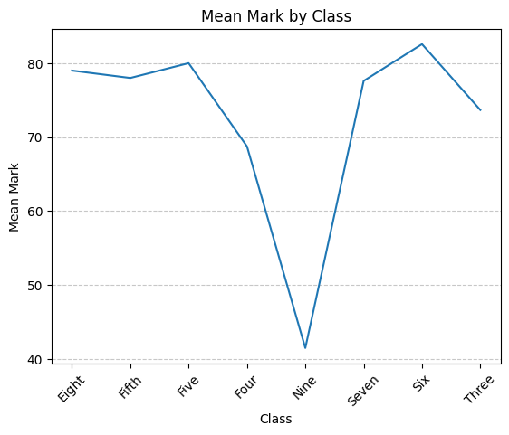

Day 4: Task 1

Using the ‘GDP (nominal) per Capita.csv’ which can be downloaded here, complete the below exercises and paste your input and output. Work individually, but we will work and support each other in the room.

- Read and save the ‘GDP (nominal) per Capita’ data to a data frame called “df” in Jupyter notebook
- Print the first 10 rows
- Print the last 5 rows
- Print ‘Country/Territory’ and ‘UN_Region’ columns

      - display(df[['Country/Territory', 'UN_Region']].head())
Country/Territory | UN_Region
1 | Monaco | Europe
2 | Liechtenstein | Europe
3 | Luxembourg | Europe
4 | Ireland | Europe
5 | Bermuda | Americas

import pandas as pd
df = pd.read_csv("GDP (nominal) per Capita.csv",encoding= 'unicode_escape', index_col=0)
display(df.head(10))

 | Country/Territory | UN_Region | IMF_Estimate | IMF_Year | WorldBank_Estimate | WorldBank_Year | UN_Estimate | UN_Year
1 | Monaco | Europe | 0 | 0 | 234316 | 2021 | 234317 | 2021
2 | Liechtenstein | Europe | 0 | 0 | 157755 | 2020 | 169260 | 2021
3 | Luxembourg | Europe | 132372 | 2023 | 133590 | 2021 | 133745 | 2021
4 | Ireland | Europe | 114581 | 2023 | 100172 | 2021 | 101109 | 2021
5 | Bermuda | Americas | 0 | 0 | 114090 | 2021 | 112653 | 2021
6 | Norway | Europe | 101103 | 2023 | 89154 | 2021 | 89242 | 2021
7 | Switzerland | Europe | 98767 | 2023 | 91992 | 2021 | 93525 | 2021
8 | Singapore | Asia | 91100 | 2023 | 72794 | 2021 | 66822 | 2021
9 | Isle of Man | Europe | 0 | 0 | 87158 | 2019 | 0 | 0
10 | Cayman Islands | Americas | 0 | 0 | 86569 | 2021 | 85250 | 2021

display(df.tail(5))
 | Country/Territory | UN_Region
1 | Monaco | Europe
2 | Liechtenstein | Europe
3 | Lux embourg | Europe
4 | Ireland | Europe
5 | Bermuda | Americas

Note: ‘print can be used` instead od display. Eg:
print(df[['Country/Territory', 'UN_Region']].head())
Country/Territory UN_Region
1 Monaco Europe
2 Liechtenstein Europe
3 Luxembourg Europe
4 Ireland Europe
5 Bermuda Americas

**Reason for using display is, it returns the output clearly and organised in a table.

Day 4: Task 2

Back with ‘GDP (nominal) per Capita’. As a group, import and work your way through the Day_4_Python_Activity.ipynb notebook which can be found here. There are questions to answer, but also opportunities to have fun with the data – paste your input and output below.

Once complete, and again as a group, work with some more data and have some fun –there is no set agenda for this section, other than to embed the skills developed this week. Paste your input and output below and upon return we’ll discuss progress made.

Additional data found here.

Sent as a separate file

Course Notes

It is recommended to take notes from the course, use the space below to do so, or use the revision guide shared with the class:

Additional Information

We have included a range of additional links to further resources and information that you may find useful, these can be found within your revision guide.

END OF WORKBOOK

Please check through your work thoroughly before submitting and update the table of contents if required.

Please send your completed work booklet to your trainer.

