# Name: Umar Bilal Khan

# Roll no: 21F-9250

# Task 1:

## Html:

<!DOCTYPE html>

<html>

<head>

<title>Task 1</title>

<style>

.name{

font-size: 36px;

}

</style>

<link rel="stylesheet" href="task1.css">

</head>

<body style="background-color: blue;">

<p>My name is <b class="name">Umar bilal Khan</b>. My Roll NO is <b>21F-9250</b>. <br>I am student of computer science and it

has now become my passion to study computer science, and solve problems in computer science.</p>

</body>

</html>

## CSS:

*{

text-shadow: 1.5px 1.5px;

}

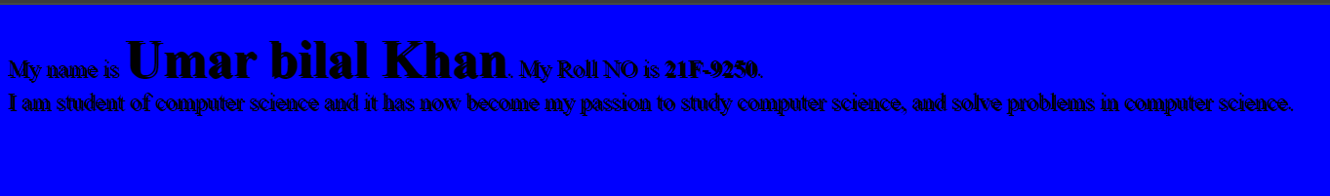

# Task 2:

## Html:

<html>

<head>

<title>Task 2</title>

<link rel="stylesheet" href="task2.css">

</head>

<body>

<h1>Start CSS Exercises</h1>

<p>Good luck!</p>

<button class="button" style="vertical-align:middle">Start CSS Exercises</button>

</body>

</html>

## Css:

button{

background-color: green;

color: white;

width: 180px;

height: 45px;

border: 0px solid;

border-radius: 5px;

}

body{

background-color: rgb(33, 32, 32);

color: white;

}

# Task 3:

## Html:

<html>

<head>

<title>Task 3</title>

</head>

<link rel="stylesheet" href="task3.css">

<body>

<div>

<form action="/submitForm" method="post">

<h1 style="text-align: center;">Contact Us</h1>

<label for="name">Your Name</label>

<input type="text" id="name" name="name" required placeholder="Umar Bilal">

<label for="email">Your Email</label>

<input type="email" id="email" name="email" required placeholder="umar@example.com">

<label for="phone">Your Phone Number</label>

<input type="tel" id="phone" name="phone" required pattern="[0-9]{3}-[0-9]{3}-[0-9]{4}" placeholder="Format: 123-456-7890">

<label for="message">Your Message</label>

<textarea id="message" name="message" required rows="4" placeholder="Type your message here..."></textarea>

<button type="submit">Submit</button>

<button type="reset">Reset</button>

</form>

</div>

</body>

</html>

## Css:

input[type=text],input[type=email],input[type=tel],textarea[id=message]{

width: 100%;

padding: 10px 20px;

margin: 7px 0;

border: 1px solid #ccc;

border-radius: 4px;

}

div {

width: 35%;

height: 90%;

margin-top: 2%;

margin-left: 30%;

border-radius: 5px;

padding: 25px;

background-color: white;

}

body{

background-color: #ccc;

}

button{

margin-top: 10px;

background-color: green;

color: white;

width: 100%;

height: 45px;

border: 0px solid;

border-radius: 5px;

}

# Task 4:

## Html:

<html>

<head>

<title>Task 4</title>

<link rel="stylesheet" href="task4.css">

</head>

<body>

<div class="gallery">

<img src="../img2.jpg" alt="Cinque Terre">

<div class="desc">Cinque Terre</div>

</div>

</body>

</html>

## Css:

div.gallery {

margin: 25px;

border: 1px solid #ccc;

float: left;

width: 300px;

box-shadow: 5px 5px 5px 5px rgb(183, 178, 178);

}

div.gallery img {

width: 100%;

height: auto;

}

div.desc{

padding: 20px;

text-align: center;

font-family: 'Gill Sans', 'Gill Sans MT', Calibri, 'Trebuchet MS', sans-serif;

font-size: larger;

}

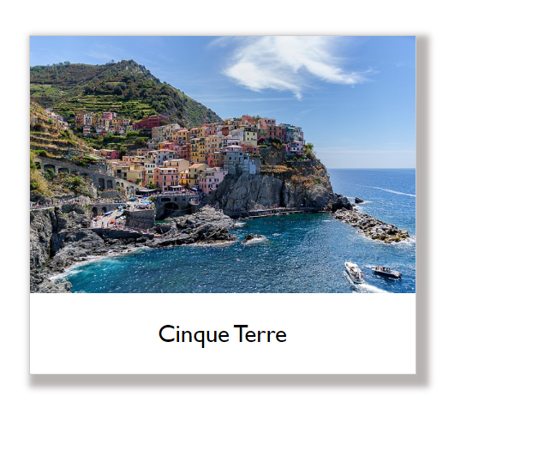

# Task 5:

## Html:

<!DOCTYPE html>

<html>

<head>

<title>Resume</title>

<link rel="stylesheet" href="task5.css">

</head>

<body>

<div class="header">

<div class="header-text">

<h1>Umar Bilal Khan</h1>

<p style="text-align: center;">Student</p>

<p><a href="https://www.linkedin.com/in/umar-bilal-04b0b7286/" target="_blank">LinkedIn</a> |

<a href="mailto:bumar1289@gmail.com" target="_blank">bumar1289@gmail.com</a> |

<a href="https://github.com/umarbilalkhan" target="_blank"> GitHub</a></p>

</div>

<img src="../profile.jpg" alt="Profile Picture">

</div>

<div class="content">

<h2>About Me</h2>

<p>Greetings everyone! I am thrilled to introduce myself as an aspiring undergraduate in the field of Computer Science. With a genuine passion for all things tech, I have eagerly immersed myself in the world of coding and problem-solving. </p>

</div>

<div class="content">

<ul>

<h2>Personal Information</h2>

<li><b>Date of birth:</b> 16 Dec,2002</li>

<li><b>Nationality</b>: Pakistani</li>

<li><b>Address:</b> Address</li>

<li><b>Email</b>: Bumar1289@gmail.com</li>

<li><b>Phone:</b> +92-3117275268</li>

</ul>

</div>

<div class="content">

<ul>

<h2>Education</h2>

<li><b>Degree:</b> BS in Computer Science</li>

<li><b>Institution:</b> FAST National University</li>

<li><b>Graduation Year: </b>2025</li>

</ul>

</div>

<div class="content">

<ul>

<h2>Job Experience</h2>

<li><b>Job Title:</b> Free lancer</li>

<li><b>Company:</b> CGA inc.</li>

<li><b>Duration:</b> 2022 - Till now</li>

<li><b>Resposibilities:</b> Front-End Developer</li>

</ul>

</div>

<div class="content">

<h2>My Projects</h2>

<h3>Project 1</h3>

<p><i>Car Price Prediction App, revolutionizing the automotive market.</i><br><br> Technology Stack:

- Backend: Python Flask was employed as the robust backend framework for model training. Leveraging the power of machine learning, our application utilized a Linear Regression model trained on a substantial dataset of over 6000 entries to predict car prices with impressive accuracy. <br><br>

- Frontend: The user-friendly and intuitive frontend of the application was crafted using Flutter, ensuring a seamless and consistent experience across both mobile and desktop platforms.</p>

<button><span>View Details </span></button>

</div>

<div class="content">

<h2>Skill</h2>

<ul>

<li>Flutter</li>

<li>HTMl/CSS</li>

<li>Oracle Database</li>

<li>Python</li>

<li>C++</li>

</ul>

</div>

<footer>Contact me at: Bumar1289@gmail.com</footer>

</body>

</html>

## Css:

body {

font-family: Arial, sans-serif;

margin: 0;

padding: 0;

display: flex;

flex-direction: column;

align-items: center;

background-color: rgb(213, 218, 218);

}

.header {

background-color: #333;

color: white;

padding: 20px;

width: 100%;

display: flex;

justify-content: center;

align-items: center;

}

.header-text {

text-align: right;

margin-right: 20px;

}

.content {

margin-top: 20px;

margin-bottom: 0;

background-color: rgb(255, 255, 255);

width: 85%;

border-radius: 20px;

padding: 20px;

}

.content:hover{

width: 95%;

transition: ease;

transition-duration: 0.5s;

}

img {

width: 120px;

height: 120px;

border-radius: 10px;

}

a{

color: white;

}

button{

background-color: rgb(62, 62, 231);

color: white;

width: 100px;

height: 30px;

border-radius: 5px;

border: 0;

}

button span {

transition: 0.5s;

}

button span:after {

content: '\00bb';

opacity: 0;

transition: 0.5s;

}

button:hover{

width: 120px;

transition-duration: 0.5s;

}

button:hover span:after {

opacity: 1;

}

footer{

height: 50px;

text-align: center;

padding-top: 20px;

background-color: #333;

width: 102%;

color: white;

margin-right: 0;

margin-top: 20px;

}

