UVM Register Model Environment with APB
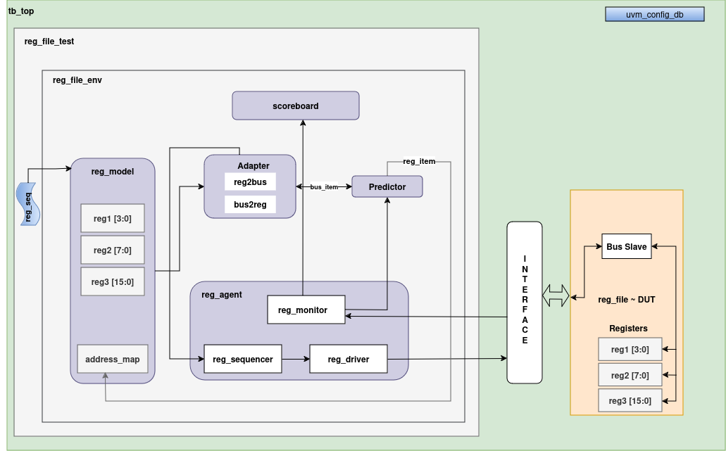

1. Overview
- Objective: The APB3 UVM environment is designed to verify an automated RTL that implements the APB3 protocol with a register file. The environment comprises UVM components like agent, sequences, sequencer, driver, monitor, adapter, predictor(default),scoreboard and a register model to perform verification.

2. Components of the APB3 UVM Environment
- APB3 Interface:
  - Defines the signals used in the APB3 protocol (PCLK, PRESETn, PSEL, PENABLE, PWRITE, PADDR, PWDATA, PRDATA, PREADY, PSLVERR).
  - Contains modports for the slave to connect with different components and DUT.
- Sequencer(default):
  - Controls the flow of transactions (read/write) to the driver.
  - Fetches the sequence items, such as address, data, and type of operation (read/write).
- Driver:
  - Receives sequence items from the sequencer and drives the corresponding signals onto the APB3 interface.
  - Responsible for driving the appropriate signal values for write and read operations on the APB bus.
  - Drive signals here which could also be assumed as a master.
- Monitor:
  - Observes the transactions on the APB3 interface and forwards them to the scoreboard and the predictor.
  - Passively monitors signals like PSEL, PENABLE, PWRITE and different signals to extract the transaction details.
- APB3 Agent:
  - Driver: The reg_file_driver drives APB signals to the DUT by converting sequence items from the sequencer into APB transactions and it will act like a master as we are initiating the signals to the DUT.
  - Monitor: The reg_file_monitor observes bus transactions on the APB interface and converts them back into sequence items. It plays a crucial role by forwarding these items to the scoreboard for verification and to the predictor for expected behavior comparison.
  - Sequencer: The agent implements the UVM default sequencer (uvm_sequencer) to manage the flow of sequence items to the driver, coordinating sequences that define the stimulus to the DUT.

- Register Model:
  - It is automatically written by the systemRDL compiler, specifically PeakRDL.
  - It Represents the register map of the DUT.
  - Used to automatically generate sequences for reading/writing registers.
  - Integrates with UVM Register Layer to perform register-level operations and checks.
- Register Adapter:
  - Converts UVM register transactions (uvm_reg_bus_op) to sequence items (reg_file_sequence_item) and vice versa.
  - The reg2bus method maps the register operation to a bus transaction.
  - The bus2reg method converts the bus transaction back to a register operation.

- Sequences(reg_file_sequence):
  - Contains read/write operations to be given to the register model and specifying a path to access the specific register for writing or reading from the register.
- Scoreboard:
  - Compares the expected results with actual results from the DUT.
  - Ensures that the read/write operations produce the correct data values.
- Environment (reg_env):
  - Instantiates and connects the agent, register model, scoreboard, driver, and adapter.
  - Responsible for the overall coordination of the testbench components.
- Test (uvm_test):
  - Configures the environment, selects sequences to run, and starts the simulation
  - Set the register block reference in the sequence.

3. Data Flow
- Write Transaction:
  - The sequences are given from reg_seq to the register model(reg_model) and then it will go to the reg_adapter for conversion from reg2bus transaction and then fetch by sequencer from the reg_adapter.
  - The driver drives the write address, data, and control signals on the APB3 interface.
  - The DUT writes the data to the appropriate register with the help of slave architecture followed in RTL.
  - The monitor observes the transaction and updates the scoreboard and predictor.
- Read Transaction:
  - The sequences are given from reg_seq to the register model(reg_model) and then it will go to the reg_adapter for conversion from reg2bus/bus2reg transaction and then fetch by sequencer from the reg_adapter.
  - The driver drives the read address and controls signals i.e, is_write will be low in case of read operation on the APB3 interface.
  - The DUT responds with the data.
  - The monitor observes the transaction and updates the scoreboard and predictor.
  - The register model verifies the data read against expected values.

4. Example of a Register Operation

- Register Write Operation
  - Sequence Initiation:
    - The sequence triggers a write operation to a specific address with a specific data value.
  - Driver Behavior:
The driver sets the APB3 signals as follows:
    - PSEL is asserted to select the peripheral.
    - PADDR is set to the target register address.
    - PWDATA is set to the data value for the write operation.
    - PWRITE is set to 1 to indicate a write operation.
    - PENABLE is asserted after the address and data are set after one clock cycle, to indicate the start of the data transfer.
    - It checks if PREADY is active then transaction would be complete and PSEL and PENABLE will go low.

  - Monitor Action:
    - The monitor observes the bus transaction.
    - The captured transaction is passed to the scoreboard and the predictor for comparison and checking.
  - Register Model Update:
    - The register model updates the internal state to reflect the new value written to the register at the specified address.
    - This update is used for later read operations to verify the correct value is stored.

- Register Read Operation:
    - The sequence triggers a read from a specific address.
    - The driver sets PSEL, PENABLE, PADDR, and PWRITE = 0 to initiate the read.
    - After the transaction, the monitor captures the data and passes it to the scoreboard and predictor.
    - The register model compares the captured data with the expected register value.

5. Waveform of APB Transaction (HW- Read/Write Access & SW-Read/Write Access)
When HW write access is given then RTL will write in register after every clock as it can be seen in waveform as well.

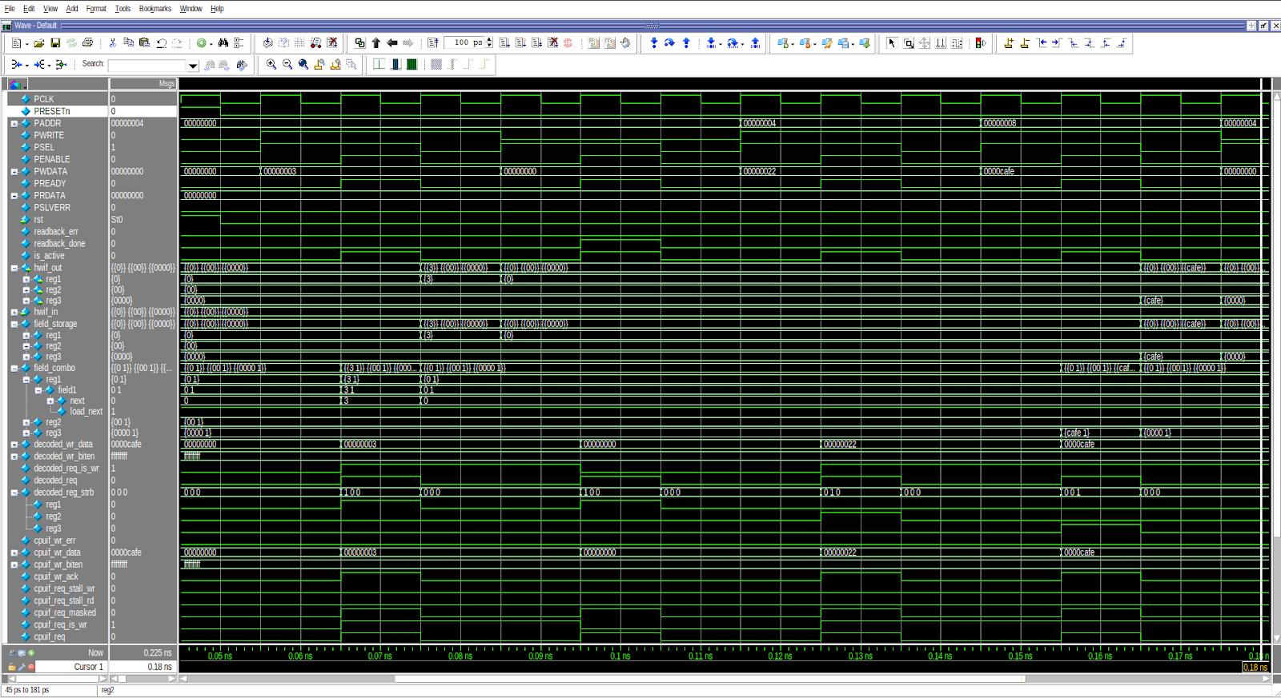

6. Waveform of APB Transaction (HW- Read Access & SW-Read/Write Access)
When HW read access is given only then RTL will not write in register after every clock as it can be seen in waveform as well.
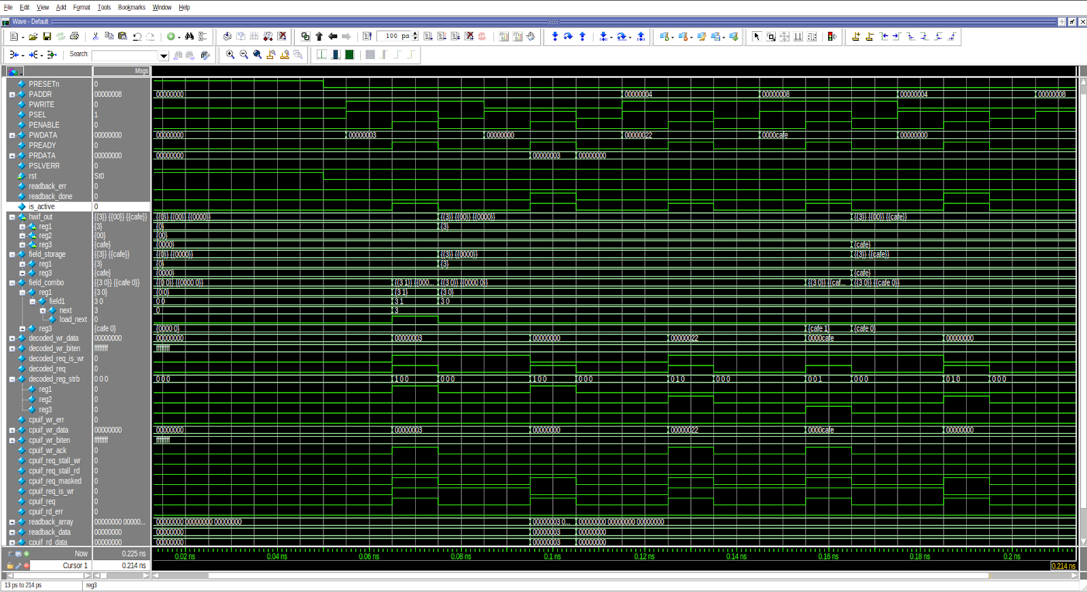

7. Waveform of APB Implementation with Displays


