ECE 526L Spring 2025 Lab 3
Simulation and Delay Analysis of Primitive Logic Gates and SR Latch Design in Verilog

I hereby attest that this lab report is entirely my own work. I have not copied either code or text from anyone, nor have I allowed or will I allow anyone to copy my work.

Name (printed): Muhammad Umar

Name (signed): Date: 02/26/2025

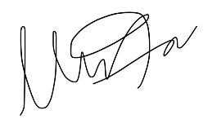


Muhammad Umar
CSUN ID: 204533244

Instructor: Prof. Orod Haghighiara

INTRODUCTION
In this lab, we analyze and simulate the behavior of logic circuits with propagation delays using Verilog. The goal is to observe how delay values impact circuit performance and identify the critical path in each design. At the end we implemented an SR latch using primitive gates and verify its functionality through a testbench.

Firstly, we simulate a given logic circuit using zero delays, testing all possible input combinations. then, we introduce specified delays to different components and observe the resulting waveform changes. The critical path, representing the longest propagation delay, is then determined. Secondly, we modify the circuit structure with addition of OR gate and repeat the simulation to analyze differences in delay and performance.

Lastly, we design an SR latch using primitive logic gates with delays provided in earlier tasks and create a testbench to verify its functionality. We have used Verilog system tasks, including $monitor, $display, $write, and $strobe, to capture and analyze simulation results effectively.

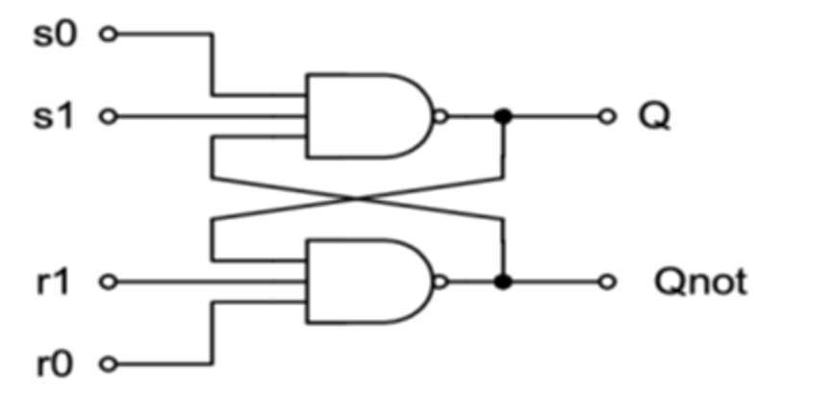
Figure 2.1 SR Latch Circuit

TABLE I. States of SR Latch
s0 | s1 | r0 | r1 | Q (Output) | Qnot (Complement) | State
1 | 1 | 1 | 1 | Qprev | Qprev | Hold
0 | 1 | 1 | 1 | 1 | 0 | Set (Q=1)
1 | 1 | 0 | 1 | 0 | 1 | Reset (Q=0)
0 | 1 | 0 | 1 | Invalid | Invalid | Invalid State

We will be testing all sixteen combinations in our test plan for SR Latch, In aforementioned table we just discussed the basic states that SR Latch can have if specific Set and Reset signal applied to it.

METHODOLOGY AND TEST PLAN

- Simulating the Initial Circuit (With Delay and Without Delay):

The first part of the lab involved compiling and simulating the provided Verilog design. The simulation tested all possible input combinations (00, 01, 10, and 11) while monitoring internal wire signals A1, A2, and NT using the “.” Operator and can be seen from the code. The waveform results were recorded for analysis. Next, delays were introduced as specified in the Lab Exercise, with different values assigned to primary outputs and fan-out signals. The design was then simulated again to observe how the delays influenced signal transitions which can be seen in a snapshot as well . The critical path, defined as the longest delay in the circuit, was determined based on these simulations.
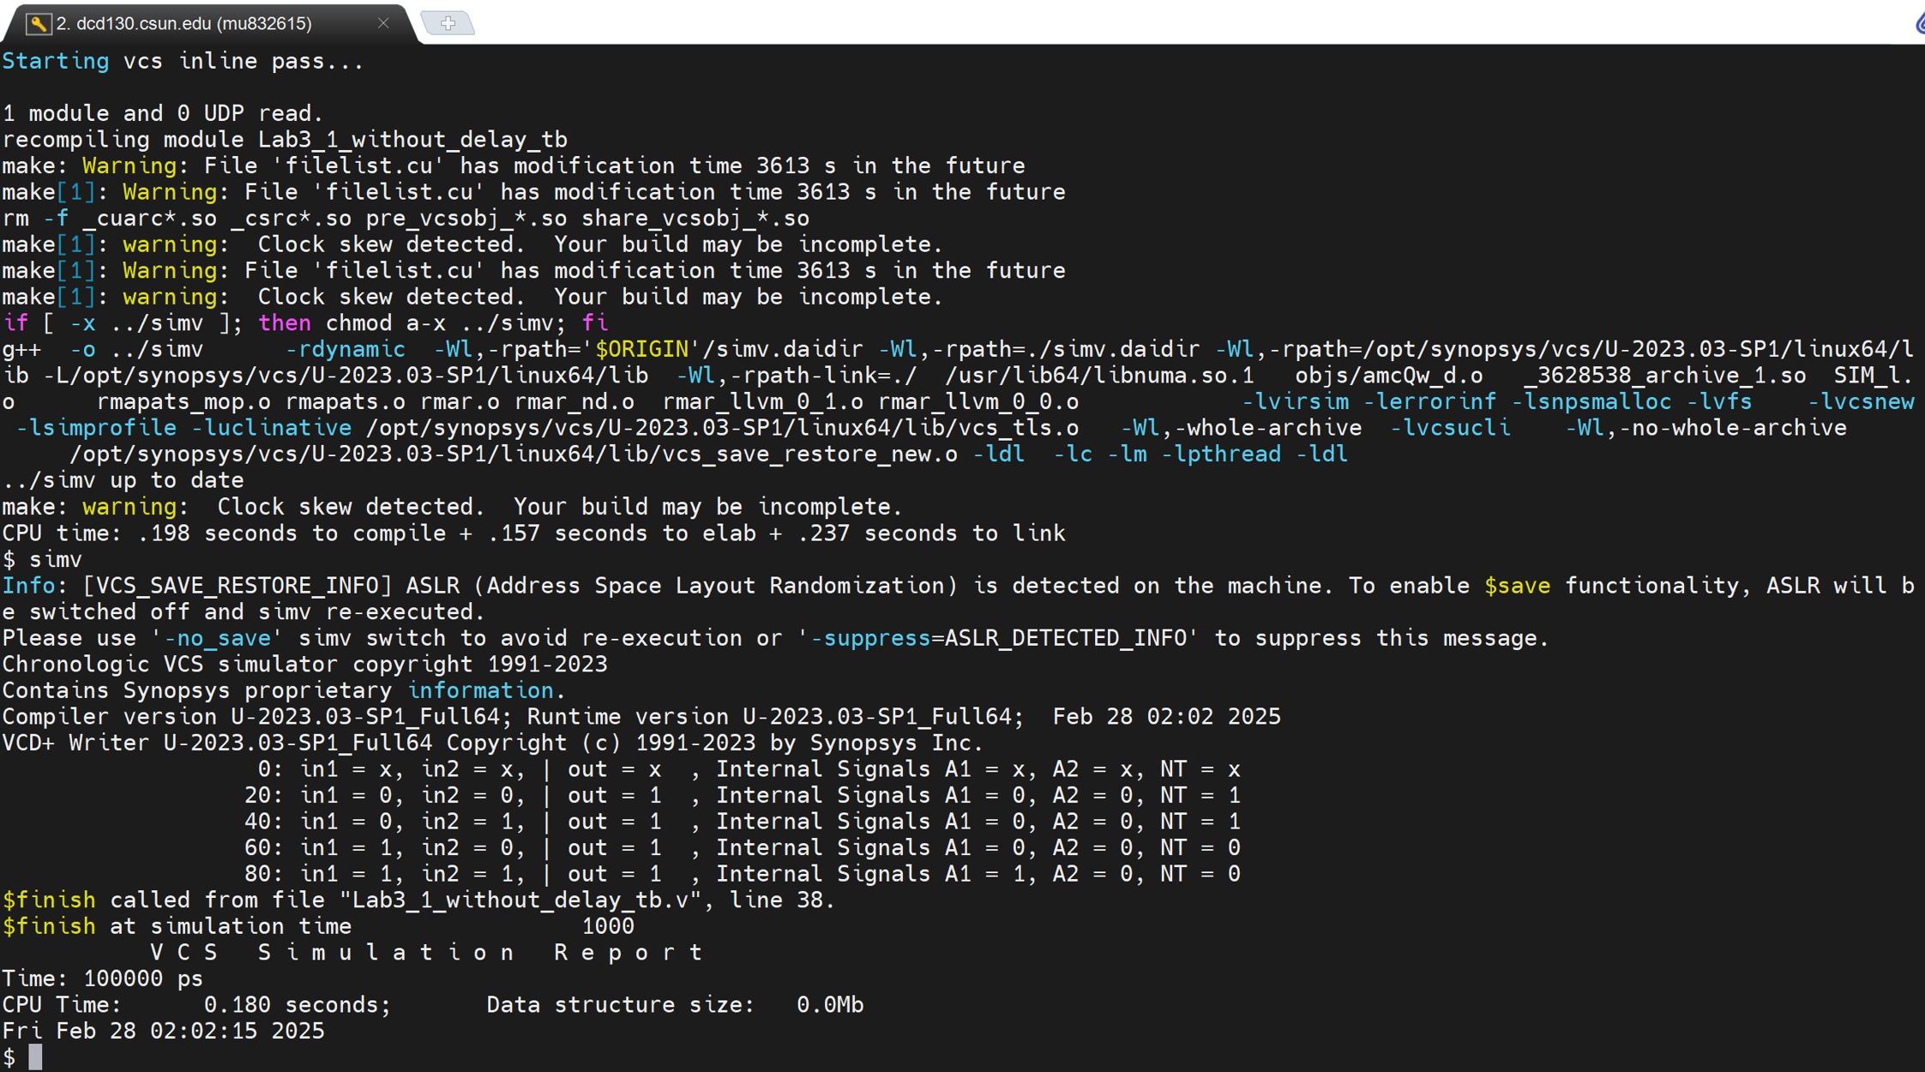
Figure 2.2 Terminal screenshot of the provided circuit simulation results without delay

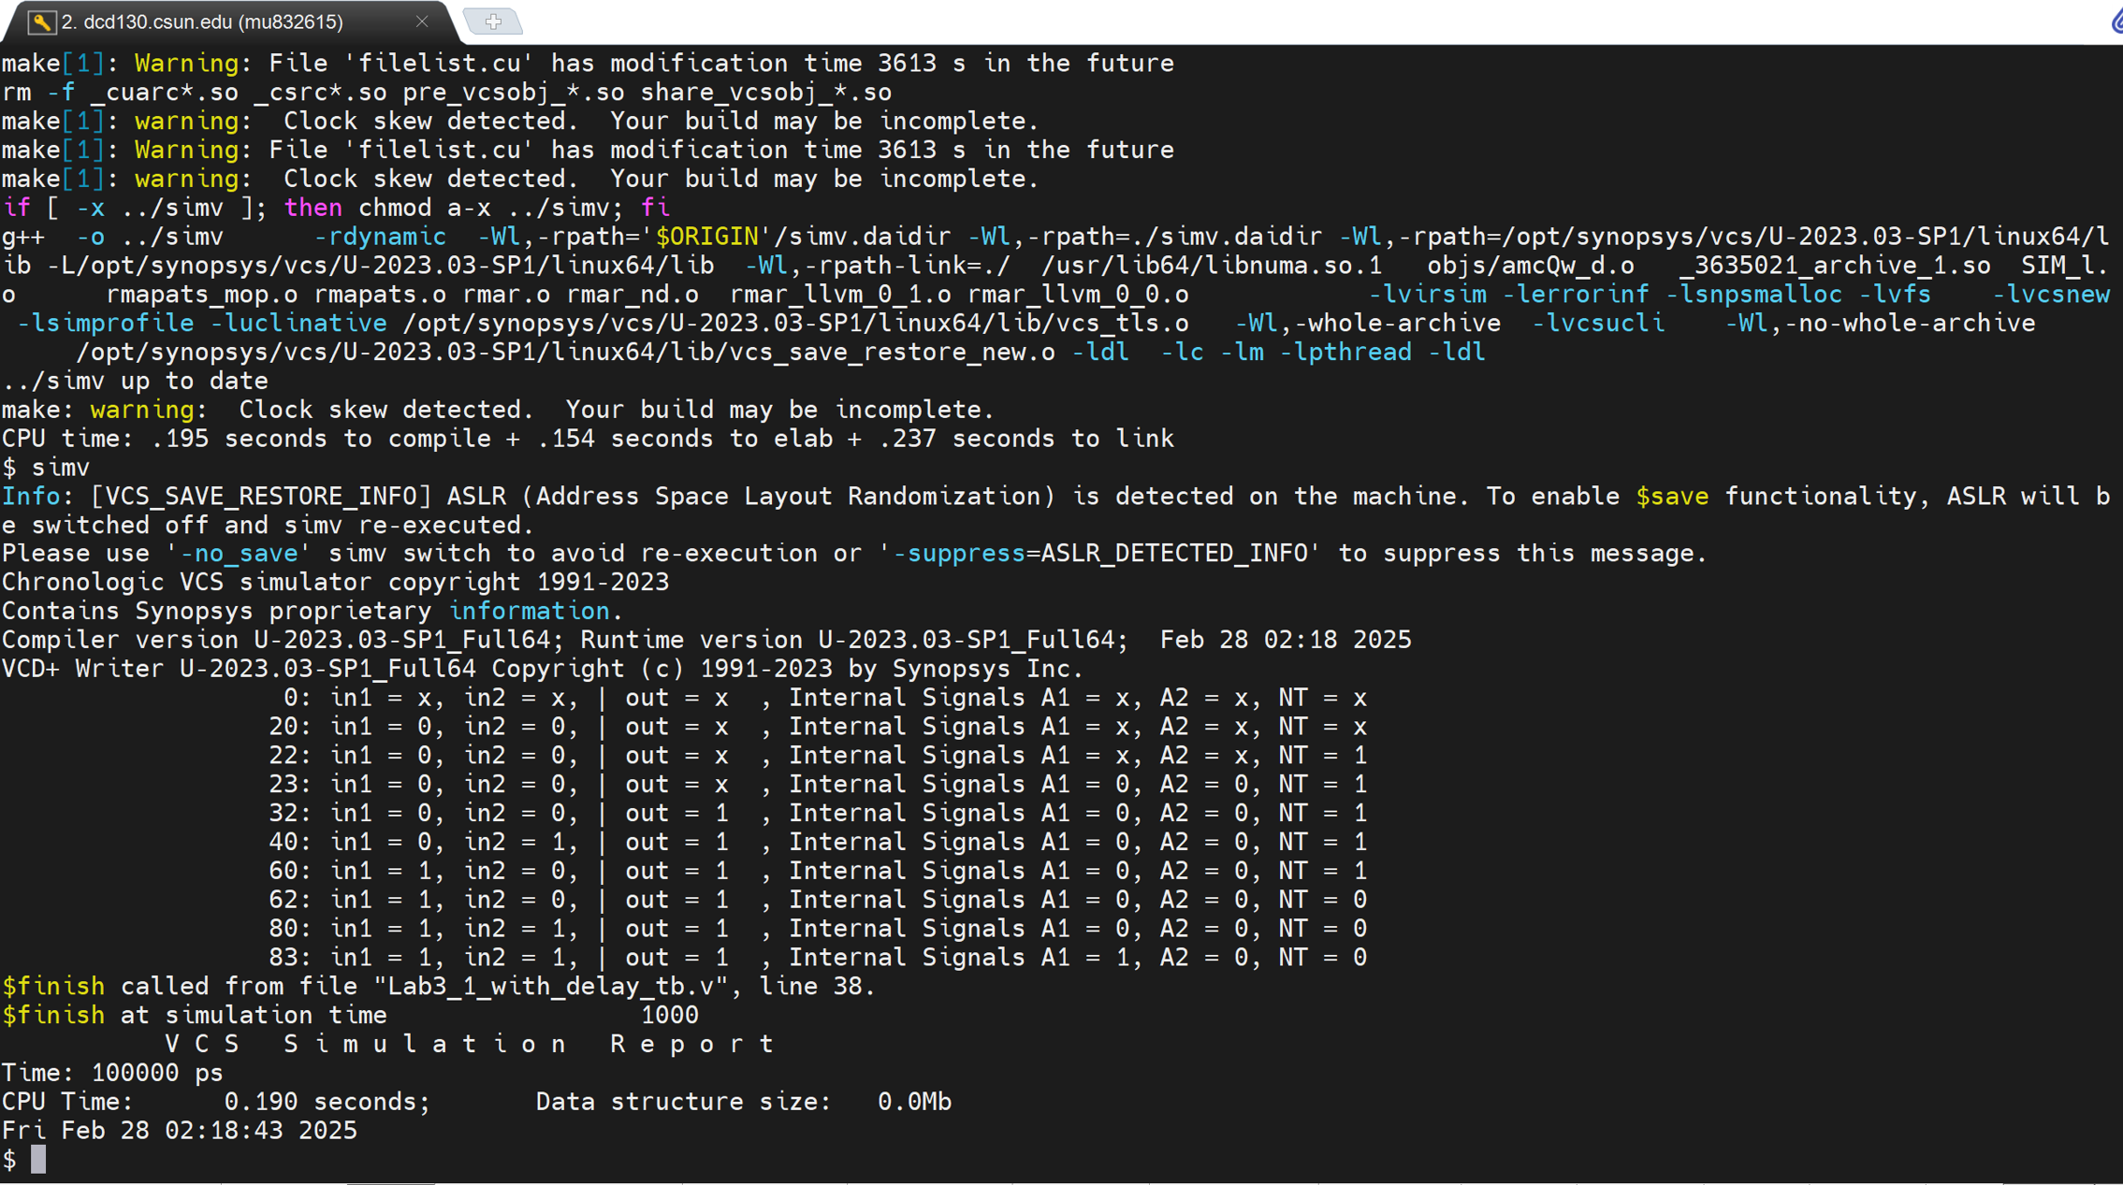
Figure 2.3 Terminal screenshot of the provided circuit simulation results with delay

From Figure 2.4 and 2.5 we can get an idea that with no delay, output transitions occur instantly with input changes. When delays are introduced, internal signals (A1, A2, NT) and the final output takes time to stabilize, causing delayed responses. The circuit no longer updates simultaneously, with each signal following its respective delay. This shows real-world propagation effects, which also highlights the importance of timing analysis in digital design. Verilog Code and Log Files can be found in Appendices at the end.
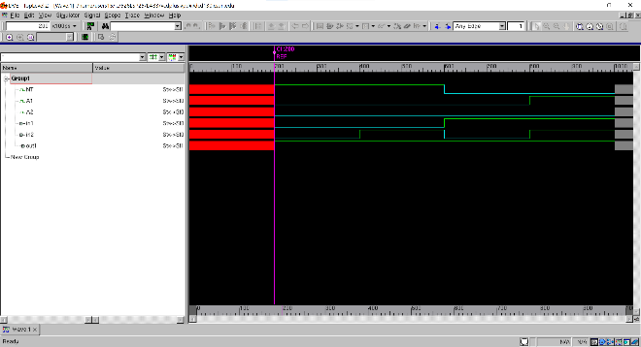
Figure 2.4 Task 1 Waveview Before Delay

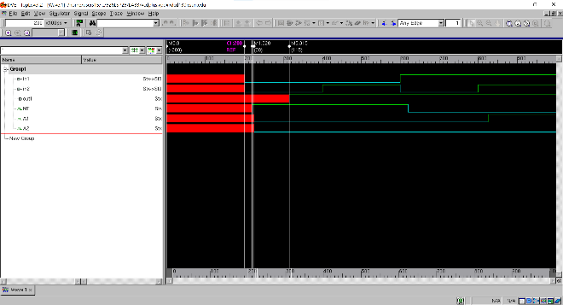
Figure 2.5 Task 1 Waveview After Delay

The critical path delay is 13.5 ns, with the path from in1 → NOT1 → AND2 → NAND1 → out1, where NOT1 has a delay of 2 ns, AND2 has 2.5 ns, and NAND1 takes 9 ns.

- Modifying the Circuit and Repeating Simulation:

In the second part of the lab, we modified the original design to a new circuit structure with the addition of OR gate and repeated the simulation process with the applied delays. Again, we analyzed the timing behavior and identified the new critical path. Here is the simulation result, verilog code and log file can be found in Appendices at the end.
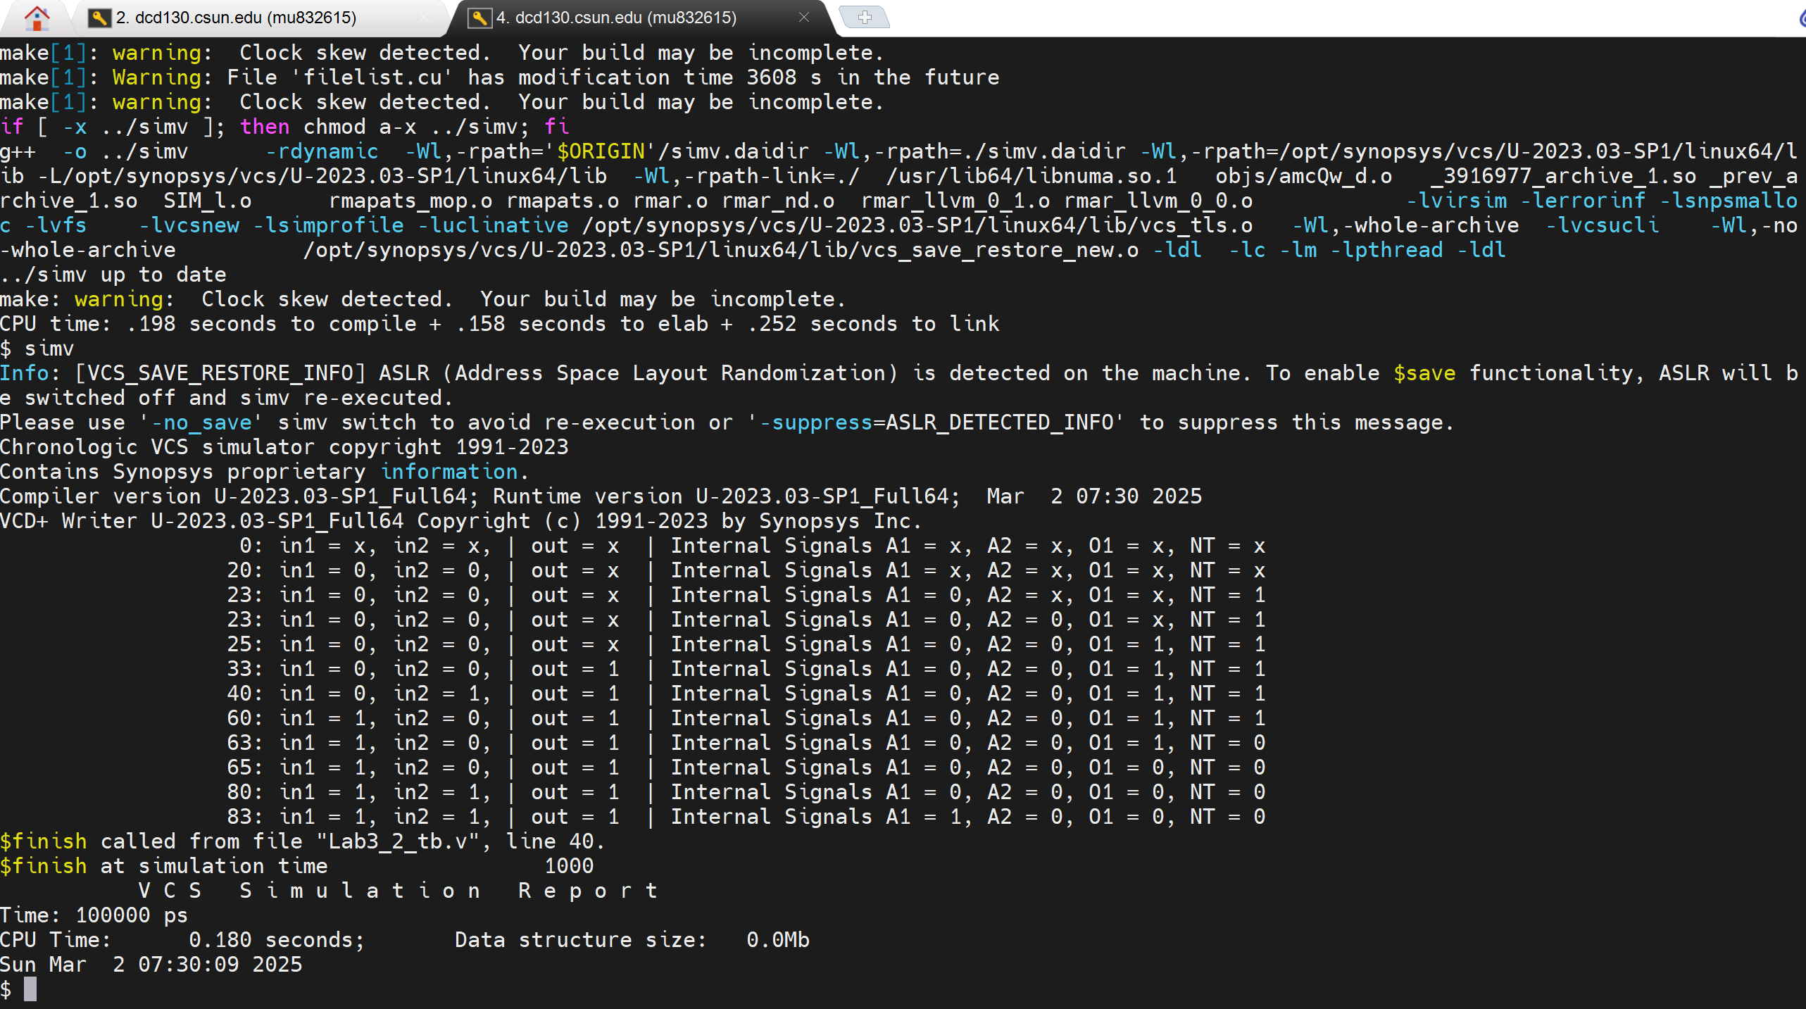
Figure 2.6 Terminal screenshot of the updated circuit results with delay

From the figure 2.6 we can conclude that after the addition of OR gate, our Output delay has been increased as compared to the previous circuit.
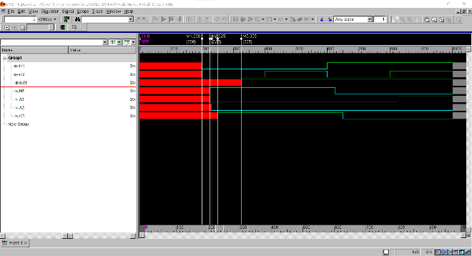
Figure 2.7 Task 2 Waveview with Delay

The critical path delay is 18 ns, with the path from in1 → NOT1 → AND2 → OR1 → NAND1 → out1, where NOT1 has a delay of 2.5 ns, AND2 has 3 ns, OR1 has 2.5 ns, and NAND1 takes 10 ns.

- Designing and Simulating the SR Latch:
The SR latch implemented using primitive gates with delays as defined earlier and tested by using timescale for the design is 1 ns / 100 ps, which is appropriate given the implemented delay values. The time unit is 1 ns, it ensures that all specified delays, which are also in nanoseconds, are accurately represented. The time precision is 100 ps, meaning that the smallest time difference the simulator can resolve is 0.1 ns. This precision is sufficient since the smallest delay in the design is 0.5 ns (FAN_OUT_1), allowing for accurate simulation of all timing characteristics without loss of resolution.
The critical path was identified to analyze the longest delay. A testbench was developed to verify functionality using system tasks such as $monitor which tracks signals in real time. Whenever a signal changes, $monitor displays the updated values. $display which prints values at specific time instances and it is useful for checking outputs at different times. $write is similar to $display but does not add a newline and allowing formatted output on the same line. $strobe prints values at the end of the simulation time step, making sure all updates are considered before displaying output. We have used all these system tasks in the the testbench. The Verilog Code and Log files can be found at the end of the report.
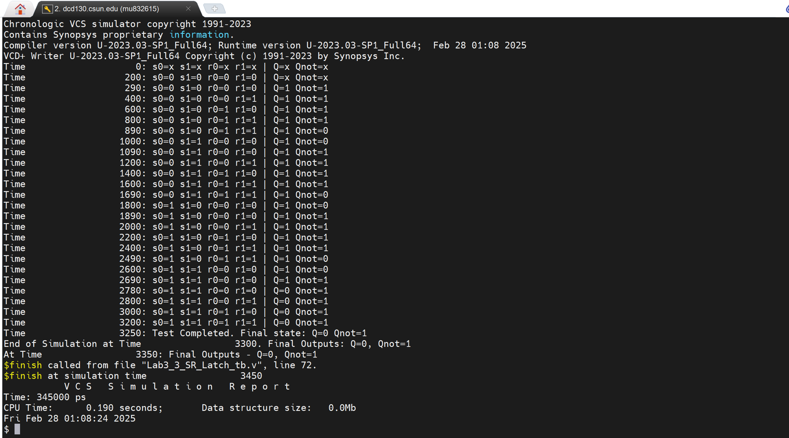
Figure 2.8 Task 3 Terminal screenshot of the SR Latch Simulation

We have applied all the 16 combinations in the testbench designed for SR Latch, where we can see that when it should Hold the Previous values and act like a memory and there are also states where the output of the SR Latch is invalid, just because of providing incorrect form of inputs, If you want to Set the SR latch then for this circuit you should give S0,S1 = (0,1) and R0,R1 = (1,1) or vice versa for the Reset.

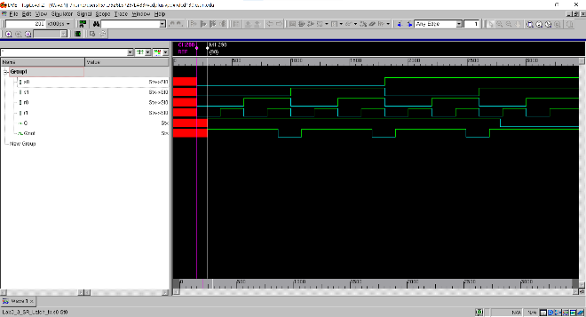
Figure 2.9 Task 3 Waveview with Delay

Since the output of one NAND depends on the other, the longest path involves the cumulative delay of both NAND gates in the feedback loop.
The critical path delay = 9 ns (NAND1) + 9 ns (NAND2) = 18 ns.

ANALYSIS OF RESULTS
The simulation results validate the functionality and timing behavior of the tested circuits. Initially, the circuit was simulated without delays, where output occurred instantly. Introducing delays mimic real world propagation effects, with a critical path delay of 13.5 ns (in1 → NOT1 → AND2 → NAND1 → out1). After modifying the circuit by adding an OR gate, the delay increased to 18 ns (in1 → NOT1 → AND2 → OR1 → NAND1 → out1), highlighting the impact of additional logic on performance. The SR latch simulation confirmed correct functionality for valid inputs and identified invalid states, with a critical path delay of 18 ns due to NAND gate feedback dependency. Screenshots and waveform results demonstrate proper signal transitions, and Verilog system tasks such as $monitor, $display, $write, and $strobe were used for tracking and analyzing outputs in the testbench.

CONCLUSION
In this lab, we simulated and analyzed provided logic circuits with propagation delays using Verilog. We explored the impact of delays on circuit performance and identified the critical path in both the original and modified designs. By adding an OR gate, we observed an increase in critical path delay from 13.5 ns to 18 ns, reinforcing the effect of additional logic on signal timing.
We gained hands-on experience in structural hardware design and the significance of precise timing analysis in digital circuits. The SR latch simulation deepened our understanding of feedback loops and their influence on propagation delays. While high-level behavioral design simplifies FPGA development, mastering gate-level design provides a solid foundation in digital logic. This lab enhanced our proficiency in Verilog and critical path analysis, contributing to a more comprehensive understanding of digital system design.

APPENDIX
Appendix A: Lab3_1_without_delay.v
/****************************************************************************
*** ***
*** EE 526 L Experiment #3 Muhammad Umar, Spring, 2025 ***
*** ***
*** Experiment #3 Design of a circuit with different gates ***
*** ***
*** Filename: Lab3_1_without_delay.v Created by Muhammad Umar, 02/26/2025***
*** ***
*** This module implements a logic circuit with NOT, AND, and NAND *** *** gates, each having specified delays to simulate gate-level timing. ***
****************************************************************************/

`timescale 1 ns / 100 ps

`define PRIMARY_OUT 0 // ns (primary outputs)
`define FAN_OUT_1 0 // ns (one output fanout)
`define FAN_OUT_2 0 // ns (two output fanout)
`define TIME_DELAY_1 0 // ns (one input gates)
`define TIME_DELAY_2 0 // ns (two input gates)
`define TIME_DELAY_3 0 // ns (three input gates)

module Lab3_1_without_delay (in1, in2, out1);
input in1, in2;
output out1;

wire NT, A1, A2;

not #(`TIME_DELAY_1 + `FAN_OUT_2) NOT1(NT, in1);
and #(`TIME_DELAY_2 + `FAN_OUT_1) AND1(A1, in2, in1);
and #(`TIME_DELAY_2 + `FAN_OUT_1) AND2(A2, in1, NT);
nand #(`TIME_DELAY_3 + `PRIMARY_OUT) NAND1(out1, NT, A1, A2);
endmodule
Appendix B: Lab3_1_without_delay_tb.v /****************************************************************************
*** ***
*** EE 526 L Experiment #3 Muhammad Umar, Spring, 2025 ***
*** ***
*** Experiment #3 Design of a circuit with different gates ***
*** ***
*** Filename:Lab3_1_without_delay_tb.v Created by Muhammad Umar 02/26/2025***
*** ***
*** This testbench simulates the Lab3_1_without_delay module, applying ***
*** different input combinations while monitoring internal signals and ***
*** displaying results with the $monitor system task. ***
****************************************************************************/
`timescale 1 ns / 100 ps // 0.5ns can be captured by applying this timescale

`define MONITOR_STR_1 "%d: in1 = %b, in2 = %b, | out = %b , Internal Signals A1 = %b, A2 = %b, NT = %b"

module Lab3_1_without_delay_tb();
reg in1, in2;
wire out;

Lab3_1_without_delay UUT(in1, in2, out);

initial begin
$monitor(`MONITOR_STR_1, $time, in1, in2, out, UUT.A1, UUT.A2, UUT.NT); // Accessing internal signals by providing instance name with "."
end

initial begin
$vcdpluson;

#20 in1 = 1'b0; in2 = 1'b0;
#20 in1 = 1'b0; in2 = 1'b1;
#20 in1 = 1'b1; in2 = 1'b0;
#20 in1 = 1'b1; in2 = 1'b1;

#20 $finish;
end
endmodule
Appendix C: Lab3_1_with_delay.v
/****************************************************************************
*** ***
*** EE 526 L Experiment #3 Muhammad Umar, Spring, 2025 ***
*** ***
*** Experiment #3 Design of a circuit with different gates ***
*** ***
*** Filename: Lab3_1_with_delay.v Created by Muhammad Umar, 02/26/2025 ***
*** ***
*** This module implements a logic circuit with NOT, AND, and NAND *** *** gates, each having specified delays to simulate gate-level timing. ***
****************************************************************************/

`timescale 1 ns / 100 ps

`define PRIMARY_OUT 5 // ns (primary outputs)
`define FAN_OUT_1 0.5 // ns (one output fanout)
`define FAN_OUT_2 1 // ns (two output fanout)
`define TIME_DELAY_1 1 // ns (one input gates)
`define TIME_DELAY_2 2 // ns (two input gates)
`define TIME_DELAY_3 4 // ns (three input gates)

module Lab3_1_with_delay (in1, in2, out1);
input in1, in2;
output out1;

wire NT, A1, A2;

not #(`TIME_DELAY_1 + `FAN_OUT_2) NOT1(NT, in1);
and #(`TIME_DELAY_2 + `FAN_OUT_1) AND1(A1, in2, in1);
and #(`TIME_DELAY_2 + `FAN_OUT_1) AND2(A2, in1, NT);
nand #(`TIME_DELAY_3 + `PRIMARY_OUT) NAND1(out1, NT, A1, A2);
endmodule
Appendix D: Lab3_1_with_delay_tb.v /****************************************************************************
*** ***
*** EE 526 L Experiment #3 Muhammad Umar, Spring, 2025 ***
*** ***
*** Experiment #3 Design of a circuit with different gates testbench ***
*** ***
*** Filename:Lab3_1_with_delay_tb.v Created by Muhammad Umar 02/26/2025 ***
*** ***
*** This testbench simulates the Lab3_1_with_delay_tb module, applying ***
*** different input combinations while monitoring internal signals and ***
*** displaying results with the $monitor system task. ***
****************************************************************************/
`timescale 1 ns / 100 ps // 0.5ns can be captured by applying this timescale

`define MONITOR_STR_1 "%d: in1 = %b, in2 = %b, | out = %b , Internal Signals A1 = %b, A2 = %b, NT = %b"

module Lab3_1_with_delay_tb();
reg in1, in2;
wire out;

Lab3_1_with_delay UUT(in1, in2, out);

initial begin
$monitor(`MONITOR_STR_1, $time, in1, in2, out, UUT.A1, UUT.A2, UUT.NT); // Accessing internal signals by providing instance name with "."
end

initial begin
$vcdpluson;

#20 in1 = 1'b0; in2 = 1'b0;
#20 in1 = 1'b0; in2 = 1'b1;
#20 in1 = 1'b1; in2 = 1'b0;
#20 in1 = 1'b1; in2 = 1'b1;

#20 $finish;
end
endmodule

Appendix E: Lab3_2.v
/****************************************************************************
*** ***
*** EE 526 L Experiment #3 Muhammad Umar, Spring, 2025 ***
*** ***
*** Experiment #3 Design of a circuit with different gates ***
*** ***
*** Filename: Lab3_2.v Created by Muhammad Umar, 02/26/2025 ***
*** ***
*** This module implements a logic circuit with NOT, AND, and NAND *** *** gates, each having specified delays to simulate gate-level timing. ***
****************************************************************************/

`timescale 1 ns / 100 ps

`define PRIMARY_OUT 5 // ns (primary outputs)
`define FAN_OUT_1 0.5 // ns (one output fanout)
`define FAN_OUT_2 1 // ns (two output fanout)
`define FAN_OUT_3 1.5 // ns (three output fanout)
`define TIME_DELAY_1 1 // ns (one input gates)
`define TIME_DELAY_2 2 // ns (two input gates)
`define TIME_DELAY_3 4 // ns (three input gates)
`define TIME_DELAY_4 5 // ns (four input gates)

module Lab3_2 (in1, in2, out1);
input in1, in2;
output out1;

wire NT, A1, A2, O1;

not #(`TIME_DELAY_1 + `FAN_OUT_3) NOT1(NT, in1);
and #(`TIME_DELAY_2 + `FAN_OUT_1) AND1(A1, in2, in1);
and #(`TIME_DELAY_2 + `FAN_OUT_2) AND2(A2, in1, NT);
or #(`TIME_DELAY_2 + `FAN_OUT_1) OR1(O1, NT, A2); // addition of OR gate, output will be stored in "O1" declared above
nand #(`TIME_DELAY_4 + `PRIMARY_OUT) NAND1(out1, NT, A1, A2, O1);
endmodule
Appendix F: Lab3_2_tb.v /****************************************************************************
*** ***
*** EE 526 L Experiment #3 Muhammad Umar, Spring, 2025 ***
*** ***
*** Experiment #3 Design of a circuit with different gates testbench ***
*** ***
*** Filename:Lab3_2_tb.v Created by Muhammad Umar 02/26/2025 ***
*** ***
*** This testbench simulates the Lab3_2 module, applying ***
*** different input combinations while monitoring internal signals and ***
*** displaying results with the $monitor system task. ***
****************************************************************************/
` `timescale 1 ns / 100 ps // 0.1ns can be captured by selecting this timescale

`define MONITOR_STR_1 "%d: in1 = %b, in2 = %b, | out = %b | Internal Signals A1 = %b, A2 = %b, O1 = %b, NT = %b"

module Lab3_2_tb();
reg in1, in2;
wire out;

Lab3_2 UUT(in1, in2, out);

initial begin
$monitor(`MONITOR_STR_1, $time, in1, in2, out, UUT.A1, UUT.A2,UUT.O1, UUT.NT);
end

initial begin
$vcdpluson;

// All possible combinations applied here without x and z conditions

#20 in1 = 1'b0; in2 = 1'b0;
#20 in1 = 1'b0; in2 = 1'b1;
#20 in1 = 1'b1; in2 = 1'b0;
#20 in1 = 1'b1; in2 = 1'b1;

#20 $finish;
end
endmodule
Appendix G: Lab3_3_SR_Latch.v
/***************************************************************************
*** ***
*** EE 526 L Experiment #3 Muhammad Umar, Spring, 2025 ***
*** ***
*** Experiment #3 Design of a circuit with different gates and SR Latch ***
*** ***
*** Filename: Lab3_3_SR_Latch.v Created by Muhammad Umar, 02/26/2025 ***
*** ***
*** This module implements an SR latch using NAND gates with specified ***
*** delays to observe timing effects. ***
***************************************************************************/

`timescale 1ns/100ps // Timescale for delay observation

`define PRIMARY_OUT 5 // ns (primary outputs)
`define FAN_OUT_2 1 // ns (two output fanout)
`define TIME_DELAY_3 4 // ns (three input gates)

module Lab3_3_SR_Latch(
output Q, // Output for SR latch
output Qnot, // invert of Q
input s0,
input s1,
input r0,
input r1
);

nand #(`TIME_DELAY_3 + `PRIMARY_OUT) NAND1(Q, s0, s1, Qnot); // 3-input NAND gate for Q
nand #(`TIME_DELAY_3 + `PRIMARY_OUT) NAND2(Qnot, r0, r1, Q); // 3-input NAND gate for Qnot

endmodule
Appendix H: Lab3_3_SR_Latch_tb.v /***************************************************************************
*** ***
*** EE 526 L Experiment #3 Muhammad Umar, Spring, 2025 ***
*** ***
*** Experiment #3 Different gates logical circuit and SR Latch testbench ***
*** ***
*** Filename: Lab3_3_SR_Latch_tb.v Created by Muhammad Umar, 02/26/2025***
*** ***
*** This testbench verifies the functionality of the SR latch by ***
*** applying different input combinations and monitoring the outputs ***
*** with different system tasks like monitor, strobe and display. ***
***************************************************************************/

`timescale 1ns/100ps // Timescale for delay observation

module Lab3_3_SR_Latch_tb();
reg s0, s1, r0, r1;
wire Q, Qnot;

// DUT Instantiation
Lab3_3_SR_Latch UUT(Q, Qnot, s0, s1, r0, r1);

// Monitor signal changes display whenever each one changed
initial
$monitor("Time %t: s0=%b s1=%b r0=%b r1=%b | Q=%b Qnot=%b",
$time, s0, s1, r0, r1, Q, Qnot);

initial begin

$vcdpluson;

// Apply all 16 possible input combinations

#20 s0=0; s1=0; r0=0; r1=0; // Invalid (Both Q and Qnot = 1)
#20 s0=0; s1=0; r0=0; r1=1; // Invalid
#20 s0=0; s1=0; r0=1; r1=0; // Invalid
#20 s0=0; s1=0; r0=1; r1=1; // Invalid

#20 s0=0; s1=1; r0=0; r1=0; // Invalid
#20 s0=0; s1=1; r0=0; r1=1; // Invalid (Simultaneous Set & Reset occur here)
#20 s0=0; s1=1; r0=1; r1=0; // Invalid (Both Q and Qnot = 1)
#20 s0=0; s1=1; r0=1; r1=1; // Correct Set (Q=1, Qnot=0)

#20 s0=1; s1=0; r0=0; r1=0; // Invalid
#20 s0=1; s1=0; r0=0; r1=1; // Set (Q=1, Qnot=0)
#20 s0=1; s1=0; r0=1; r1=0; // Invalid (Both Q and Qnot = 1)
#20 s0=1; s1=0; r0=1; r1=1; // Set (Q=1, Qnot=0)

#20 s0=1; s1=1; r0=0; r1=0; // Reset (Q=0, Qnot=1)
#20 s0=1; s1=1; r0=0; r1=1; // Reset (Q=0, Qnot=1)
#20 s0=1; s1=1; r0=1; r1=0; // Reset (Q=0, Qnot=1)
#20 s0=1; s1=1; r0=1; r1=1; // Hold (Q and Qnot remain unchanged)

// Demonstrate usage of different output system tasks

// $display prints immediately with a newline
#5 $display("Time %t: Test Completed. Final state: Q=%b Qnot=%b",
$time, Q, Qnot);

// $write prints immediately without a newline
#5 $write("End of Simulation at Time %t. ", $time);
$write("Final Outputs: Q=%b, Qnot=%b\n", Q, Qnot);

// $strobe prints at the end of the current time step
#5 $strobe("At Time %t: Final Outputs - Q=%b, Qnot=%b",
$time, Q, Qnot);

#10 $finish;
end
endmodule

Appendix I: Lab3_1_without_delay.log

Command: /home/users15/mu832615/526LSP25/LAB3/./simv -l Lab3_1_without_delay.log
Chronologic VCS simulator copyright 1991-2023
Contains Synopsys proprietary information.
Compiler version U-2023.03-SP1_Full64; Runtime version U-2023.03-SP1_Full64; Feb 28 02:04 2025
VCD+ Writer U-2023.03-SP1_Full64 Copyright (c) 1991-2023 by Synopsys Inc.
0: in1 = x, in2 = x, | out = x , Internal Signals A1 = x, A2 = x, NT = x
20: in1 = 0, in2 = 0, | out = 1 , Internal Signals A1 = 0, A2 = 0, NT = 1
40: in1 = 0, in2 = 1, | out = 1 , Internal Signals A1 = 0, A2 = 0, NT = 1
60: in1 = 1, in2 = 0, | out = 1 , Internal Signals A1 = 0, A2 = 0, NT = 0
80: in1 = 1, in2 = 1, | out = 1 , Internal Signals A1 = 1, A2 = 0, NT = 0
$finish called from file "Lab3_1_without_delay_tb.v", line 38.
$finish at simulation time 1000
V C S S i m u l a t i o n R e p o r t
Time: 100000 ps
CPU Time: 0.180 seconds; Data structure size: 0.0Mb
Fri Feb 28 02:04:46 2025

Appendix J: Lab3_1_with_delay.log

Command: /home/users15/mu832615/526LSP25/LAB3/./simv -l Lab3_1_with_delay.log
Chronologic VCS simulator copyright 1991-2023
Contains Synopsys proprietary information.
Compiler version U-2023.03-SP1_Full64; Runtime version U-2023.03-SP1_Full64; Feb 28 02:20 2025
VCD+ Writer U-2023.03-SP1_Full64 Copyright (c) 1991-2023 by Synopsys Inc.
0: in1 = x, in2 = x, | out = x , Internal Signals A1 = x, A2 = x, NT = x
20: in1 = 0, in2 = 0, | out = x , Internal Signals A1 = x, A2 = x, NT = x
22: in1 = 0, in2 = 0, | out = x , Internal Signals A1 = x, A2 = x, NT = 1
23: in1 = 0, in2 = 0, | out = x , Internal Signals A1 = 0, A2 = 0, NT = 1
32: in1 = 0, in2 = 0, | out = 1 , Internal Signals A1 = 0, A2 = 0, NT = 1
40: in1 = 0, in2 = 1, | out = 1 , Internal Signals A1 = 0, A2 = 0, NT = 1
60: in1 = 1, in2 = 0, | out = 1 , Internal Signals A1 = 0, A2 = 0, NT = 1
62: in1 = 1, in2 = 0, | out = 1 , Internal Signals A1 = 0, A2 = 0, NT = 0
80: in1 = 1, in2 = 1, | out = 1 , Internal Signals A1 = 0, A2 = 0, NT = 0
83: in1 = 1, in2 = 1, | out = 1 , Internal Signals A1 = 1, A2 = 0, NT = 0
$finish called from file "Lab3_1_with_delay_tb.v", line 38.
$finish at simulation time 1000
V C S S i m u l a t i o n R e p o r t
Time: 100000 ps
CPU Time: 0.180 seconds; Data structure size: 0.0Mb
Fri Feb 28 02:20:52 2025

Appendix K: Lab3_2.log
Command: /home/users15/mu832615/526LSP25/LAB3/./simv -l Lab3_2.log
Chronologic VCS simulator copyright 1991-2023
Contains Synopsys proprietary information.
Compiler version U-2023.03-SP1_Full64; Runtime version U-2023.03-SP1_Full64; Feb 28 02:31 2025
VCD+ Writer U-2023.03-SP1_Full64 Copyright (c) 1991-2023 by Synopsys Inc.
0: in1 = x, in2 = x, | out = x | Internal Signals A1 = x, A2 = x, O1 = x, NT = x
20: in1 = 0, in2 = 0, | out = x | Internal Signals A1 = x, A2 = x, O1 = x, NT = x
23: in1 = 0, in2 = 0, | out = x | Internal Signals A1 = 0, A2 = x, O1 = x, NT = 1
23: in1 = 0, in2 = 0, | out = x | Internal Signals A1 = 0, A2 = 0, O1 = x, NT = 1
25: in1 = 0, in2 = 0, | out = x | Internal Signals A1 = 0, A2 = 0, O1 = 1, NT = 1
33: in1 = 0, in2 = 0, | out = 1 | Internal Signals A1 = 0, A2 = 0, O1 = 1, NT = 1
40: in1 = 0, in2 = 1, | out = 1 | Internal Signals A1 = 0, A2 = 0, O1 = 1, NT = 1
60: in1 = 1, in2 = 0, | out = 1 | Internal Signals A1 = 0, A2 = 0, O1 = 1, NT = 1
63: in1 = 1, in2 = 0, | out = 1 | Internal Signals A1 = 0, A2 = 0, O1 = 1, NT = 0
65: in1 = 1, in2 = 0, | out = 1 | Internal Signals A1 = 0, A2 = 0, O1 = 0, NT = 0
80: in1 = 1, in2 = 1, | out = 1 | Internal Signals A1 = 0, A2 = 0, O1 = 0, NT = 0
83: in1 = 1, in2 = 1, | out = 1 | Internal Signals A1 = 1, A2 = 0, O1 = 0, NT = 0
$finish called from file "Lab3_2_tb.v", line 40.
$finish at simulation time 1000
V C S S i m u l a t i o n R e p o r t
Time: 100000 ps
CPU Time: 0.190 seconds; Data structure size: 0.0Mb
Fri Feb 28 02:31:23 2025

Appendix L: Log3_3_SR_Latch.log
Command: /home/users15/mu832615/526LSP25/LAB3/./simv -l Log3_3_SR_Latch.log
Chronologic VCS simulator copyright 1991-2023
Contains Synopsys proprietary information.
Compiler version U-2023.03-SP1_Full64; Runtime version U-2023.03-SP1_Full64; Feb 28 01:12 2025
VCD+ Writer U-2023.03-SP1_Full64 Copyright (c) 1991-2023 by Synopsys Inc.
Time 0: s0=x s1=x r0=x r1=x | Q=x Qnot=x
Time 200: s0=0 s1=0 r0=0 r1=0 | Q=x Qnot=x
Time 290: s0=0 s1=0 r0=0 r1=0 | Q=1 Qnot=1
Time 400: s0=0 s1=0 r0=0 r1=1 | Q=1 Qnot=1
Time 600: s0=0 s1=0 r0=1 r1=0 | Q=1 Qnot=1
Time 800: s0=0 s1=0 r0=1 r1=1 | Q=1 Qnot=1
Time 890: s0=0 s1=0 r0=1 r1=1 | Q=1 Qnot=0
Time 1000: s0=0 s1=1 r0=0 r1=0 | Q=1 Qnot=0
Time 1090: s0=0 s1=1 r0=0 r1=0 | Q=1 Qnot=1
Time 1200: s0=0 s1=1 r0=0 r1=1 | Q=1 Qnot=1
Time 1400: s0=0 s1=1 r0=1 r1=0 | Q=1 Qnot=1
Time 1600: s0=0 s1=1 r0=1 r1=1 | Q=1 Qnot=1
Time 1690: s0=0 s1=1 r0=1 r1=1 | Q=1 Qnot=0
Time 1800: s0=1 s1=0 r0=0 r1=0 | Q=1 Qnot=0
Time 1890: s0=1 s1=0 r0=0 r1=0 | Q=1 Qnot=1
Time 2000: s0=1 s1=0 r0=0 r1=1 | Q=1 Qnot=1
Time 2200: s0=1 s1=0 r0=1 r1=0 | Q=1 Qnot=1
Time 2400: s0=1 s1=0 r0=1 r1=1 | Q=1 Qnot=1
Time 2490: s0=1 s1=0 r0=1 r1=1 | Q=1 Qnot=0
Time 2600: s0=1 s1=1 r0=0 r1=0 | Q=1 Qnot=0
Time 2690: s0=1 s1=1 r0=0 r1=0 | Q=1 Qnot=1
Time 2780: s0=1 s1=1 r0=0 r1=0 | Q=0 Qnot=1
Time 2800: s0=1 s1=1 r0=0 r1=1 | Q=0 Qnot=1
Time 3000: s0=1 s1=1 r0=1 r1=0 | Q=0 Qnot=1
Time 3200: s0=1 s1=1 r0=1 r1=1 | Q=0 Qnot=1
Time 3250: Test Completed. Final state: Q=0 Qnot=1
End of Simulation at Time 3300. Final Outputs: Q=0, Qnot=1
At Time 3350: Final Outputs - Q=0, Qnot=1
$finish called from file "Lab3_3_SR_Latch_tb.v", line 72.
$finish at simulation time 3450
V C S S i m u l a t i o n R e p o r t
Time: 345000 ps
CPU Time: 0.180 seconds; Data structure size: 0.0Mb
Fri Feb 28 01:12:07 2025

