ECE 526L Spring 2025 Lab 2 Design a Full Adder

2/13/2025


Muhammad Umar
CSUN ID: 204533244

Instructor: Prof. Orod Haghighiara

I hereby attest that this lab report is entirely my own work. I have not copied either code or text from anyone, nor have I allowed or will I allow anyone to copy my work.

Name (printed): Muhammad Umar

Name (signed): Date: 02/13/2025

Introduction
This introductory lab objective is to familiarize ourselves with using digital design concepts by implementing and testing basic combinational circuits using Verilog. The primary objective is to design and verify a half adder and full adder at the gate level and how to instantiate the design in the testbench for verification.

Connecting to the CSUN Server
Before starting the lab, we need to connect to a CSUN server using VPN and then open MobaXterm. The available machines range from 130 -159 and I have selected dcd130. After connecting, we navigate to the working directory and create a directory for the lab as mentioned in the below snapshot.
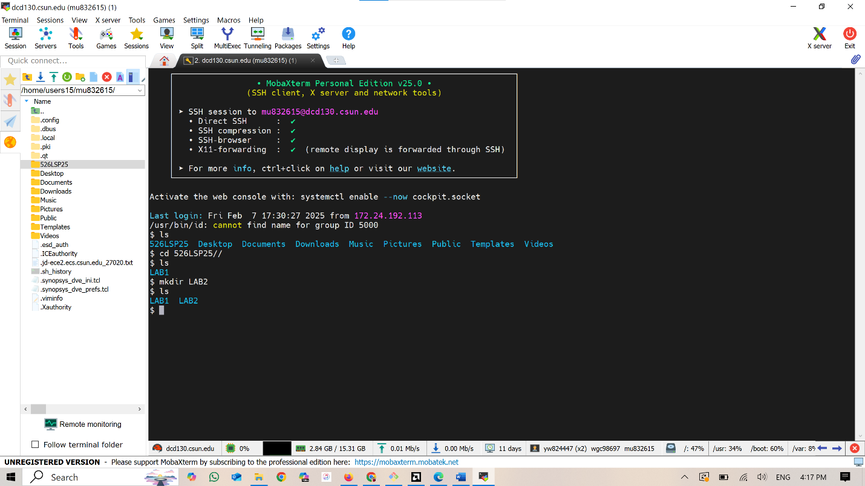

Writing Verilog Code for Half Adder and Full Adder using Vim
I used a text editor called Vim for writing Verilog code and we can access it by using the command vi half_adder.v.

Half Adder Design (half_adder.v)
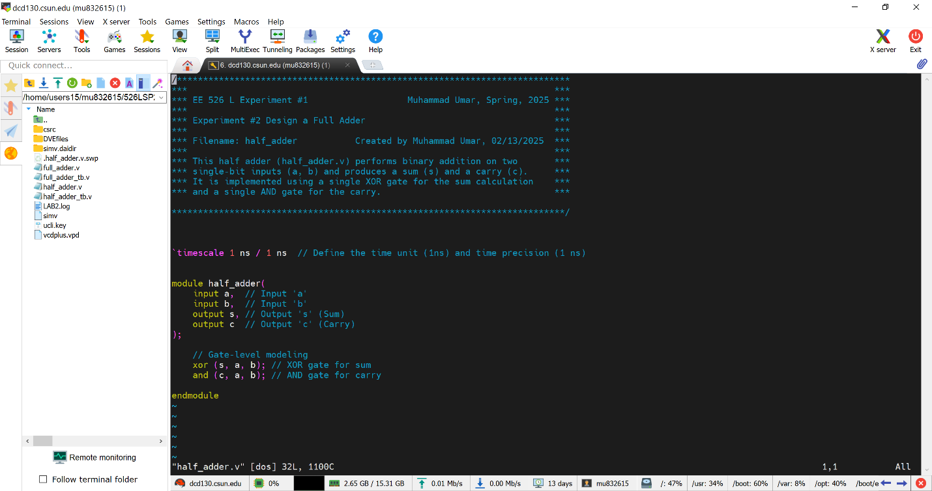

Half Adder Testbench (half_adder_tb.v)
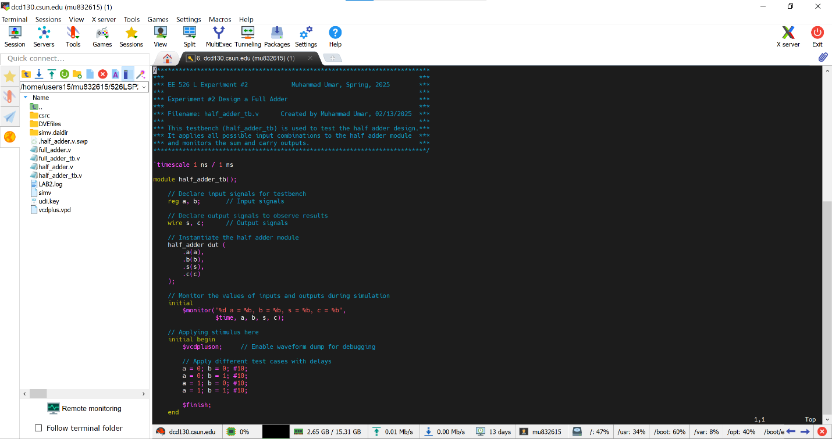

Compiling and Simulating Using VCS
Now compiling the design and testbench ﬁle using the following command:
vcs -debug_access+all half_adder.v half_adder_tb.v

Invoking VCS Simulator
By using simv command
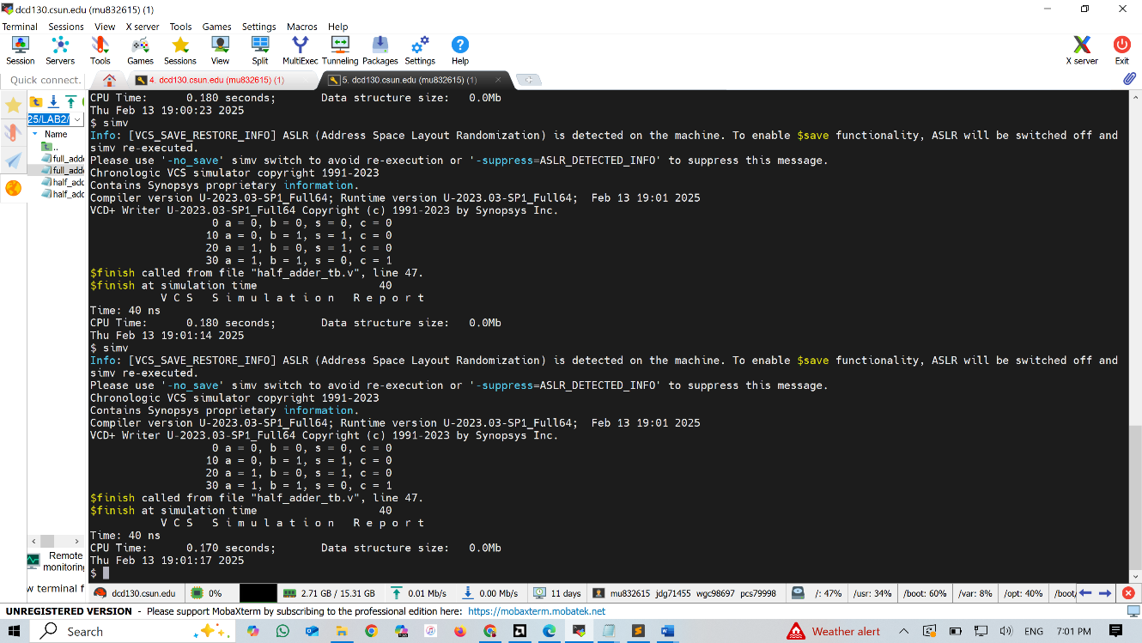

Full Adder Design (full_adder.v)
By using prior half adder and instantiating it two times with different instance.
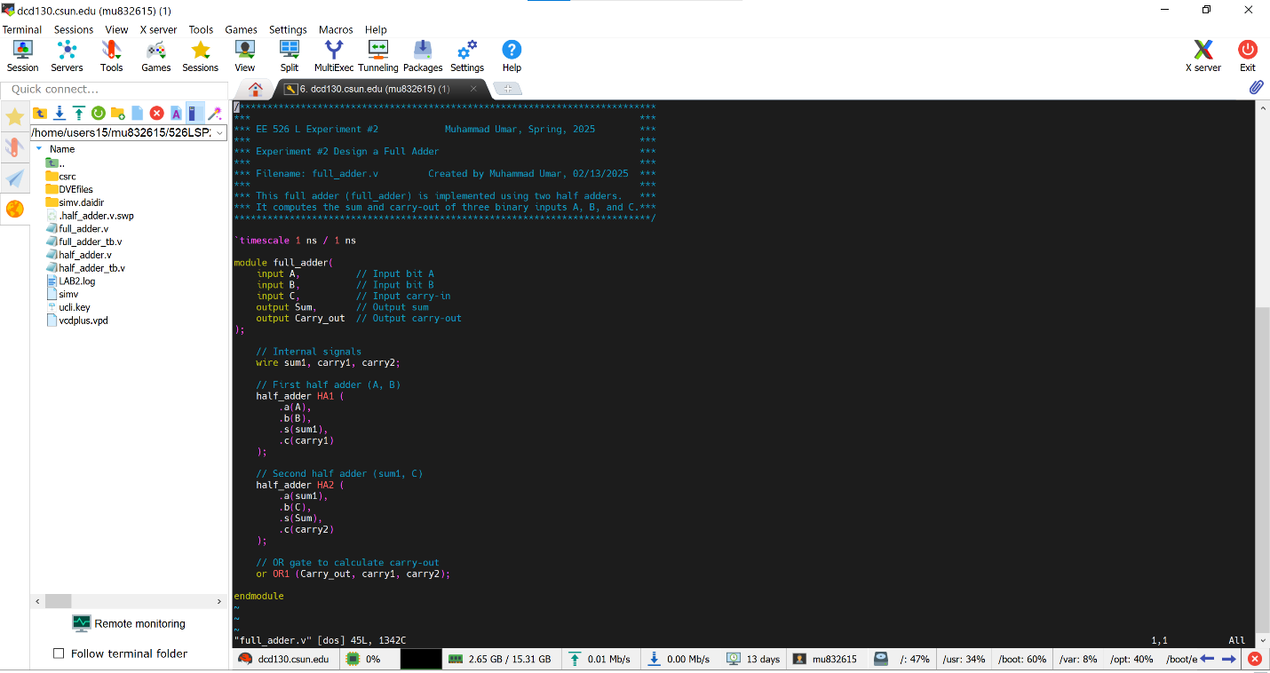

Full Adder Testbench (full_adder_tb.v)
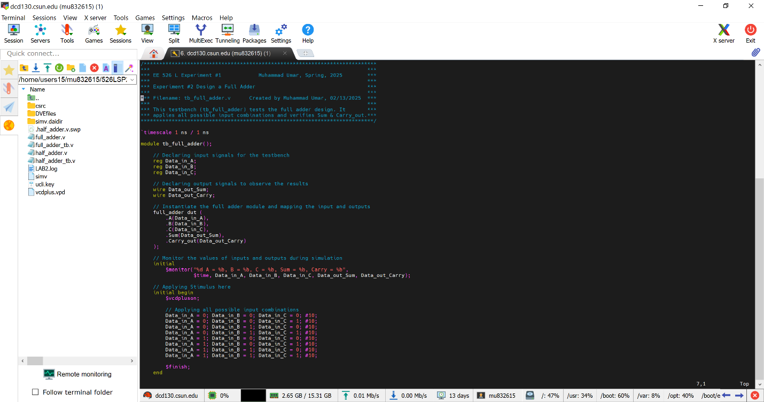

Compiling and Simulating Using VCS
Now compiling the design and testbench ﬁle using the following command:
vcs -debug_access+all half_adder.v full_adder.v full_adder_tb.v

Invoking VCS Simulator
By using simv command
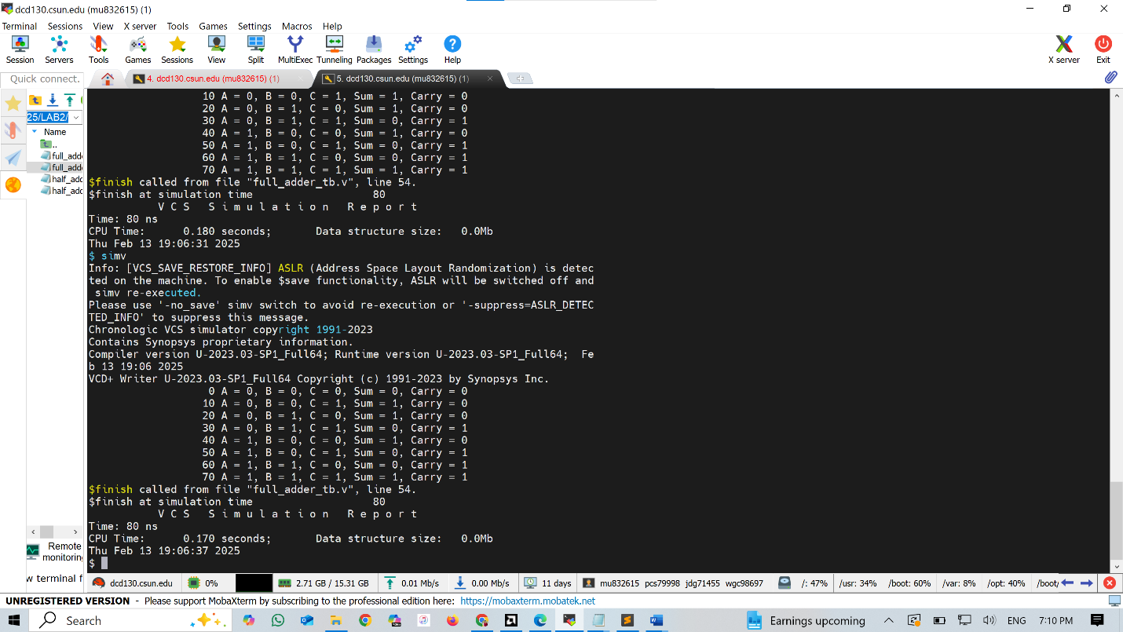

Creating Log File
We have to use the following command for log file generation.
simv –l LAB2.log

Waveform
We have to use the following command to display dve and add vpd file for dumping signals in a waveform.
dve -full64

Adding Signals to Waveform
We have to add signals by selecting all signals including the internal signals of the module by getting it from the module after double-clicking it and then adding all signals to the New Wave View.
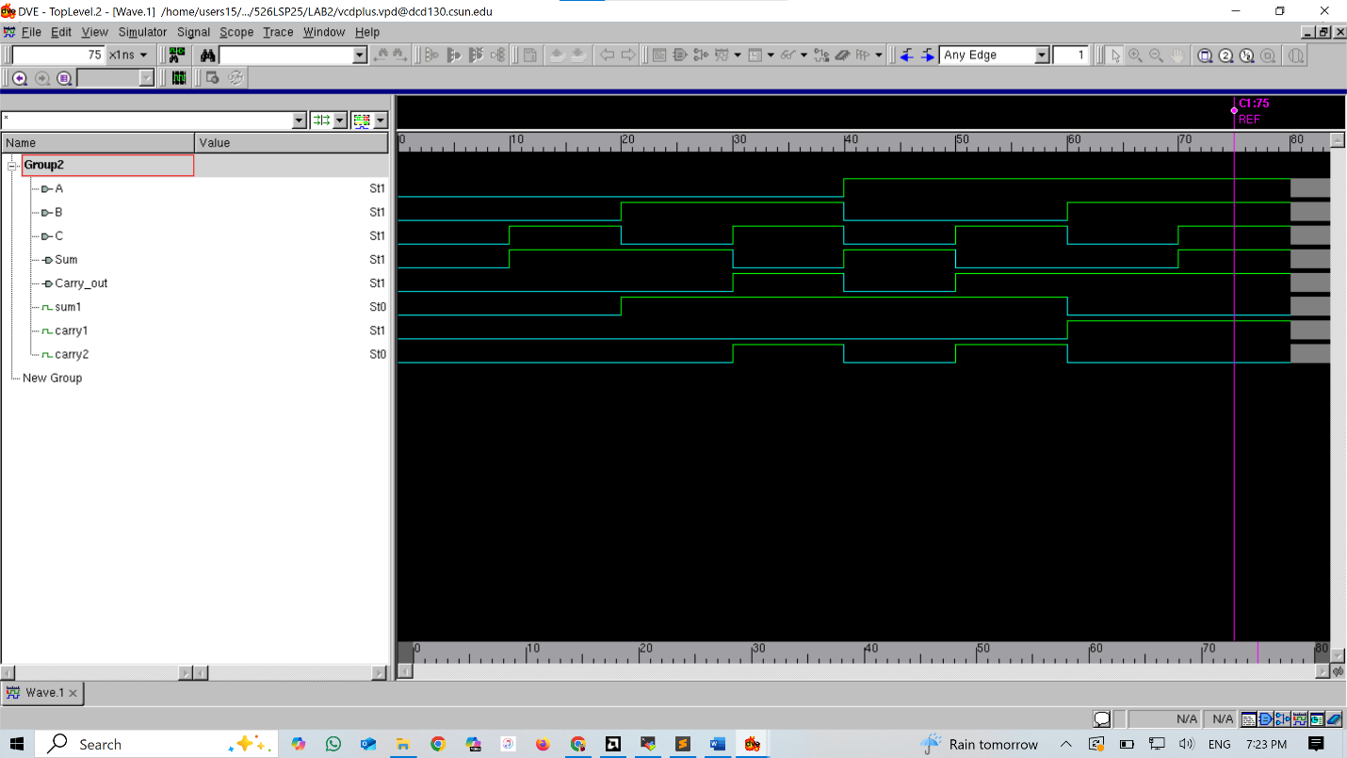

Source Code
Design File (half_adder.v)
/***************************************************************************
*** ***
*** EE 526 L Experiment #1 Muhammad Umar, Spring, 2025 ***
*** ***
*** Experiment #2 Design a Full Adder ***
*** ***
*** Filename: half_adder Created by Muhammad Umar, 02/13/2025 ***
*** ***
*** This half adder (half_adder.v) performs binary addition on two ***
*** single-bit inputs (a, b) and produces a sum (s) and a carry (c). ***
*** It is implemented using a single XOR gate for the sum calculation ***
*** and a single AND gate for the carry. ***

***************************************************************************/
`timescale 1 ns / 1 ns // Define the time unit (1ns) and time precision (1 ns)

module half_adder(
input a, // Input 'a'
input b, // Input 'b'
output s, // Output 's' (Sum)
output c // Output 'c' (Carry)
);

// Gate-level modeling
xor (s, a, b); // XOR gate for sum
and (c, a, b); // AND gate for carry

endmodule

Testbench File(half_adder_tb.v)
/***************************************************************************
*** EE 526 L Experiment #2 Muhammad Umar, Spring, 2025 ***
*** Experiment #2 Design a Full Adder ***
*** Filename: half_adder_tb.v Created by Muhammad Umar, 02/13/2025 ***
*** ***
*** This testbench (half_adder_tb) is used to test the half adder design. ***
*** It applies all possible input combinations to the half adder module ***
*** and monitors the sum and carry outputs. ***
***************************************************************************/

`timescale 1 ns / 1 ns

module half_adder_tb();

// Declare input signals for testbench
reg a, b; // Input signals

// Declare output signals to observe results
wire s, c; // Output signals

// Instantiate the half adder module
half_adder dut (
.a(a),
.b(b),
.s(s),
.c(c)
);

// Monitor the values of inputs and outputs during simulation
initial
$monitor("%d a = %b, b = %b, s = %b, c = %b",
$time, a, b, s, c);

// Applying stimulus here
initial begin
$vcdpluson; // Enable waveform dump for debugging

// Apply different test cases with delays
a = 0; b = 0; #10;
a = 0; b = 1; #10;
a = 1; b = 0; #10;
a = 1; b = 1; #10;

$finish;
end

endmodule

Design File (full_adder.v)
/***************************************************************************
*** EE 526 L Experiment #2 Muhammad Umar, Spring, 2025 ***
*** Experiment #2 Design a Full Adder ***
*** Filename: full_adder.v Created by Muhammad Umar, 02/13/2025 ***
*** ***
*** This full adder (full_adder) is implemented using two half adders. ***
*** It computes the sum and carry-out of three binary inputs A, B, and C .***
***************************************************************************/

`timescale 1 ns / 1 ns

module full_adder(
input A, // Input bit A
input B, // Input bit B
input C, // Input carry-in
output Sum, // Output sum
output Carry_out // Output carry-out
);

// Internal signals
wire sum1, carry1, carry2;

// First half adder (A, B)
half_adder HA1 (
.a(A),
.b(B),
.s(sum1),
.c(carry1)
);

// Second half adder (sum1, C)
half_adder HA2 (
.a(sum1),
.b(C),
.s(Sum),
.c(carry2)
);

// OR gate to calculate carry-out
or OR1 (Carry_out, carry1, carry2);

endmodule

Testbench File(full_adder_tb.v)
/***************************************************************************
*** EE 526 L Experiment #2 Muhammad Umar, Spring, 2025 ***
*** ***
*** Experiment #2 Design a Full Adder ***
*** Filename: tb_full_adder.v Created by Muhammad Umar, 02/13/2025 ***
*** ***
*** This testbench (tb_full_adder) tests the full adder design. It ***
*** applies all possible input combinations and verifies Sum & Carry_out. ***
***************************************************************************/

`timescale 1 ns / 1 ns

module tb_full_adder();

// Declaring input signals for the testbench
reg Data_in_A;
reg Data_in_B;
reg Data_in_C;

// Declaring output signals to observe the results
wire Data_out_Sum;
wire Data_out_Carry;

// Instantiate the full adder module and mapping the input and outputs
full_adder dut (
.A(Data_in_A),
.B(Data_in_B),
.C(Data_in_C),
.Sum(Data_out_Sum),
.Carry_out(Data_out_Carry)
);

// Monitor the values of inputs and outputs during simulation
initial
$monitor("%d A = %b, B = %b, C = %b, Sum = %b, Carry = %b",
$time, Data_in_A, Data_in_B, Data_in_C, Data_out_Sum, Data_out_Carry);

// Applying Stimulus here
initial begin
$vcdpluson;

// Applying all possible input combinations
Data_in_A = 0; Data_in_B = 0; Data_in_C = 0; #10;
Data_in_A = 0; Data_in_B = 0; Data_in_C = 1; #10;
Data_in_A = 0; Data_in_B = 1; Data_in_C = 0; #10;
Data_in_A = 0; Data_in_B = 1; Data_in_C = 1; #10;
Data_in_A = 1; Data_in_B = 0; Data_in_C = 0; #10;
Data_in_A = 1; Data_in_B = 0; Data_in_C = 1; #10;
Data_in_A = 1; Data_in_B = 1; Data_in_C = 0; #10;
Data_in_A = 1; Data_in_B = 1; Data_in_C = 1; #10;

$finish;
end

endmodule

RESULT

After simulating the design and verifying it through waveform and log file, we can see from the snapshot that there are no errors noted and results shown below.

Conclusion
We have compiled a Verilog module for a half adder and full adder, instantiating half adder twice with different instance name and make it the full adder module, checks its functionality using a test bench module by using Synopsys VCS simulator. The simulation results confirmed that the full adder operated correctly according to the provided stimulus.

