Name : K Uma

TOPIC : MICROSOFT AZURE

BATCH : CC-MINOR AUGUST

Abstract

Azure includes many wonderful Platform as a Service (PaaS) options, such as Azure App Service and Azure SQL Database, that can provide geoscaling and fast agility. This project explains the various Azure Virtual Machines (VM) options and how to deploy and configure Windows Server and Linux VMs in Azure. Each Azure region consists of multiple data centers; each data center consists of thousands of hardware blade servers. Microsoft supports Windows Client VM images in Azure only for development purposes. Perhaps the fastest way to deploy a VM in Azure is to do so from the Azure Marketplace. At a higher level of abstraction, an Azure virtual machine is a cloud resource that consists of the following three subsystems: compute, storage and network. Scalabilityrefers to developers ability to resize their VM. Configuration management in the Azure cloud is essentially the same as it is on premises.

INTRODUCTION

The Azure Load Balancer is one of four load-balancing solution options offered by Microsoft Azure for distributing inbound network traffic evenly across a group of backend compute resources within our virtual networks. The backend pool can consist of virtual machines or virtual machine scale sets of the same type. The Azure Load Balancer operates at OSI Layer 4 (TCP/UDP protocols), can handle non-HTTP(S) traffic, provides high performance and low latency, and is recommended for non-web workloads. Other load-balancing options include Application Gateway, Front Door, and Traffic Manager, which will each be discussed in a future article.
The load balancer is a point of contact for inbound client traffic and clients access the load balancer by connecting to its frontend IP address. It receives the inbound traffic on its frontend IP and then distributes that flow to its backend pool of resources using routing rules that we configure to specify how that traffic should flow from the frontend to the backend.
While there are several use cases for a load balancer, enabling high availability is an important one and the case that is presented in this article and lab demonstration. The load balancer solves the server high availability problem for us such that we are able to utilize a pool of servers that each have the ability to receive inbound client traffic, rather than a single server, and thus avoids a single point of failure.

Create the virtual network
Step 1 is to create the virtual network that will provide connectivity for the Azure resources that need to communicate on the network. Here, a new Resource group was configured to contain all of the resources that will be used in this deployment. The virtual network was given the name of “IntLB-VNet” and is deployed to the East US region.
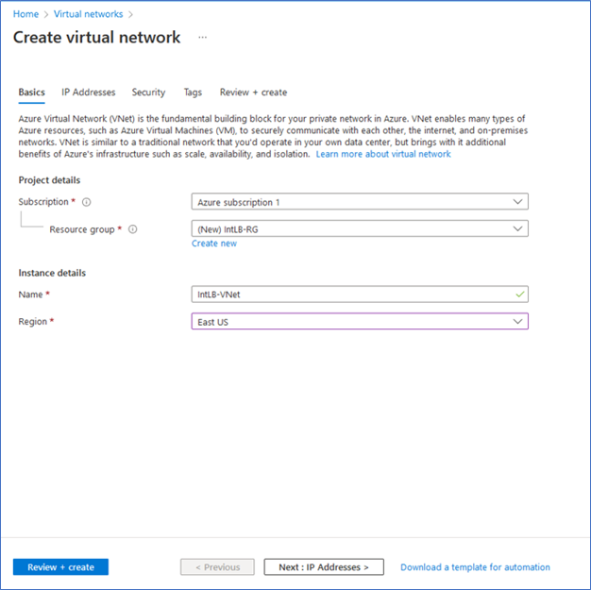

After clicking Next to advance to the IP addresses configuration page, the virtual network was configured with an IPv4 network address space of 10.1.0.0/16.
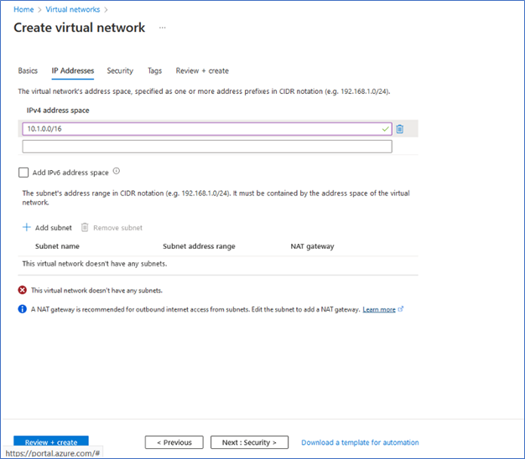

In the next step, we configure the backend subnet (10.1.0.0/24) and frontend subnet (10.1.2.0/24) with address ranges that were taken from the virtual network’s IPv4 address space.

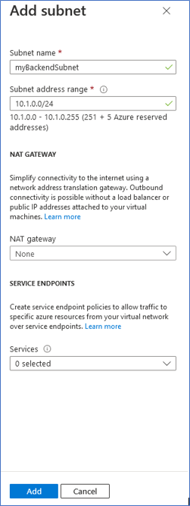

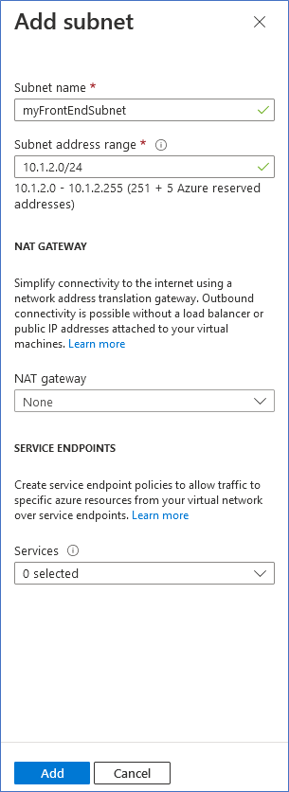

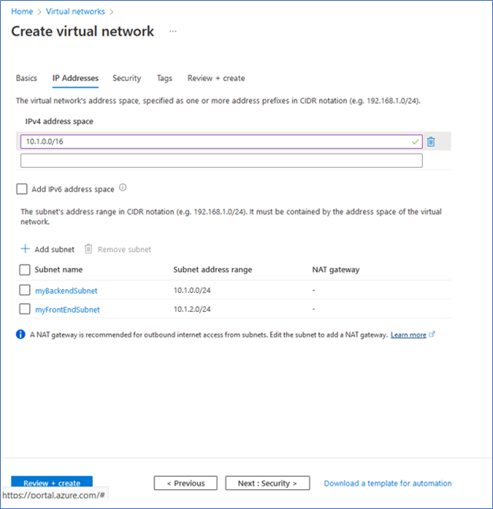

After clicking on Next to advance to the security configuration, an Azure Bastion host with a public IP address was enabled to provide me with an Internet-facing connection to the virtual network that will be needed for access to the “test” virtual machine when it is time to test out the load balancing solution. After completing this step, I clicked on Review + Create to kick off the creation of the virtual network and the BastionHost.

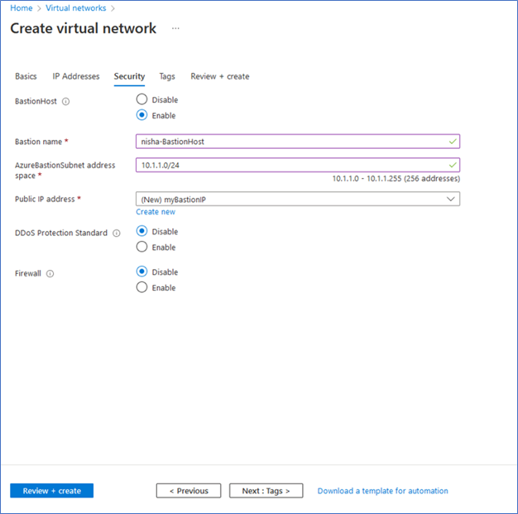
Create backend servers
In Step 2, I deployed the backend servers by uploading ARM templates to the Azure Cloudshell. The commands listed below were executed on the Cloudshell to initiate the creation of the three virtual machines using the parameters provided in the JSON files of the ARM templates. These virtual machines will be used as the backend pool of compute resources in this load-balancing solution.
$RGName = “IntLB-RG”
New-AzResourceGroupDeployment -ResourceGroupName $RGName -TemplateFile azuredeploy.json -TemplateParameterFile azuredeploy.parameters.vm1.json

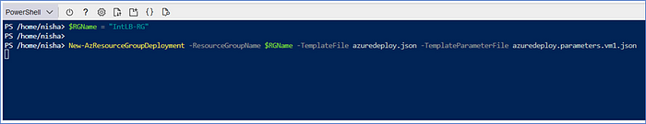

After waiting about ten minutes for the three virtual machines to complete the deployment process, I verified that they were successfully deployed before moving on to the next step, as they will be needed in order to include them as the backend pool resources for the Azure Load Balancer configuration.

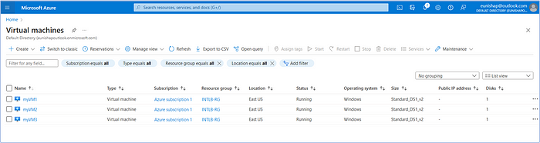

Create the load balancer
In Step 3, I created the Azure Load Balancer by searching for it in the list of available Azure resources and then I clicked on “Create”. I named the instance “myIntLoadBalancer” and deployed it into the same Resource Group and Region as the configured virtual network. Here, the Standard SKU was selected, Type Internal, and the Regional Tier.

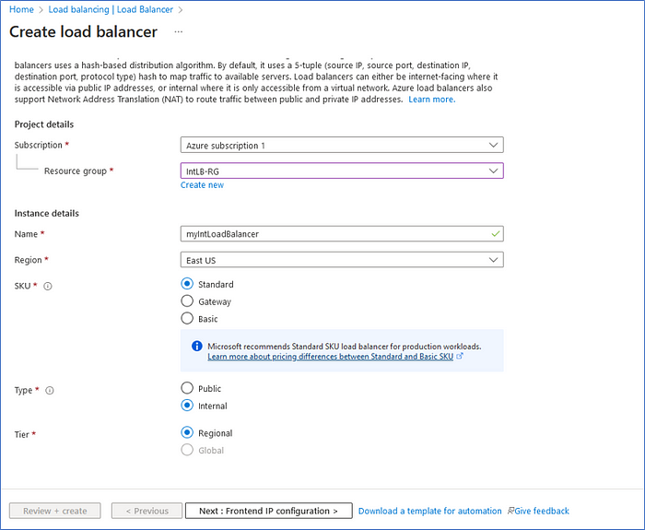

After clicking on Next to advance to the Frontend IP configuration, here we click on + Add a Frontend IP configuration to open the Add frontend IP configuration blade.

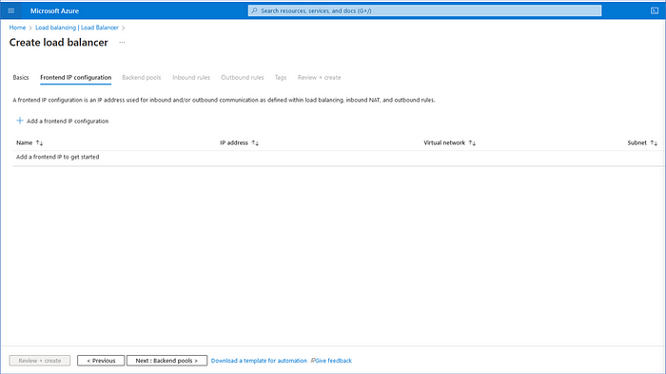

Here, I requested the assignment of a dynamic IP address to the load balancer, named it, and specified which subnet is associated with the backend pool. Note that the Load balancer can have multiple frontend IPs, but only a single frontend IP is configured in this lab scenario. For the Availability zone, I selected Zone-redundant to create a zone-redundant data path across the region for deploying the IP address. I then clicked on Add, then Review + Create, and then clicked on Create to initiate the deployment of the Azure Load Balancer and its Frontend IP configuration.

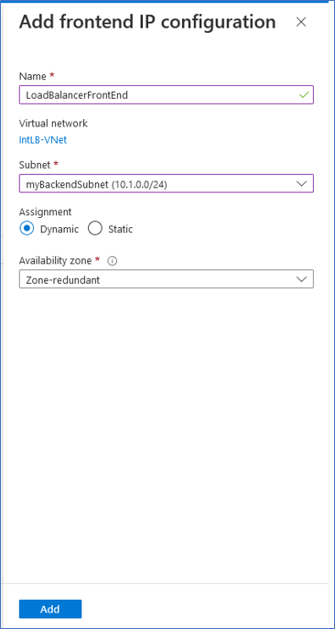

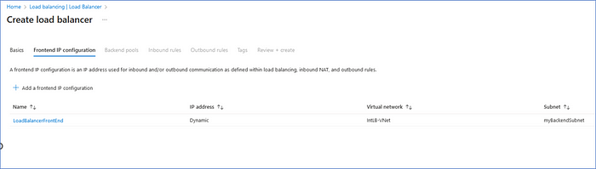

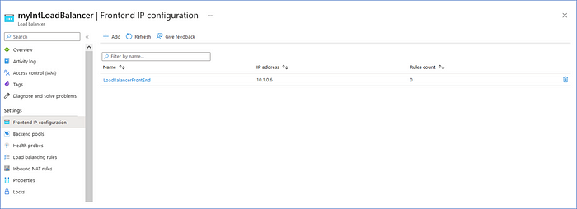

Create load balancer resources
Once the load balancer deployment completed, I navigated back to the load balancer resource to configure the load balancer settings for the backend address pool, create a health probe, and create a load balancer rule.

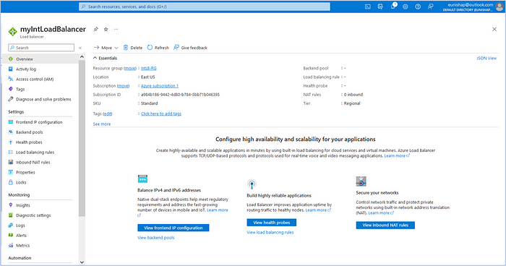

Create backend pool
In the first step of creating the load balancer resources, I created a backend pool and added VMs to the backend pool. I accomplished this by clicking on “Backend pools” on the load balancer and then clicking on + Add.

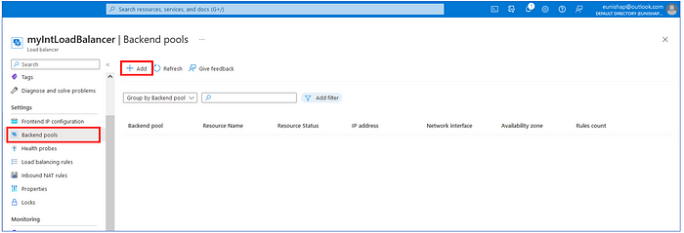

On the next screen, we are required to provide a name for the backend pool, select NIC or IP address configuration, and then click on + Add to select the resources that will be members of this backend pool.

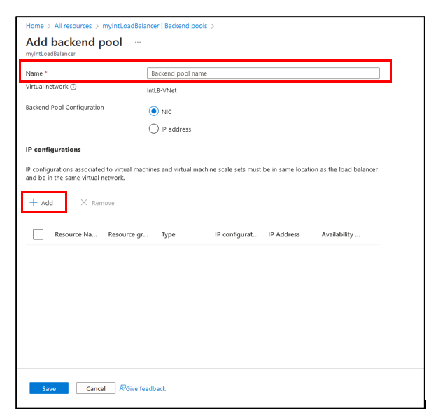

We advance next to the “Add IP configurations to backend pool” page where we select the resources that we want to add to the pool. Here, I selected each of the three virtual machines that exist on the backend subnet that we previously defined. Then, click on “Add”.

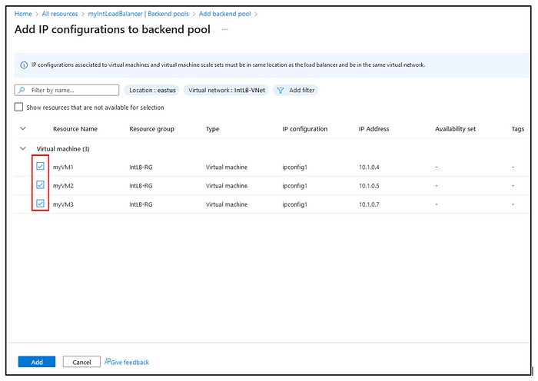

Before finalizing the backend pool selection, enter a name for the backend pool. Here I provided the name of “myBackendPool” and then clicked on Save.

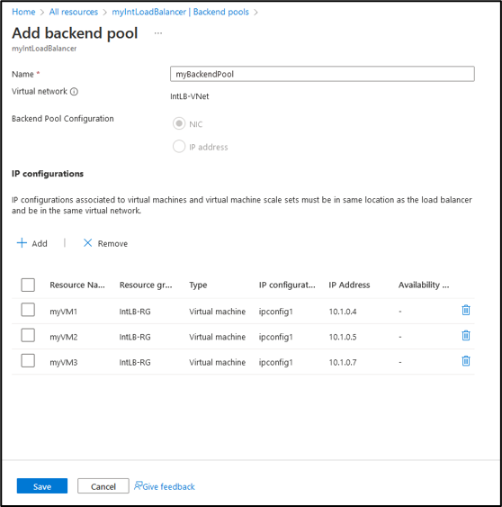

We advance next to the “Add IP configurations to backend pool” page where we select the resources that we want to add to the pool. Here, I selected each of the three virtual machines that exist on the backend subnet that we previously defined. Then, click on “Add”.

Before finalizing the backend pool selection, enter a name for the backend pool. Here I provided the name of “myBackendPool” and then clicked on Save.

Next, we are able to verify the configured Backend pools and verify that all resources are in a “running” state.
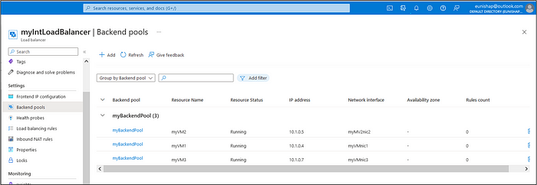

3. Add Load Balancing Rule
The next step of the load balancer component configuration is to configure a load balancer rule. A load balancer rule maps a given frontend IP configuration and port to multiple backend IP addresses and ports. Here, you will select the frontend IP configuration for the incoming traffic and the backend IP pool that is to receive the traffic. The source and destination ports are defined in the rule. We begin this process by clicking on “Load balancing rules” under the settings section and then click on + Add.

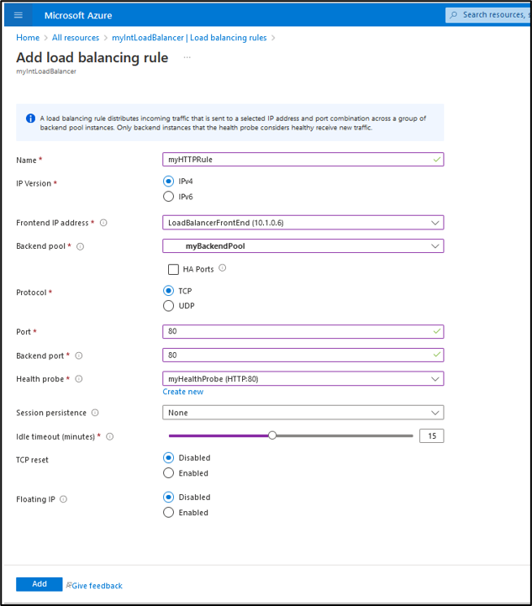

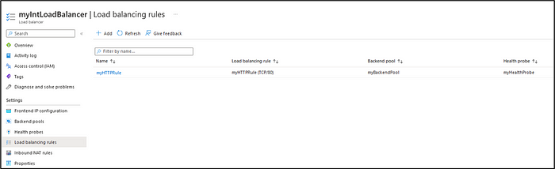

Test the load balancer
The final step in this demonstration consisted of deploying a test VM that was used to connect to the Azure Load Balancer’s frontEnd IP address. I deployed this virtual machine into the virtual network’s Backend subnet. While the testVM does not have an Internet-facing IP address configuration, a BastionHost was configured at the beginning of this demonstration to allow me to connect to internal Azure resources over the Internet. Azure Bastion Service is a managed jump server resource in Azure that will allow you to connect to workload VM using browser and the Azure Portal without the need of Public IP on your Virtual Machines

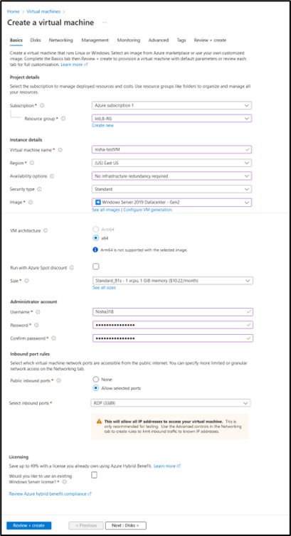

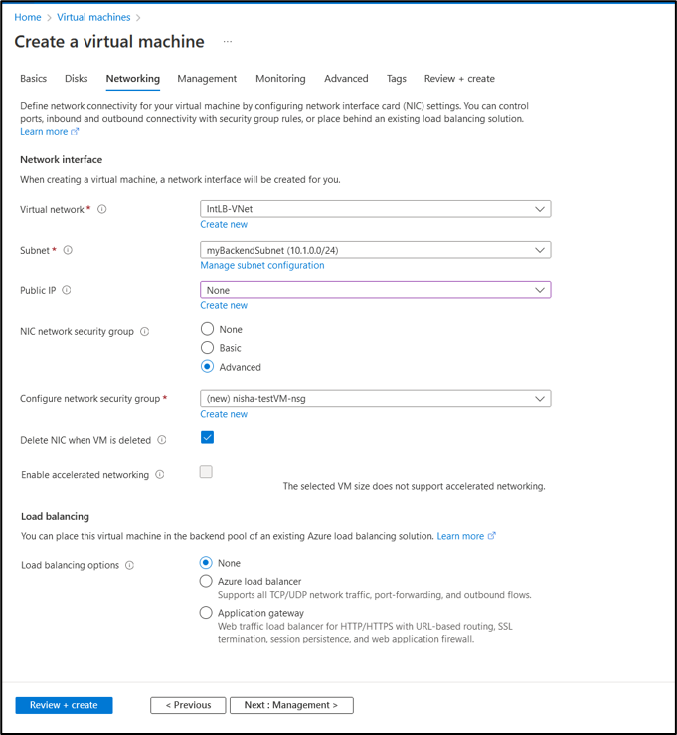

I created and configured an internal load balancer to load balance traffic to a set of internal backend webservers and then tested the solution by using an Azure BastionHost to connect to a “test” virtual machine that I deployed into the virtual network. The following tasks were executed to accomplish this:
Task 1: Created the virtual network
Task 2: Created backend servers
Task 3: Created the load balancer
Task 4: Created load balancer resources
Task 5: Tested the load balancer

Create the virtual network
Step 1 is to create the virtual network that will provide connectivity for the Azure resources that need to communicate on the network. Here, a new Resource group was configured to contain all of the resources that will be used in this deployment. The virtual network was given the name of “IntLB-VNet” and is deployed to the East US region.
After clicking Next to advance to the IP addresses configuration page, the virtual network was configured with an IPv4 network address space of 10.1.0.0/16.
In the next step, we configure the backend subnet (10.1.0.0/24) and frontend subnet (10.1.2.0/24) with address ranges that were taken from the virtual network’s IPv4 address space.
After clicking on Next to advance to the security configuration, an Azure Bastion host with a public IP address was enabled to provide me with an Internet-facing connection to the virtual network that will be needed for access to the “test” virtual machine when it is time to test out the load balancing solution. After completing this step, I clicked on Review + Create to kick off the creation of the virtual network and the BastionHost.

Create backend servers
In Step 2, I deployed the backend servers by uploading ARM templates to the Azure Cloudshell. The commands listed below were executed on the Cloudshell to initiate the creation of the three virtual machines using the parameters provided in the JSON files of the ARM templates. These virtual machines will be used as the backend pool of compute resources in this load-balancing solution.
$RGName = “IntLB-RG”

After waiting about ten minutes for the three virtual machines to complete the deployment process, I verified that they were successfully deployed before moving on to the next step, as they will be needed in order to include them as the backend pool resources for the Azure Load Balancer configuration.

Create the load balancer
In Step 3, I created the Azure Load Balancer by searching for it in the list of available Azure resources and then I clicked on “Create”. I named the instance “myIntLoadBalancer” and deployed it into the same Resource Group and Region as the configured virtual network. Here, the Standard SKU was selected, Type Internal, and the Regional Tier.

After clicking on Next to advance to the Frontend IP configuration, here we click on + Add a Frontend IP configuration to open the Add frontend IP configuration blade.

Here, I requested the assignment of a dynamic IP address to the load balancer, named it, and specified which subnet is associated with the backend pool. Note that the Load balancer can have multiple frontend IPs, but only a single frontend IP is configured in this lab scenario. For the Availability zone, I selected Zone-redundant to create a zone-redundant data path across the region for deploying the IP address. I then clicked on Add, then Review + Create, and then clicked on Create to initiate the deployment of the Azure Load Balancer and its Frontend IP configuration.

Create load balancer resources
Once the load balancer deployment completed, I navigated back to the load balancer resource to configure the load balancer settings for the backend address pool, create a health probe, and create a load balancer rule.

Create backend pool
In the first step of creating the load balancer resources, I created a backend pool and added VMs to the backend

pool. I accomplished this by clicking on “Backend pools” on the load balancer and then clicking on + Add.

On the next screen, we are required to provide a name for the backend pool, select NIC or IP address configuration, and then click on + Add to select the resources that will be members of this backend pool.

We advance next to the “Add IP configurations to backend pool” page where we select the resources that we want to add to the pool. Here, I selected each of the three virtual machines that exist on the backend subnet that we previously defined. Then, click on “Add”.

Before finalizing the backend pool selection, enter a name for the backend pool. Here I provided the name of “myBackendPool” and then clicked on Save.

Next, we are able to verify the configured Backend pools and verify that all resources are in a “running” state.

3. Add Load Balancing Rule

The next step of the load balancer component configuration is to configure a load balancer rule. A load balancer rule maps a given frontend IP configuration and port to multiple backend IP addresses and ports. Here, you will select the frontend IP configuration for the incoming traffic and the backend IP pool that is to receive the traffic. The source and destination ports are defined in the rule. We begin this process by clicking on “Load balancing rules” under the settings section and then click on + Add.
Here we enter a name for the load balancing rule and select an IP Version. From the following drop-down lists, we select the Frontend IP address and the Backend pool that was created in the previous step.
Next, click on “Add” to add the load balancing rule to the load balancer.
Inbound NAT Rules were not configured for this scenario. Configuring this type of rule enables the load balancer to use port forwarding to receive traffic on the frontend IP on a specific port to connect to a designated virtual machine on a specific backend port based on the inbound NAT rule.

Test the load balancer

The final step in this demonstration consisted of deploying a test VM that was used to connect to the Azure Load Balancer’s frontEnd IP address. I deployed this virtual machine into the virtual network’s Backend subnet. While the testVM does not have an Internet-facing IP address configuration, a BastionHost was configured at the beginning of this demonstration to allow me to connect to internal Azure resources over the Internet. Azure Bastion Service is a managed jump server resource in Azure that will allow you to connect to workload VM using browser and the Azure Portal without the need of Public IP on your Virtual Machines
The testVM that will be used to test out the load balancer deployment has a private IP address of 10.1.0.8. However, we can use the Azure Bastion service from the Azure portal in order to securely connect to testVM over the Internet.

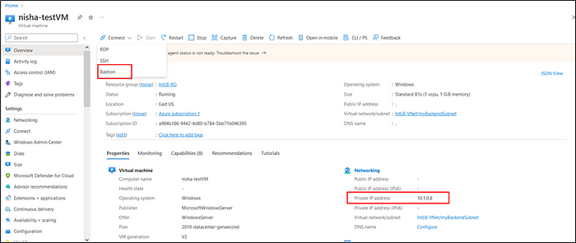
Here, we enter the username and password credential information that was created for the BastionHost when it was initially configured and then click on “Connect”.

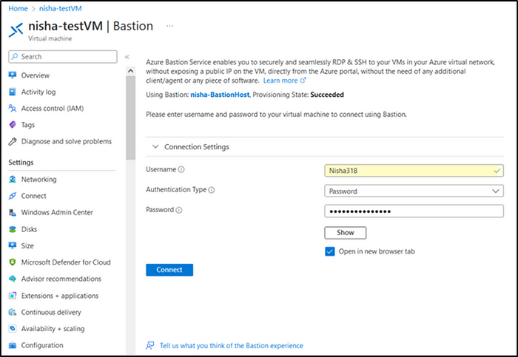

After getting connected to the testVM, we launch the Internet browser and use it to browse to the private IP address of the Azure Load Balancer’s frontend IP address.
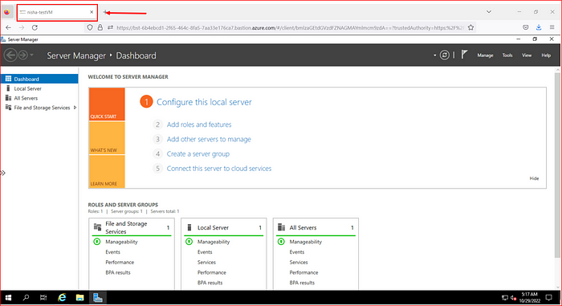

The load balancer has a frontEnd IP address of 10.1.0.6.
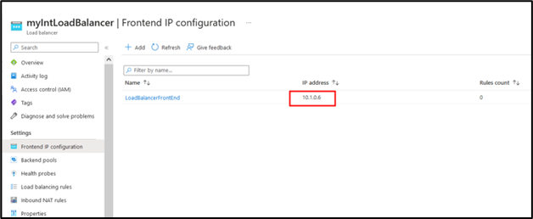

In the final step of this demonstration, we launch the web browser on the testVM and navigate to the frontend IP address of the load balancer of 10.1.0.6. On the initial connection to the frontend IP address of the load balancer, I got connected to VM2.

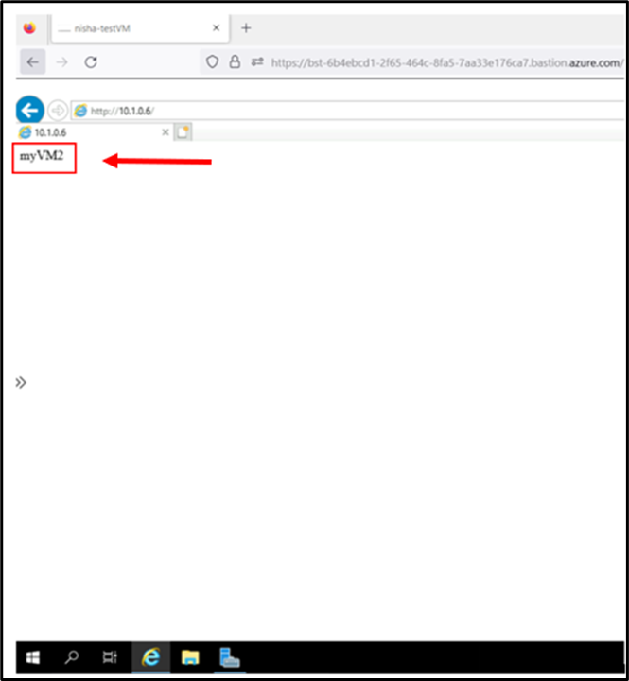

On the second connection attempt to the load balancer’s frontend IP address, the load balancer sent my request to VM3.

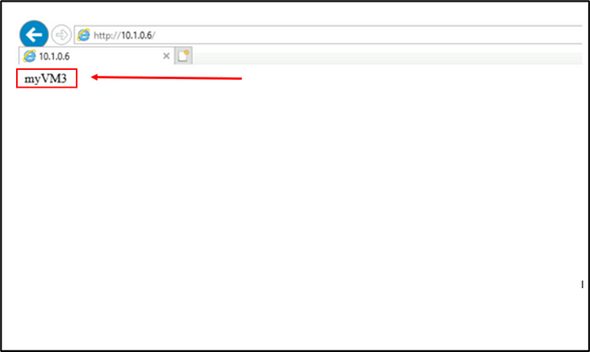
On the third connection attempt to the load balancer’s frontend IP address, the load balancer sent my request to VM3.

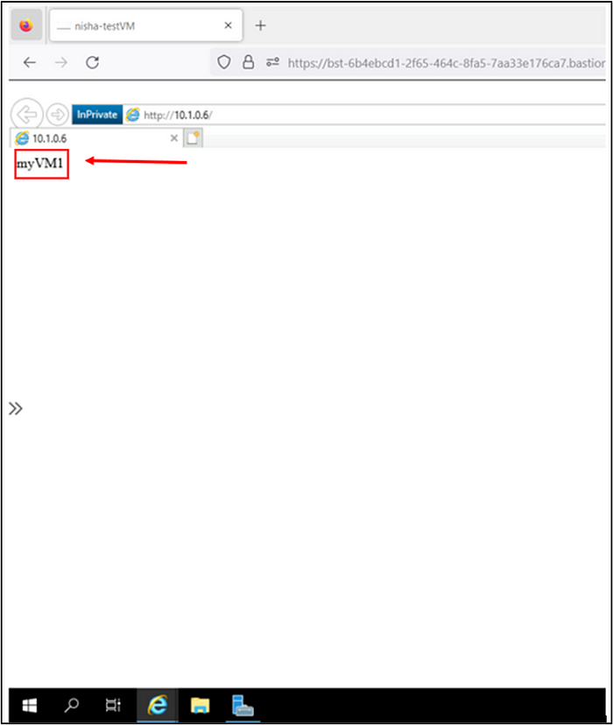

As observed in the testing phase of this demonstration, we see that the response comes randomly from the different VMs in the backend pool of the internal load balancer.
This concludes the demonstration of using an internal load balancer to evenly balance traffic to a backend pool of servers on Azure. Please stay tuned because the load balancer will make a return to my lab for a future project!

