**Abstract:**

Secure Cam is an advanced software solution designed to enhance the functionality of webcams by providing real-time video analysis for enhanced security. Utilizing state-of-the-art computer vision algorithms, it detects unauthorized movements and immediately responds by sending alert messages along with an image of the detected person. Additionally, Secure Cam integrates SMS functionality to ensure timely notifications to users, enabling rapid action in critical situations. With a latency of just 0.8 seconds, Secure Cam delivers instant Gmail and SMS alerts upon detecting intruders. The system incorporates secure coding practices, such as indirect referencing for database interactions, ensuring all transactions are secure. By offering a user-friendly interface, high detection accuracy, and scalable performance, Secure Cam aims to redefine modern security systems and significantly reduce incidents like home robberies.

**Introduction:**

The purpose of "Secure Cam" is to address the challenge of preventing robberies in real-time. While webcams traditionally record events, they often fail to deter crimes in the moment. Secure Cam aims to offer real-time footage analysis to detect unauthorized movements, thereby enhancing home security and preventing robberies. By ensuring instant notifications through Gmail and SMS and maintaining secure database interactions, Secure Cam provides a reliable and robust security solution.

**Methodologies:**

The development of Secure Cam follows a structured approach to ensure functionality, usability, and performance. The system is designed with both functional and non-functional requirements in mind. Functionally, Secure Cam processes live video feeds from webcams using advanced computer vision algorithms to detect and track individuals in real time. Upon detecting intruders, the system instantly sends Gmail and SMS alerts, along with an image of the detected individual, ensuring rapid notification to users. Secure database interactions are facilitated through secure coding practices, such as indirect referencing, to protect sensitive data and transactions. Integration with external security systems is achieved via APIs, enabling seamless interaction with alarms or access control systems.

Non-functional requirements focus on the reliability, scalability, and usability of the software. Secure Cam guarantees minimal latency, achieving an end-to-end delay of just 0.8 seconds to ensure real-time performance. The architecture is modular and scalable, allowing for horizontal scaling as the number of video streams or users increases. The system employs robust security measures, including role-based access control, to protect user data and restrict access to sensitive functionalities. A user-friendly interface ensures that both technical and non-technical users can easily configure the system, monitor activity, and generate reports. Sequence and use case diagrams have been utilized during development to streamline workflows and visualize user interactions, aiding in both design and implementation phases. This methodical approach ensures that Secure Cam is efficient, reliable, and accessible to a wide range of users.

**Diagrams:**



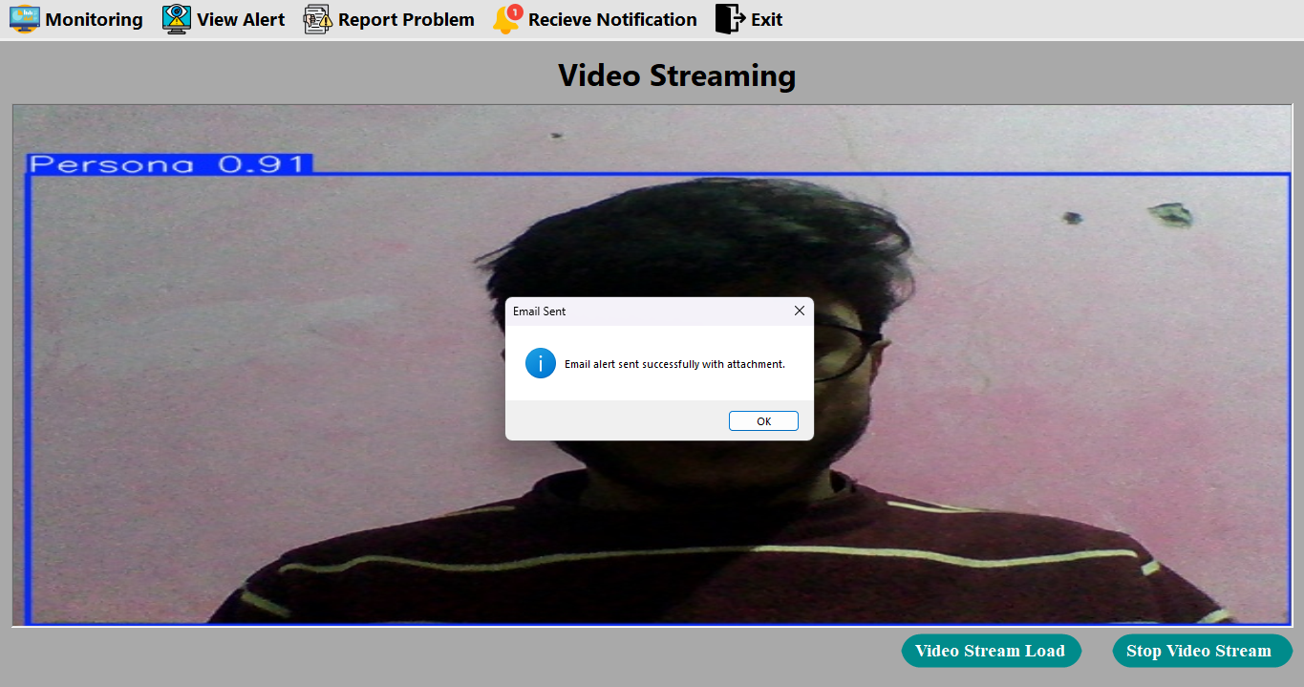

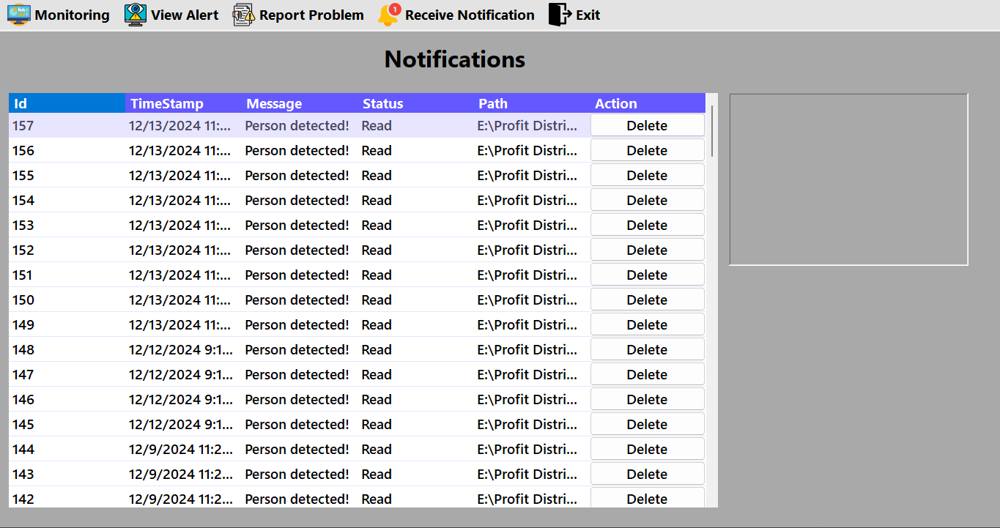

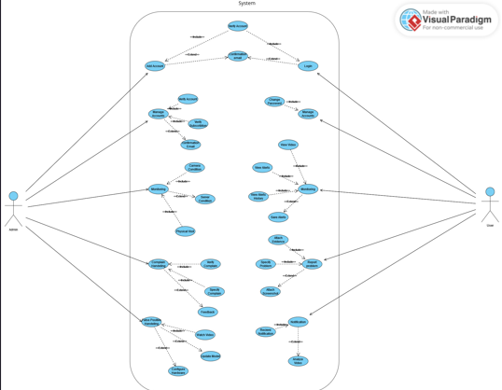

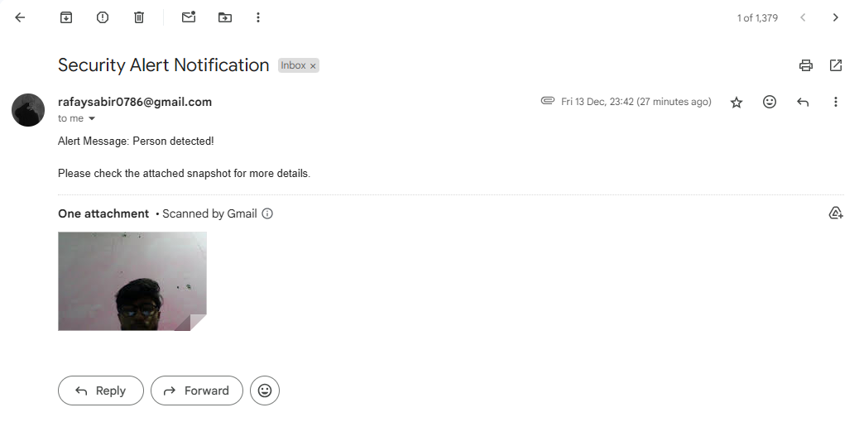

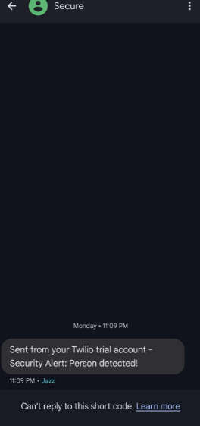

**Result:**

Secure Cam successfully enhances traditional webcam setups by providing real-time person detection and alert capabilities. It accurately identifies unauthorized movements and promptly sends Gmail and SMS alerts, including the detected person’s image, with a latency of just 0.8 seconds. The system achieves high detection accuracy, secure database transactions using indirect referencing, and a seamless integration process, ensuring both security and ease of use. These features make Secure Cam an effective and accessible solution for modern security needs.

**Diagram:**

