SE-301L Web Engineering Lab

Deptt of COMPUTER SOFTWARE ENGINEERING

Web Engineering Lab Task 10


Name | Umar Hayat
Registration No | 23MDSWE274
Submitted To | Engr. Humayun
Semester | 6th , Spring 2026

Task 01:
Create following web page using ordered lists, unordered lists and definition lists.
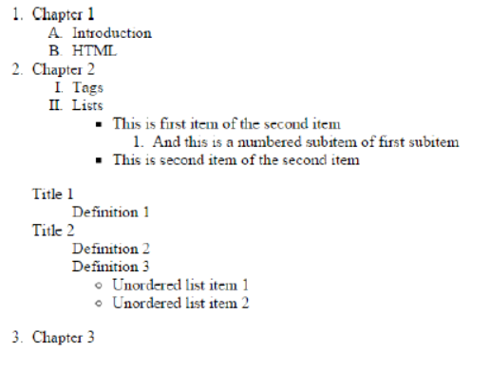
Code:
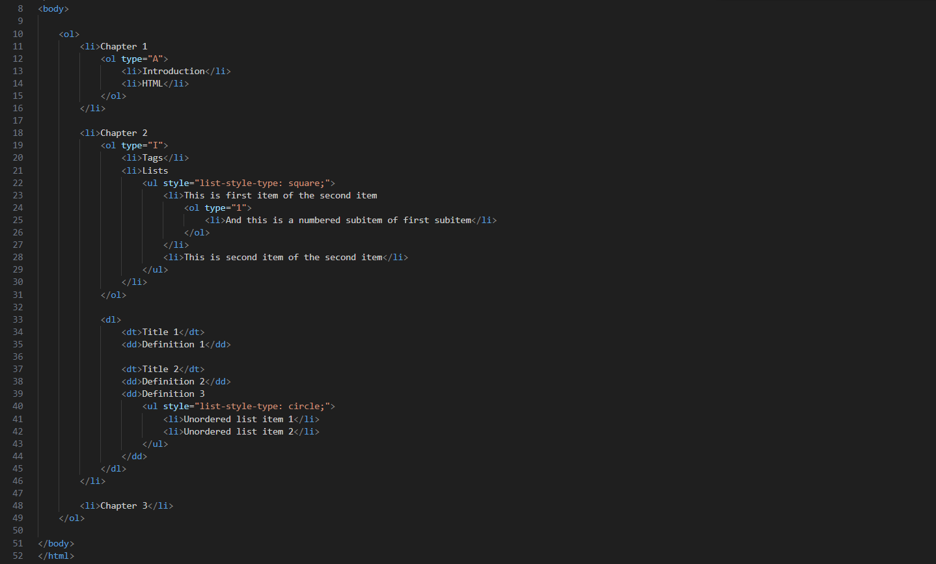

Output:
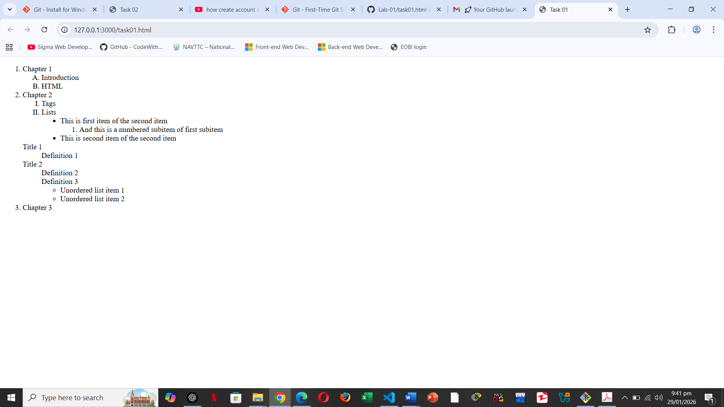

Task 02:
Create following registration form using HTML Form controls and tables.
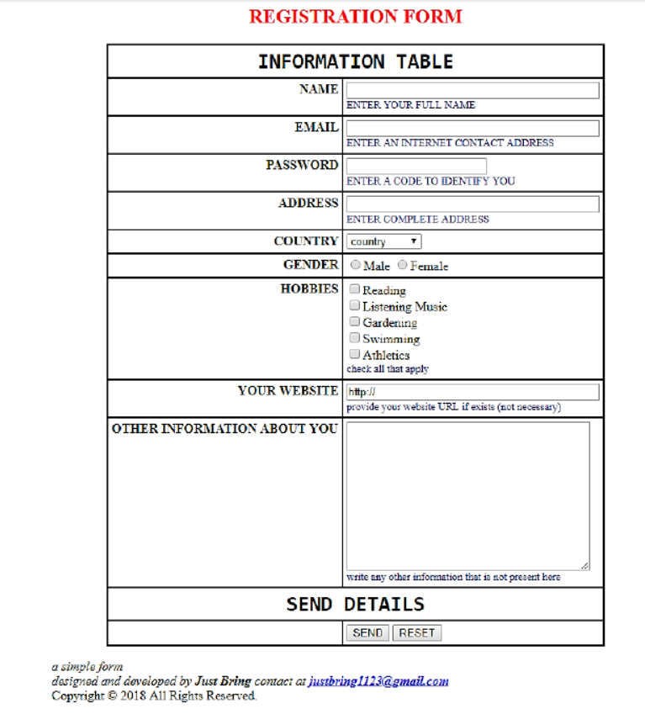

Code:
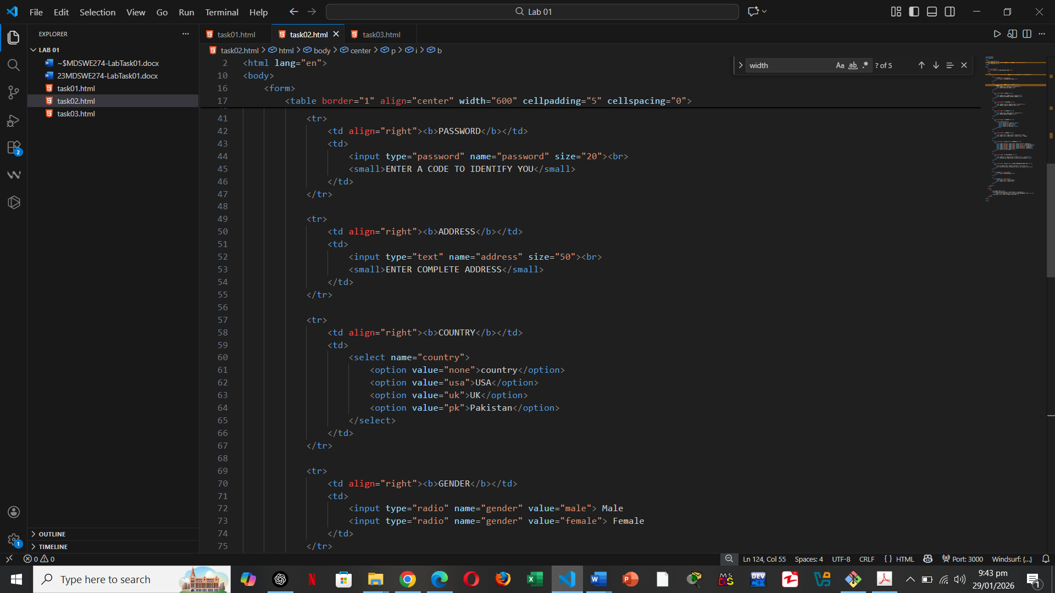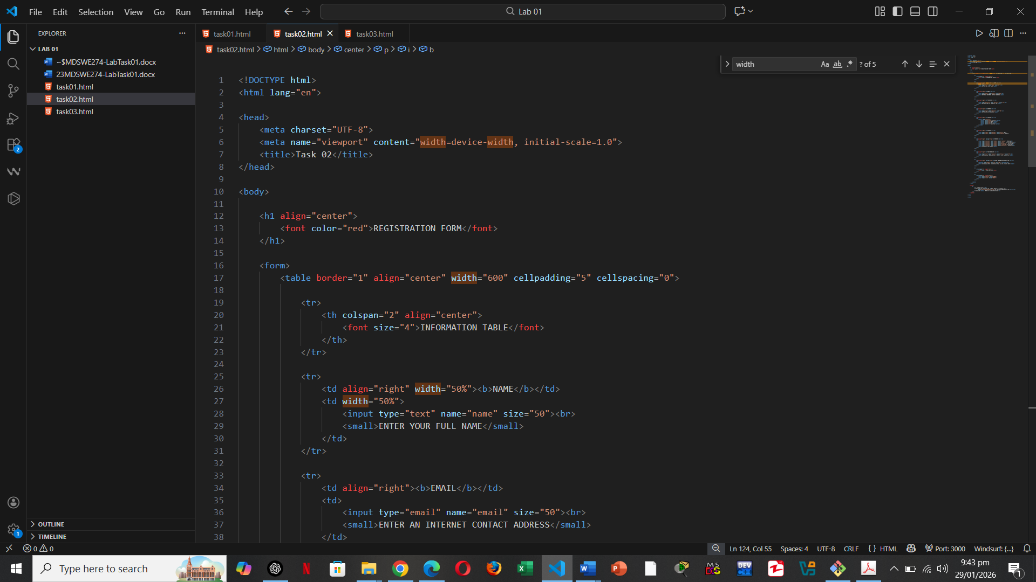

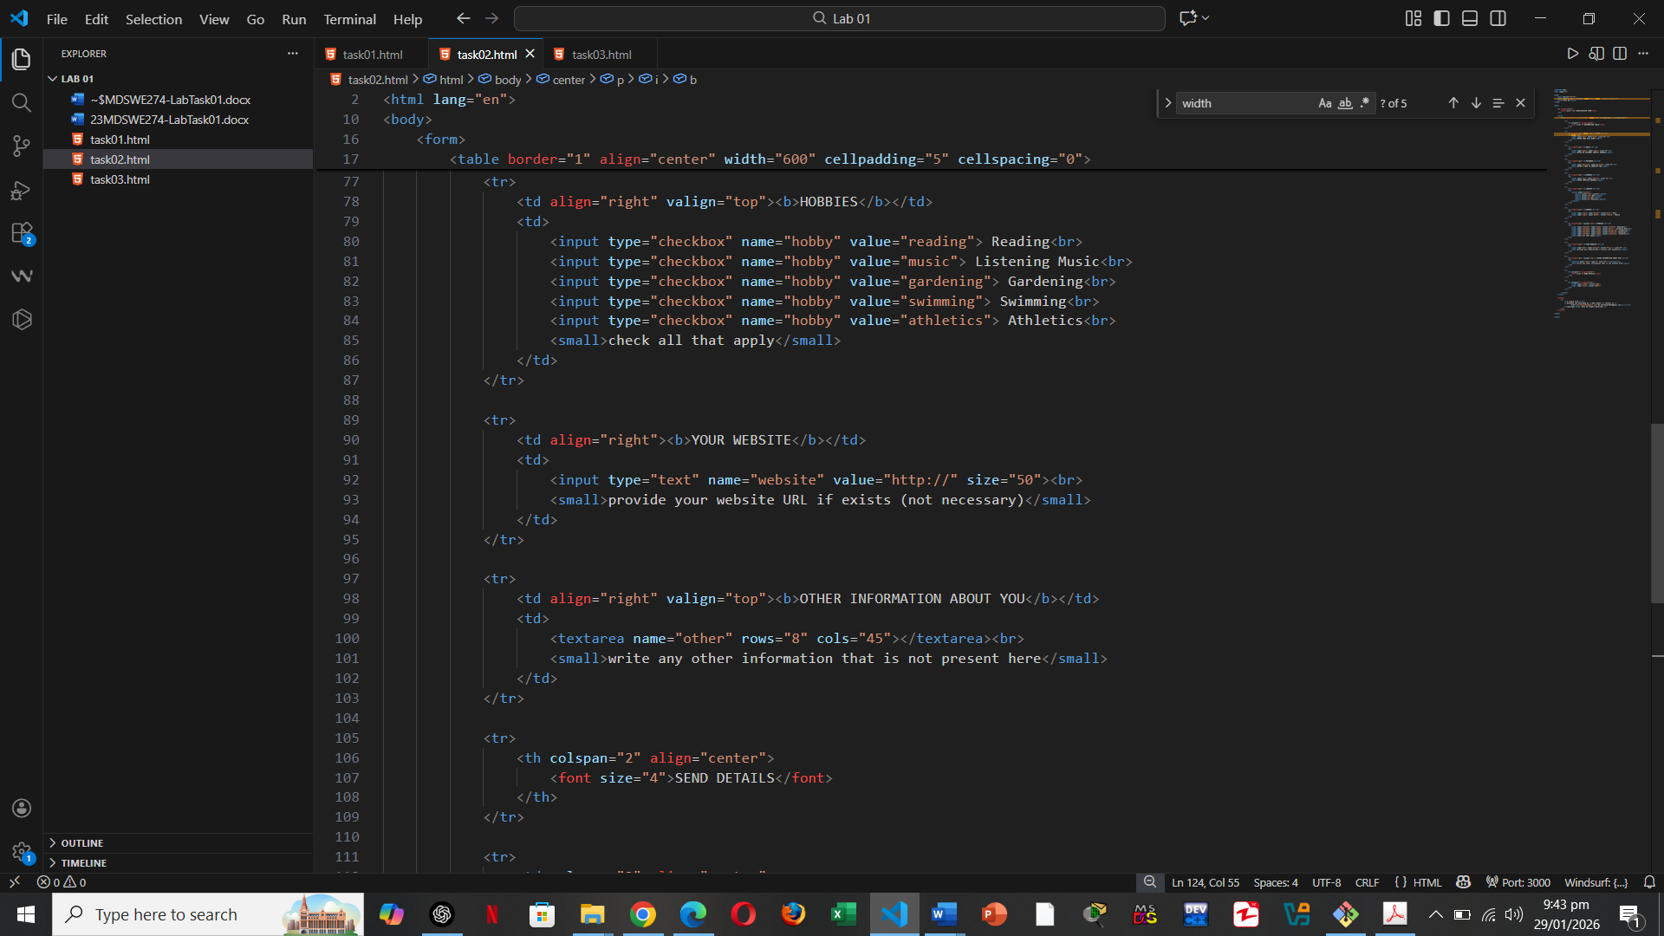
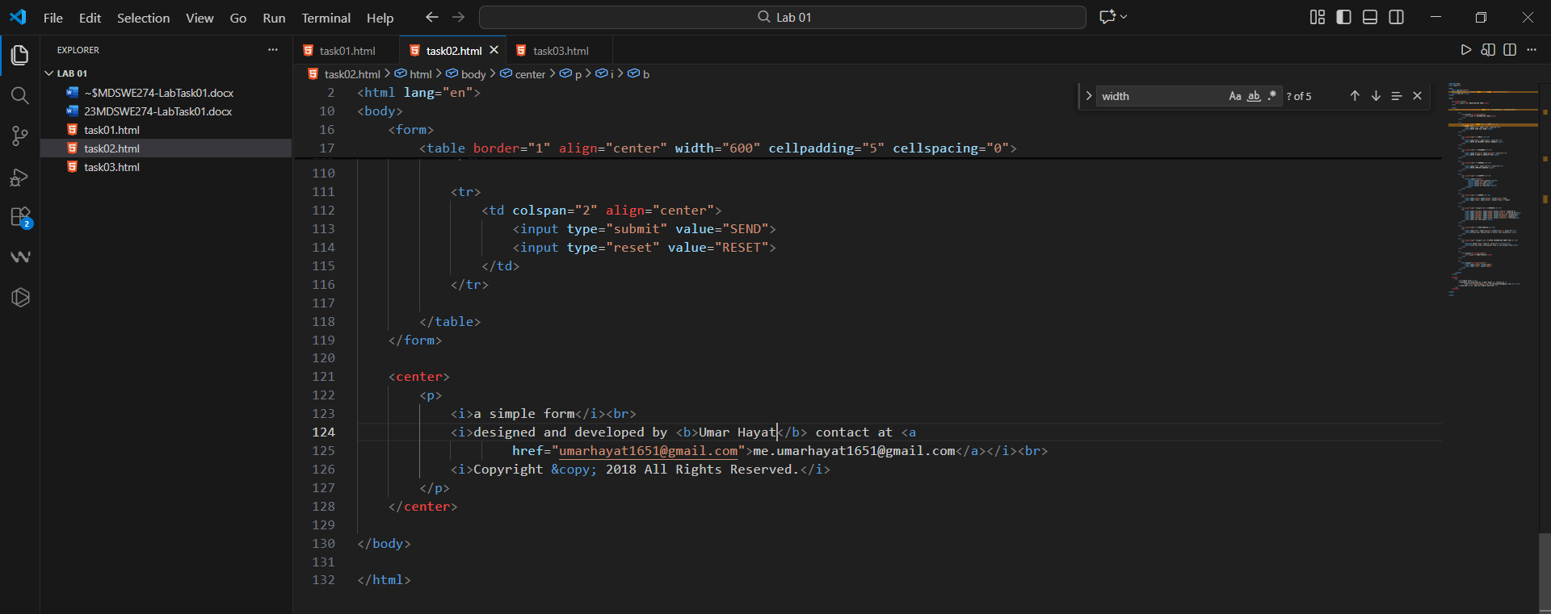
Output:
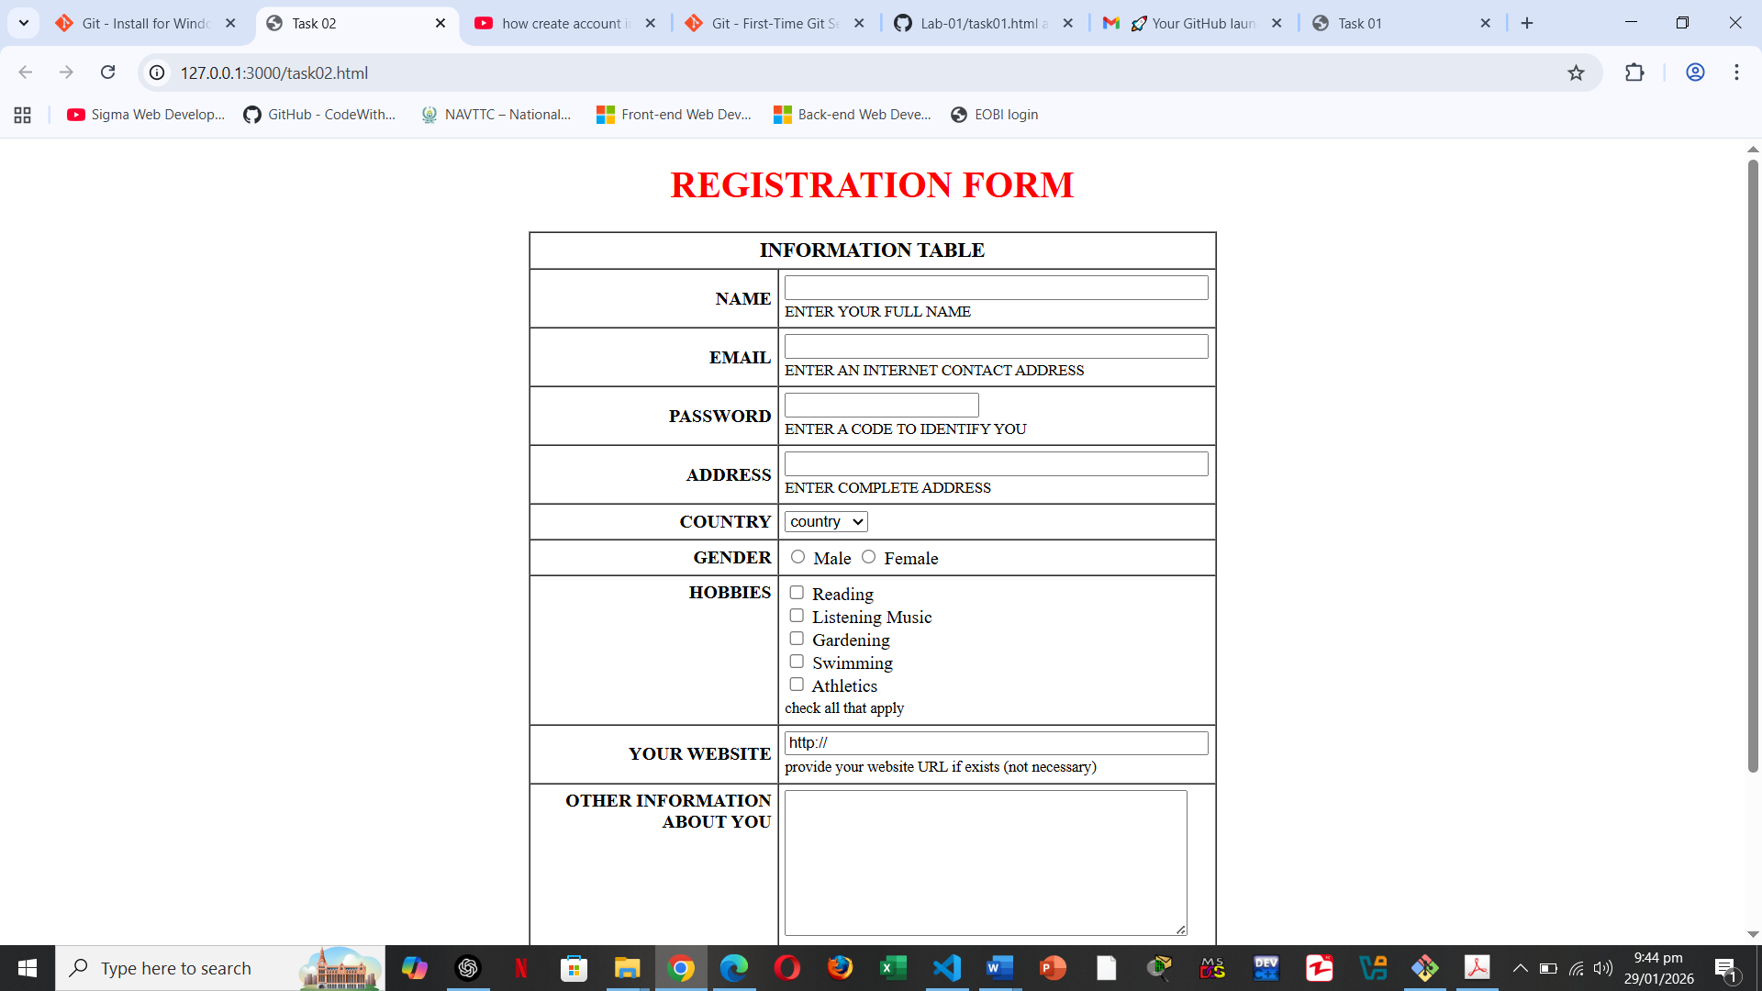
Task 03:
Use HTML 5 tags only to implement the following in Figure 04.
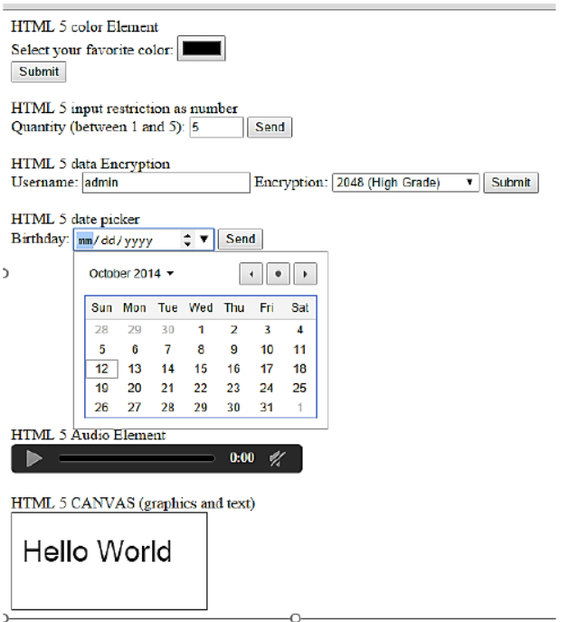

Code: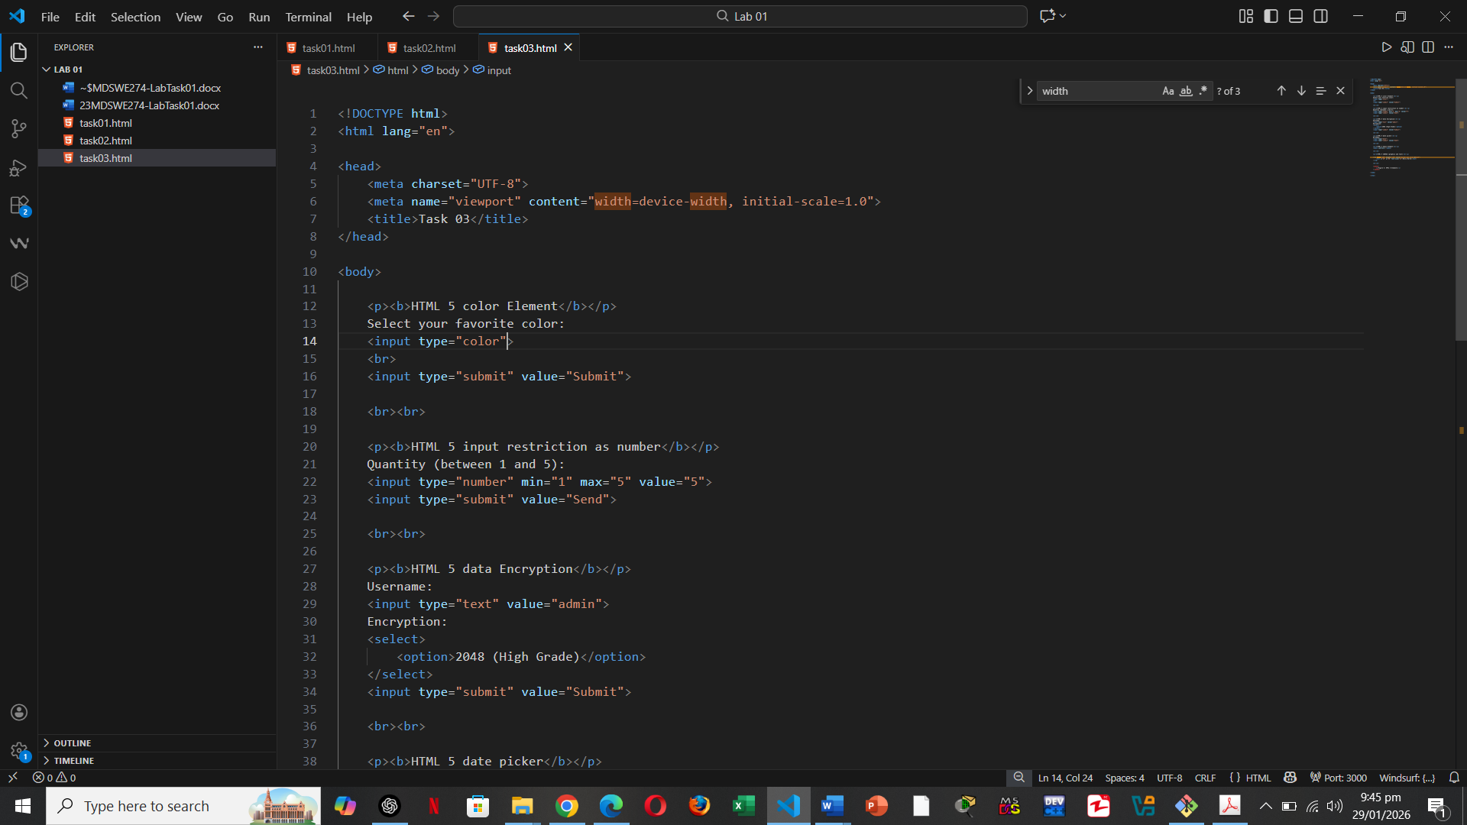

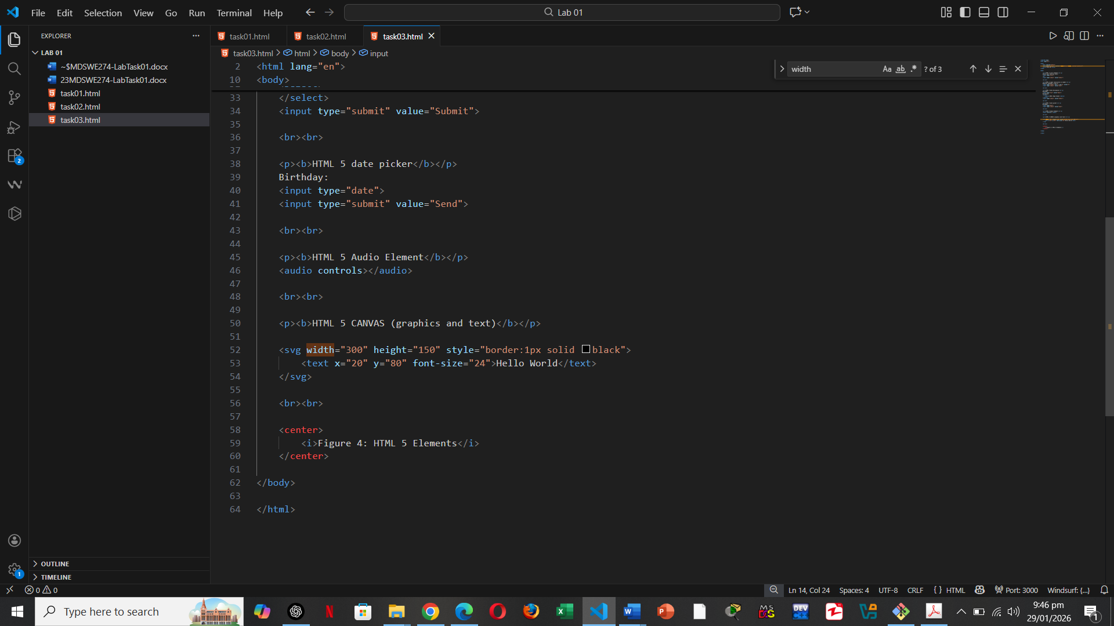

Output:
