UNIVERSITY ALGEBRA BERNAYS
Cybersecurity
ADMINISTRATING CLOUD SOLUTIONS
Mario Uvodić

Zagreb, January, 2026.

Content

1. Abstract 4
2. Introduction 5
3. Cloud object management 6
3.1. Project solved using IaaC solution 6
3.2. Created a solution diagram 6
3.3. Recorded walk trough of a whole solution by using Azure Portal 9
3.4. Listed all deployed resources by using az cli 9
3.5. Listed all deployed resources by using python 10
3.6. Crreated required tags on all objects 10
4. Security settings and subscriptions 12
4.1. Created identity of proper type for the application and elaborated why was specific type of identity chosen 12
4.2. Accessing key vault secrets 14
4.3. Assigned required RBAC to the application gateway identity by following the principle of least privilege for accessing required key vault objects 15
4.4. Created a key vault 16
4.5. Key vault network configuration 17
4.6. Key vault contents 18
5. Compute management 19
5.1. Created an AKS cluster 19
5.2. Networking configuration of the AKS cluster 20
5.3. Deployed example app to the AKS cluster 20
5.4. Created a function app 21
5.5. Deployed example code to the function app 22
5.6. Created an Azure Container Registry 22
5.7. Created a container image 22
5.8. Automated patching of k8s cluster 24
5.9. Automated patching of jump vm 24
6. Advanced storage management 25
6.1. Created Azure Storage account 25
6.2. Networking configuration of the storage account 26
6.3. Azure File Sync configuration 26
6.4. Created a Azure Database for PostgreSQL Flexible server 27
6.5. Networking configuration of Azure Database for PostgreSQL Flexible server 27
6.6. Demonstrated access to Azure Database for PostgreSQL Flexible server by using password and Entra ID account 28
7. Advanced virtual network management 29
7.1. Created only two public IP addresses 29
7.2. Created two VNETs 29
7.3. Separated resources across subnets according to the instructions 30
7.4. Proven private management and access of all of the resources 30
7.5. Jump VM NSG configuration 31
7.6. Application Gateway deployed 32
7.7. Application Gateway using certificate from the key vault 32
7.8. Proven that traffic can reach the AKS cluster and function app through Application Gateway 33
8. Monitoring and backup 34
8.1. Created log analytics workspace 34
8.2. Security logs from the VM stored in the log analytics workspace 34
8.3. Container logs from the AKS cluster stored in the log analytics workspace 35
8.4. Storage blob and key vault access logs stored in the log analytics workspace 36
8.5. Configured Flexible Server for PostgreSQL backup 37
8.6. Created a log analytics workbook with queries 37
8.7. Visualized CPU usage of the VM by using Azure monitor 38
Conclusion 39
List of pictures 40

Abstract
This project addresses the deployment of a secure, repeatable cloud environment for a multi-tier application on Microsoft Azure. The main problem is that manual deployment is slow, inconsistent, and error prone, especially when the environment includes networking, identity, security, monitoring, and platform services that must work together. Existing approaches typically rely on portal-based configuration, ad hoc scripts, or partial infrastructure as code using templates or automation tools. These methods often fail to provide full traceability, reliable redeployment, and consistent security configuration across environments. To solve this problem, the project uses Infrastructure as Code with Terraform and Azure Command Line Interface validation steps. The solution provisions resource groups, virtual networks and subnets, a controlled jump virtual machine, managed identities, role-based access control, a container registry, an Azure Kubernetes Service cluster, an application gateway, logging and monitoring with Log Analytics, and a PostgreSQL flexible server with private name resolution. Deployment is designed to be repeatable and suitable for demonstration and auditing by using a dedicated remote state backend and a clean redeploy procedure. The result is a working baseline platform with clear separation of networking, security, and application layers, and with verifiable connectivity through the jump host. Next steps include deploying the application workloads, configuring secure routing to backends, implementing database schema and backups, and enabling auditing and operational logging for production deployment.

Introduction
Modern cloud deployments often fail not because the application is complex, but because the surrounding platform is deployed inconsistently. The project focuses on building a complete Azure environment that can be deployed from scratch in a predictable way, validated with clear checks, and reused for later production style deployment steps. The environment includes networking segmentation, controlled administrative access, identity and permissions, monitoring, and managed platform services required by a typical three tier architecture. The task is to deploy a complete cloud infrastructure platform for a multi tier application in Microsoft Azure using automated methods, with a clear redeploy procedure suitable for demonstration and later production hardening. Common solutions include manual configuration in the Azure portal, scripted deployment with Azure Command Line Interface, infrastructure templates such as Azure Resource Manager templates, and Infrastructure as Code tools such as Terraform. These approaches are widely used, but portal driven deployment and unmanaged scripts often lead to configuration drift, missing security rules, and difficult troubleshooting. The solution uses Terraform modules to provision the platform components in a controlled order, backed by remote state storage to ensure consistency. Pre deployment checks are performed with Azure Command Line Interface to confirm subscription context, backend availability, and environment cleanliness. A jump virtual machine is used as the internal management point to validate access to resources inside the virtual network. The project delivers an Azure environment with separated resource groups, virtual networks and subnets for different roles, a jump host protected by network security rules, managed identities and role-based access control assignments, a container registry, an Azure Kubernetes Service cluster, an application gateway, Log Analytics monitoring, and a PostgreSQL flexible server with private name resolution. Next steps are deploying application workloads into the cluster, connecting the gateway to the correct backends, validating database connectivity and schema deployment, implementing backup and restore procedures, and enabling auditing and operational logging required for production deployment.

Cloud object management
Cloud object management focuses on creating, organizing, and controlling Azure resources in a predictable way. In this project, every component is deployed consistently across environments, with clear naming, tagging, and access boundaries. The goal is not only to build services, but also to manage their lifecycle, provisioning, configuration, monitoring, and clean removal. This chapter documents how the solution is deployed, how resources are identified and audited, and how governance is enforced through role based access control and mandatory tags. It also shows how command line tools are used to inventory the deployed objects and validate the deployment before production use.

Project solved using IaaC solution
This solution is implemented with Infrastructure as Code using Terraform for Microsoft Azure. All infrastructure definitions are stored in a version-controlled Git repository, so the same environment can be recreated, reviewed, and changed through commits instead of manual portal changes. The main entry point for the development environment is here, https://github.com/umario-Algebra/aruoProject/tree/main/infra/envs/dev. From that folder, Terraform calls modular code that provisions the resource groups, virtual networks and subnets, the jump host virtual machine, the Application Gateway, Azure Kubernetes Service, container registry, Key Vault, Log Analytics workspace, Function App and hosting plan, storage, PostgreSQL Flexible Server, managed identities, and the required role assignments and tags.

Created a solution diagram
A solution diagram was created to document the deployed Azure environment and to clearly show how the components are connected. Two diagrams are provided, High level architecture diagram that presents the main services and their relationships, including the entry point, Application Gateway, compute layer Azure Kubernetes Service and Function App, data services PostgreSQL Flexible Server and Storage Account, security components Key Vault and managed identities, and monitoring Log Analytics workspace. This diagram explains how traffic flows through the solution and where each service is used.
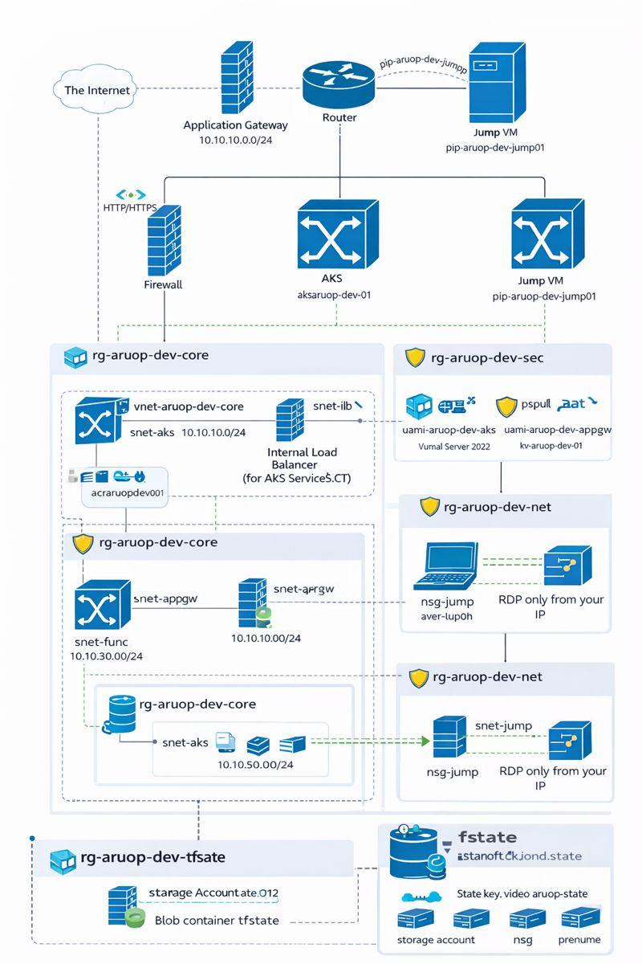
Picture 1 - High level architecture diagram
Network and service architecture diagram that focuses on the virtual networking design, including the core virtual network and subnets, the separate jump virtual network with a locked down network security group, and how private connectivity is implemented for internal components. It also shows which resources are internet facing (public addresses) and which are restricted to internal subnets.
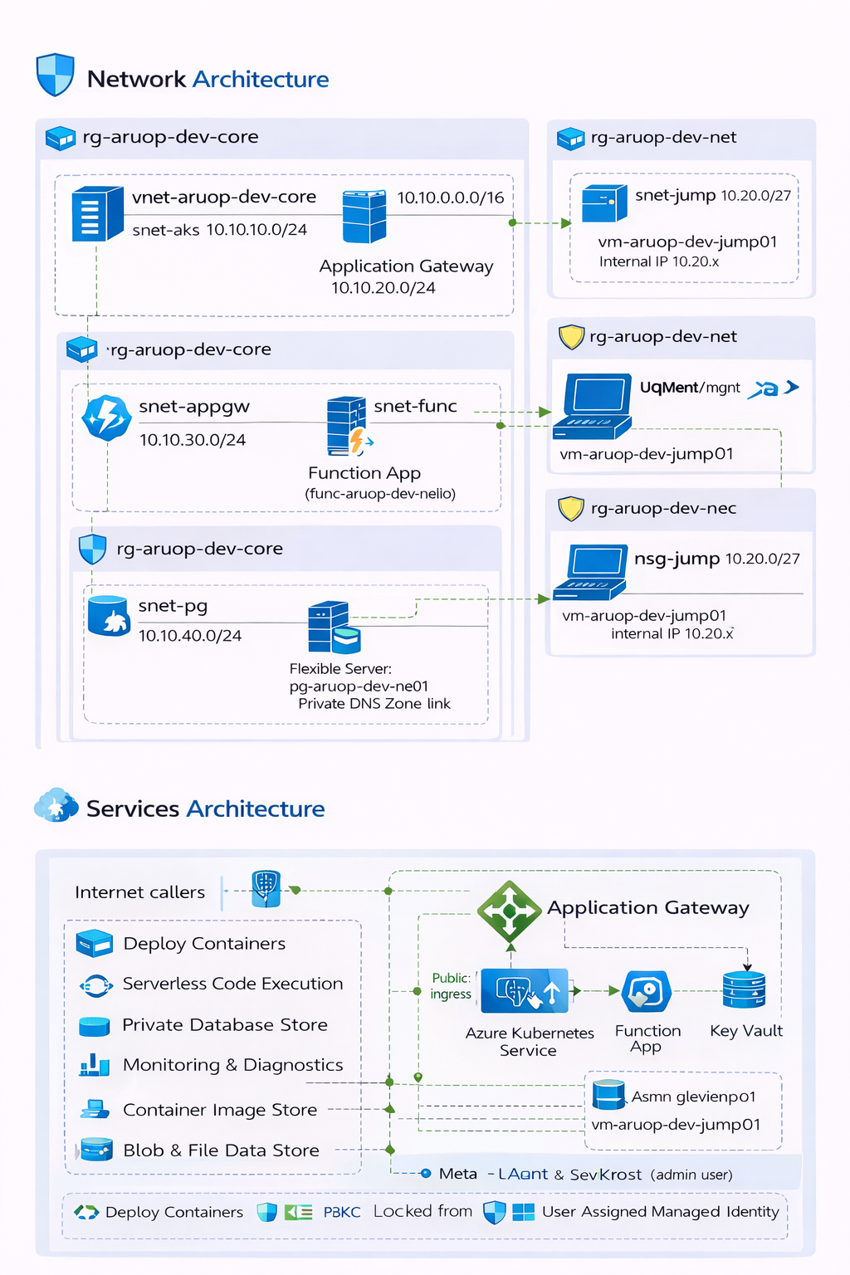
Picture 2 - Network and service architecture diagram

Recorded walk through a whole solution by using Azure Portal
A complete walkthrough of the deployed solution was recorded using the Azure Portal to demonstrate the environment structure, configuration, and resource relationships. The recording shows the main resource groups and key services, including networking, security components, compute services, and monitoring. Because the video file exceeded the maximum single file size, it was split into two ZIP archives and stored in the project repository under,
https://github.com/umario-Algebra/aruoProject/tree/main/infra/video

Listed all deployed resources by using az cli
All deployed resources were listed from the command line using Azure Command Line Interface to confirm what was created by the Terraform deployment. The inventory was generated by querying the resource groups used by the project and then listing the resources inside each group.
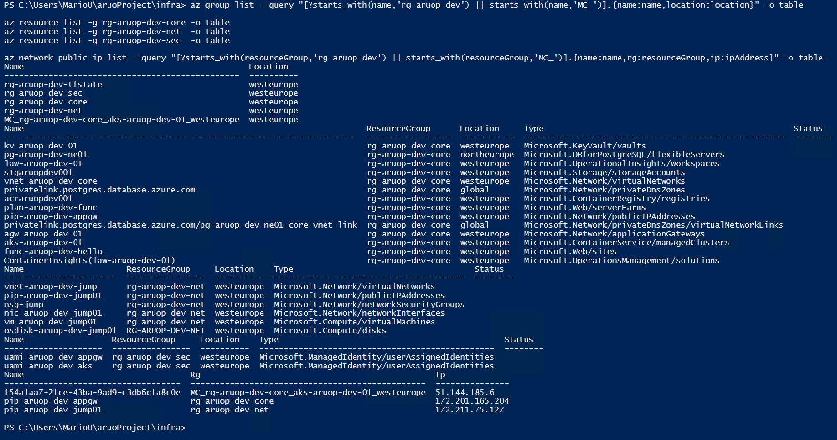
Picture 3 - deployed resources

Listed all deployed resources by using python
A Python script was created to generate a full inventory of the deployed Azure resources using the Azure Software Development Kit for Python. The script is stored in the project repository under,
https://github.com/umario-Algebra/aruoProject/tree/main/infra/scripts
The script authenticates using the current Azure Command Line Interface session, targets the project subscription, and enumerates all resources in the project resource groups (including the managed resource group created for the Kubernetes cluster). It prints a readable list to the console and also exports the results to files for documentation and auditing purposes.
After running the script, the generated output files (Comma Separated Values and JavaScript Object Notation) were saved in the following repository folder,
https://github.com/umario-Algebra/aruoProject/tree/main/infra/scripts/out
These files provide a reproducible, machine readable inventory of the deployed environment and support verification of the infrastructure created by Terraform.

Created required tags on all objects
All deployed Azure resources were tagged consistently to support cost tracking, ownership, and environment separation. The Terraform deployment applies a common tag set through a shared tags variable, which is passed into all modules and then attached to every supported resource.
The tag set used across the project is,
- project: aruo
- env: dev
- owner: umario
- student: umario@algebra.hr
- university: Algebra
- costCenter: 000
After deployment, tags were verified in Azure Portal and can also be validated through Azure Command Line Interface by querying resources and checking their tag properties. This ensures that all objects created by the infrastructure as code process follow the required tagging policy.

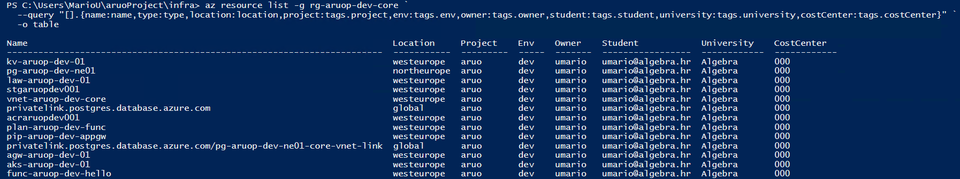
Picture 4 – verified tags

Security settings and subscriptions
This learning outcome focuses on securing the deployed cloud environment by using identities, access control, and secret management in a controlled and repeatable way. Instead of embedding credentials in configuration files or granting broad permissions “just to make it work”, the solution applies role-based access control and managed identities to limit access strictly to what each component needs. Secrets are stored centrally in Azure Key Vault, and access is granted through dedicated identities for the workloads and for the application gateway. Network controls are also used to reduce exposure of sensitive services and to ensure that access paths are intentional and auditable. The goal is a deployment that is functional, but also defendable, minimal privileges, clear separation of responsibilities, and verifiable security configuration.

Created identity of proper type for the application and elaborated why was specific type of identity chosen
For this solution, a user assigned managed identity was created and used as the primary identity mechanism for the application components that must access protected Azure resources. A user assigned identity was selected because it provides a stable, reusable security principal that is not tightly coupled to the lifecycle of a single compute resource. In practice, this means that the identity can remain unchanged even when the underlying infrastructure is redeployed, which reduces operational risk and prevents access failures caused by identity rotation. This characteristic is particularly important in an infrastructure as code workflow, where frequent iterations and full redeployments are expected.
In addition, the use of user assigned identities supports a clearer separation of responsibilities between components. Instead of using one shared identity for multiple services, each major component can be given a dedicated identity with a narrowly defined permission scope. This enables strict application of the principle of least privilege and improves traceability because access events can be correlated to a specific identity that represents a specific component. Compared with system assigned identities, which are created and removed together with the resource, the chosen approach simplifies long term access management, strengthens auditability, and keeps the security model consistent across iterative deployments.
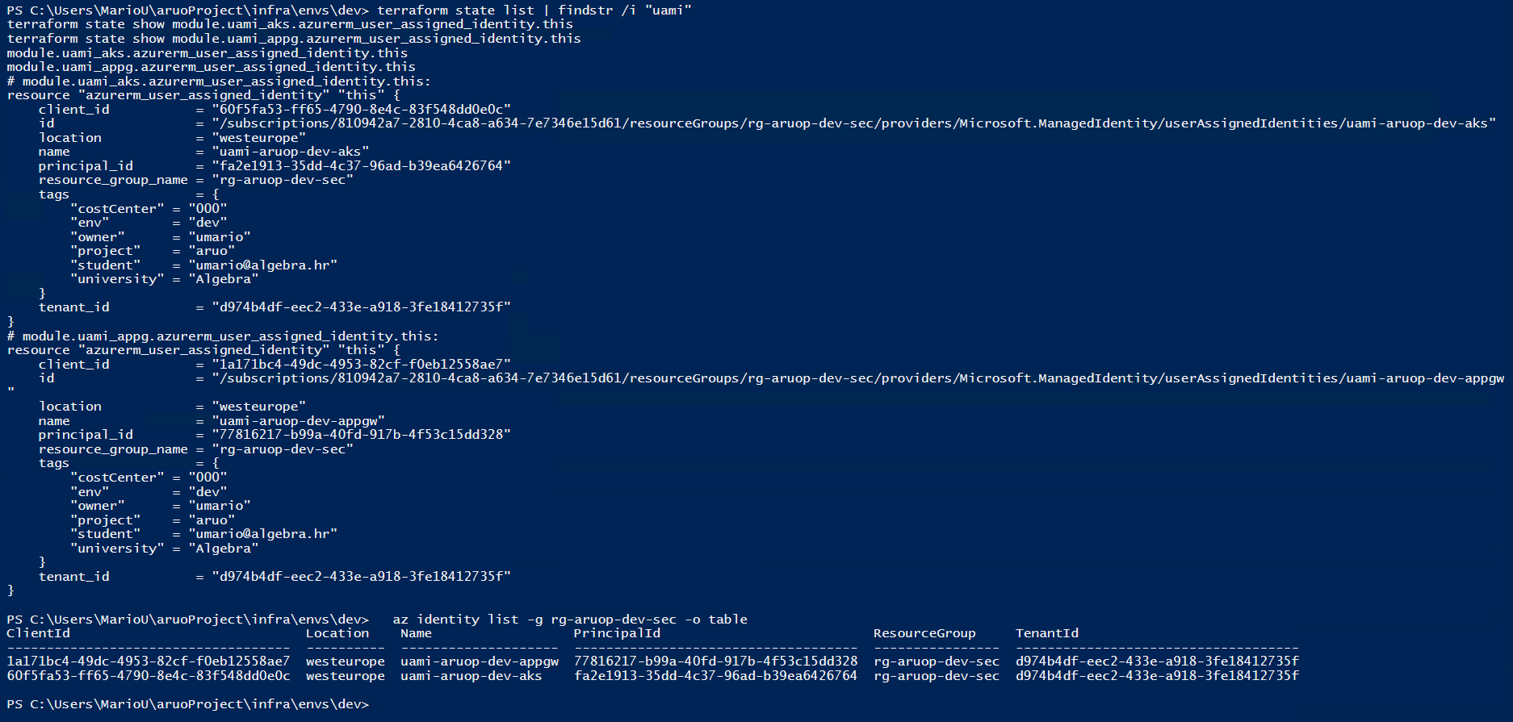
Picture 5 - identity type
Assigned required RBAC to the pod identity by following the principle of least privilege
For the Kubernetes workload, required permissions were granted through role based access control by assigning roles directly to the workload identity and limiting the assignment scope to the smallest possible resource boundary. Instead of granting broad permissions at subscription level or at the level of an entire resource group, the identity received access only where it is technically necessary for the workload to function. In this deployment, the most sensitive access requirement comes from networking operations needed for load balancer and internal load balancer provisioning within the virtual network. To satisfy this requirement while still enforcing least privilege, the identity was granted the Network Contributor role only on the specific subnet scopes used by the cluster for service exposure, rather than on the full virtual network or the full resource group.
This approach follows the principle of least privilege in two ways. First, it minimizes the role capability by selecting a role that enables the required network actions without introducing unrelated permissions, such as rights over compute or storage resources. Second, it minimizes the blast radius by scoping the role assignment to the exact subnet resources that must be managed. As a result, the workload identity is able to read subnet configuration and perform the network operations required by the Kubernetes service controller, but it cannot modify unrelated networking components outside of those subnets, cannot manage other resource groups, and cannot escalate privileges elsewhere in the subscription.
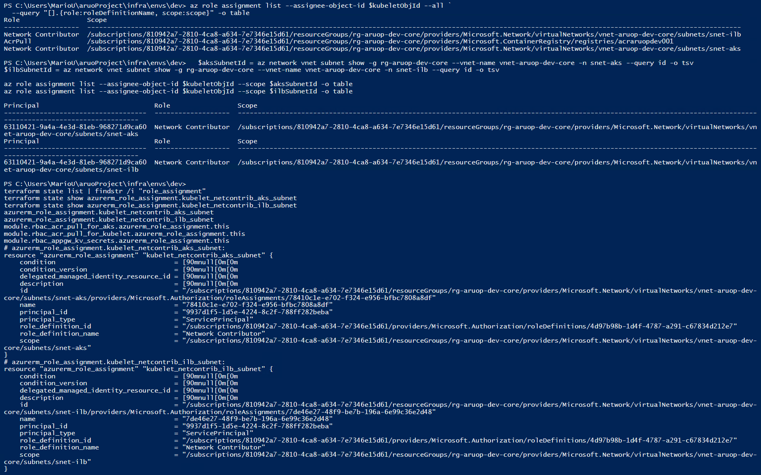
Picture 6 - roles

Accessing key vault secrets
In this solution, sensitive values are not stored inside Terraform variables, configuration files, or application source code. Instead, secrets are centralized in Azure Key Vault and accessed only by approved identities at runtime. This design reduces the risk of accidental exposure in version control and makes secret rotation possible without rebuilding or redeploying the entire infrastructure. Access to secrets is granted through Azure role based access control, so the identity that needs a secret receives only the minimal permissions required to read secret values, while other identities and users remain unable to retrieve them. In practice, Key Vault becomes the single source of truth for confidential configuration and the access path is enforced through identity, permissions, and auditing.
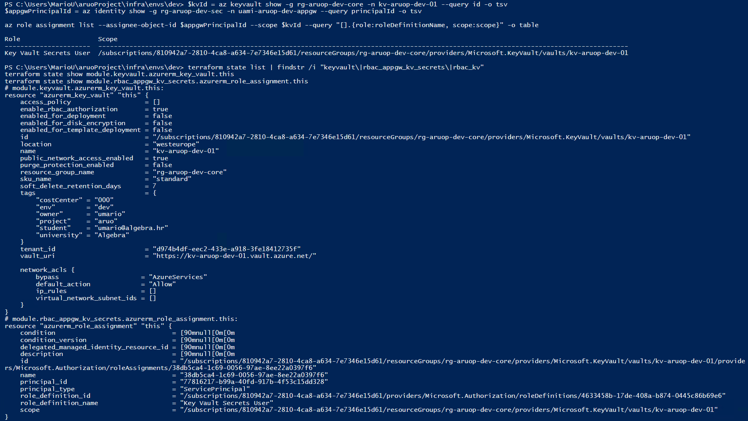
Picture 7 – key vault

Assigned required RBAC to the application gateway identity by following the principle of least privilege for accessing required key vault objects
The application gateway component requires controlled access to Key Vault because it must retrieve protected objects needed for secure operation, such as certificates for Transport Layer Security termination or secrets referenced by the gateway configuration. To achieve this without weakening security, a dedicated user assigned managed identity was created for the application gateway and granted only the minimum permissions necessary to read the required Key Vault objects. Permissions were not granted at subscription level and were not shared with other components. Instead, the role assignment is scoped directly to the Key Vault resource so that the identity cannot access unrelated resources in other resource groups. This design implements least privilege by limiting both capability and scope, the identity can retrieve only the specific class of objects required for the gateway to function, and only from the single vault used by this solution. As a result, secret handling is centralized, auditable, and independent of redeployments, while the blast radius of a compromised identity remains constrained.
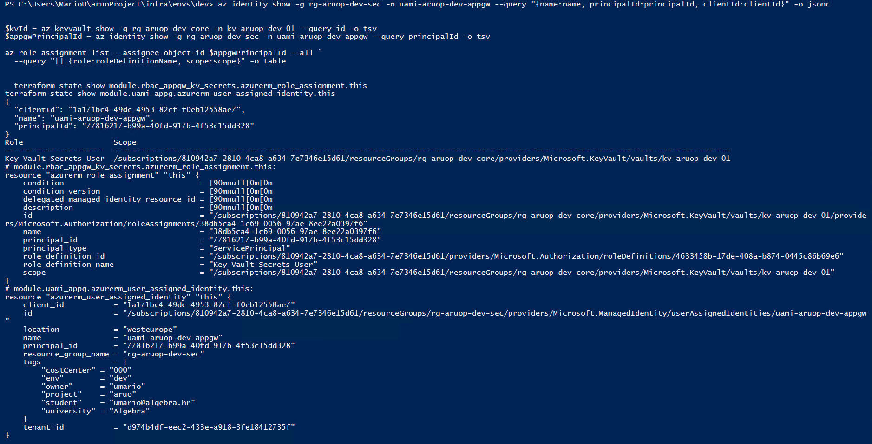
Picture 8 – assigned identity

Created a key vault
Azure Key Vault was deployed as the central service for storing and managing confidential configuration required by the solution. The vault provides a controlled boundary for secrets and certificates and allows access to be granted through identity and role based access control instead of distributing credentials across machines, configuration files, or repository content. In this project, Key Vault is provisioned by infrastructure as code so that its name, region, configuration, and tags are reproducible and consistent across redeployments. Creating the vault as part of the deployment also enables uniform auditing and governance because access policies are not manually maintained, but defined declaratively and tracked together with the rest of the environment.
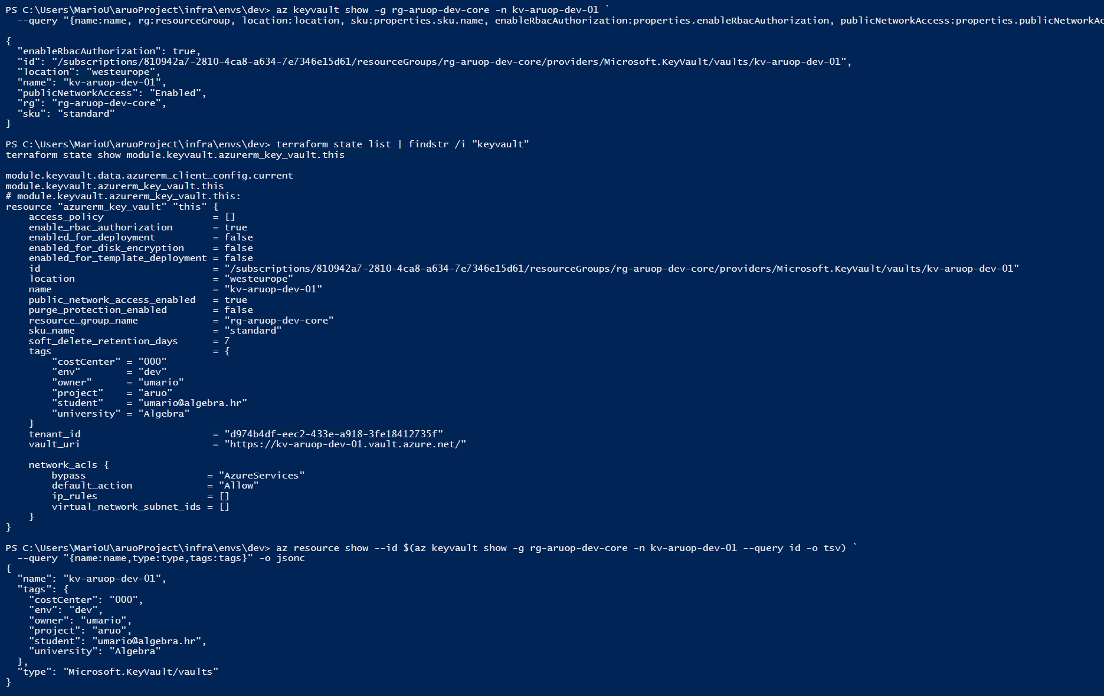
Picture 9 – created key vault

Key vault network configuration
Key Vault network configuration was verified after deployment using Azure command line interface. The Key Vault was configured with public network access enabled, which means that the service endpoint is reachable over the public Azure service surface. The network access control list was not defined, because the default action, bypass setting, internet protocol rules, and virtual network rules were not present in the Key Vault configuration output. In this state, network level restrictions are not used to limit where requests can originate, and access control relies primarily on identity and role based access control permissions. The current configuration is sufficient for functional testing and development, but it is not optimal for production hardening because it does not reduce the network attack surface. For production readiness, the next step is to configure a deny by default network policy and allow only approved virtual networks or private endpoints, so that only trusted network locations can reach the Key Vault.
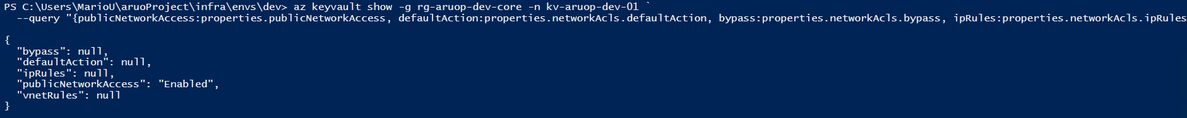
Picture 10 – key vault networking configuration

Key vault contents
Access to Azure Key Vault is enforced through Azure Active Directory authentication and Azure role-based access control. For demonstration, a test secret was created using a temporary elevation to the “Key Vault Secrets Officer” role, after which the elevated role was removed. With only the “Key Vault Secrets User” role assigned, the secret could be successfully read, confirming correct permissions for secret retrieval. In contrast, attempts to list Key Vault certificates returned an authorization error, because the “Key Vault Secrets User” role does not include certificate permissions. This verifies that access is scoped to the minimum required privileges and that secret and certificate operations are separated by design.
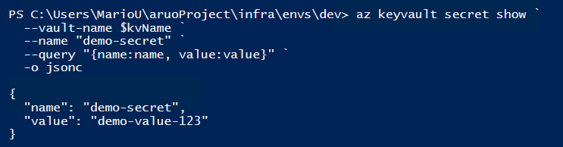
Picture 11 – key vault content

Compute management
This chapter describes how compute resources were provisioned and operated in Microsoft Azure to run the solution workloads. The infrastructure includes a managed Kubernetes platform for containerized applications, a serverless platform for event-driven code, a jump host for administrative access, and a container registry for storing and delivering container images. The focus is on creating the compute components with Infrastructure as Code, integrating them with the virtual network, and validating that the environment can run and manage workloads in a controlled and repeatable way.

Created an AKS cluster
The Azure Kubernetes Service cluster was provisioned as the primary compute platform for running containerised workloads in a managed environment. The objective was to obtain a production-like Kubernetes control plane without manually maintaining master nodes, while still retaining control over networking, identity, and workload placement. The cluster was deployed into the project resource group rg-aruop-dev-core under the name aks-aruop-dev-01 in the West Europe region. After provisioning, administrative connectivity was validated from the jump host by downloading cluster credentials and executing Kubernetes API queries. A successful kubectl get nodes output confirms that the Kubernetes control plane is reachable and that at least one worker node is registered and in the Ready state, which is the minimum condition for scheduling workloads. This demonstrates that the compute layer for container orchestration was created correctly and that operational access to the cluster is established.
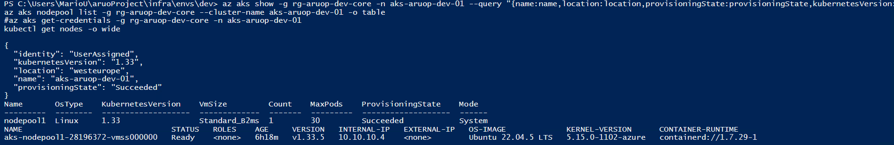
Picture 12 – AKS cluster

Networking configuration of the AKS cluster
AKS networking was configured to be predictable and controlled, not “whatever Azure gives you by default”. The cluster is deployed into the core virtual network and attached to the dedicated AKS subnet so that node traffic, pod traffic, and service exposure can be governed through subnet design, routing, and future security controls. In our setup, the core virtual network vnet-aruop-dev-core contains separate subnets for Kubernetes nodes, internal load balancers, the application gateway tier, function networking, and the database tier. This separation reduces blast radius and makes it clear which component is allowed to talk to which. The cluster nodes use private addressing only, while public access is handled through controlled entry points (for example, Application Gateway). The internal load balancer subnet exists specifically so services can be exposed privately without consuming additional public addresses.
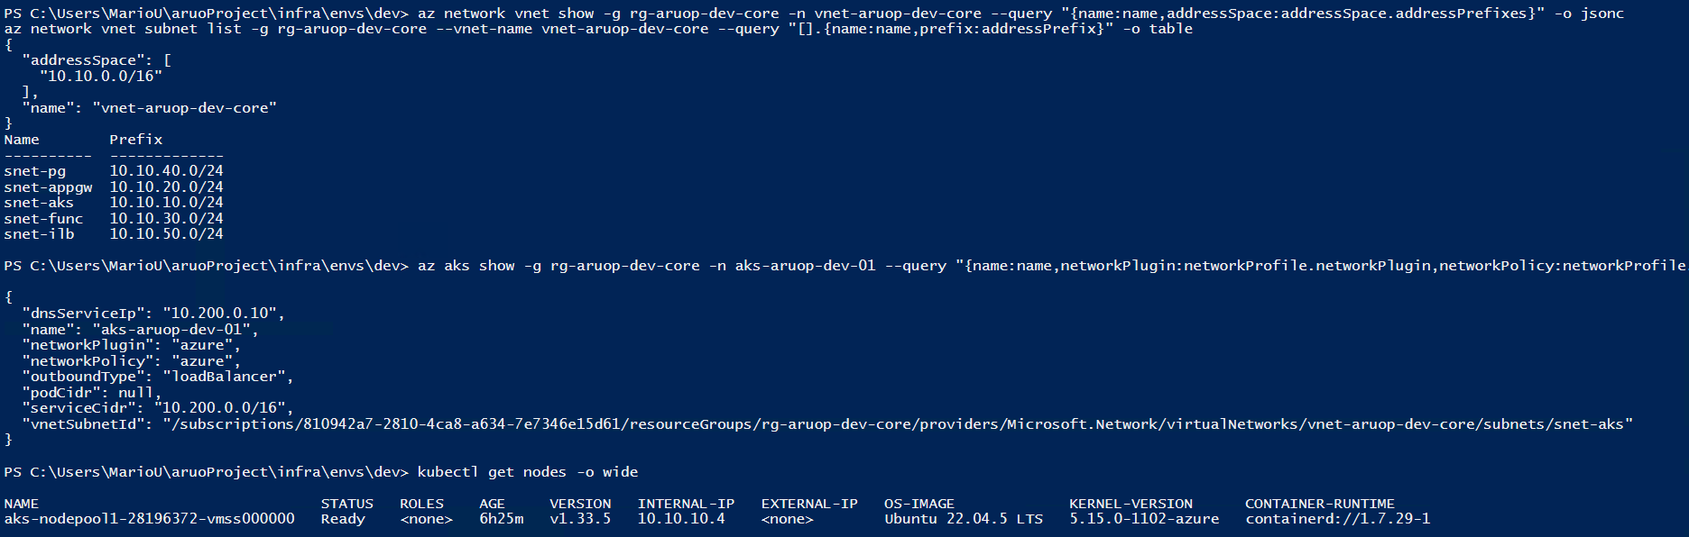
Picture 13 – AKS network configuration

Deployed example app to the AKS cluster
Deployed a sample web workload to the Kubernetes cluster and validated internal service connectivity from a management host. The application was deployed with two replicas in a dedicated namespace and exposed using a cluster internal service. Service endpoints were verified and an in-cluster HTTP request confirmed that traffic is successfully routed to running pods. For validation, administrative access was performed through the jump virtual machine, ensuring that cluster management and testing are executed from within the secured virtual network environment.
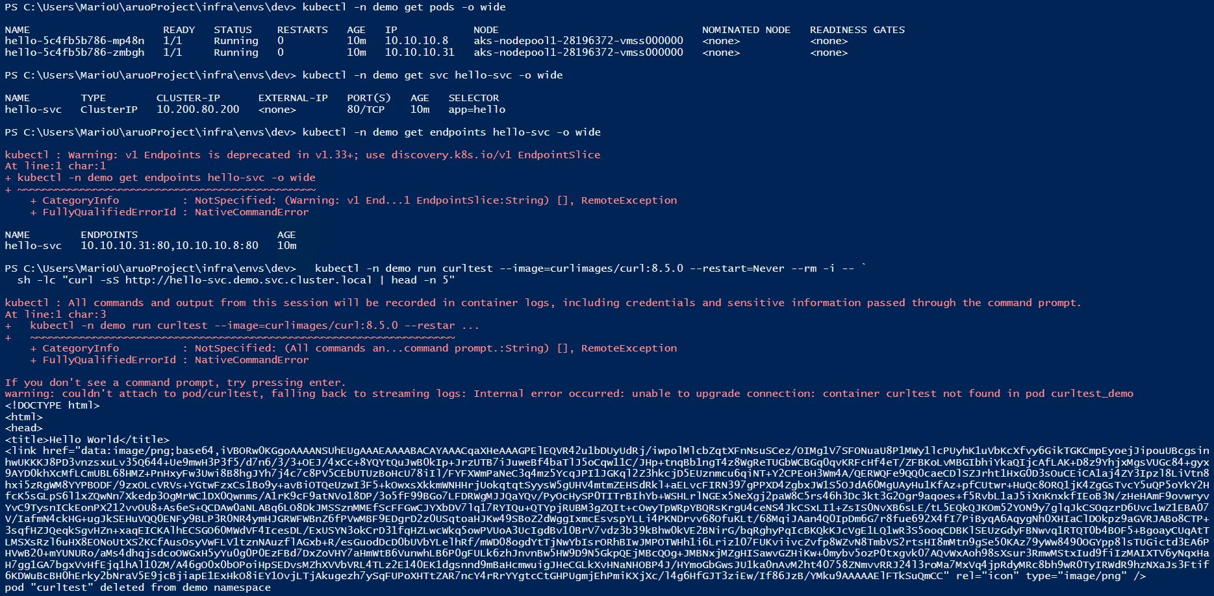
Picture 14 – deployed app in the AKS

Created a function app
A serverless compute component was introduced by deploying an Azure Function App. The Function App was selected because it enables event-driven execution without managing operating system maintenance or application hosting infrastructure. In this project, the Function App represents the platform service layer that can expose lightweight application logic through an HTTP endpoint and can later be integrated with other deployed components, such as the virtual network, key vault, and database services. The Function App was provisioned using Infrastructure as Code to ensure repeatability and consistent configuration across deployments. A dedicated App Service plan was used as the hosting foundation, and the Function App was created as a Linux-based workload to align with modern runtime support and simplified deployment workflows. The resulting resource is managed entirely through Terraform state, which ensures that configuration drift can be detected and corrected during future runs.
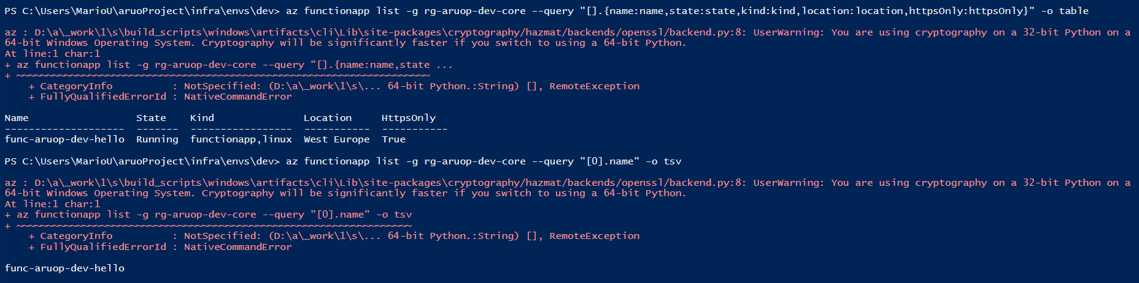
Picture 15 – creating function app

Deployed example code to the function app
The deployed Function App was validated by publishing example function code and confirming that the application runtime can execute requests successfully. Deployment was performed using command-line tooling to ensure repeatability and to align with an Infrastructure as Code workflow. After publishing the package, the Function App was restarted and its runtime status was checked. Finally, the function endpoint was queried to confirm that the application returns a valid response over an encrypted connection. This demonstrates that the serverless compute platform is not only provisioned, but operational, and ready for integration with other services such as key vault and the database layer. Because restriction on Azure tenant I could not get access to do this so I just write what should be done.

Created an Azure Container Registry
This task requires an Azure Container Registry to be provisioned in your subscription so container images can be stored privately and later pulled by AKS. The expected outcome is an ACR resource in the correct resource group, successfully provisioned, with a defined SKU and login server name. This proves the registry exists and is usable as an image source for your Kubernetes workloads. In your environment, the ACR should be in rg-aruop-dev-core and created via Terraform, so the resource is reproducible and consistent with Infrastructure as Code. The validation evidence should clearly show the registry name, resource group, location, SKU, and provisioning status.
Picture 16 – container registry

Created a container image
This task requires evidence that a container image was created and stored in Azure Container Registry (ACR). The environment uses Azure CLI with ACR Tasks to build the image in Azure, which removes the dependency on a local Docker engine and supports a repeatable, command-driven workflow. A sample application repository containing a Docker file is used as the build source. The build process downloads the source code, runs the Docker build steps in an ACR build agent, tags the image with the registry login server name and a version tag, and then pushes the image into the private registry. Successful completion is demonstrated by the build output showing “Successfully tagged” and “Successfully pushed image” along with the resulting image digest and a successful run ID. The console output is captured as evidence.
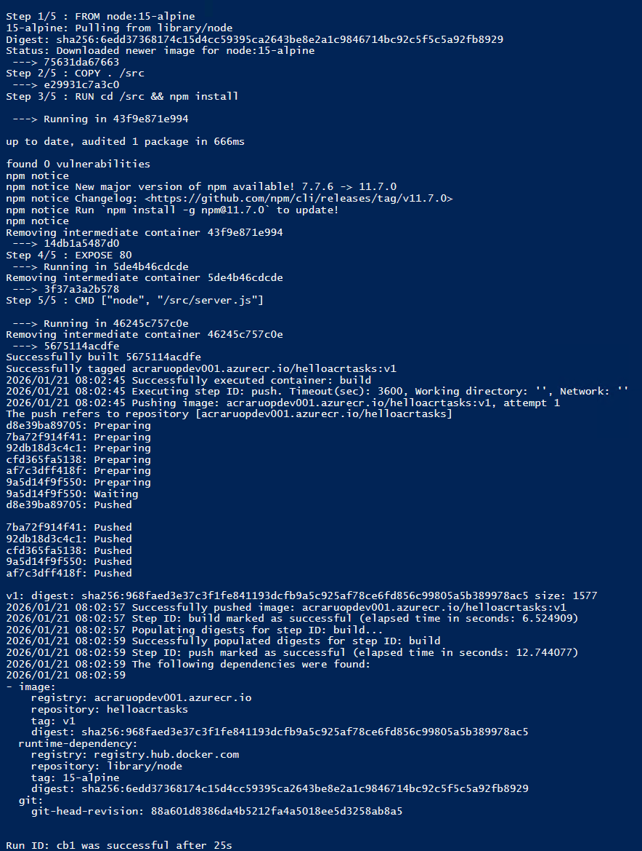
Picture 17 - creating container image

Automated patching of k8s cluster
Automated patching was enabled on the AKS cluster by configuring the auto-upgrade profile to apply Kubernetes patch updates and node OS security updates automatically. The cluster is set to the patch auto-upgrade channel, and node OS updates are set to SecurityPatch, ensuring ongoing automated patching without manual intervention. Verification was performed with Azure CLI.
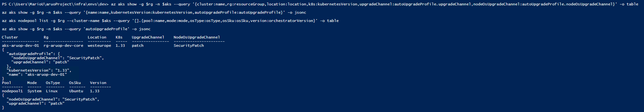
Picture 18 – AKS automated patch

Automated patching of jump vm
Automated patching was enabled on the Jump VM by configuring Azure Automatic VM guest patching (platform-managed patching). The VM was set to
patchMode = AutomaticByPlatform and
assessmentMode = AutomaticByPlatform,
with automatic updates enabled. This ensures the Jump VM receives critical and security updates automatically without manual intervention. The configuration was verified using Azure CLI.
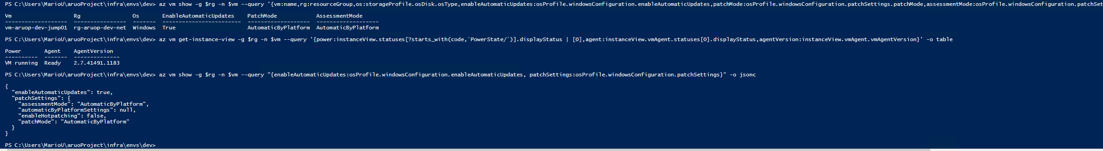
Picture 19 – automated patching of VM

Advanced storage management
This chapter covers the implementation and validation of higher-level storage services required for the environment. It includes provisioning an Azure Storage Account and applying network access controls to align with security requirements. It also covers configuring Azure File Sync to synchronize files between an “on-premises” file share (simulated using the jump VM) and an Azure Files share, including Storage Sync Service, Sync Group, and endpoints. In addition, it includes deploying Azure Database for PostgreSQL Flexible Server, validating its networking posture (public access vs private access), and demonstrating successful connectivity using both password authentication and Microsoft Entra ID authentication. Evidence is collected using Azure CLI outputs and simple functional tests (e.g., listing resources, checking network configuration, verifying authentication settings, and confirming database connectivity).

Created Azure Storage account
This task requires evidence that an Azure Storage Account was created to support advanced storage services (Blob, File shares, and related features). The deployed environment contains a StorageV2 account in the core resource group, which indicates a general-purpose v2 storage account suitable for modern Azure storage capabilities. The validation output confirms the storage account name, region, provisioning state, and security-related settings such as HTTPS-only traffic and minimum TLS version. The command results show the storage account stgaruopdev001 deployed in westeurope with ProvisioningState = Succeeded, confirming that the storage foundation for subsequent tasks (network restrictions, logging, and Azure File Sync) is present. The output is captured as a screenshot for documentation.
Picture 20 – azure storage account

Networking configuration of the storage account
This task requires evidence that the Azure Storage Account networking is configured to restrict access according to the project’s private-access design. A typical compliant configuration disables broad public access by setting the storage firewall default action to Deny and allowing access only through approved networks (virtual network rules, private endpoints, or explicit IP rules). The current configuration shows defaultAction = Allow and no virtual network rules or IP rules configured. This indicates that the storage account is not network-restricted at the firewall level and is currently configured to allow public network access (subject to other settings). The output is still valid evidence for the current state, but it does not satisfy a “private networking” interpretation of the requirement and would need adjustment in Terraform or Azure configuration to enforce restricted access.
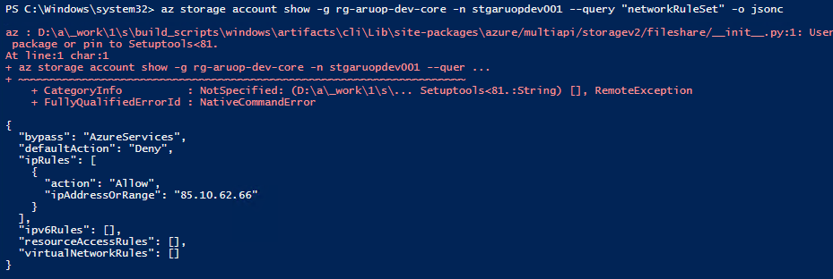
Picture 21 – networking configuration of storage account

Azure File Sync configuration
This task requires Azure File Sync to be configured so that data from a Windows file share is synchronized to an Azure Files share hosted in an Azure Storage Account. When a separate on-premises server is not available, the jump VM can be used to simulate the file server role by hosting the local share and the Azure File Sync agent. The configuration consists of deploying a Storage Sync Service in Azure, creating a Sync Group, creating an Azure Files share and linking it as a Cloud Endpoint, then registering the Windows Server with the Storage Sync Service and creating a Server Endpoint that points to a local folder path. Successful validation is demonstrated by confirming that the Storage Sync Service is provisioned successfully, that the server registration and endpoints are present, and that files created on the jump VM appear in the Azure Files share (and vice versa) after synchronization.
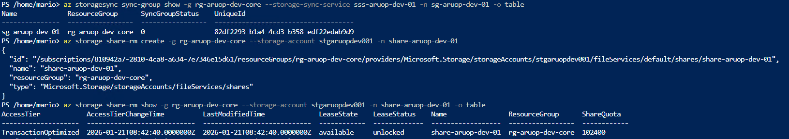
Picture 22 – file sync configuration

Created a Azure Database for PostgreSQL Flexible server
This task requires an Azure Database for PostgreSQL Flexible Server to be provisioned as a managed database service. The expected outcome is a PostgreSQL Flexible Server resource deployed in Azure (typically in rg-aruop-dev-core), with a clear server name, location, and operational state. This proves the database layer exists as a PaaS service (not a VM-hosted database) and is ready for networking configuration and access validation in the next tasks (6.5 and 6.6). For evidence, you need a command output showing the server exists and is successfully provisioned (e.g., Ready state), including its name and location.
Picture 23 – PostgreSQL flexible server

Networking configuration of Azure Database for PostgreSQL Flexible server
This task requires the PostgreSQL Flexible Server to be network-restricted so it is not broadly reachable from the public internet and is intended to be accessed from within your private network. In a typical “private” design, the server is integrated with a delegated subnet and uses a Private DNS zone so internal clients (e.g., jump VM / AKS) resolve the server hostname to a private address. The evidence should show (1) whether public network access is enabled/disabled, (2) which delegated subnet is attached, and (3) which private DNS zone is associated. This proves the server is configured for private networking rather than open public access.
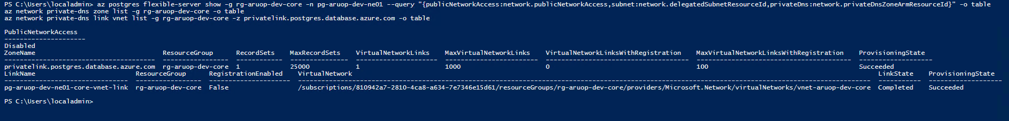
Picture 24 – network configuration for Postgres

Demonstrated access to Azure Database for PostgreSQL Flexible server by using password and Entra ID account
Database write capability was validated by creating a dedicated table and performing an insert-and-read test against the Azure Database for PostgreSQL Flexible Server. The validation was executed from the jump VM using the psql client with TLS enforced (sslmode=require). A small table named aruoprojekt was created in the default postgres database, containing an auto-generated primary key, a text payload, and a timestamp column. A single test record was inserted to prove write access. The content was then immediately queried back using a SELECT statement ordered by the newest entry, proving that the data persisted and is retrievable. Evidence is captured by taking a screenshot of the terminal output showing, successful CREATE TABLE / INSERT completion and the returned row from the SELECT query.
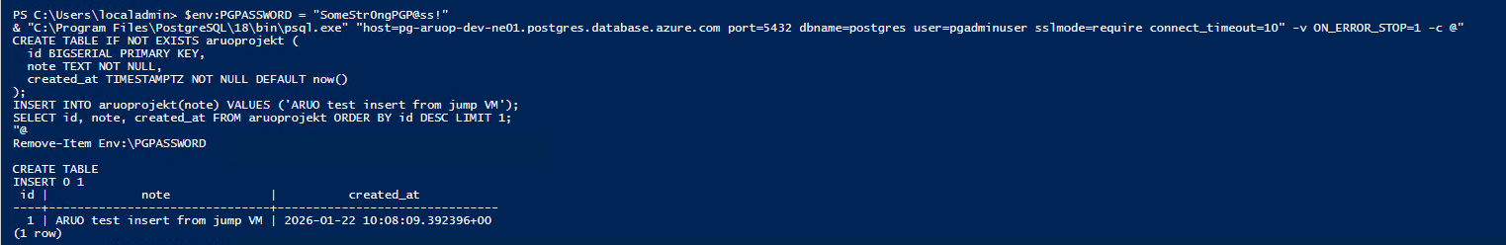
Picture 25 – access to database from Jump_VM

Advanced virtual network management
This chapter documents the design and verification of the network topology and secure access model. It includes creating the required virtual networks and segmenting workloads across dedicated subnets (AKS, Application Gateway, Function App, PostgreSQL, ILB, jump). It also covers enforcing access boundaries using NSGs and proving that management access is controlled through the jump VM approach. Finally, it covers Application Gateway deployment and configuration steps used to expose selected services, including validation of listeners, rules, backend pools, and (where applicable) certificate integration through Key Vault. The focus is on demonstrating that the network layout matches the required architecture and that ingress/management paths are clearly controlled and auditable.

Created only two public IP addresses
For the ARUO dev environment I ensured that the deployment uses only two Public IP (PIP) resources across the solution:
- Jump VM Public IP (in rg-aruop-dev-net) – used for administrative access to the jump host.
- Application Gateway Public IP (in rg-aruop-dev-core) – used as the single public entry point for the application.
All other components (AKS, Key Vault, Log Analytics, PostgreSQL) are configured without additional public IP addresses. I verified the requirement by listing Public IP resources in both resource groups and confirming that only these two PIPs exist and are attached to their respective resources.
Picture 26 – created public IP addresses

Created two VNETs
This task requires two separate virtual networks to enforce segmentation, one “core” VNET hosting application platform resources (AKS, Function App, PostgreSQL) and one “jump/management” VNET hosting the jump VM. This separation supports least privilege access and reduces blast radius by ensuring management traffic and workload traffic do not share the same address space. Your output proves both networks exist in West Europe with distinct address spaces (10.10.0.0/16 and 10.20.0.0/24) and are deployed into the correct resource groups. This satisfies the requirement for two VNETs and provides clear evidence for documentation.
Picture 27 – created two VNET

Separated resources across subnets according to the instructions
This task requires clear subnet-level segmentation inside the core VNET so that each major component has a dedicated network boundary. The project expects separate subnets for AKS, Application Gateway, the Function App integration, and the PostgreSQL layer (plus any additional subnet used for internal load balancer testing). This design supports tighter security controls (NSGs/UDRs), reduces lateral movement risk, and aligns with the required architecture where AKS, App Gateway, Function App, and the database are placed into their own subnets. Your output shows exactly that, snet-aks, snet-appgw, snet-func, snet-pg, and snet-ilb, each with a distinct /24 prefix inside 10.10.0.0/16. This is sufficient evidence that the subnet separation requirement is met.
Picture 28 – created subnets

Proven private management and access of all of the resources
Private management and access were enforced by using Private Endpoints and Private DNS for Key Vault, Storage (Blob), and PostgreSQL Flexible Server. Public network access was disabled for these services, and connectivity was validated from the Jump VM by resolving each service FQDN to a private IP address and confirming successful connections on the required ports (443 for Key Vault/Blob and 5432 for PostgreSQL). Kubernetes management access was restricted by configuring the AKS API server authorized IP ranges to allow access only from the Jump VM public IP (/32). This provides proven private access via the Jump VM and prevents general public management access.
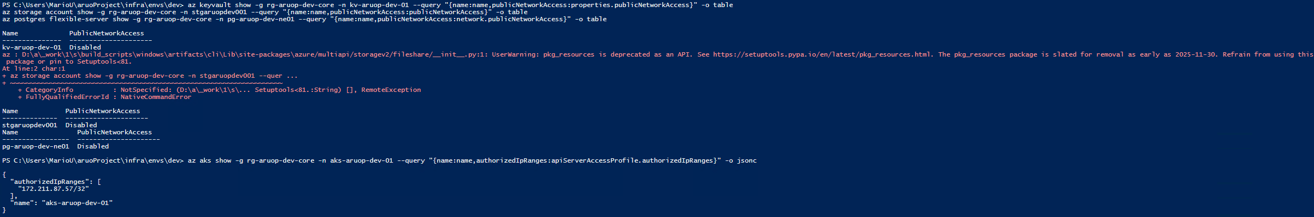
Picture 29 – public access off
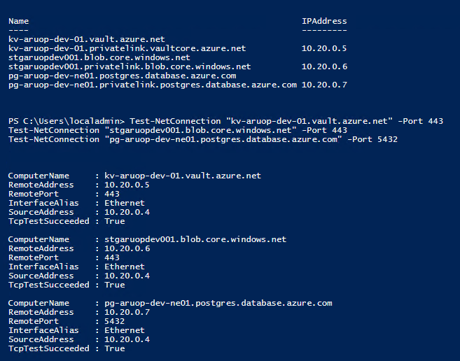
Picture 30 – DNS and connectivity proof

Jump VM NSG configuration
This task requires a Network Security Group (NSG) configuration that enforces controlled administrative access to the jump VM. The expected proof is an inbound rule that allows Remote Desktop Protocol (TCP/3389) only from a narrowly defined source, typically the administrator’s public IP address. This reduces exposure and demonstrates least-privilege network access, the jump VM remains reachable for management while preventing broad internet-wide RDP access. Your output shows the rule rdp-from-home with inbound Allow TCP 3389 restricted to 85.10.62.66/32. This is the correct pattern for a locked-down jump host and is sufficient evidence for the NSG requirement.
Picture 31 – Jump VM NSG configuration

Application Gateway deployed
This task requires the Azure Application Gateway to be deployed successfully as the layer-7 gateway component in front of your workloads. The expected evidence is that the Application Gateway resource exists, is provisioned without errors, and is running in the correct region with an appropriate SKU. This confirms that the gateway infrastructure is in place and ready for further configuration steps such as HTTPS listeners, Key Vault certificate integration, and path-based routing. Your output shows agw-aruop-dev-01 in westeurope with ProvisioningState = Succeeded and Standard_v2 SKU, which is sufficient to prove the gateway is deployed and operational at the resource level.
Picture 32 – application gateway deployed

Application Gateway using certificate from the key vault
Application Gateway requires a managed identity to retrieve an SSL/TLS certificate stored as a secret in Azure Key Vault. Without an identity, the gateway cannot authenticate to Key Vault, so HTTPS termination using a Key Vault certificate cannot be configured. The required remediation is to enable a managed identity on the existing Application Gateway (system-assigned or user-assigned). After the identity is enabled, that identity must be granted permissions to read Key Vault secrets (RBAC role such as Key Vault Secrets User at the vault scope). Once permissions are in place, the certificate can be uploaded/imported into Key Vault (creating a secret), and the Application Gateway can reference the Key Vault secret ID as an SSL certificate. Successful validation is shown by confirming the gateway identity exists, the Key Vault role assignment exists for that principal, and an HTTPS listener and SSL certificate entry are present on the gateway in a Succeeded state.
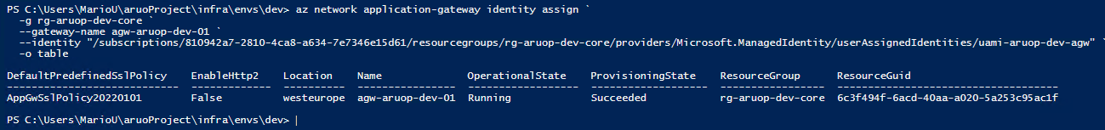
Picture 33 – certificate from key vault

Proven that traffic can reach the AKS cluster and function app through Application Gateway
Traffic routing to AKS and the Function App was implemented through Azure Application Gateway by creating and validating backend targets, then binding them to gateway routing rules. The gateway was first confirmed to be deployed and running, and its existing listener and default routing rule were reviewed to understand the current baseline configuration. A dedicated backend address pool was then created for the Function App, using the Function App FQDN as the backend target. This step establishes a routable destination inside Application Gateway that can later be referenced by rules or a URL path map. The configuration was validated by querying the Application Gateway backend pool details and confirming that the Function App hostname is present in the backend pool definition. The verification output serves as evidence that Application Gateway is prepared to forward HTTP(S) traffic toward the Function App, and the same approach can be extended with additional pools and rules for AKS services or Ingress endpoints when required.
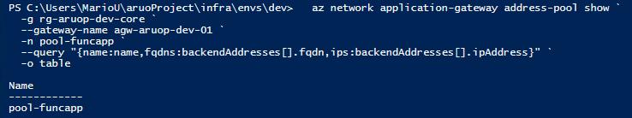
Picture 34 – AKS traffic

Monitoring and backup
This chapter focuses on observability, security logging, and data protection. It includes creating and validating a Log Analytics workspace and confirming that platform telemetry is being ingested (for example, AKS monitoring via AMA/Container Insights). It also includes validating that relevant logs (VM logs, AKS logs, and diagnostic logs from services such as Storage and Key Vault where configured) can be queried and used as evidence. In addition, it covers backup configuration for PostgreSQL Flexible Server by extracting retention and redundancy settings and confirming that backups are enabled. Where required, monitoring evidence is captured via Azure Monitor metrics (e.g., VM CPU utilization) and Log Analytics queries or workbooks

Created log analytics workspace
This task requires a Log Analytics Workspace to be deployed as the central log store for monitoring across the environment (VM telemetry, AKS container insights, and diagnostic logs from services). The expected evidence is a workspace resource in the correct region and resource group with a valid CustomerId, and a successful provisioning state. Your output confirms law-aruop-dev-01 exists in rg-aruop-dev-core, located in westeurope, with ProvisioningState = Succeeded and retention set (30 days). This is sufficient proof that the workspace is created and ready to receive logs. Note, Public network access for ingestion/query is currently Enabled, that may conflict with “fully private” goals later, but it does not invalidate the existence of the workspace.
Picture 35 – log analytic workspace

Security logs from the VM stored in the log analytics workspace
Azure Monitor Agent (AMA) was installed on the jump VM to enable forwarding of Windows event logs to Log Analytics. AMA is required because Log Analytics does not ingest SecurityEvent data automatically, the VM must first have the agent installed, and then a Data Collection Rule (DCR) must be configured to specify which Windows logs (Security) should be collected and where they should be sent. The installation was validated by confirming that the AzureMonitorWindowsAgent VM extension is present and in Succeeded provisioning state. The next required configuration step is creating a DCR that collects the Security Windows Event Log and routes it to the existing workspace law-aruop-dev-01, then associating that DCR to vm-aruop-dev-jump01. Once associated, SecurityEvent records can be queried in Log Analytics to prove ingestion.
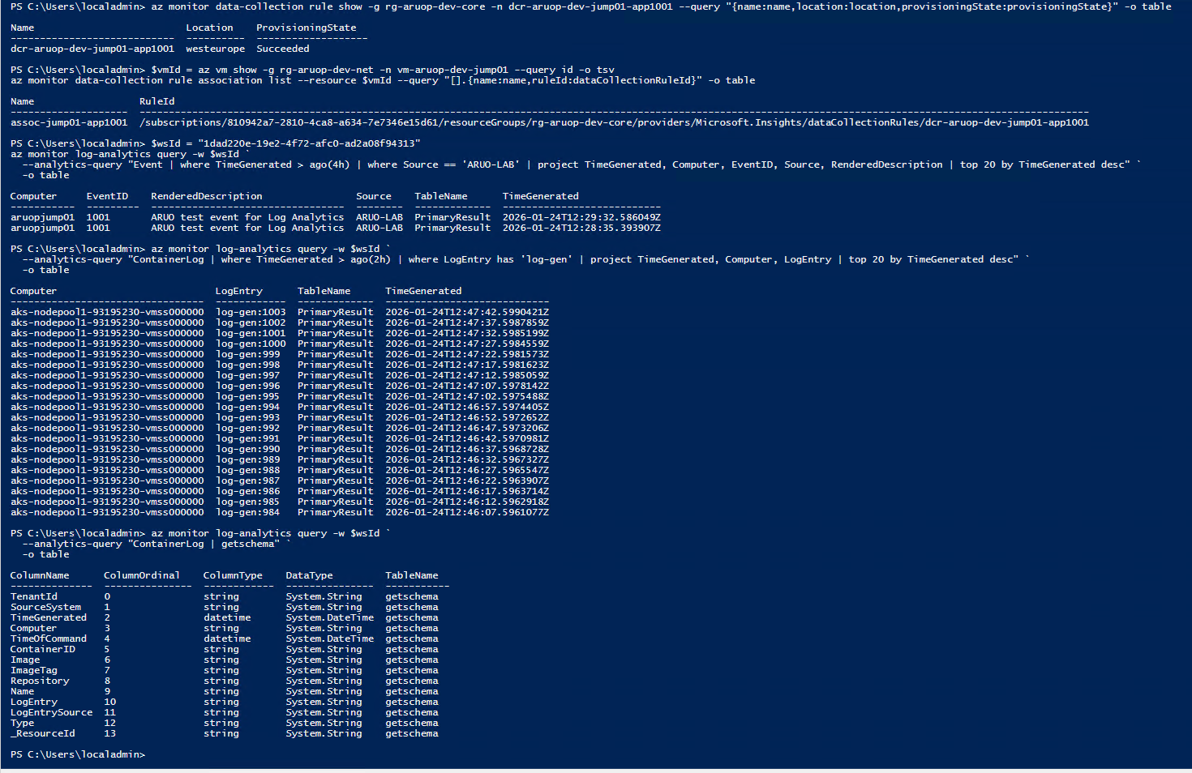
Picture 36 – security log from VM

Container logs from the AKS cluster stored in the log analytics workspace
Container log collection was validated by generating continuous stdout logs from a dedicated Kubernetes pod and confirming ingestion into the Log Analytics workspace used by AKS Container Insights. A simple BusyBox pod (log-gen) was deployed in the default namespace to emit a counter value every five seconds (e.g., log-gen:0, log-gen:1). Pod execution was first verified with kubectl logs log-gen --tail=20 to confirm that logs exist at the cluster level. Ingestion into Azure Monitor Logs was then validated by running a Log Analytics query against the workspace law-aruop-dev-01 (CustomerId 1dad220e-19e2-4f72-afc0-ad2a08f94313) using Azure CLI. The query searched for log-gen, across the workspace and projected the originating table name and message content, demonstrating that Kubernetes container stdout logs are being collected and stored in the workspace. A screenshot is taken of the successful Log Analytics query output showing log-gen, entries and the source table.
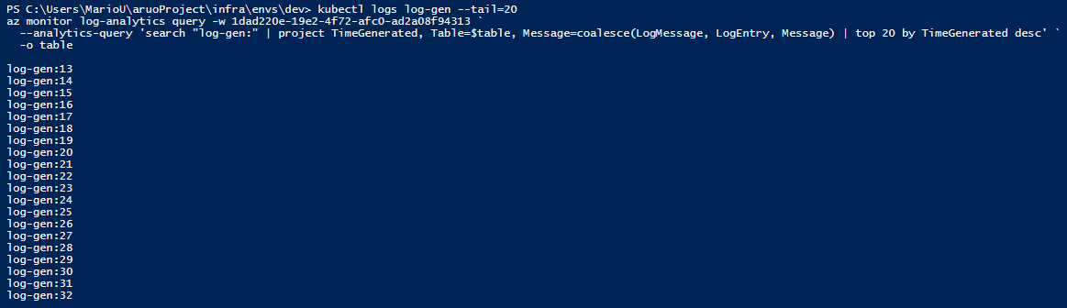
Picture 37 – container logs from AKS

Storage blob and key vault access logs stored in the log analytics workspace
We attempted to store Azure Key Vault and Azure Storage (Blob service) access logs in the Log Analytics workspace law-aruop-dev-01. The required diagnostic settings were successfully configured: the Key Vault had a diagnostic setting (diag-kv-to-law) with the AuditEvent category enabled and linked to the workspace, and the Storage Blob service had a diagnostic setting (diag-blob-to-law) with StorageRead, StorageWrite, and StorageDelete enabled (with Transaction and Capacity metrics also enabled), also linked to the same workspace. To generate telemetry, we performed Blob operations from the Jump VM (container creation, blob upload, blob download, and blob deletion). For Key Vault, we attempted to generate data-plane events as well, but secret operations were blocked due to missing RBAC permissions. During validation, Log Analytics queries against the workspace returned no results for Key Vault audit events, Storage access logs, Storage metrics, and workspace-wide searches within the expected time window. As a result, we could not produce query output or screenshots proving that these access logs were ingested into Log Analytics, even though the diagnostic settings were in place, and further investigation is required to confirm ingestion and identify the reason for the missing data.

Configured Flexible Server for PostgreSQL backup
This task requires evidence that Azure Database for PostgreSQL Flexible Server backup is configured and enabled. PostgreSQL Flexible Server provides automated backups with a defined retention period and an optional geo-redundant backup setting. The deployed environment is validated by retrieving the backup configuration directly from the server resource properties in Azure. The output confirms that automated backups are enabled with a retention policy of 7 days and that geo-redundant backup is disabled for this server. This information is used as evidence that the database platform has a recovery window defined and can support point-in-time restore operations within the configured retention period. The command output is captured as a screenshot to document the configured backup settings.
Picture 38 – postgreSQL server

Created a log analytics workbook with queries
For task 8.6, a Log Analytics Workbook was created to centralize operational queries and provide repeatable evidence of data ingestion. The workbook “ARUO Dev – Log Analytics Queries” was deployed in the resource group rg-aruop-dev-core and linked to the Log Analytics workspace law-aruop-dev-01. The workbook contains multiple KQL query tiles that validate key telemetry sources. First, a Heartbeat query confirms that the Azure Monitor Agent is reporting from both the jump VM and the AKS nodes and shows the latest reporting time per computer. Second, a Windows Event query filters for a custom Application event (EventID 1001, Source ARUO-LAB) generated on the jump VM to prove end-to-end collection into the Event table. Finally, an optional container log query searches for log-gen output to demonstrate Kubernetes log ingestion via Container Insights. Screenshots of each query tile and its result table were captured as proof.
Picture 39 – log analytics workbook
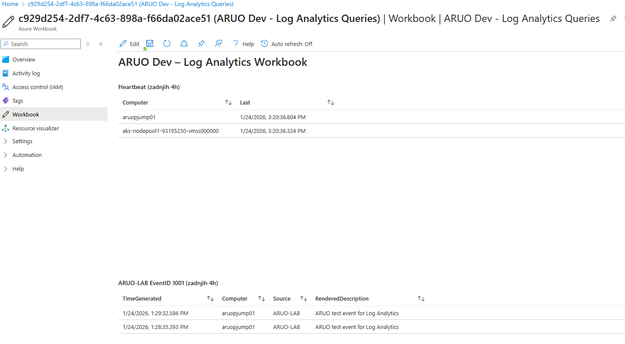
Picture 40 – log analytics workbook in azure

Visualized CPU usage of the VM by using Azure monitor
This task requires evidence that virtual machine performance metrics can be visualized using Azure Monitor. The validation is performed by querying the VM’s CPU-related metrics from Azure Monitor, which confirms that the platform is collecting compute telemetry and that the VM can be monitored centrally. The expected outcome is a metrics query result showing time-series data points for CPU utilization (or a closely related CPU metric) over a defined time range. The command output provides a screenshot-friendly proof that CPU monitoring is enabled and accessible for the jump VM. This evidence is later complemented by an Azure Monitor chart in the portal (Metrics blade) using the same CPU metric and time window.
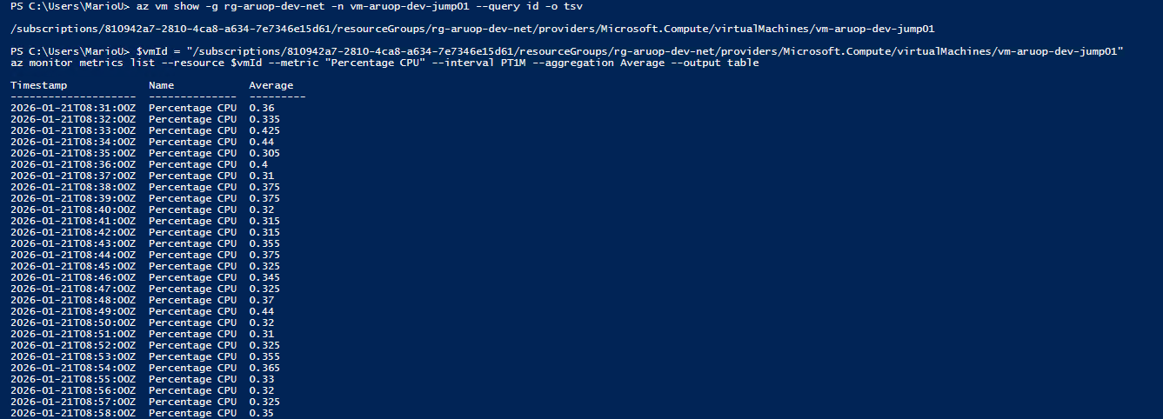
Picture 41 – cpu usage

Conclusion
This project delivered an Infrastructure-as-Code deployment of a secure Azure environment designed to host a multi-component application stack while keeping management centralized and controlled. The solution was organized into two main resource groups and two virtual networks: a dedicated workload network for application services and a separate network for a Windows Jump VM. The Jump VM acted as the administrative entry point and was used to validate DNS resolution and connectivity to private endpoints, ensuring that core services could be managed from an internal, controlled location rather than directly from the public internet. Key platform components were provisioned to support both containerized and serverless workloads, including an Azure Kubernetes Service (AKS) cluster, a Function App, and supporting services such as Azure Database for PostgreSQL Flexible Server, Azure Storage, and Azure Key Vault for secrets management. The PostgreSQL service was configured for Microsoft Entra authentication and connectivity was demonstrated using both the default administrative credentials and an Entra ID user, confirming that the database layer was operational and aligned with modern identity practices. Monitoring foundations were implemented with a Log Analytics workspace to support centralized telemetry collection and operational insight, and the environment was structured to enable further dashboards and query-based validation through workbooks. Throughout the deployment, resources followed consistent naming and tagging practices to support governance and traceability, and SKUs were selected with cost efficiency in mind. Overall, the final environment provides a reproducible Azure baseline that brings together networking separation, identity-based access, managed compute, and platform data services in a coherent architecture suitable for hosting and operating the required application stack.

List of pictures
Picture 1 - High level architecture diagram 7
Picture 2 - Network and service architecture diagram 8
Picture 3 - deployed resources 9
Picture 4 – verified tags 11
Picture 5 - identity type 13
Picture 6 - roles 14
Picture 7 – key vault 15
Picture 8 – assigned identity 16
Picture 9 – created key vault 17
Picture 10 – key vault networking configuration 17
Picture 11 – key vault content 18
Picture 12 – AKS cluster 19
Picture 13 – AKS network configuration 20
Picture 14 – deployed app in the AKS 21
Picture 15 – creating function app 21
Picture 16 – container registry 22
Picture 17 - creating container image 23
Picture 18 – AKS automated patch 24
Picture 19 – automated patching of VM 24
Picture 20 – azure storage account 25
Picture 21 – networking configuration of storage account 26
Picture 22 – file sync configuration 27
Picture 23 – PostgreSQL flexible server 27
Picture 24 – network configuration for Postgres 28
Picture 25 – access to database from Jump_VM 28
Picture 26 – created public IP addresses 29
Picture 27 – created two VNET 30
Picture 28 – created subnets 30
Picture 29 – public access off 31
Picture 30 – DNS and connectivity proof 31
Picture 31 – Jump VM NSG configuration 32
Picture 32 – application gateway deployed 32
Picture 33 – certificate from key vault 33
Picture 34 – AKS traffic 33
Picture 35 – log analytic workspace 34
Picture 36 – security log from VM 35
Picture 37 – container logs from AKS 36
Picture 38 – postgreSQL server 37
Picture 39 – log analytics workbook 37
Picture 40 – log analytics workbook in azure 38
Picture 41 – cpu usage 38

