
National University of Computer and Emerging Sciences, H-11/4, Isb

CS3014 Applied HCI
Deliverable D4
Information Architecture

Team: G10 — MSM Technologies
Project: FAST-NU Insignia Library Portal — Free Rooms First (room booking)
Date: 4/11/2026
Facilitator: Muhammad Umar

Part A

1. Purpose
This record documents the information architecture for our D4 prototype, derived from a card sort with six stand-in participants (not team members). The functional build is a Manifest V3 browser extension on `nu.insigniails.com`; this document explains how users grouped booking-related tasks and how that maps to navigation in the prototype.

2. Navigation Pattern
We use three patterns together:
- Hierarchical — Global portal shell (Home, My Account, etc.); our extension reskins header and Home layout without replacing the whole site map.
- Hub-and-spoke — From Home, Book a study room is a primary spoke to `/Library/Room`.
- Sequential wizard — On the room page: Day → Room & time → Confirm, then a success pass screen.
Help is a separate spoke: Ask a librarian is not a step inside the booking wizard (supported by card sort: 6/6 participants separated it from the booking sequence).

3. Card Sort Method
Item | Detail
Method | Open card sort (participants arranged cards; order recorded as task flow)
Participants | 6 stand-in students who book or would book study rooms
Location | FAST-NUCES Islamabad
Cards used | Six (see Section 4)

Card labels
# | Card
1 | Ask a librarian
2 | Start Room Booking
3 | See which rooms are free
4 | pick date for booking
5 | pick time for booking
6 | confirm booking

4. Individual Participant Results
Note: In every sort, Ask a librarian appeared before the booking sequence and is treated as separate from booking. Below is each participant’s booking order.

P1 — Hashim Rahim
See which rooms are free → Start Room Booking → pick date for booking → pick time for booking → confirm booking

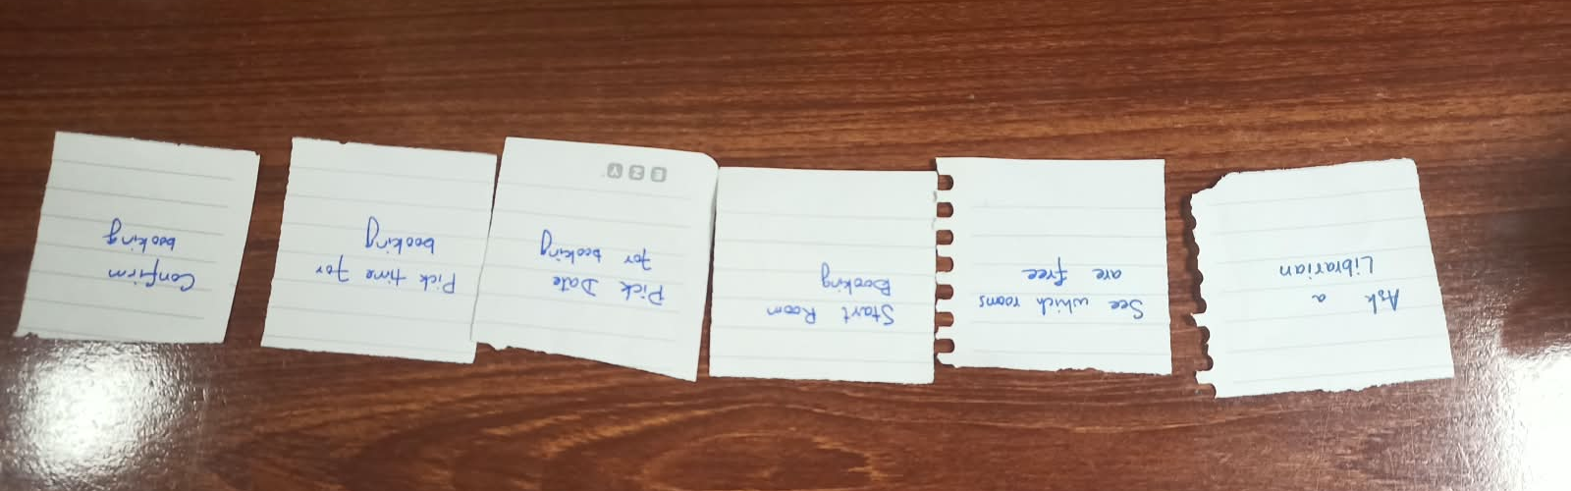P2 — Saud ur Rehman
Start Room Booking → pick date for booking → See which rooms are free → pick time for booking → confirm booking

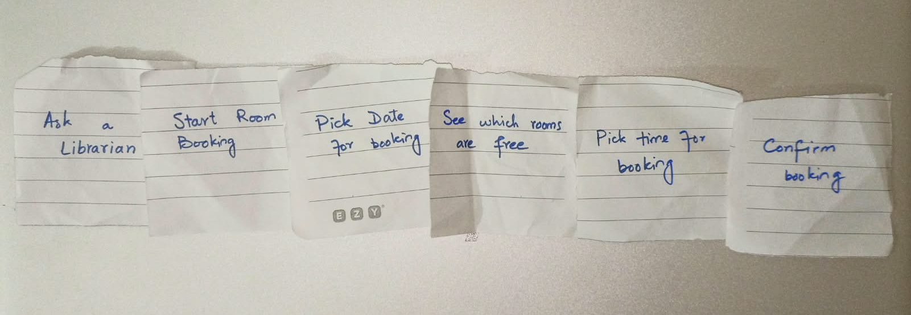P3 — Zaid Bin Umar
Start Room Booking → pick date for booking → See which rooms are free → pick time for booking → confirm booking

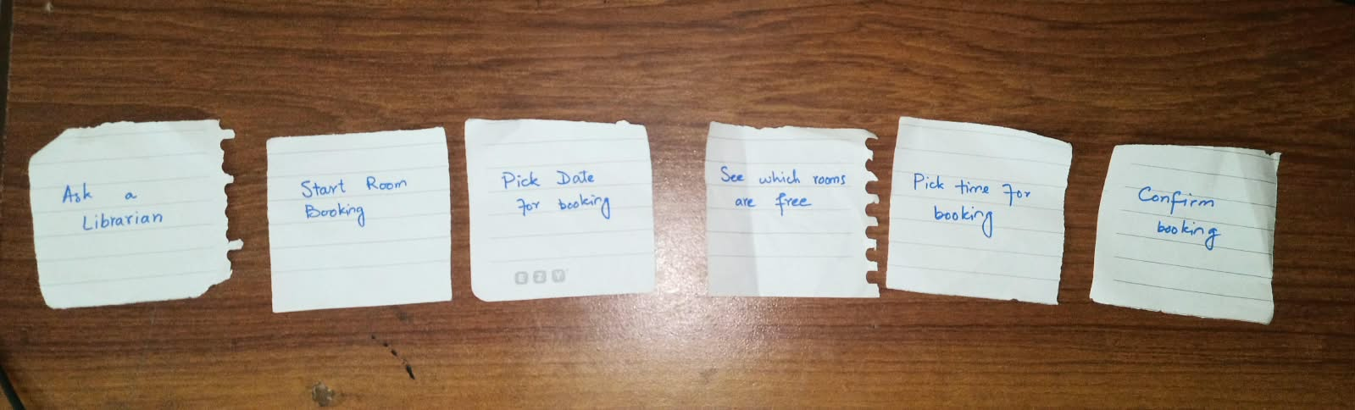P4 — Muhammad Zain
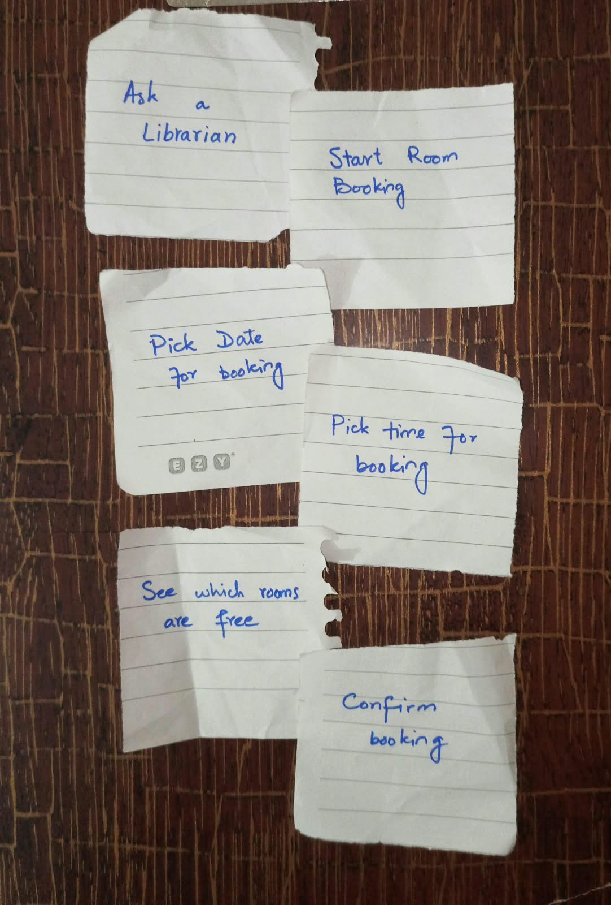
Start Room Booking → pick date for booking → pick time for booking → See which rooms are free → confirm booking

P5 — Zain ul Arifeen
Start Room Booking → pick date for booking → See which rooms are free → pick time for booking → confirm booking

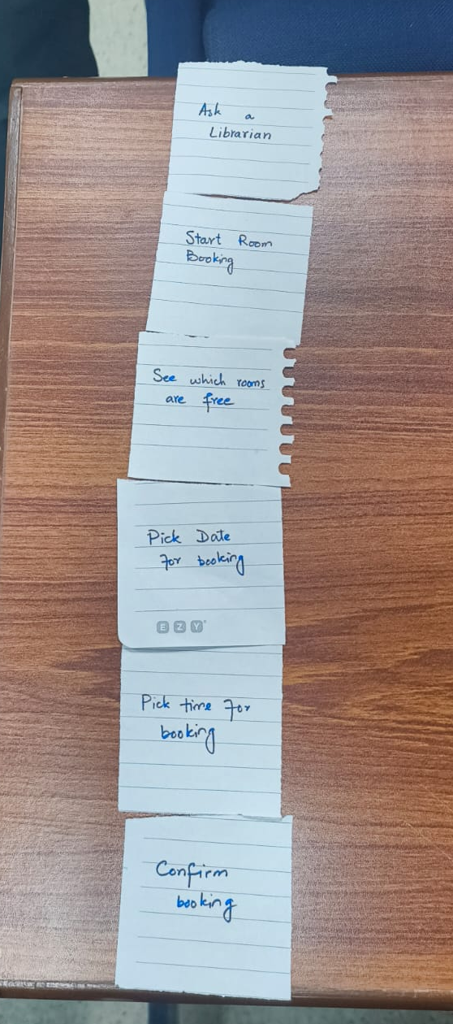
P6 — Hasan Adil
Start Room Booking → pick date for booking → See which rooms are free → pick time for booking → confirm booking

5. Cross-Participant Synthesis (n = 6)
Finding | Result | Design decision
Ask a librarian separate from booking | 6/6 | Help outside wizard (Ask Librarian / Home)
confirm booking last | 6/6 | Confirm step + booking pass after portal submit
pick date before pick time | 6/6 | Calendar step before time selection
Start Room Booking before pick date | 5/6 | Home entry then Day step (P1 outlier: see free before start)
See which rooms are free before pick time | 5/6 | Timelines on step 2 (P4 outlier: see free after time)
Pattern Start → date → see free → time → confirm | 4/6 | Matches Day → Room & time → Confirm wizard
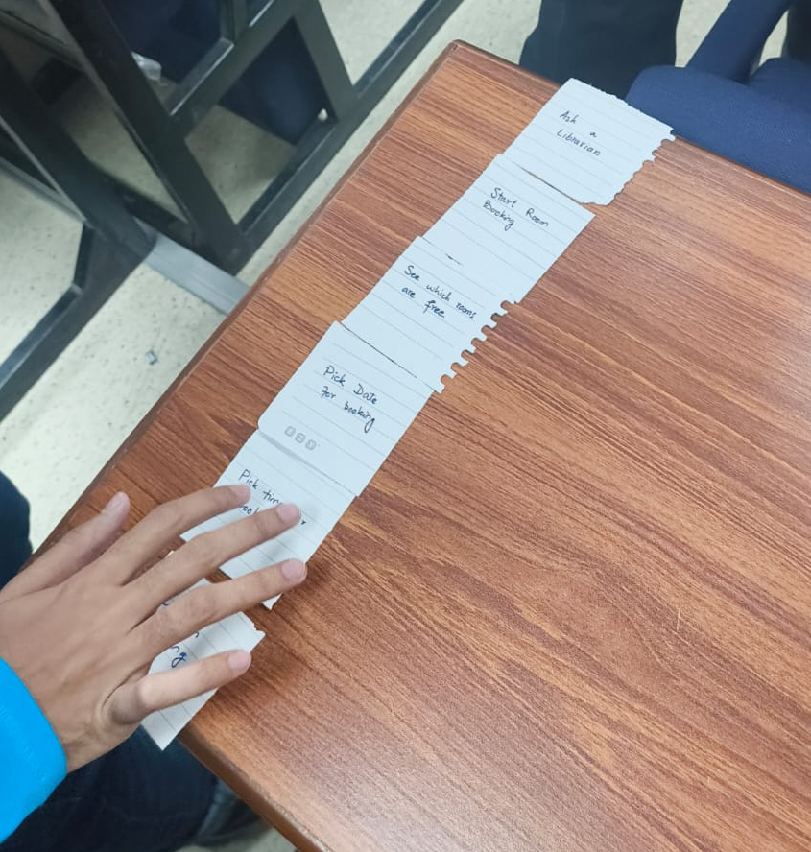
Merged groups
- Help — Ask a librarian
- Book a study room — Start → date → availability and time → confirm
Changes after sort: No change to overall structure; sort validated our wizard. Step 2 combines “see free” and “pick time” to meet requirement R2 (identify free rooms/slots on the booking path).

6. Mapping IA to Prototype
User group / task | Prototype location
Start Room Booking | Home Services → Book a study room → /Library/Room
pick date for booking | Wizard step 1 — calendar
See which rooms are free + pick time | Wizard step 2 — per-room timelines
confirm booking | Wizard step 3 — recap, Confirm Booking, live portal book
Completion / trust | Pass screen — “Your room is held”
Ask a librarian | Help entry on shell — not in wizard

Repository: `github.com/umaritics/fastnu-library-portal-hci` — `extension/` v1.0.12, documentation `docs/d4/`.

7. Gestalt Principles (Wireframe Reference)
For connected grayscale wireframes (separate Part A artifact):
- Proximity — Recap fields and timeline rows group related choices.
- Similarity — Free and taken slots share shape; status via label and pattern, not colour alone.
- Figure/ground — Wizard panel vs de-emphasised native portal chrome.

8. Summary
Six stand-ins consistently separated librarian help from booking and placed confirmation last. Date before time was unanimous; availability before time was majority (5/6). We therefore document a hub-and-spoke entry from Home and a three-step sequential room-booking flow implemented in our D4 extension, aligned with the Free Rooms First concept and requirements R1–R3.

9. Grayscale wireframes (connected flow)
Low/medium-fidelity grayscale screens for the core booking task. Gestalt: proximity (recap and timeline rows), similarity (free/taken chips), figure/ground (wizard card vs background).

9.1 Entry — Home (W0)
Hub-and-spoke: Book a study room in Services.
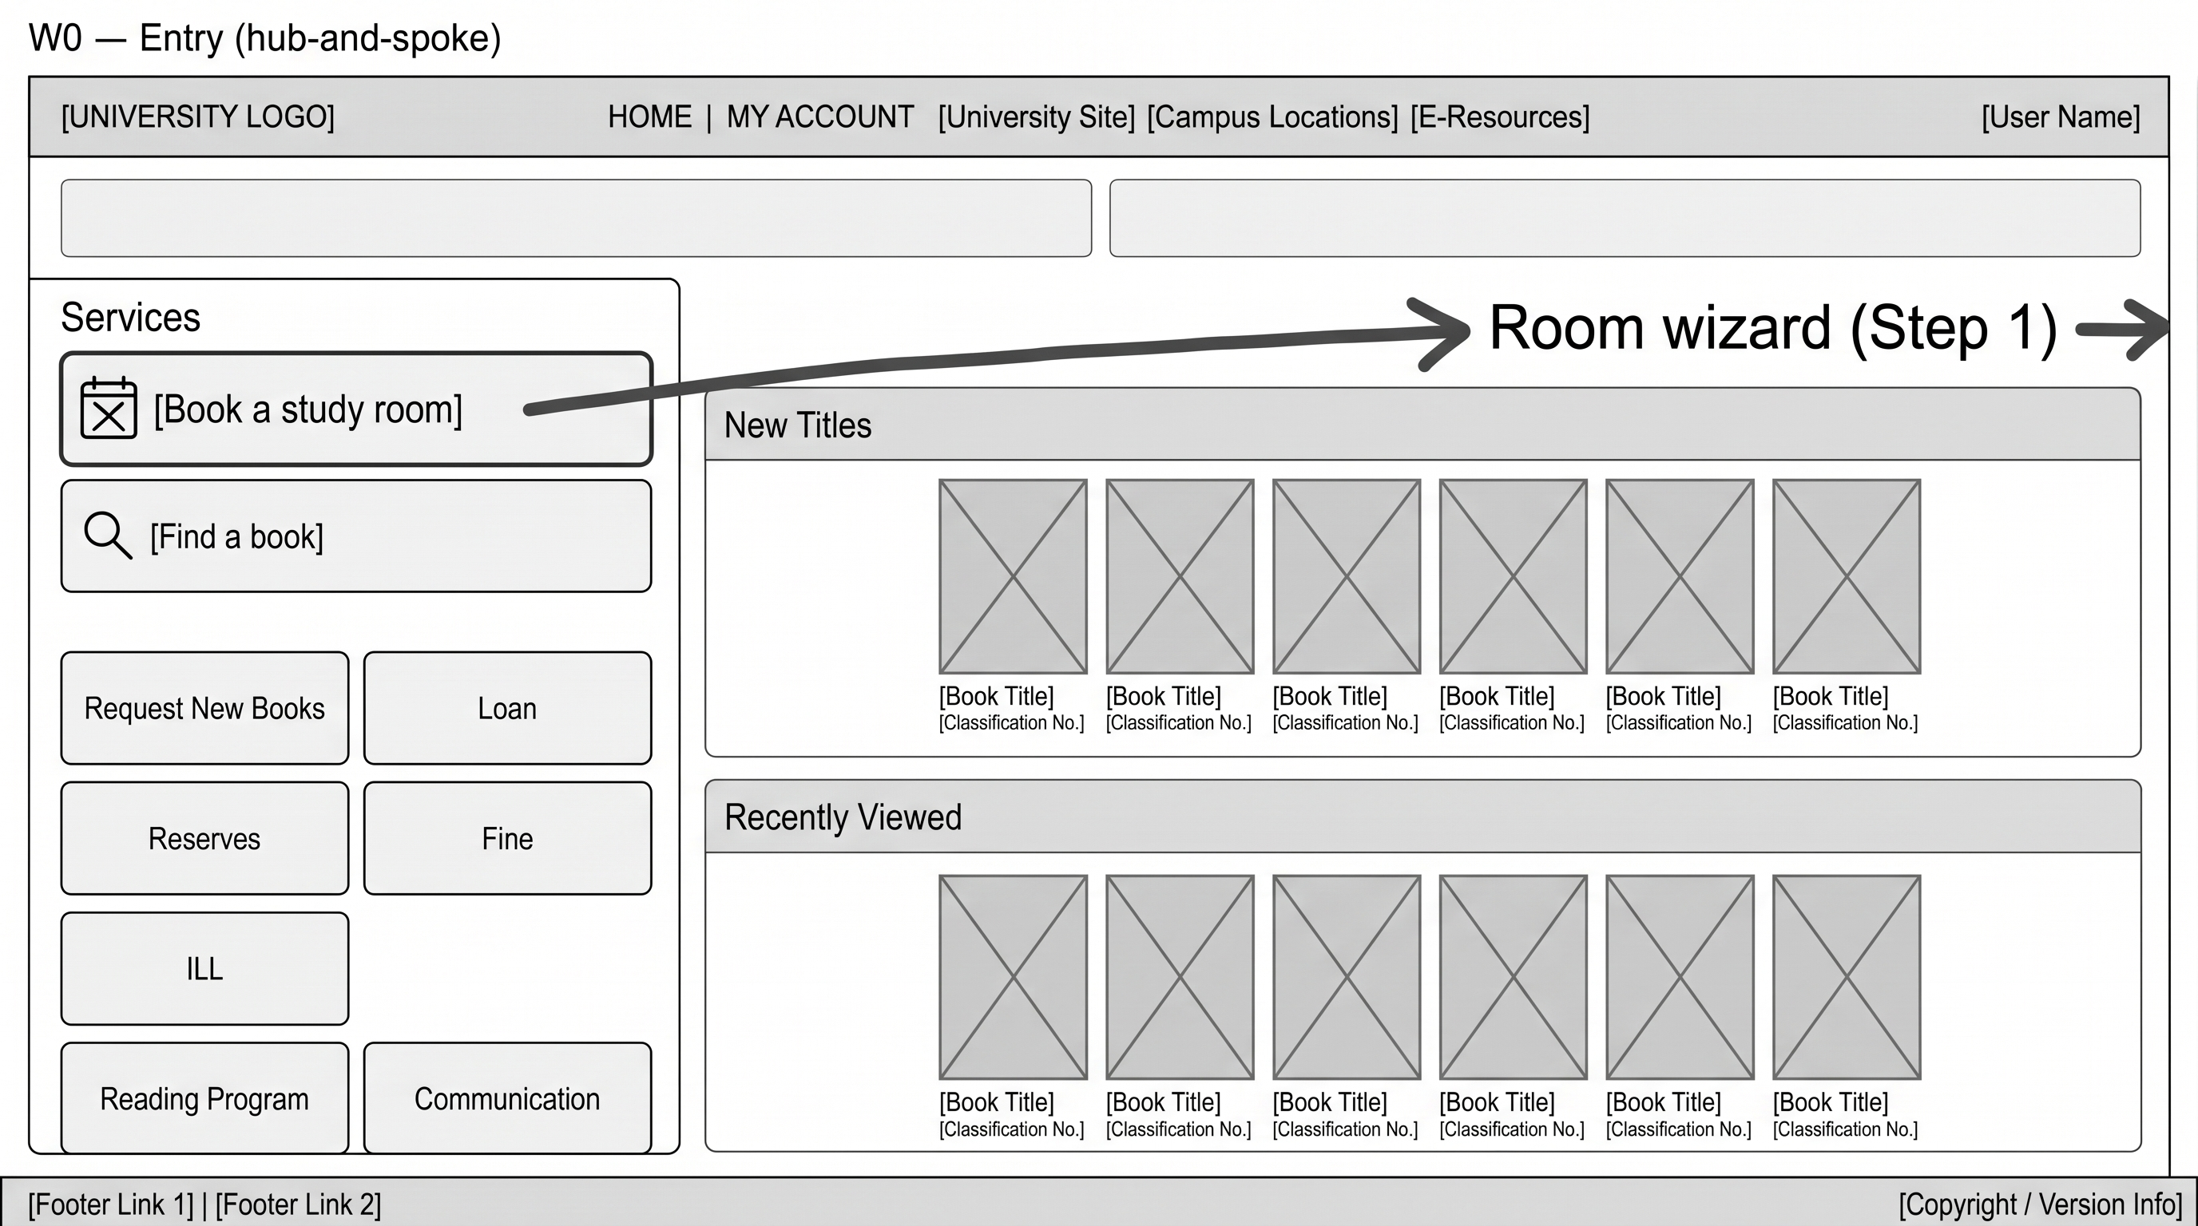

9.2 Step 1 — Day (W1)
Sequential wizard: pick date (weekdays).
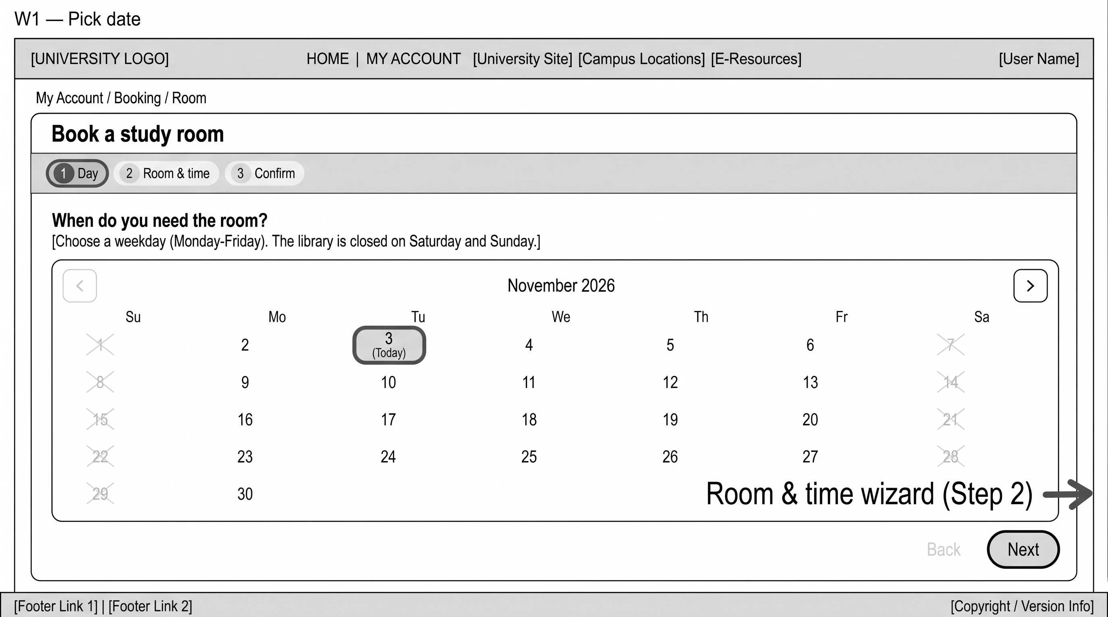

9.3 Step 2 — Room & time (W2)
Free Rooms First: timelines + end time.
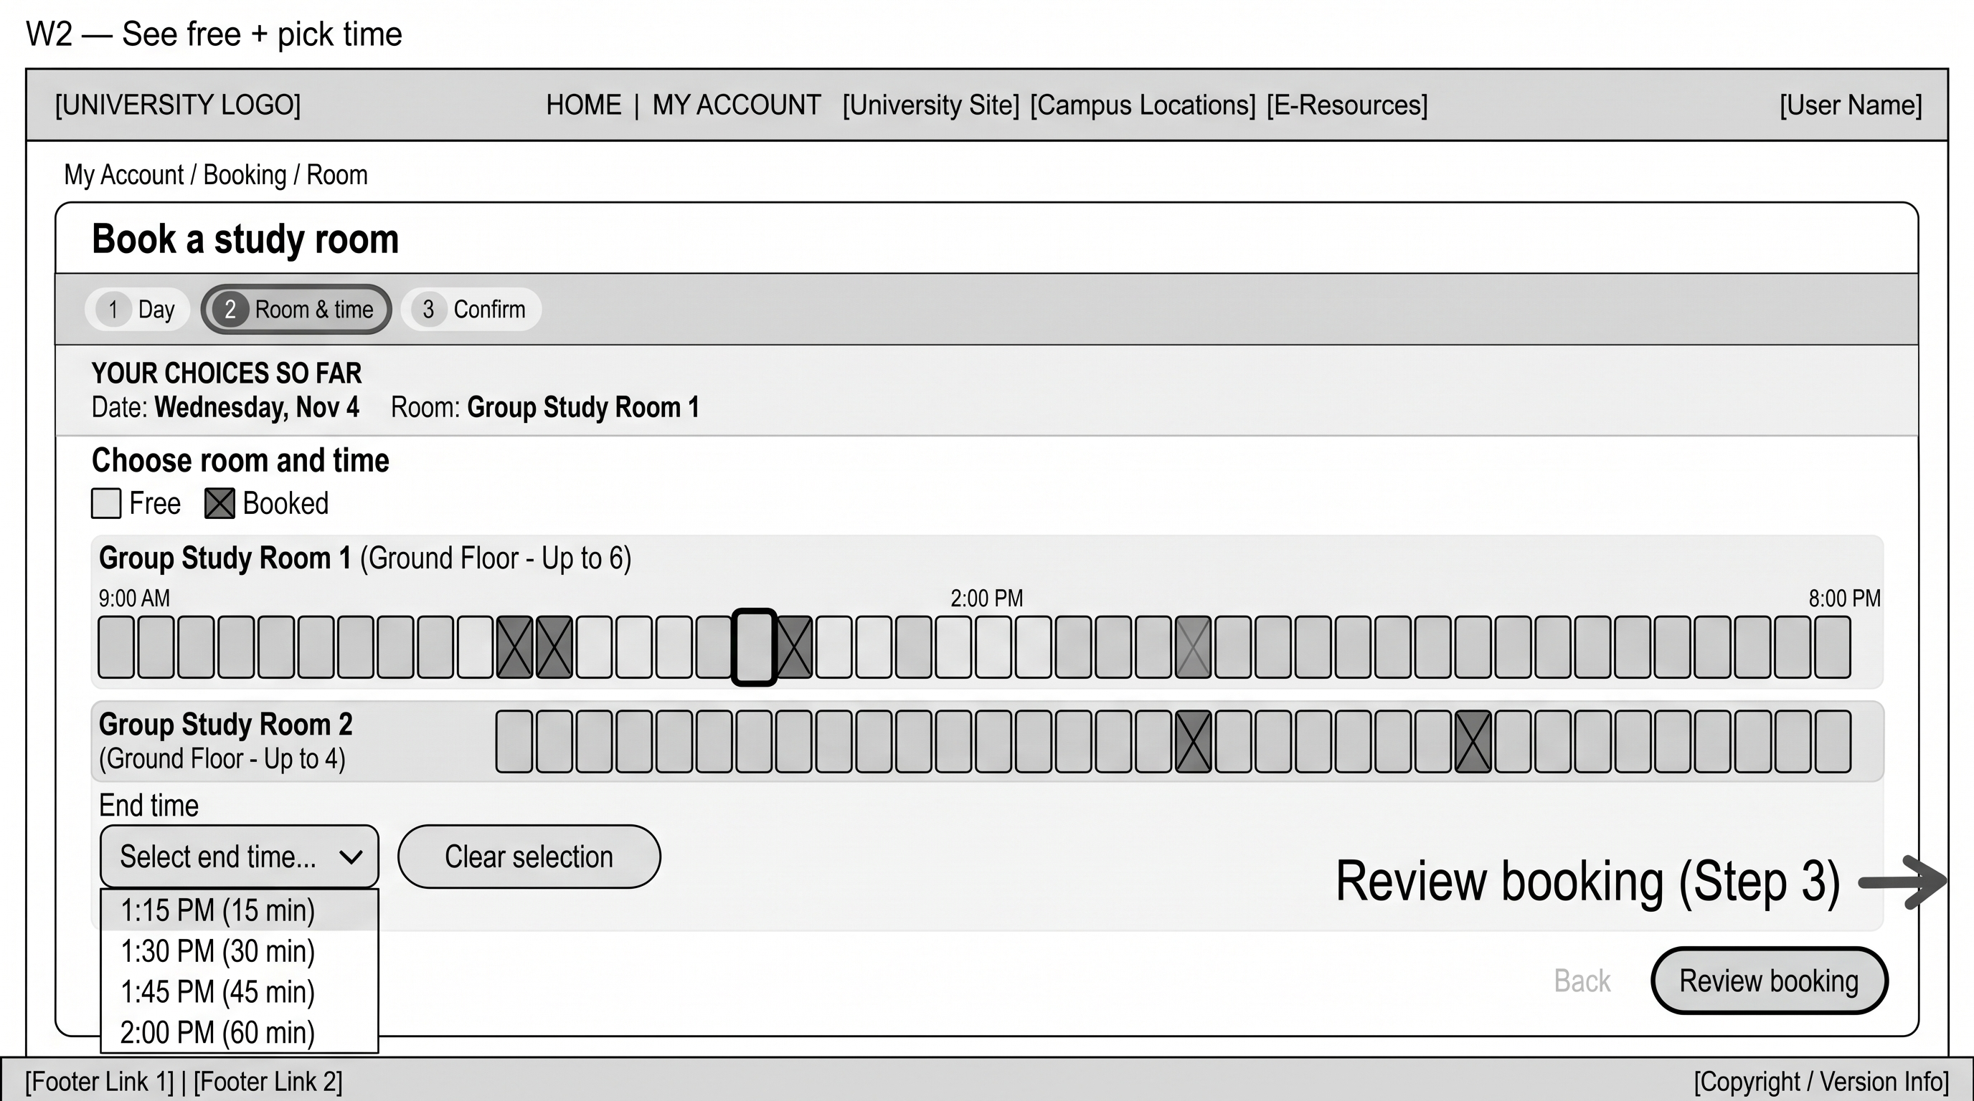

9.4 Step 3 — Confirm (W3)
Recap, purpose, Confirm Booking.
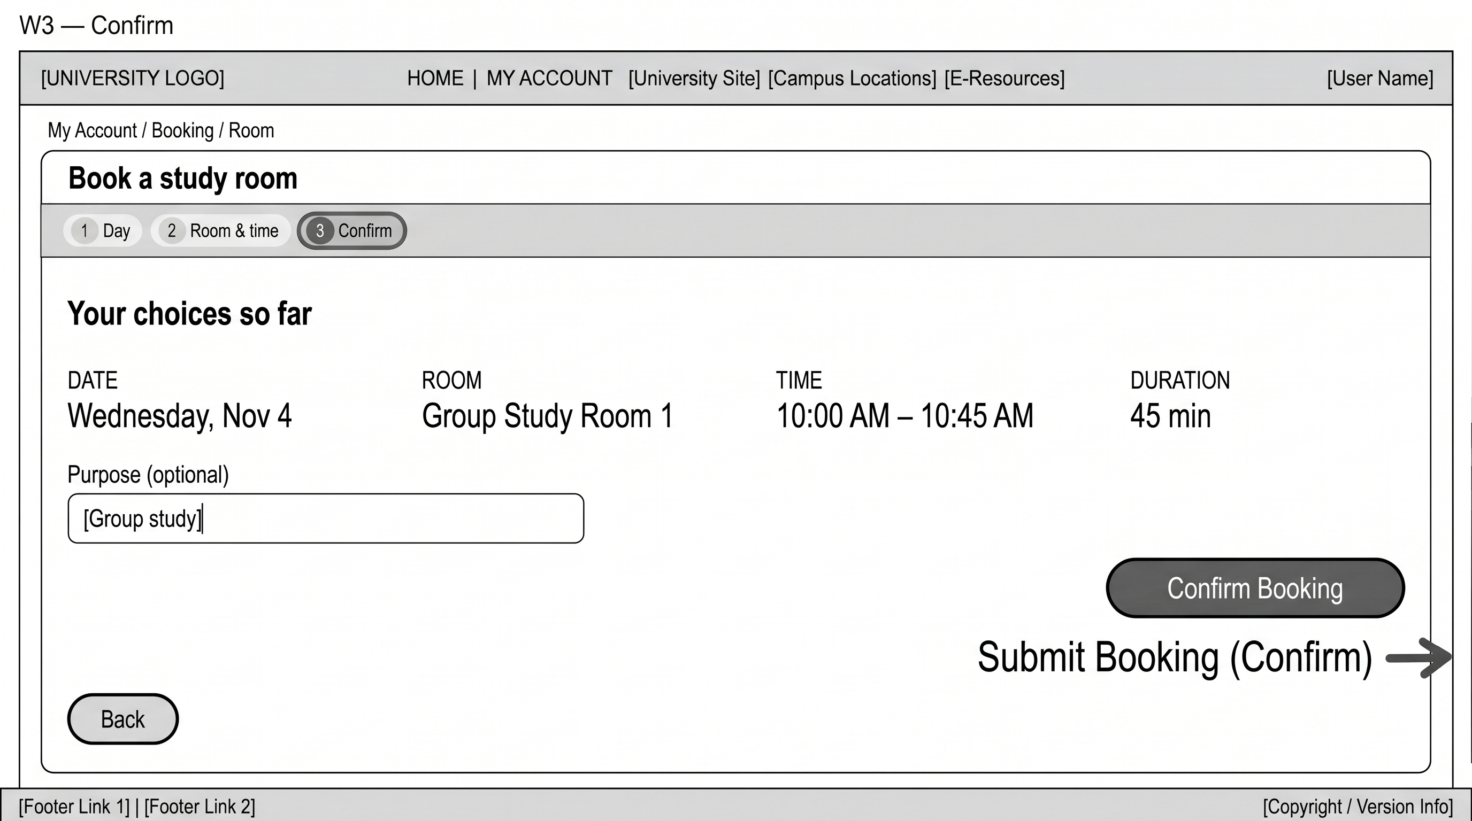

9.5 Alternate — Error (W4)
Slot no longer free; recover on same step.
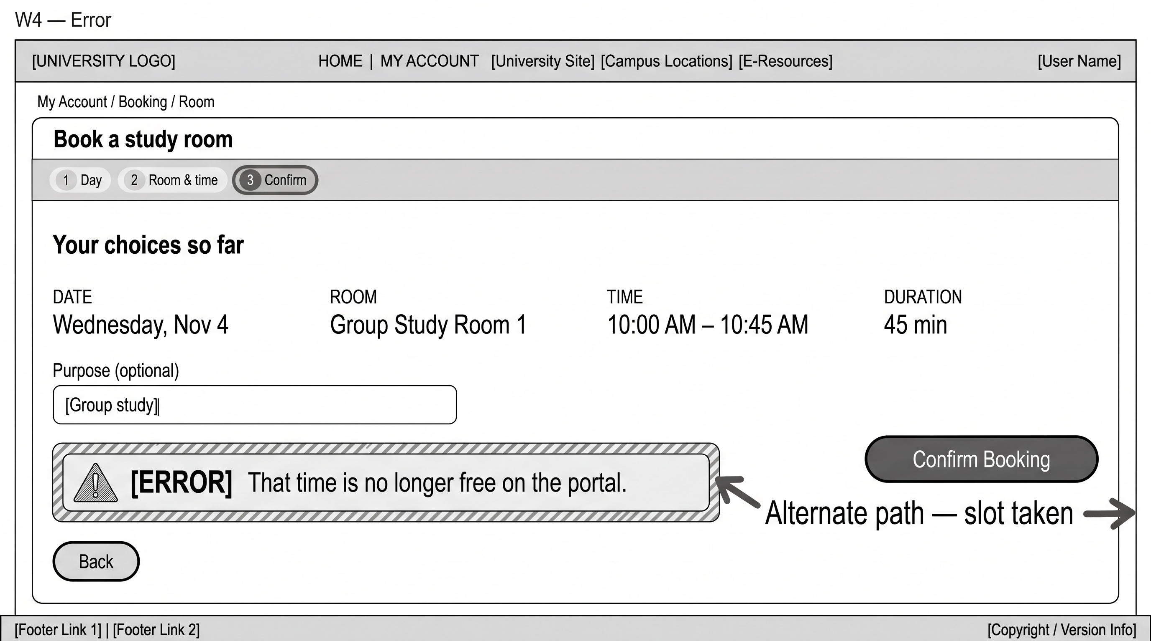

9.6 Success — Pass (W5)
Closure: Your room is held.
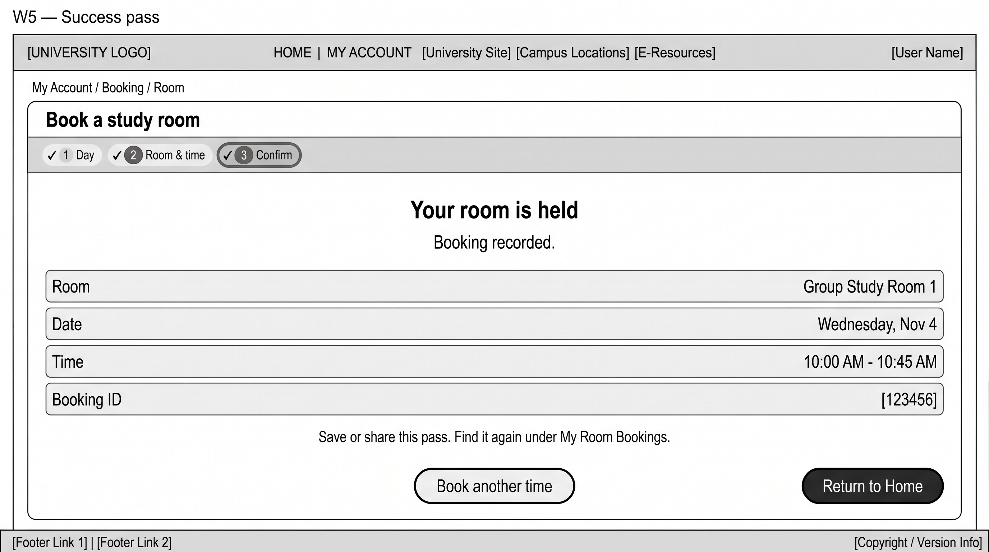

9.7 Flow diagram
Happy path and error path with arrows.
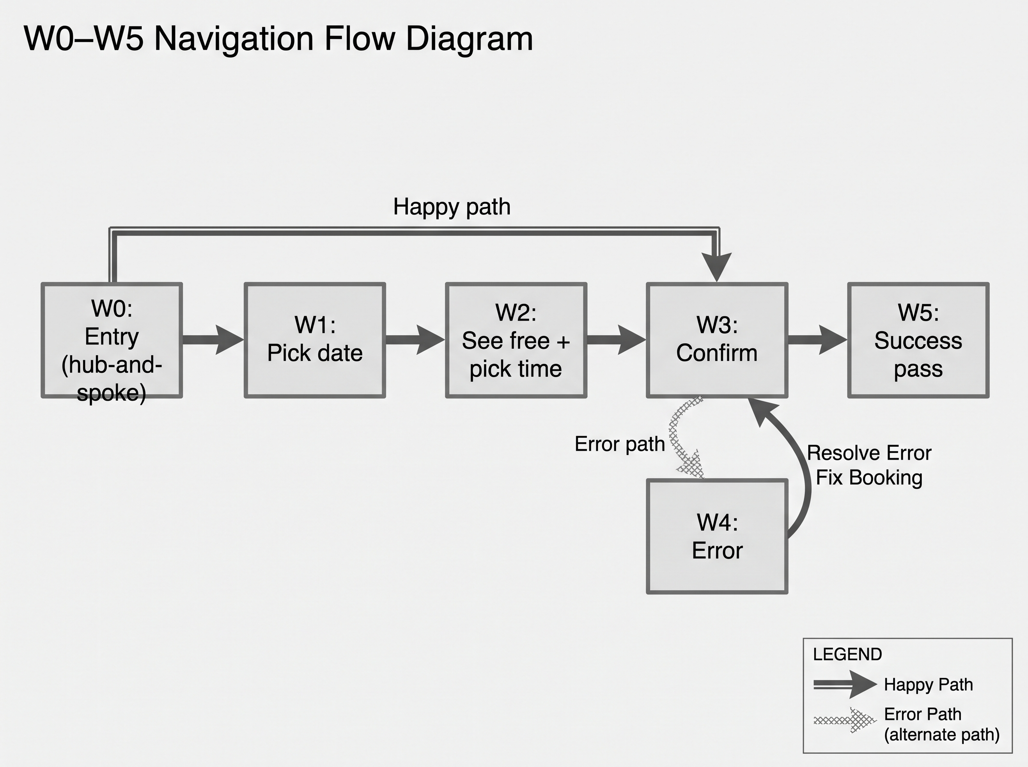

10. Accessibility audit log (summary)
Findings from team keyboard and screen reader walkthroughs on extension v1.0.12.

Keyboard (lead: Shahmeer Atif)
Focus reached Home book link, calendar, timeline slots, confirm, and pass. Fixed: centered confirm control, weekend disable, book-another button clipping, header nav when body overflow was blocking dropdowns.

Screen reader (lead: Muhammad Usman Al Haq)
Wizard title and stepper read in order; slot status uses text labels. Fixed: duplicate error in live region plus alert on confirm — now alert only.

POUR — Fixed before submit
Perceivable: slot labels, larger recap, pass screen. Operable: nav overflow, double submit, weekends. Understandable: removed redundant copy, Duration label, friendly extension reload message. Robust: bridge versioning, wizard mount retry, native DOM kept for Kendo.

Deferred
O-4: Full 320px / 200% zoom R5 study deferred to D5 moderated testing.

11. Critique record (wireframes + prototype)
Date: 4 November 2026. Team rapid critique on wireframes and live build.

Muhammad Umar (D4 lead)
Portal showed booking success but wizard stayed on confirm; users clicked again and saw 'no longer free'. Required pass screen, submit lock, and clear primary confirm.

Shahmeer Atif (Test lead)
Accessibility: duplicate errors for AT users; timeline focus visibility; do not rely on colour alone for free/taken.

Mirza Yahya Adeel (Ideate lead)
Wireframe step 2 must foreground availability before commit; help (Ask a librarian) stays outside the wizard — consistent with card sort.

Muhammad Usman Al Haq (Define lead)
Use requirement-aligned labels (Duration); do not claim success without verified portal book; keep portal-accurate error text for taken slots.
Wireframe updates: added error screen and flow diagram; simplified confirm copy. Extension checkpoint: v1.0.12.

12. Part B — Functional prototype checkpoint
Team G10 MSM Technologies · CS3014 D4 · Build: Manifest V3 browser extension v1.0.12 on https://nu.insigniails.com/Library/* · Repository: github.com/umaritics/fastnu-library-portal-hci

12.1 Functional task flow (vertical slice)
Core task: an authenticated patron books one study room on the live Insignia portal. One task in depth (not a horizontal pass across search/kiosk/assets).
- Home — Services link Book a study room → /Library/Room
- Step 1 Day — calendar (weekdays only); syncs native date picker
- Step 2 Room & time — per-room timelines (15 min slots); pick start and end
- Step 3 Confirm — recap, optional purpose, Confirm Booking
- Submit — MAIN-world bridge drives Kendo Room(), portal Book, success detection
- Pass — Your room is held; Return to Home or Book another time

Checkpoint demo (instructor)
Load unpacked extension/ in Chrome or Edge → sign in → Ctrl+F5 on Room page → verify html data-g10-extension=1.0.12 → complete happy path → demonstrate error (book same slot twice: That time is no longer free on the portal).

Built vs simulated
Capability | Status
Read rooms/slots from portal grid + time strip | Built — live DOM
Set date, search, slot, duration, purpose | Built — bridge
Submit reservation | Built when TEST_MODE is false
Booking ID on pass | Built from portal message only; never fabricated
TEST_MODE true | Simulated — skips real Book (dev only)
Wizard-of-Oz on core book | None in production config

12.2 Implementation documentation
Technology: Manifest V3 content scripts; in-place shell (content/shell/); page-world.js injected in MAIN world for jQuery/Kendo Room(). Scope: vertical slice for room booking; Home/header reskin supports R1 discoverability.
Key modules:
- content/bootstrap.js — header, Home layout
- content/booking-bootstrap.js — mounts wizard on /Library/Room
- content/shell/room-booking-shell.js — wizard UI
- content/bridge/page-world.js — submitRoomBooking, native book
- content/parsers/availability.js — grid → slots

Requirements traceability (summary)
Req | Prototype feature
R1 | Home services CTA + path to Room
R2 | Timelines, free/taken labels
R3 | Confirm recap + pass after verified book
R4 | Calendar + explicit end time (no slider in wizard)
R5 | Targets, contrast, aria-live, non-colour status (audit logs)

Known limitations
Portal max booking often 60 minutes per room row; Insignia DOM changes may break selectors; full mobile R5 battery scheduled for D5 moderated testing.

12.3 Minimal design system
Font: Plus Jakarta Sans. Tokens in portal-redesign.css and room-booking.css.
Token | Value | Use
Primary | #0d4a7a | Headings, primary buttons, active step
Text / muted | #1a2b3c / #5c6b7a | Body and labels
Success | #0d7a3e | Free emphasis, success tone
Error | #b42318 | Alerts; surface #fef3f2
Type title | ~1.35–1.5rem | Wizard title, recap heading
Type body | 14–16px | Steps, recap values
Type caption | 12–13px | dt labels, notes
Spacing | 8px grid | Card padding 8/12/16/20
Touch | min 44px height | Buttons (exceeds R5 24px min)

Components: primary/secondary buttons, stepper, calendar day, timeline slot, recap list, error alert, pass card, skeleton loader, live region #g10-rb-live.

Design system evidence (screenshots from build)
Representative screens from the functional prototype (same flows as wireframes, styled UI):

Home entry
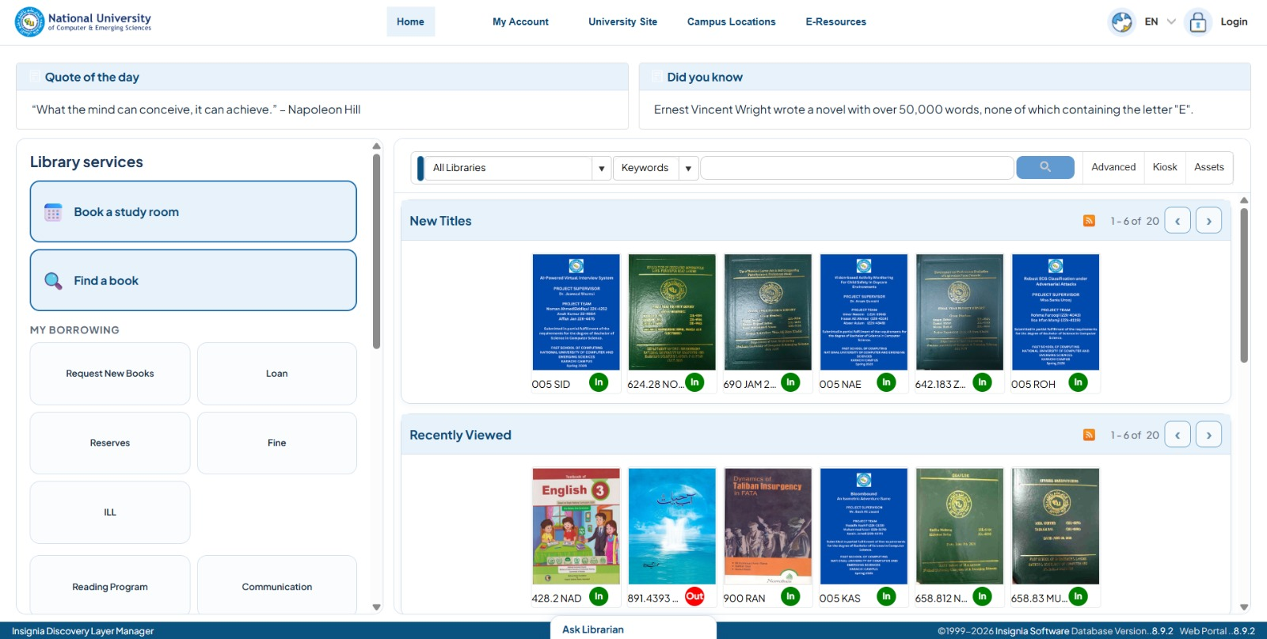

Confirm step
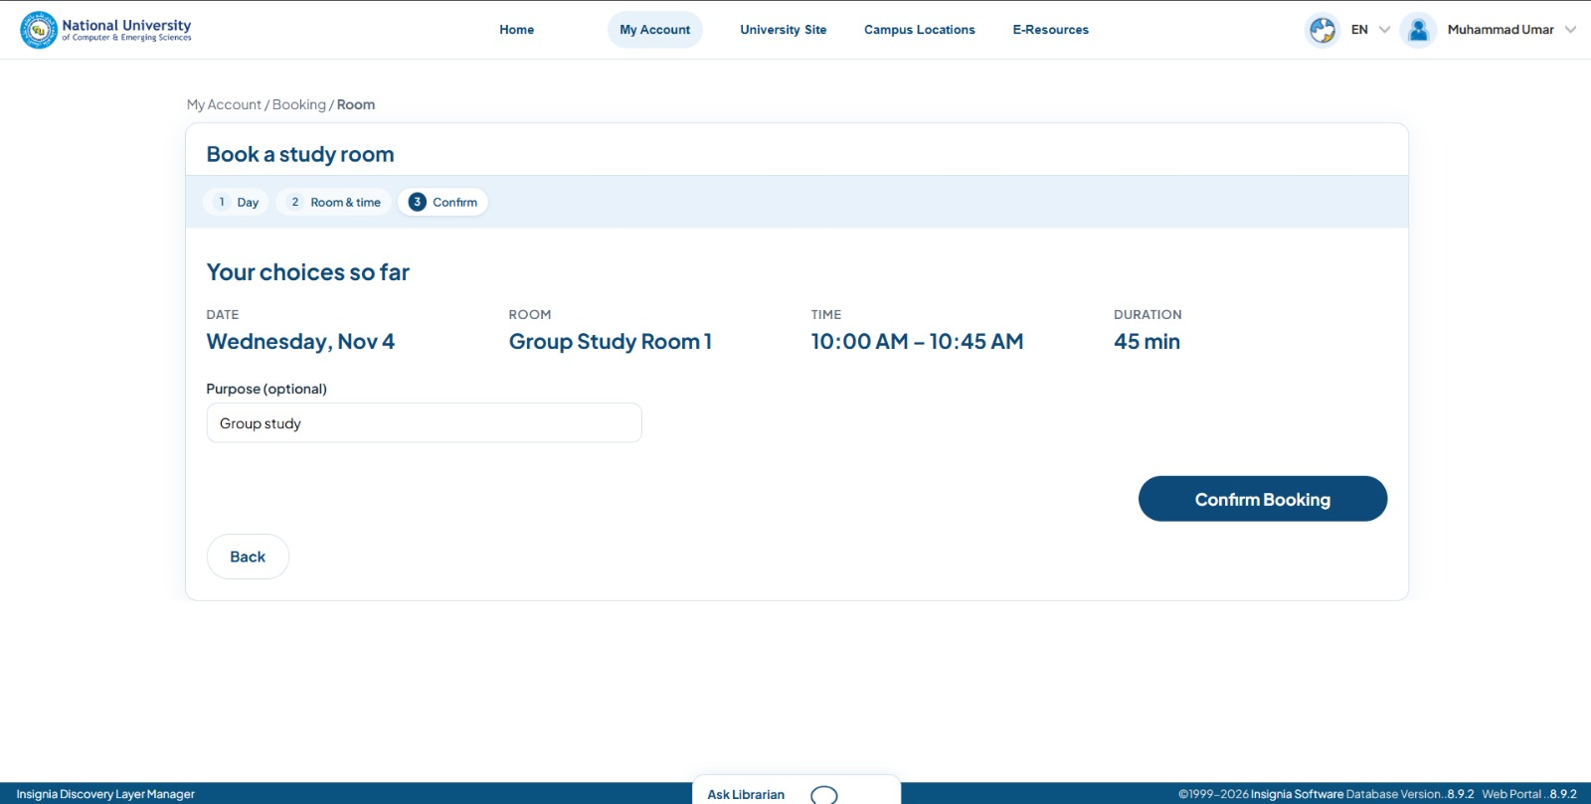

Error state

Success pass
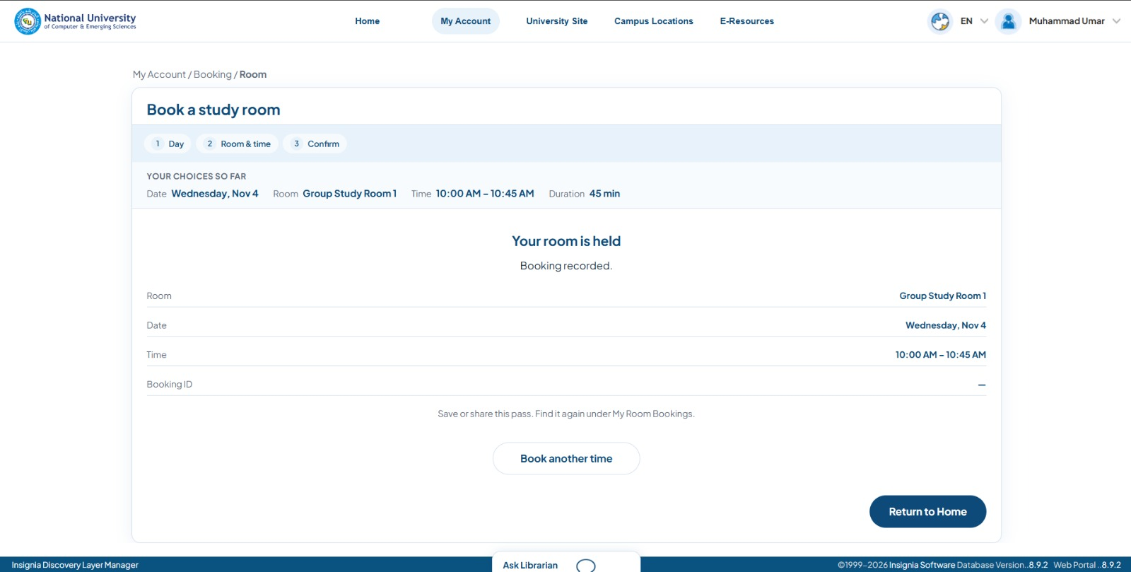

12.4 Feedback, errors, and component states
State | Where | Implementation
Default | Buttons, slots, calendar | Base CSS
Focus / hover | Buttons, slots | focus-visible rings
Active | Selected day/slot, stepper step | is-active classes
Disabled | Next, weekends, taken slots, submit | disabled / is-disabled
Loading | Step 2 load | Skeleton + Loading rooms…
Empty | No rooms | Live region message
Error | Confirm fail, weekend, extension reload | submit-error alert, banner
Success | Pass screen | g10-rb-pass, Return to Home

Handled error (required)
Deliberate case: slot no longer free on second confirm after a successful book. Message: That time is no longer free on the portal. Shown once in red alert (role=alert). Recovery: Book another time or change slot/date.

Action → feedback
Action | Feedback
Pick day | Live region date label; calendar selection
Pick slot / end | Live region room, time, duration
Confirm | Submitting… then pass or alert
Success | Pass screen replaces wizard

12.5 Accessibility re-check (Part A fixes on live build)
Team re-ran keyboard and screen reader checks on extension v1.0.12 after Part A fixes. Full table in repository: docs/d4/D4_PARTB_ACCESSIBILITY_RECHECK.md
Part A issue | Still fixed? | Verified by
P-1 Slot text labels | Yes | Shahmeer Atif
P-2 Larger recap | Yes | Muhammad Umar
P-3 Pass after verified book | Yes | Muhammad Umar
O-1 Header/nav on Room | Yes | Shahmeer Atif
O-2 Double submit | Yes | Muhammad Umar
O-3 Weekends disabled | Yes | Muhammad Usman Al Haq
U-1–U-4 Copy, Duration, single error, reload banner | Yes | Muhammad Usman Al Haq
R-1–R-3 Bridge, mount, native DOM | Yes | Muhammad Umar
O-4 Full 320px R5 | Deferred to D5 | Team

Sign-off
Role | Name | Date | Checkpoint OK?
Prototype lead | Muhammad Umar | 4 Nov 2026 | Yes
Test / a11y lead | Shahmeer Atif | 4 Nov 2026 | Yes

13. AI use disclosure
Per CS3014 D4 policy: card-sort participants and accessibility audit findings are from the team only. Below covers steps where AI use is allowed.

Where AI was used

Part A — wireframe layout
AI (e.g. Gemini) helped produce grayscale wireframe images and flow layout. Team checked navigation, error path (W4), and alignment with card-sort IA.

Part B — functional extension
Cursor / AI-assisted coding for MV3 extension structure, Kendo bridge, and wizard UI. Team verified on live portal: real booking with TEST_MODE false, error states, pass screen, extension reload.

Submission document
This Word document’s final assembly (Part A §9–11, Part B §12, and this section) was created with AI from team-written records, repo markdown, and screenshots in docs/d4/.

Where AI was not used for content
Card sort: six stand-in participants (facilitator Muhammad Umar). Accessibility audit and Part B re-check: team keyboard and screen reader walkthroughs. Critique record: team review during prototype build.

14. Reflection (completion)

1. What did you keep as your own thinking versus what came from AI?
We kept problem framing, card sort, critique decisions, accessibility walkthroughs, and live-portal verification as our own work. AI mainly helped implement the extension, draft wireframe layouts, and compile this submission document from our notes and repo docs.

2. How did it feel to flag your AI use here?
It was fine because the description document already stated that AI is allowed for specific parts. The other parts were already something that could only be done by ourselves, so it wasn’t that difficult to flag our AI usage here.

