<<today’s date>>

Private & Confidential

<<employee name>>
<<address line 1>>
<<address line 2>>
<<address line 3>>
<<address line 4>>
<<post code>>

Dear <<employee first name>>

Re: <<FT or PT>> <<Position>>

I’m delighted to offer you the <<FT or PT>>, <<position>> position with <<employer>>, contingent upon satisfactory references and background checks.

You will be paid <<salary or hourly>> <<wages>>.
You will report directly to the <<reporting to>>.
Your place, hours of work and holiday entitlement etc will be as per your contract of employment.

I enclose for your perusal a copy of Job Description, your Contract of Employment and company’s “Form of Undertakings”.

Please confirm your acceptance of this offer by signing this letter, page 7 of the contract and page 10 of the undertaking where indicated “X” and return the original to me retaining a copy for your records.
Yours Sincerely,
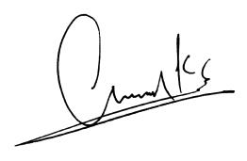
Umar Khan
For and on behalf of <<employer>>,

Candidate Signature: X---------------------------------------------
Candidate Printed Name: <<employee name>>
Date: <<today’s date>>

