Date: February 5 2018

Topic: Website changes on PRP

HOME:

* Foto di “Experience our warehouse” diganti ke gambar semula
* Diganti menjadi: Presisi owns, develops and manages sustainable logistics facilities, and provides innovative supply chain solutions across Indonesia.
* Bagian “What we do” diposisikan ke atas sesudah section ini: 
* Di bagian “WE BUILD” descriptionnya diganti: Our customers are the lifeblood of our organization.
* Foto-foto di 1. We build, 2. We manage, 3. We invest, dan 4. We own diganti dengan picture yg lebih bagus qualitynya
* Section “What we do” tolong dimasukan juga ke section “Company”
* Video di halaman pertama diganti menjadi video yang pake drone saja bukan yg slide show pictures
* Di section “experience our warehouse” videonya nge-link ke video yang pake drone
* Di section “check out our build to suit” videonya nge link ke video yang slide show photo2

COMPANY:

* Dikasih gambar di banner “our company”
* Di section who we are ada kalimat salah jadi di ganti menjadi:

PT Presisi Rekayasa Persada (PRP) is a warehouse, logistics, and supply chain solutions provider that was established in 2006 by a group of logistics professionals with experiences from various industries. With 13,000 islands and a population of over 240 million people, the group believes that international corporations could thrive in and benefit from Indonesia's extensive market by having the proper infrastructures in place.  
  
In the exciting Indonesian market, Presisi believes that the synergy between international and local companies cultivates further economic growth for both parties. At Presisi, we do not just build infrastructures, we collaborate together with our clients to unlock their competitive advantage through our innovative logistics and supply chain services. We carefully analyse the requirements and the needs of our clients', and build our solutions on warehousing and facility purposes prior to incorporating it with our distribution services. With our excellent warehouse and distribution services, and the support of bright engineers and employees, we believe that Presisi will maintain its success and continue to grow regionally.

* Ditambahkan section “what we do” dan isi2-nya (we manage, we build, we invest, we own)
* Di section “we build”:
  + Banner-nya gk usah diganti2. jadi fix aja
  + Description diganti hanya: “Our customers are the lifeblood of our organization”
  + Content-nya ada kesalahan diganti menjadi ini dan tidak ada ‘tab’-nya:

Presisi adopts a customer-focused culture. We bend-over-backwards to make sure our facilities exceed our customers’ needs and expectations. Part of the process of providing a high-quality building for our customers is by listening to their needs.

When developing a new facility for our customers, our experienced team collaborate with our clients from the sourcing of the land through the construction, and ultimately the handover of the building. Our Build-to-Suit development service allow our customers to have a customized building that meet their specific requirements down to the last detail. In the process of designing the premise, our customers can rely on our high level of attentiveness to build an efficient, fully-optimized, and personalized warehouse facility. We then obtain a planning and building permission prior to the actual construction, and deliver the finished premise according to the strict budget and schedule.

In addition to our Build-to-Suit development service, we also offer readily-available storage facilities in prime locations throughout Indonesia.

As a valued business partner, our customers can trust Presisi to deliver high-spec buildings they need in prime locations in a timely and cost-friendly manner.

* + Warna 4 tombol di bawah biru-nya di samakan dengan yg lainnya (dark blue)
* Di section “we own”:
  + Banner-nya gk usah diganti2. jadi fix aja
  + Content-nya ada kesalahan diganti menjadi ini dan tidak ada ‘tab’-nya:

With precision carved into the fabric of our motto, our customers can expect to have a high level of personalized service tailored precisely to their needs and throughout their tenancy.

We understand the importance of logistics and infrastructure in a business operation, and that is why it is always our main goal to provide more than just a space for our customers, but a home; a solid foundation for their business to grow.

Like how we build our home, our facilities are constructed with the same careful measure and considerations brick-by-brick—selecting only the finest materials to ensure its sustainability. As the owner of our buildings, we do not intend on selling our properties. Thus, providing customers with consistent long-term visibility of future expenses and high level of personalized service throughout their tenancy however long they may be.

Moreover, rest assure that our facilities will be professionally maintained and regularly managed by us. By leaving the construction of the facility and its maintenance to us, our customers can use their capital for other investment opportunities and focus more on their core business

* Di section “we manage”:
  + Banner-nya gk usah diganti2. jadi fix aja
  + Di description di banner ada kesalahan di ganti menjadi: “Well-maintained facility and individualized services everyday—all year round”
  + Foto diganti: 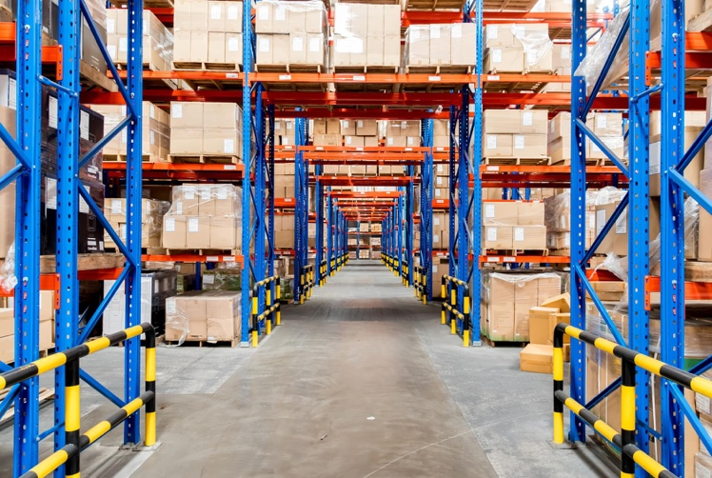
  + Content-nya ada kesalahan diganti menjadi ini dan tidak ada ‘tab’-nya:

Like developing friendships, here at Presisi, we make it our priority to get to know all of our customers on a personal level. This allow us to have a greater understanding of our customers’ business model and their requirements, and provide a high-quality level of personalized service they expect.

Equipped with an in-depth market knowledge, we are able to put forward innovative and personalized solutions that meets our customer’s specific needs, solve problems, and improve efficiency.

Our management service includes but not limited to:

* The management and maintenance of each individual warehouse property
* The management of power stations and waste water
* The maintenance of sprinkler, emergency and security systems
* Arranging favourable and cost-friendly insurance terms
* Guaranteeing safe and clean premises
* Provide clear information on the long-lastingness of different pieces of equipment   
  and how much they cost
* And more..

We are committed to walk the extra mile to exercise fast response and deliver precise solutions when dealing with any issues. To uphold such commitments, we assigned each of our customers their own Property Manager. By having personal relationships with all our customers, we are capable of providing them with the high standard of individualized services and reliability they expect.

* Di section we invest:
  + Foto diganti menjadi: 
  + Banner-nya gk usah diganti2. jadi fix aja
  + Ada kesahalan di content tlg diganti menjadi ini dan tidak usah pake tab:

According to a British real estate tycoon, Lord Harold Samuel, the three most important factors in buying a property are location, location, location.

Here at Presisi, we invest in lands and properties that are strategically located, and with near access to toll roads, industrial areas and Jakarta’s Central Business District.

Should our customers request for a storage facility in other regions of Indonesia outside of Jakarta, our experts are capable of curating the most strategic locations to build a warehouse. This includes having knowledge on:

* + Locations with the best access to factories, business districts, industrial regions, ports, and airports
  + Issues pertaining to traffic
  + Lands with the potential of becoming an in-demand location in the future
  + The type of buildings that are suitable to build in the areas
  + Planning permissions
  + Whether local authority and society support new development
  + And many more…

We understand the rapid transformation in technology, and that is why in addition to acquiring properties in prime locations, we also invest in the latest innovation to improve productivity, increase utilization and reduce cost in a warehouse operation.

Last but not least, we place great importance in the relationships we have with all our customers. If they have questions, we answer. If they have issues, we provide solutions. If they have requests, we deliver. Through our various service offerings, years of experience, excellent consistency and clear transparency, our customers can enjoy a long and fruitful relationship with us.

SERVICES:

* Services yg di offer oleh PRP itu ada 4 macam: 1. Warehouse, 2. Distribution, 3. Logistics Management, 4. Supply Chain Management.
* Under Warehouse service adalah warehouse rental (facility sudah jadi, siap digunakan) dan Build-To-Suit Development Service dimana client bisa mendapatkan Warehouse yg sesuai permintaan/design.

Build to suit development:

* Considerate diganti menjadi “Attentive”, layout diganti

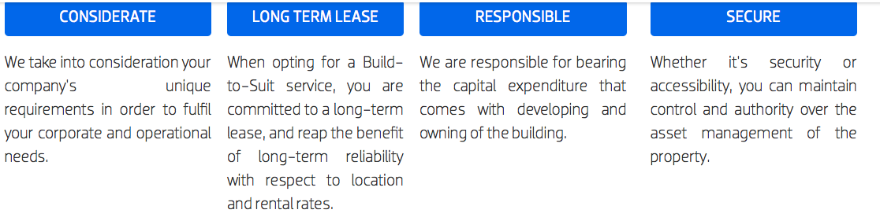

* Video di B2S development harusnya yg slideshow foto2

Warehouse service:

* Video pake drone di pindah ke bagian warehouse capacity

Distribution service:

* Bagian ini tlg diganti menjadi bullet points:
  + Employees are required to undertake training and encouraged to report issues.
  + Vehicles are regularly maintained.
* Nomor 3 dan 4 di delete, karena itu adalah service
* Logistics Management service contentnya pake bullet point aja “Repair centre and spare parts management” lalu dikasih foto ini: 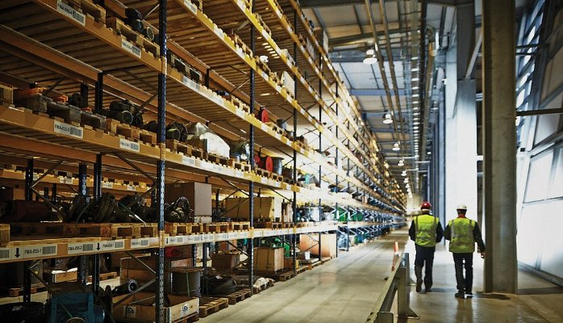 atau lebih bagus kalo ada animation2 yang cocok/related to spare parts management

Supply Chain Management

* Sentencesnya tlg dibuat supaya tidak ada “tab”nya before the start of each sentences
* bisa dibuat supaya seperti kayak processs? Jadi ada arrownya habis evaluate design etc…

CAREERS

* Banner diganti dengan picture ini:
* 
* 
* 
* Dari ketiga foto itu bagusan yg mana/lebih cocok yg mana?