Energy Innovation Agency - Innovator Questionnaire:

Please answer the following questions as thoroughly as possible as it will ensure we can support you as efficiently as possible.
Please note data is only held internally for Energy Innovation Agency purposes to support our services to you.
If you feel any questions are not relevant, please clarify in your responses.
If you feel any questions are sensitive, please clarify in your responses.
If relevant (in OTHER) please provide supporting information.
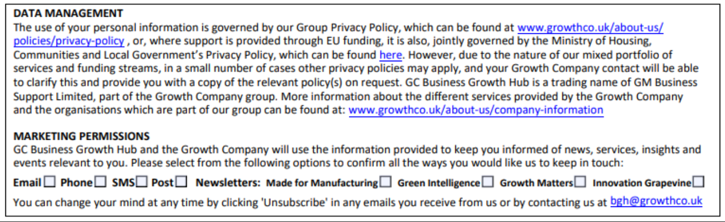

1. | Business Contact Information – please provide the following information:
Business Name:
Business Address:
Contact Name:
Contact Position:
Contact Email:
Contact Phone:
OTHER:

2. | Business Information – please provide the following information:
When founded:
Trading status:
Partner Organisations (if relevant):
Number of employees:
Registration No.
Vat No.
Do you have any sector specific accreditations or approvals from third-party organisations?
OTHER:

3. | Innovation – please provide the following information:
Innovation name and description:
Why did you create your innovation / what problem does it solve?
How does your innovation support the route to net-zero?
How much Carbon Dioxide does your innovation save? (please quantify with case studies if possible).
What IP have you registered for your innovation?
If your innovation is technology based what is its TRL? (1-9) – see bottom of questionnaire for a TRL explanation
What are your timescales for commercialising your innovation?
Can you demonstrate your innovation?
What is the end-goal for your innovation?
OTHER:

4. | Business Plan – please provide the following information:
Do you have a business plan?
Company Vision:
Key business aims and objectives:
What other products and Services do you offer?
OTHER:

5. | Market – please provide the following information:
Do you have any existing customers for your innovation?
Who is your target customer?
What markets do you operate in / aim to operate in?
Are there any barriers to bring your innovation to market? (if so please describe them)
Do you operate in a crowded market or is your innovation disruptive (new)?
OTHER:

6. | Support – please provide the following information:
The Energy Innovation Agency has access to a range of academic, business, and financial resources from our partners.
Have you secured any innovation support to date and if so what, when and from whom?
What support are you looking for now?
What will this support enable you to achieve?
OTHER:

6. | Ethnicity - Number of Employees:
White / Other White:
Asian / Asian British / Other Asian:
Black / Black British / Other Black:
Mixed / Multiple ethnic group:
Other ethnic group:

