**Topology Performance: Gossip & Push-Sum**

Group Members: ***Umar Majeed****:* 96119334 ***Gagan Sharma****:* 91349422

**Gossip**

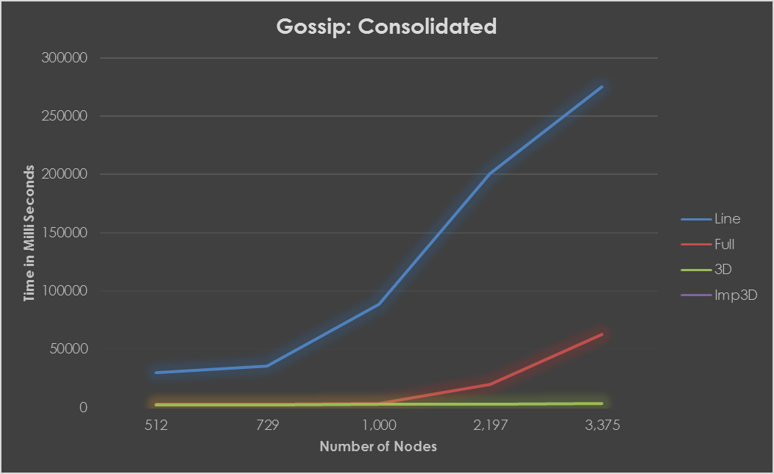

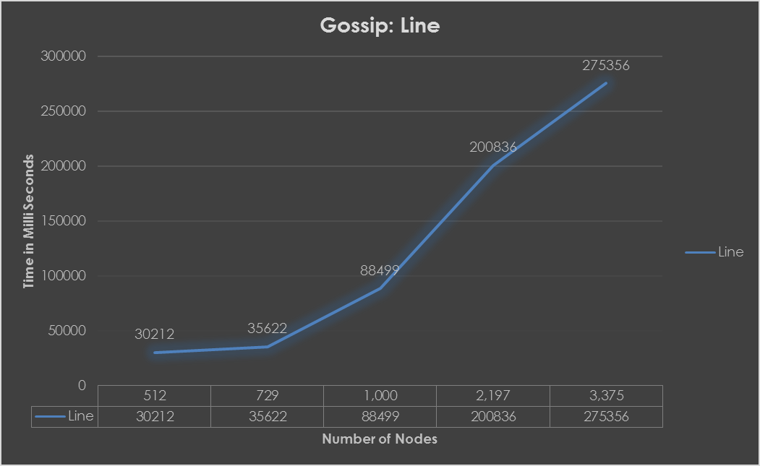

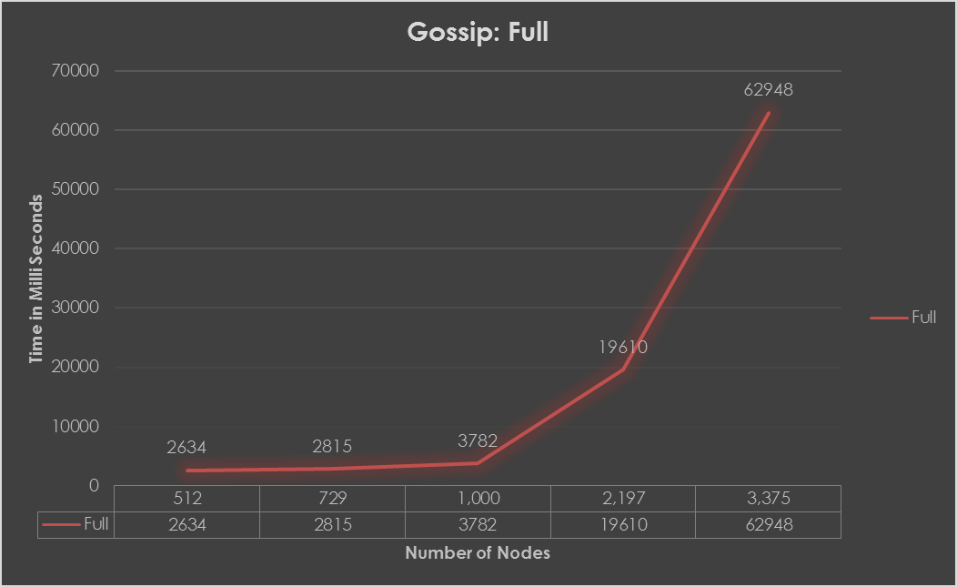

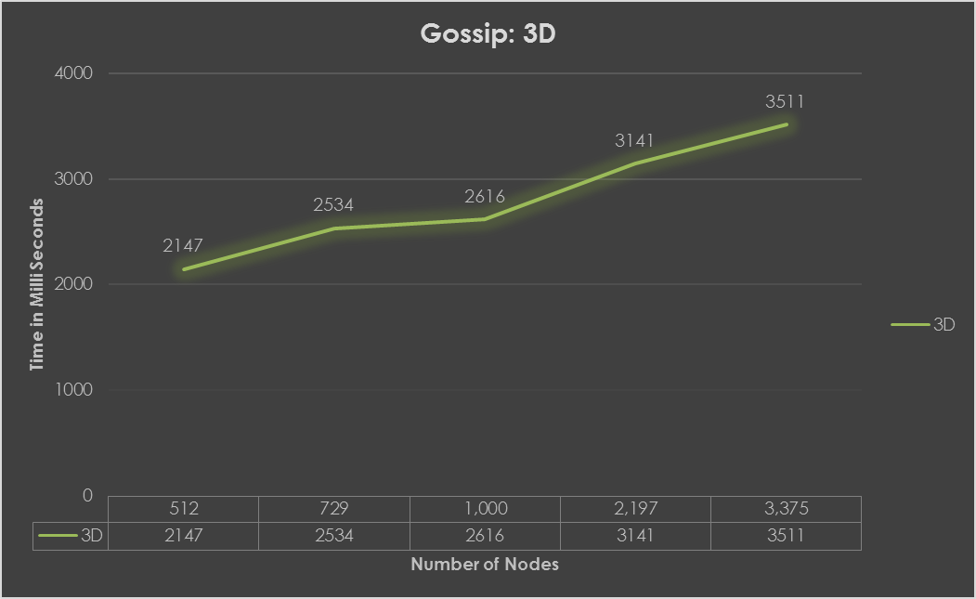

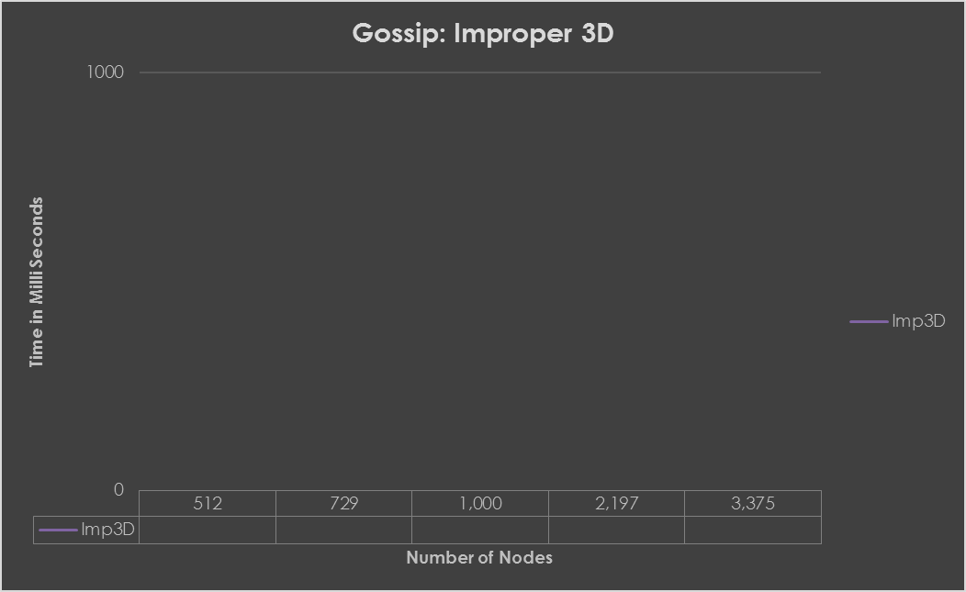

**Push-Sum**

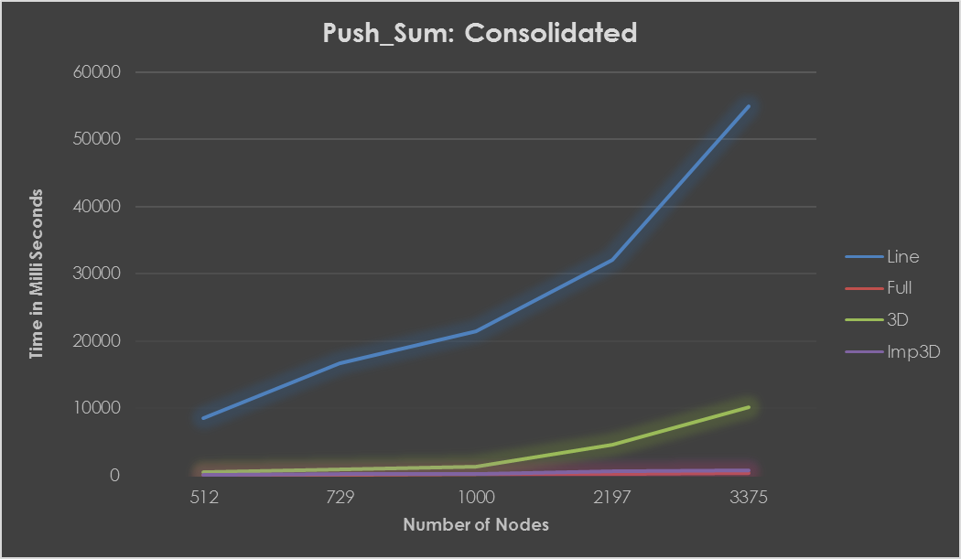

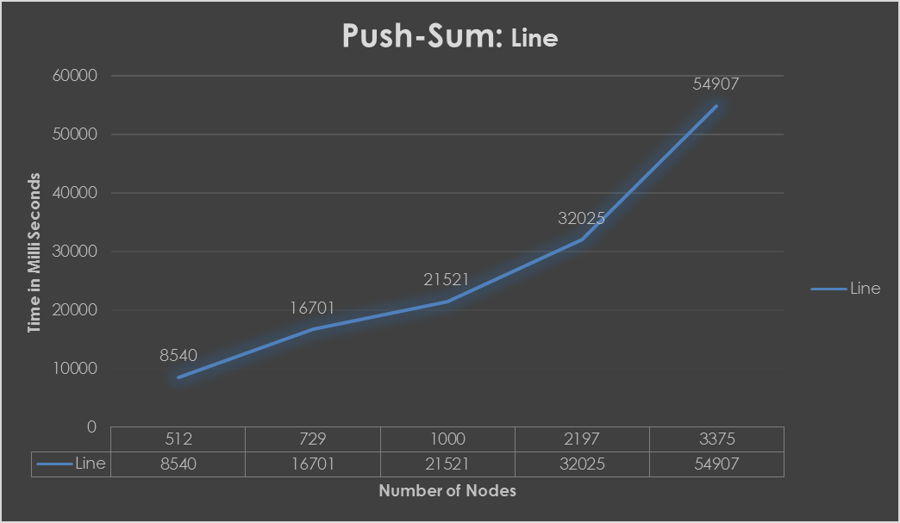

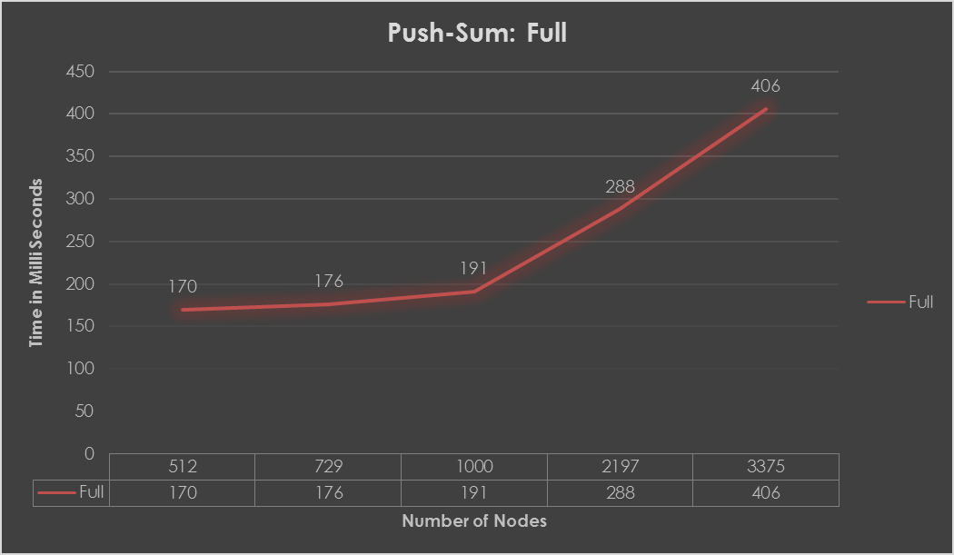

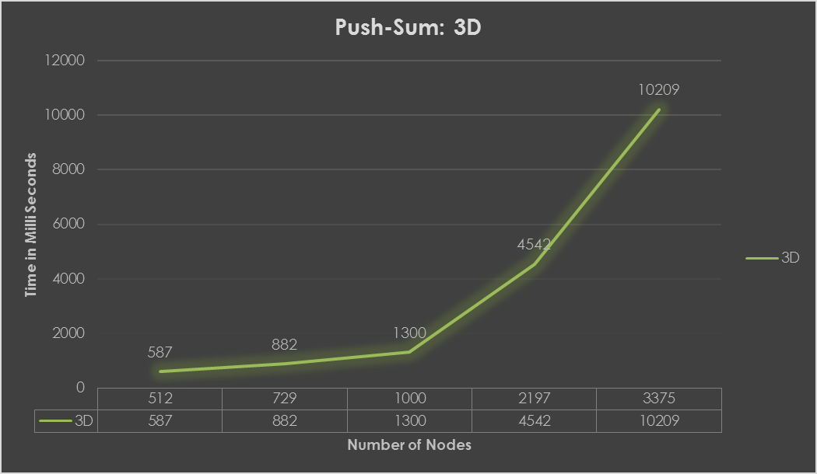

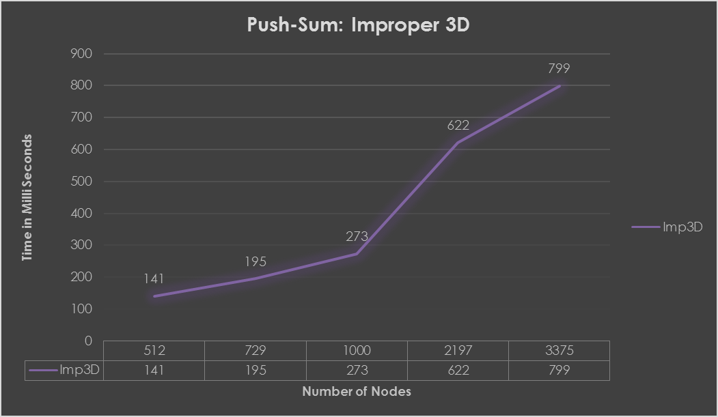

**Analysis**

**Tested System Config:**

**OS**: Windows 10

**Processor**: Intel Core i7

**RAM:** 6 GB

1. In Gossip as well as Push-Sum, Line topology takes the maximum time to converge.
2. Time taken by Push-Sum was considerably lower than Gossip
3. Executing Full topology with Gossip as well as Push-Sum, takes lesser time, but started giving memory errors as soon number of nodes were more than 7,000
4. 3D and Improper 3D could easily handle 100,000 nodes