**ADDRESS BOOK LIBRARY**

**REQUIRED MODULES**

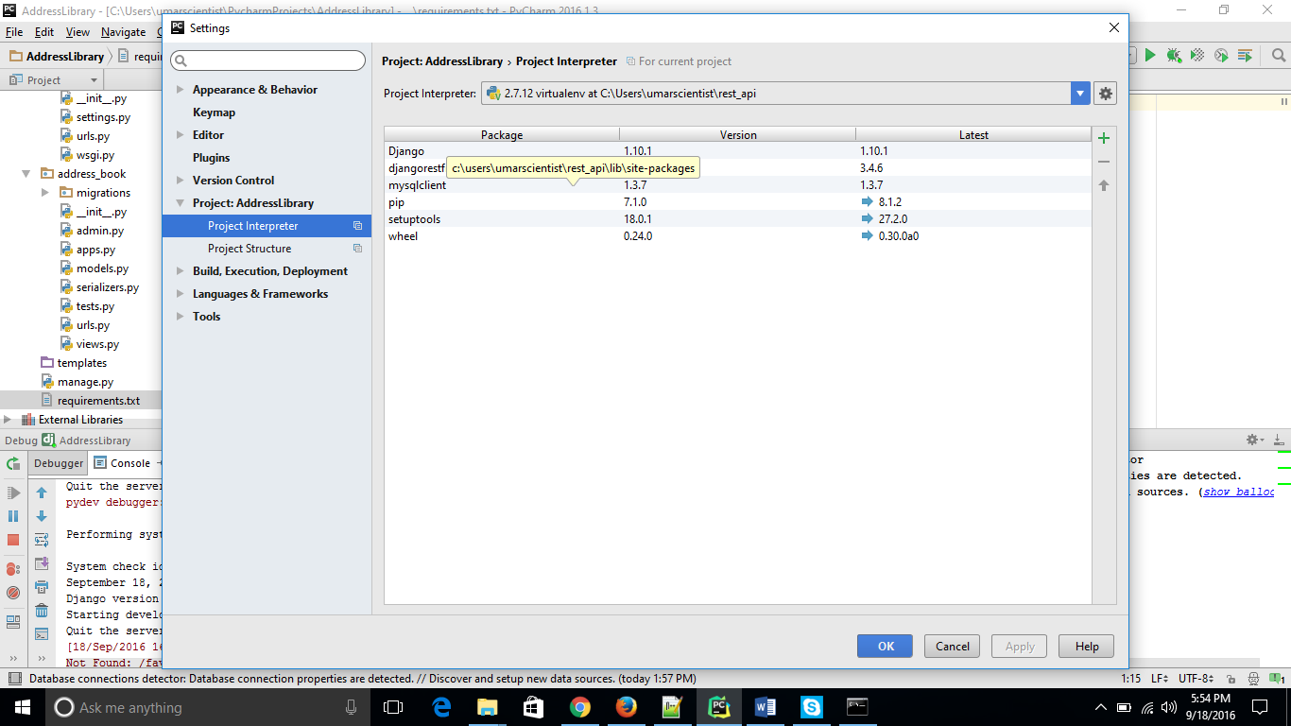

**ADD GROUP:**

POST - http://127.0.0.1:8000/groups/

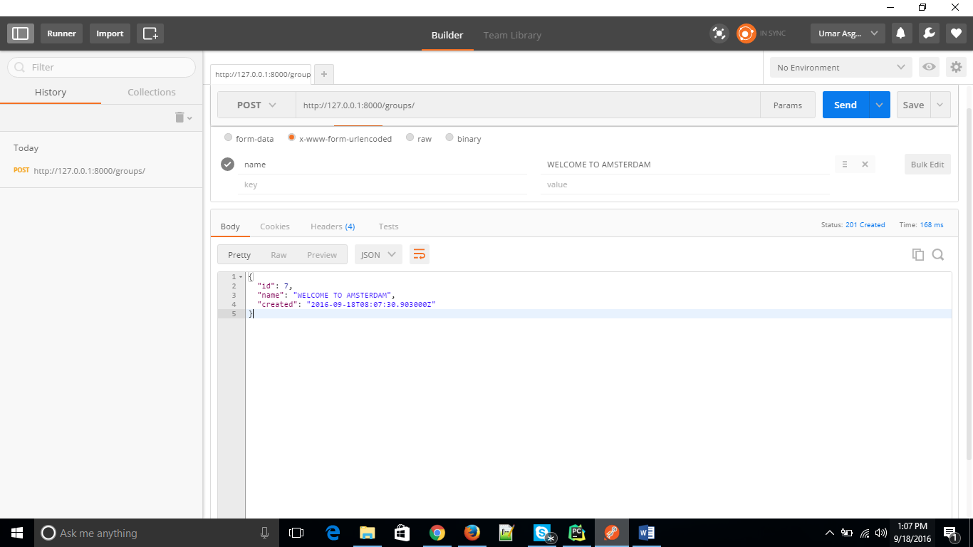

RESPONSE:

{

"id": 7,

"name": "WELCOME TO AMSTERDAM",

"created": "2016-09-18T08:07:30.903000Z"

}

**ADD PERSON TO GROUP ( one or more emails / street addresses / phone no’s )**

POST - <http://127.0.0.1:8000/persons/>

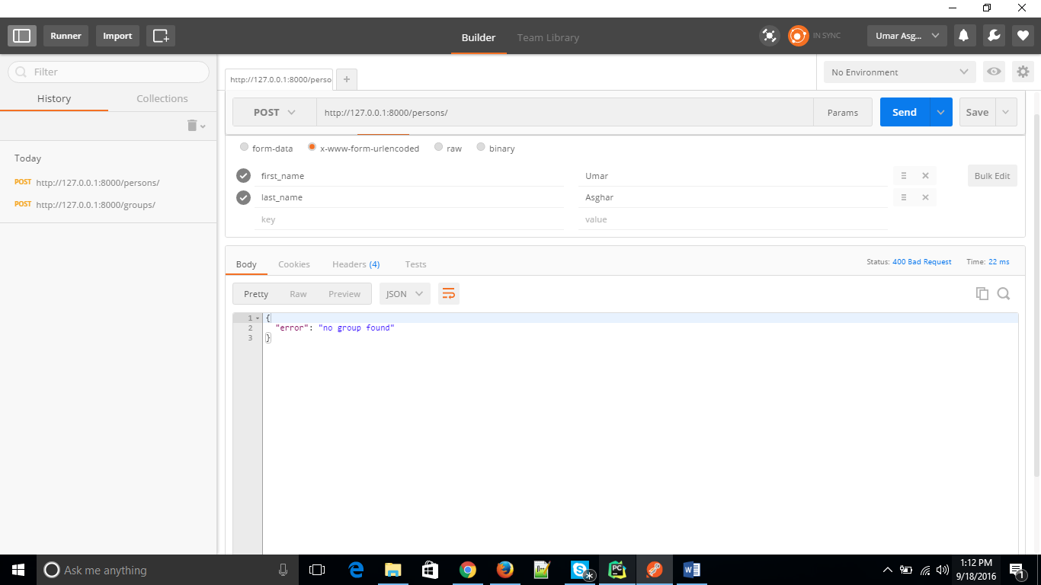

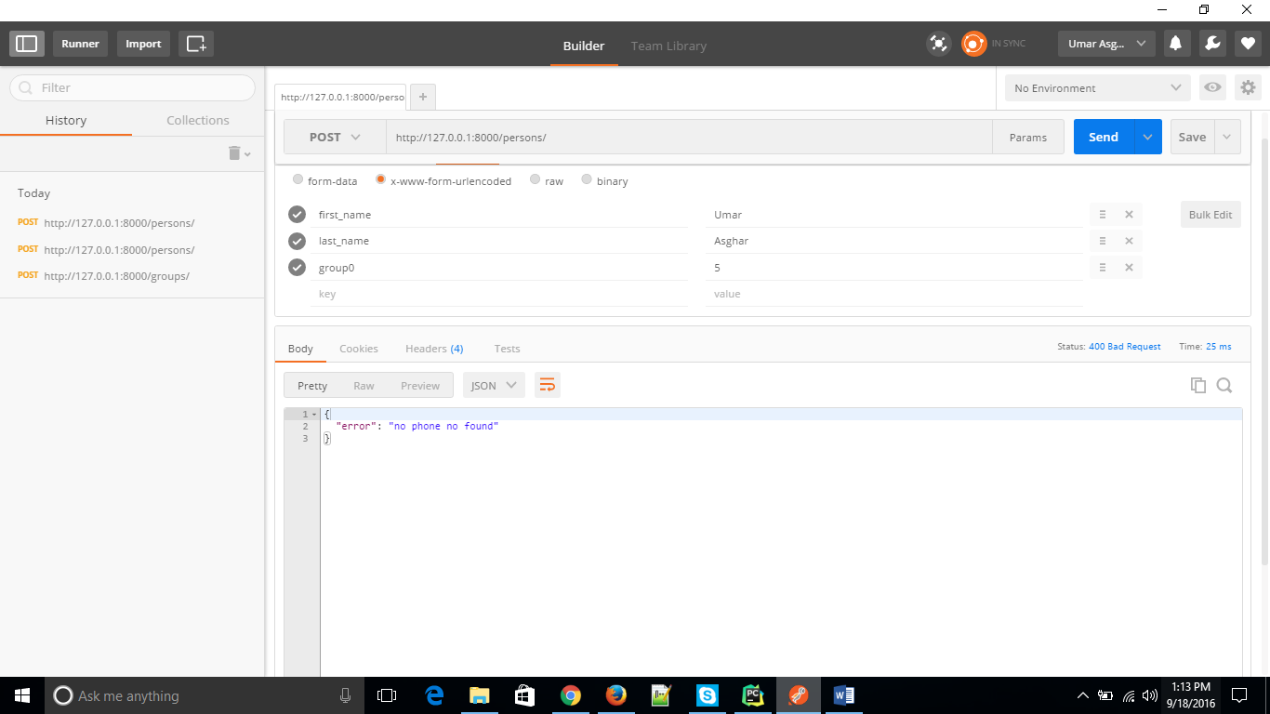

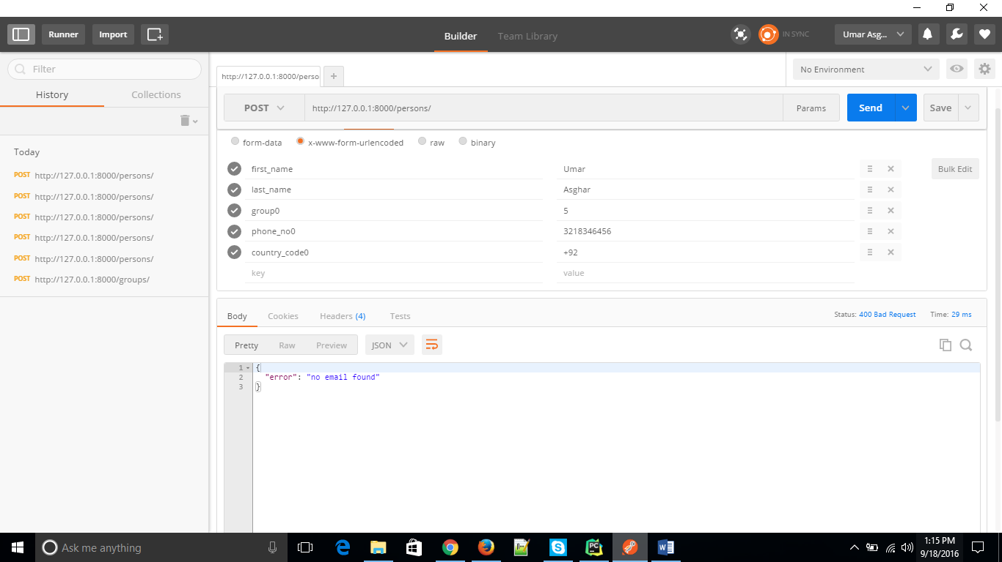

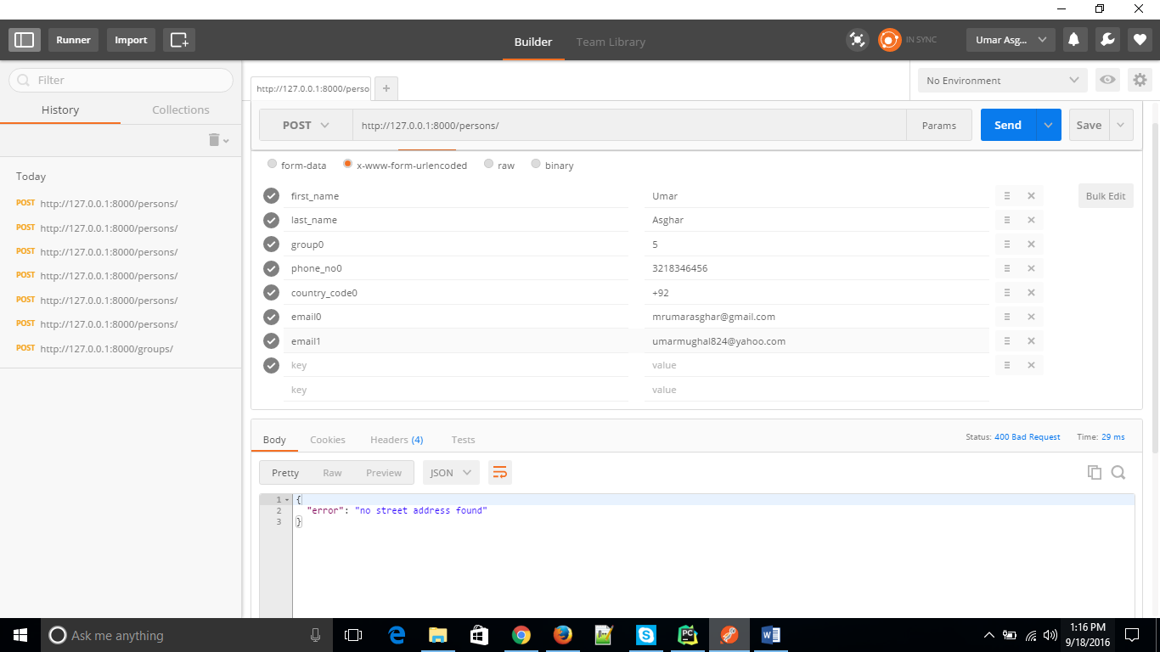

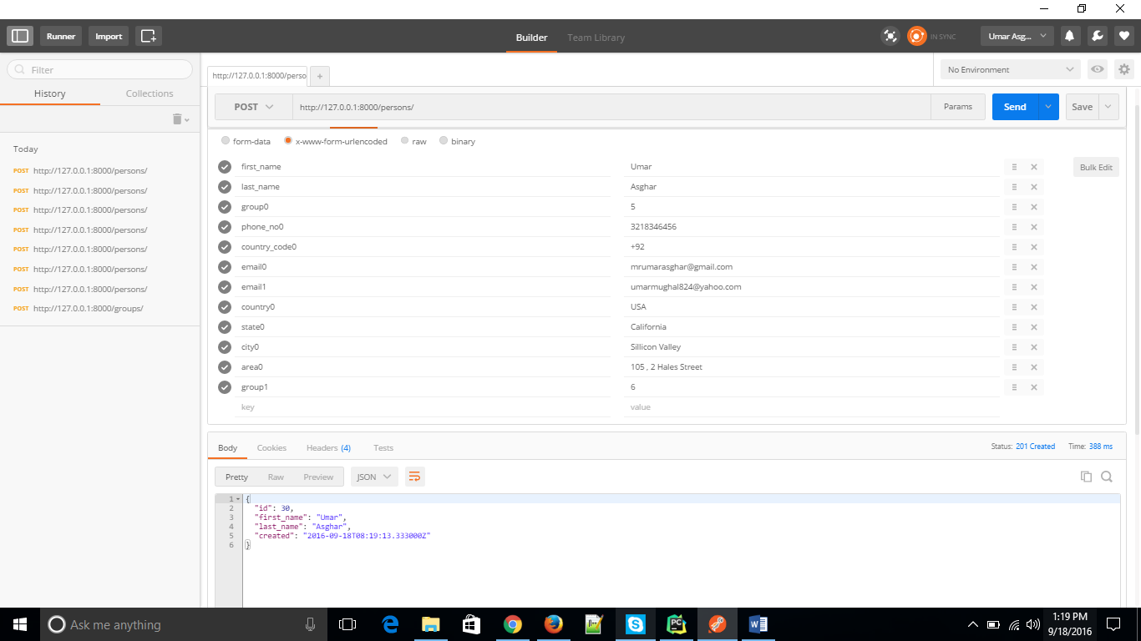

**Response:**

{

"id": 30,

"first_name": "Umar",

"last_name": "Asghar",

"created": "2016-09-18T08:19:13.333000Z"

}

**GROUP MEMBERS**

GET - <http://127.0.0.1:8000/groups/5/>

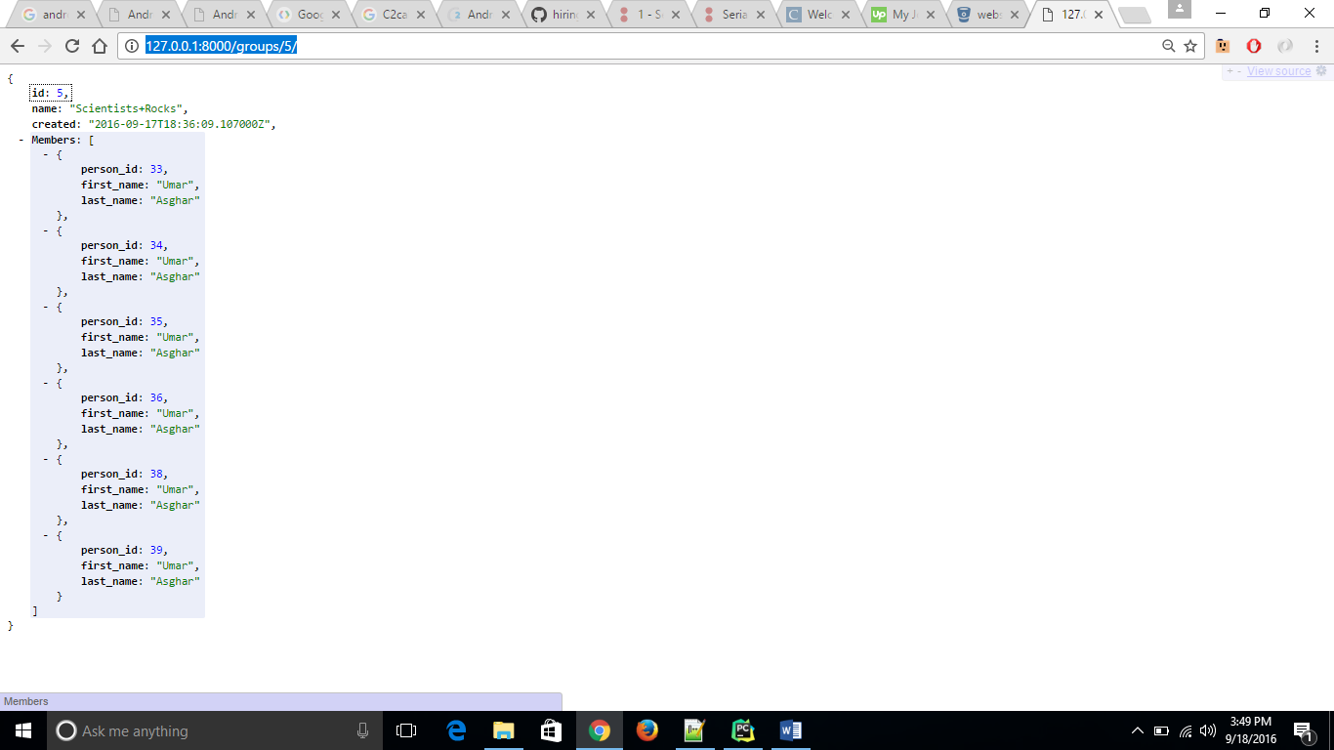

RESPONSE

{

* **id**: 5,
* **name**: "Scientists+Rocks",
* **created**: "2016-09-17T18:36:09.107000Z",
* **Members**:

[

* + {
    - **person_id**: 33,
    - **first_name**: "Umar",
    - **last_name**: "Asghar"

},

* + {
    - **person_id**: 34,
    - **first_name**: "Umar",
    - **last_name**: "Asghar"

},

* + {
    - **person_id**: 35,
    - **first_name**: "Umar",
    - **last_name**: "Asghar"

},

* + {
    - **person_id**: 36,
    - **first_name**: "Umar",
    - **last_name**: "Asghar"

},

* + {
    - **person_id**: 38,
    - **first_name**: "Umar",
    - **last_name**: "Asghar"

},

* + {
    - **person_id**: 39,
    - **first_name**: "Umar",
    - **last_name**: "Asghar"

}

]

}

**PERSON BELONGS TO WHICH GROUP**

GET - http://127.0.0.1:8000/persons/39/

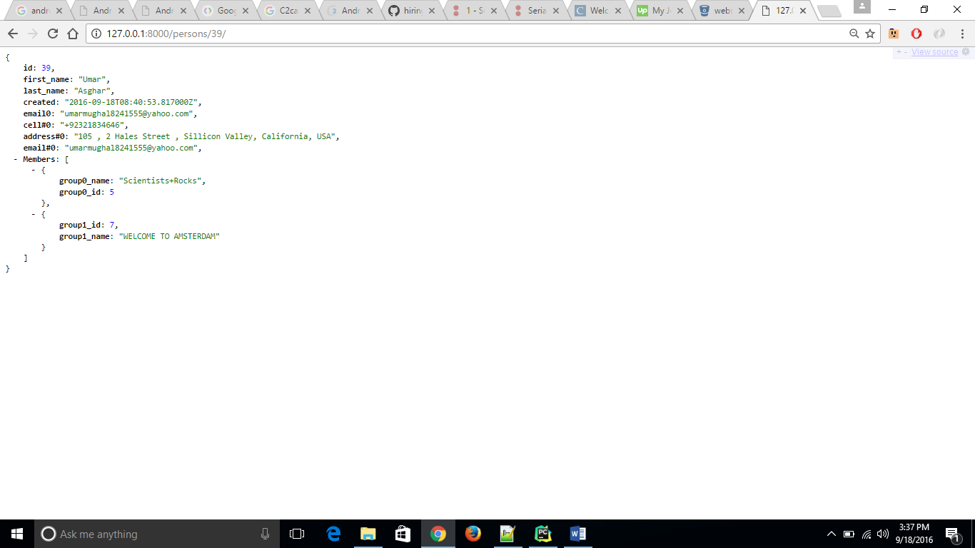

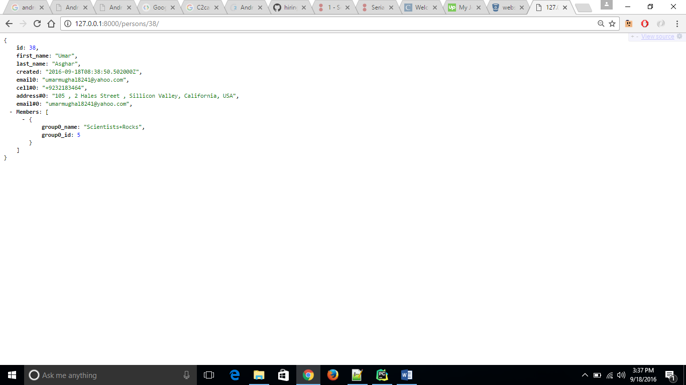

RESPONSE

{

* **id**: 39,
* **first_name**: "Umar",
* **last_name**: "Asghar",
* **created**: "2016-09-18T08:40:53.817000Z",
* **email0**: "umarmughal8241555@yahoo.com",
* **cell#0**: "+92321834646",
* **address#0**: "105 , 2 Hales Street , Sillicon Valley, California, USA",
* **email#0**: "umarmughal8241555@yahoo.com",
* **Members**:

[

* + {
    - **group0_name**: "Scientists+Rocks",
    - **group0_id**: 5

},

* + {
    - **group1_id**: 7,
    - **group1_name**: "WELCOME TO AMSTERDAM"

}

]

}

**PERSON BY BOTH FIRST AND LAST NAME**

GET - <http://127.0.0.1:8000/persons/find/Umar/Asghar/>

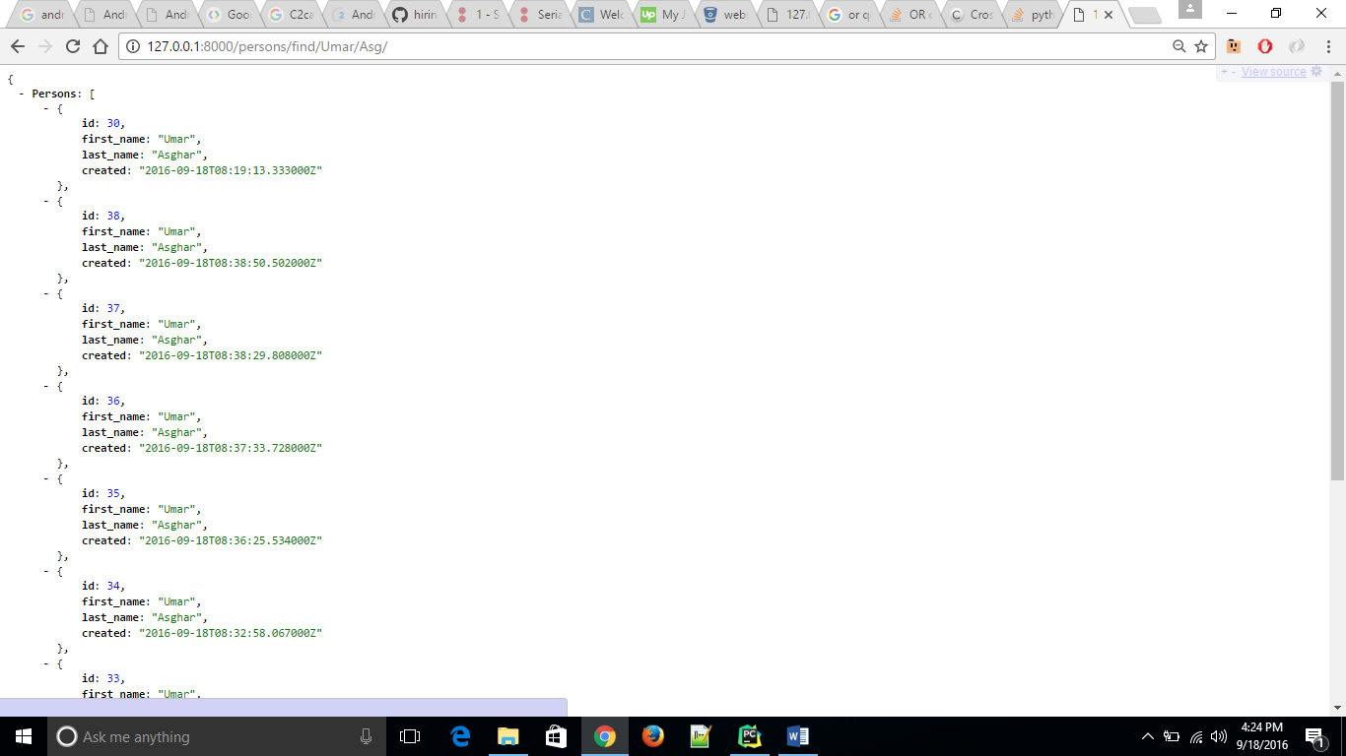

**PERSON BY BOTH FIRST NAME**

GET – http://127.0.0.1:8000/persons/find1/Uma/

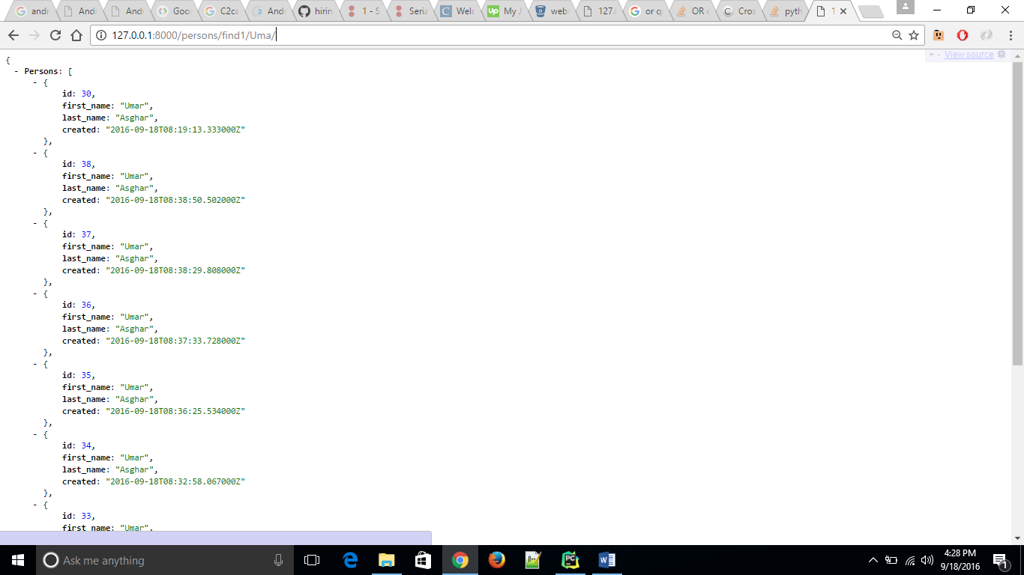

**PERSON BY LAST NAME**

GET – <http://127.0.0.1:8000/persons/find2/Asgh/>

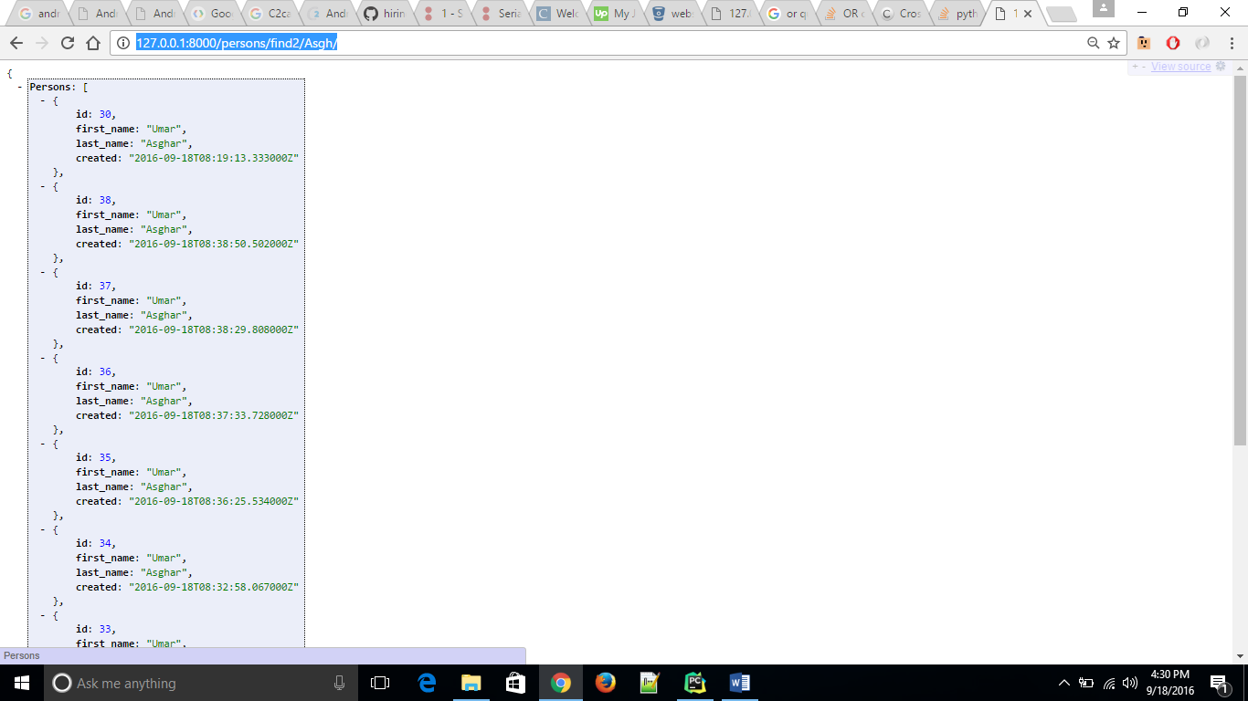

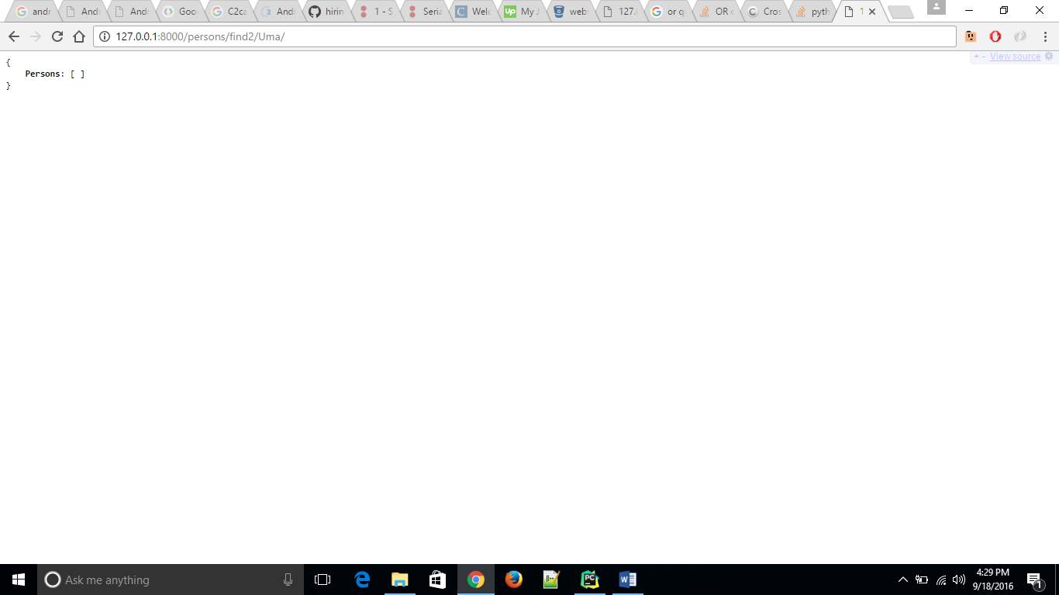

**PERSON BY EMAIL ADDRESS**

GET - <http://127.0.0.1:8000/persons/find3/mrumarasghar@/>

