Project Submission Document

Course: Enterprise Application Development

Semester: Spring 2025

Instructor: Khalid Hussain

Submission Date: July 01, 2025

# Project Title

DO IT! (TASKER)

# Team Members

| Name | Roll Number | Contribution |  
|------|-------------|--------------|  
| Syed Umer | 023-22-0196 | Complete Project |

# Project Description

A full-stack task management platform that connects clients with skilled providers for Local Tasks. Clients can post tasks and receive bids from providers, while providers can browse available tasks and submit proposals.

# Technology Stack

- Frontend: ReactJS  
- Backend: Node.js, ExpressJS  
- Database: MongoDB   
- Version Control: GitHub

# Project Features

**### For Clients:**

- **\*\*Task Management\*\***: Post, edit, and delete tasks

- **\*\*Bid Management\*\***: View and manage bids from providers

- **\*\*Task Assignment\*\***: Assign tasks to selected providers

- **\*\*Dashboard\*\***: Track task statistics and progress

- **\*\*Reviews\*\***: Rate and review completed work

**### For Providers:**

- **\*\*Task Discovery\*\***: Browse available tasks by category

- **\*\*Bidding System\*\***: Submit proposals with custom pricing

- **\*\*Dashboard\*\***: Manage applications and track earnings

- **\*\*Profile Management\*\***: Showcase skills and experience

- **\*\*Task Completion\*\***: Update task status and complete work

**### General Features:**

- **\*\*Authentication\*\***: Secure user registration and login

- **\*\*Role-based Access\*\***: Separate interfaces for clients and providers

- **\*\*Real-time Updates\*\***: Live task and bid updates

- **\*\*Responsive Design\*\***: Mobile-friendly interface

- **\*\*Dark Mode\*\***: Toggle between light and dark themes

# GitHub Repository

https://github.com/umarprivit/just_do_it

# Live Demo (If Deployed)

https://just-do-it-peach.vercel.app/

# Screenshots

DARK MODE:

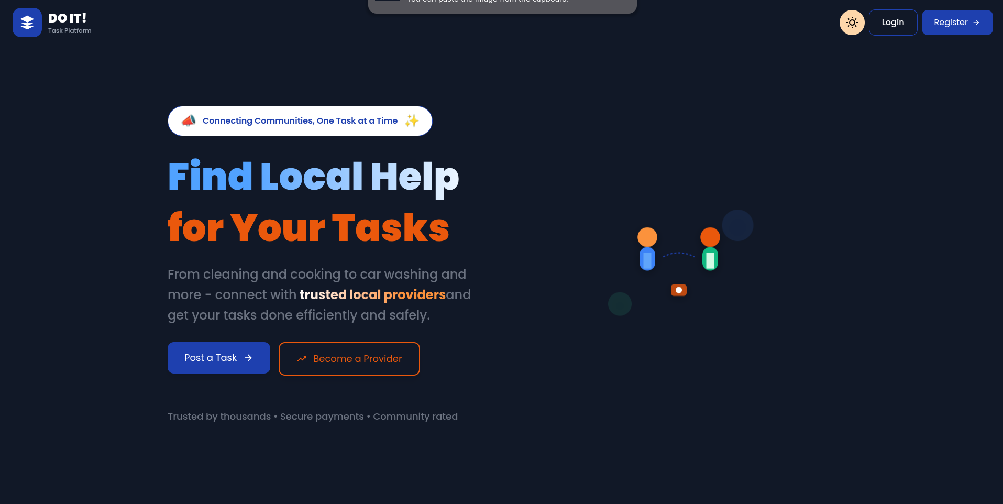

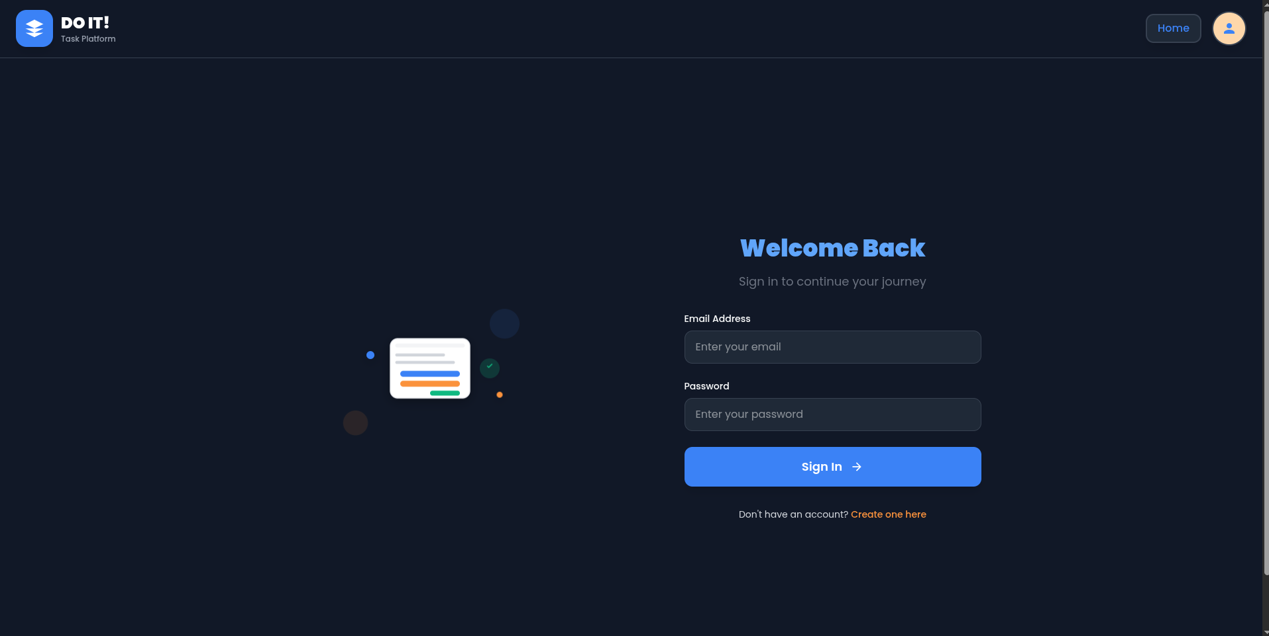

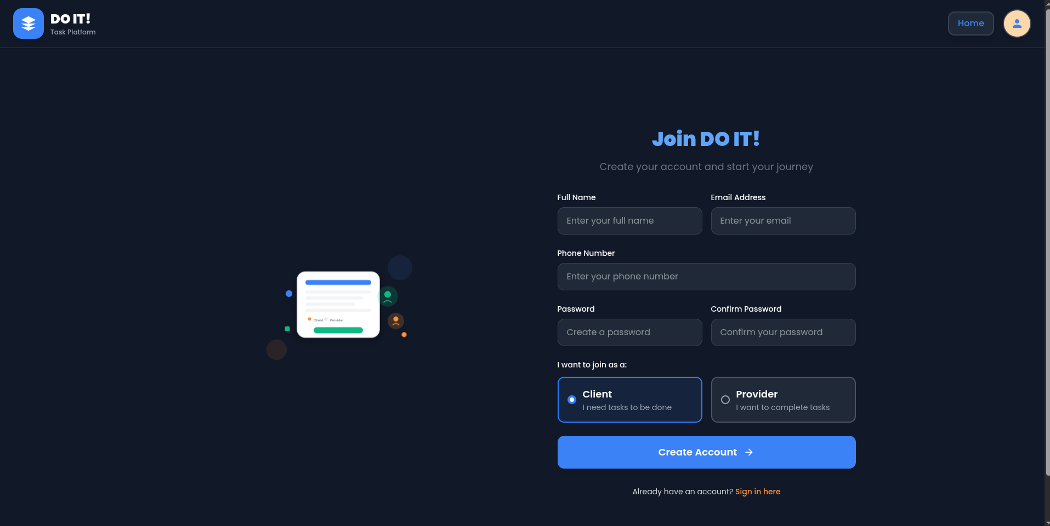

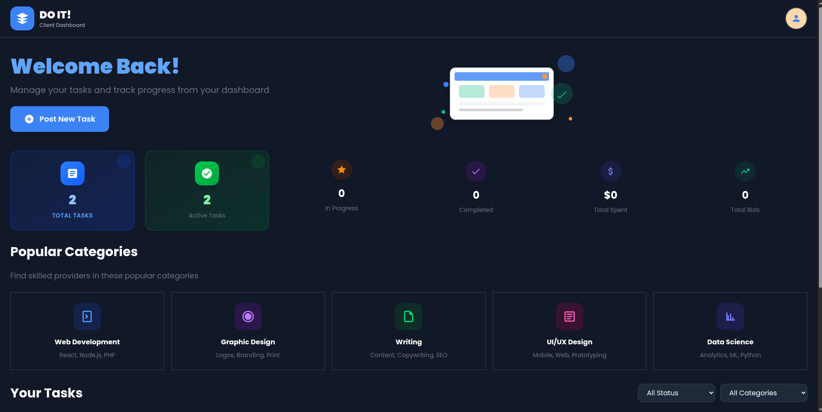

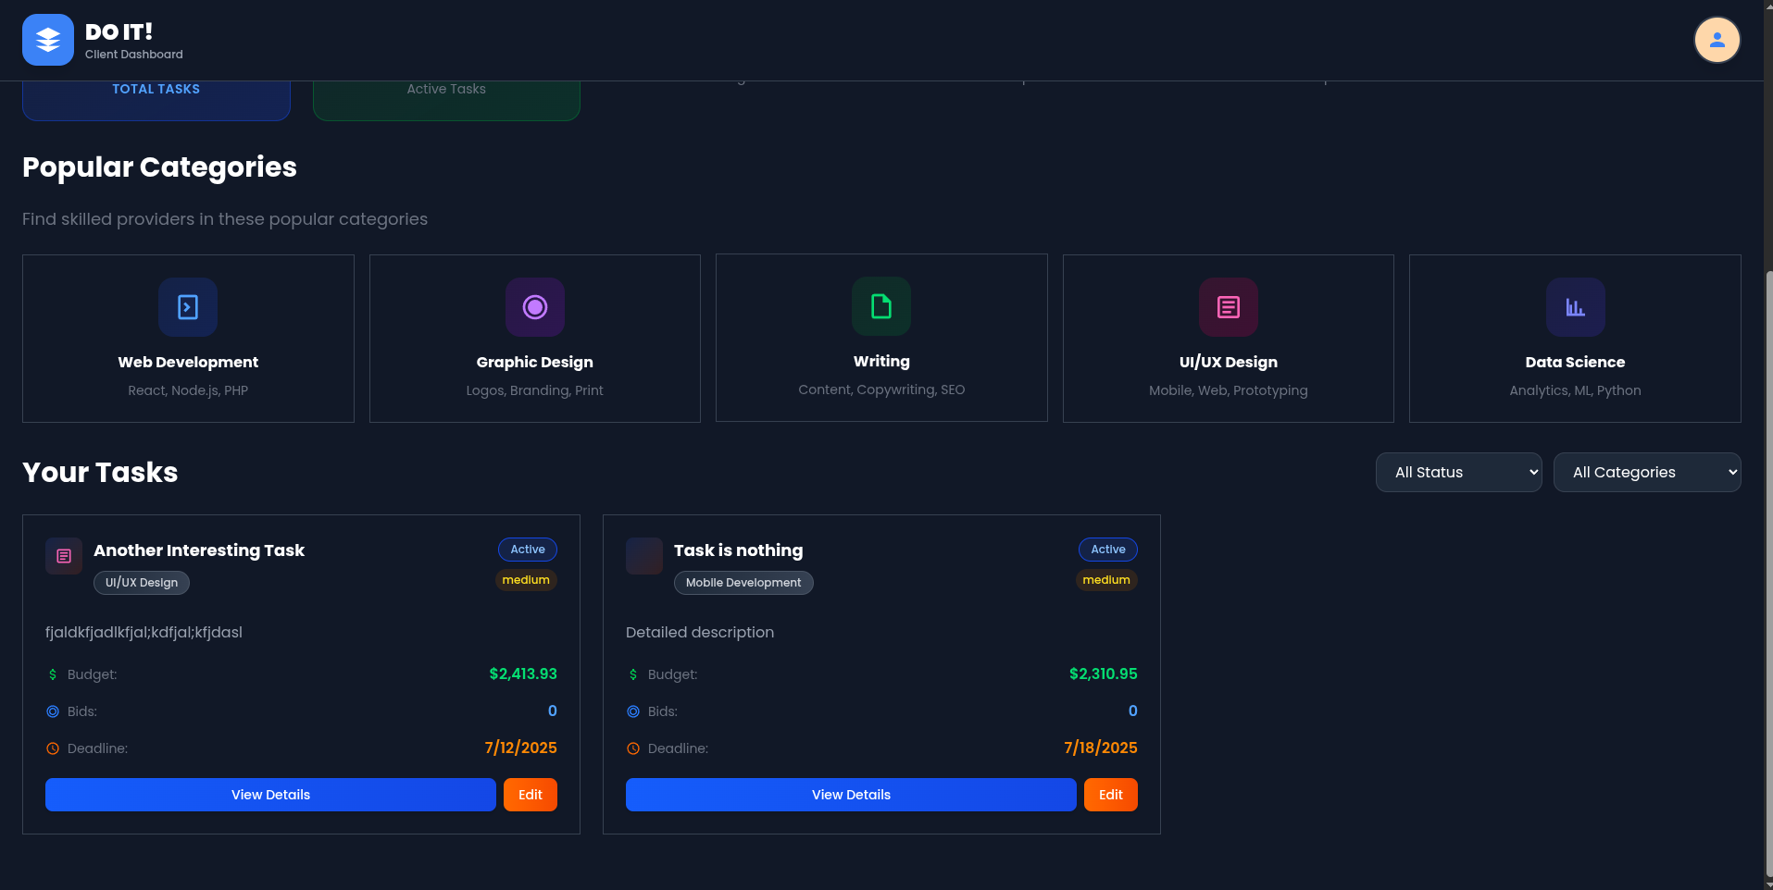

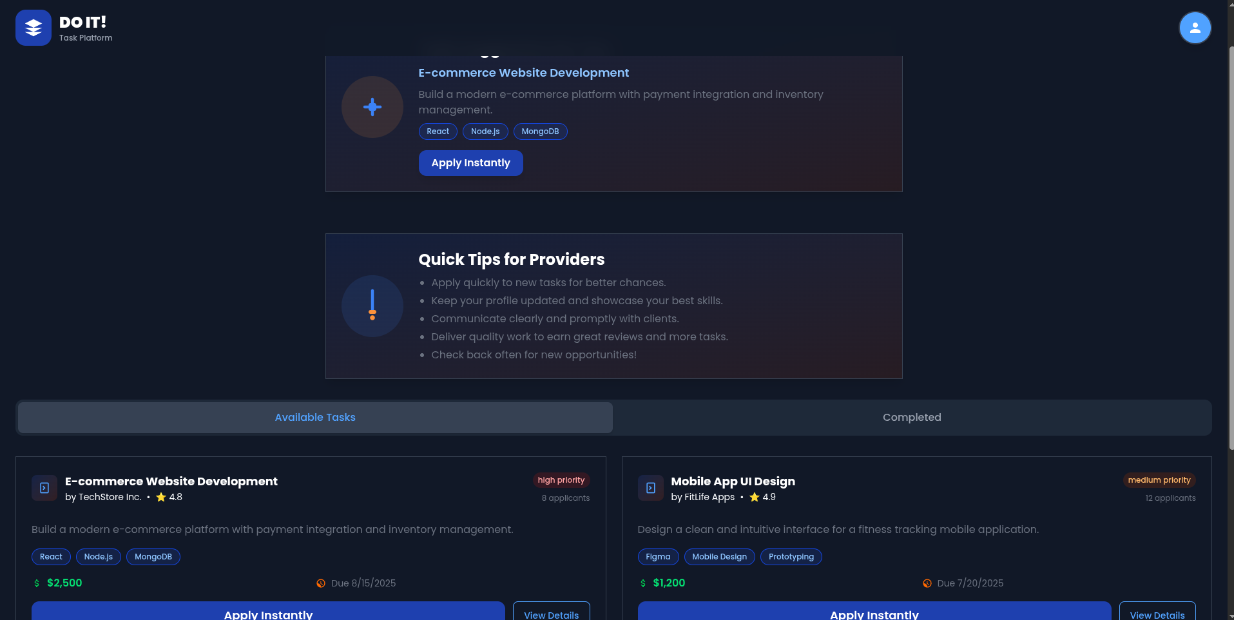

# Project Documentation

- README File: Included in GitHub repo  
- API Documentation: [Include here or link if applicable]  
- Installation Steps:

# Evaluation Criteria Checklist

| Criteria | | Completed (✔/✖) |  
|--------------------------------------|-------------------------|  
| Project Demo & Presentation done   
| Code Quality & Structure done  
| Project Understanding done  
| Functionality & Features done  
| Creativity & UI/UX done  
| Version Control & Documentation partially done

# Reflections

- Challenges faced and how they were overcome  
- What each member learned from the project  
- Suggestions for future improvements

# Submission Instructions

- Submit this document along with your project folder (don’t include the node_modules folder).  
- Ensure the GitHub repository is public or shared with me.  
- Include working links to the deployed app (if applicable).  
- Do not zip this document.  
- Submit on LMS.