Department Of Computer Science

Gujarat University

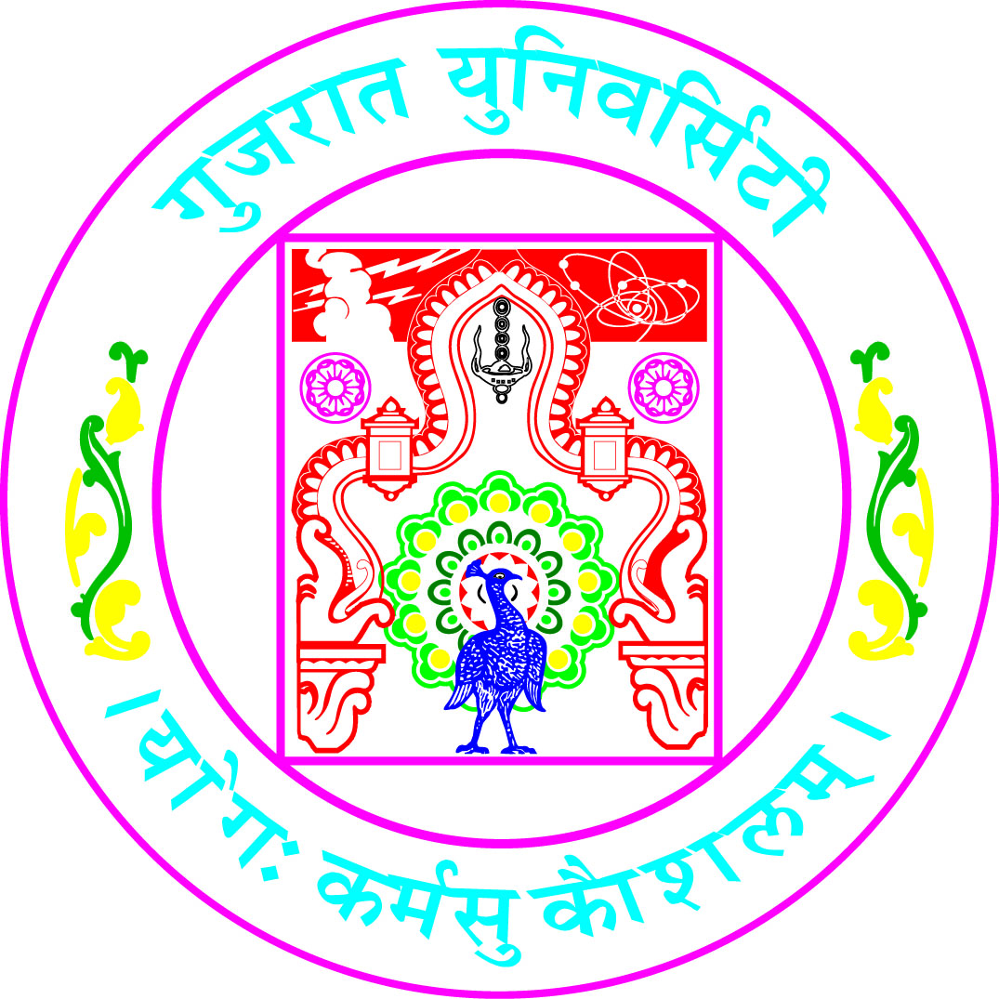

Certificate

Roll No: 09 DS Seat No: 30009

This is to certify that Mr./Ms. Mohamed Umar Ranginwala student of Third Semester of M.Sc (Artificial Intelligence and Machine Learning) – Defence Specific has duly completed his/her project titled Histopathologic Cancer Detection using Deep Learning for the semester ending in December 2023, towards partial fulfillment of degree of Master of Science (Artificial Intelligence and Machine Learning) – Defence Specific.

Date of Submission Internal Project Guide
30 December 2023 Dr. Suchit Purohit

Course Coordinator
Dr. Jyoti Pareek
Head of Department
Dr. Jyoti Pareek

