Generative Adversarial Networks for QuickDraw Sketch Generation: From Toy Data to Horses

July 6, 2025

Abstract
This report explores the use of Generative Adversarial Networks (GANs) for cre- ative sketch generation, progressing from simple 2D toy data to complex real-world sketches from the QuickDraw dataset. We begin with fundamental GAN training on synthetic 2D distributions, then train a Deep Convolutional GAN (DCGAN) on the QuickDraw ’smiley face’ class, and finally extend the method to the more challeng- ing ’horse’ category. Each stage is discussed with a focus on reasoning, architecture choices, visual and metric-based results, and personal reflections.

Contents

- Introduction 3
- Part 1: Toy 2D GANs on Synthetic Data 3
  - Overview and Motivation . . . . . . . . . . . . . . . . . . . . . . . . . . . . . 3
  - Method and Architecture . . . . . . . . . . . . . . . . . . . . . . . . . . . . . 3
  - Results and Insights . . . . . . . . . . . . . . . . . . . . . . . . . . . . . . . 3
  - Discussion . . . . . . . . . . . . . . . . . . . . . . . . . . . . . . . . . . . . . 4
- Part 2: DCGAN for QuickDraw Smiley Faces 5
  - Overview and Approach . . . . . . . . . . . . . . . . . . . . . . . . . . . . . 5
  - Why DCGAN? . . . . . . . . . . . . . . . . . . . . . . . . . . . . . . . . . . 5
  - Method and Architecture Details . . . . . . . . . . . . . . . . . . . . . . . . 5
  - Data Exploration . . . . . . . . . . . . . . . . . . . . . . . . . . . . . . . . . 5
  - Results . . . . . . . . . . . . . . . . . . . . . . . . . . . . . . . . . . . . . . . 6
  - Reflections and Evaluation . . . . . . . . . . . . . . . . . . . . . . . . . . . . 6
- Part 3: DCGAN for QuickDraw Horses (Extension) 7
  - Motivation . . . . . . . . . . . . . . . . . . . . . . . . . . . . . . . . . . . . . 7
  - Data Exploration . . . . . . . . . . . . . . . . . . . . . . . . . . . . . . . . . 7
  - Network Architecture Choices . . . . . . . . . . . . . . . . . . . . . . . . . . 7
  - Training and Results . . . . . . . . . . . . . . . . . . . . . . . . . . . . . . . 7
  - Analysis and Inferences . . . . . . . . . . . . . . . . . . . . . . . . . . . . . . 7
- References 8

Introduction
Generative Adversarial Networks (GANs) have become a cornerstone of modern generative modeling, enabling the creation of highly realistic images, art, and even medical data. In this project, I aimed to deeply understand GANs by building them from scratch, visualizing their learning process, and applying them to the creative task of generating hand-drawn sketches from the Google QuickDraw dataset. My journey started with toy 2D problems and gradually scaled up to complex sketches of horses.
The report is organized in three parts:
- Part 1: GANs on Synthetic 2D Data (learning the basics)
- Part 2: DCGAN for Smiley Faces (first real-world data)
- Part 3: DCGAN for Horses (tackling complexity and diversity)

Part 1: Toy 2D GANs on Synthetic Data

Overview and Motivation
Before jumping into images, I wanted to build intuition for GANs in a setting where every detail can be visualized. By training GANs on simple 2D shapes (like moons, rings, and circles), I could clearly see how the generator and discriminator interact and how challenges like “mode collapse” appear.

Method and Architecture
The setup involves a basic GAN, with both generator and discriminator as Multi-Layer Perceptrons (MLPs) with two or three layers each. The generator learns to map 2D Gaus- sian noise to points matching the target 2D distribution, while the discriminator tries to distinguish real from fake points.
Why this architecture? I chose MLPs because the data is 2D and doesn’t need the spatial structure that convolutional networks provide. This makes training fast and results easy to visualize.

Results and Insights
Training on moons and rings, I observed that the GAN can learn the overall data shape, but sometimes struggles with covering all modes of the distribution (mode collapse). Watching the generator’s samples evolve with each epoch gave me a strong, hands-on grasp of GAN dynamics.

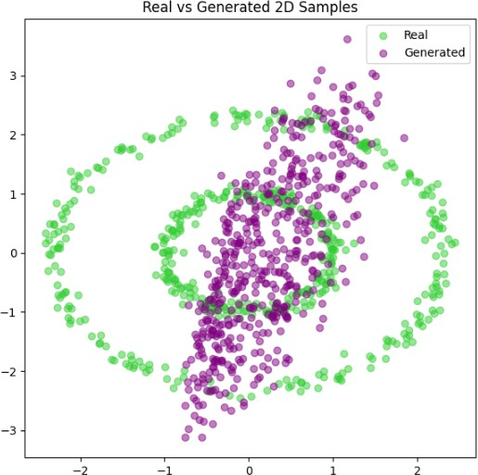

Figure 1: GAN learning on toy data (e.g., moons or rings): gree - real, purple - generated.

Discussion
This hands-on start made it much easier to diagnose problems and understand GANs’ ad- versarial learning. It was also satisfying to see the generator “discover” the right shapes, step by step.

Part 2: DCGAN for QuickDraw Smiley Faces

Overview and Approach
After building confidence with basic GANs, I moved to the QuickDraw dataset’s ’smiley face’ category, which contains thousands of hand-drawn 28x28 pixel images. The goal was to train a DCGAN to generate convincing smiley faces from random noise.

Why DCGAN?
DCGANs use convolutional layers, which are well-suited for images. They can capture spatial patterns (like eyes and mouths) much better than plain MLPs. I also chose DCGAN because it is a robust and widely adopted architecture for image synthesis, balancing quality and simplicity [?].

Method and Architecture Details
    - Generator: Upsamples a noise vector through transposed convolutions, using batch normalization and ReLU/LeakyReLU activations, outputting a 28 × 28 image.
    - Discriminator: Standard convolutional net that flattens and classifies images as real/fake.
    - Training: Used Adam optimizer, binary cross-entropy loss, and tracked generator/discriminator losses.

Data Exploration
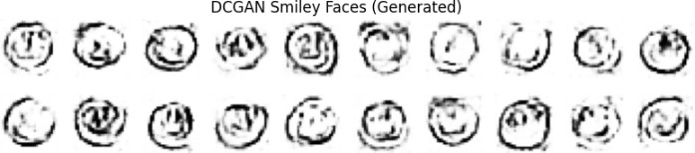

Figure 2: Sample real smiley faces from QuickDraw.

The dataset consists of simple, monochrome sketches. There’s some diversity in style, but most sketches are circles with two eyes and a mouth.

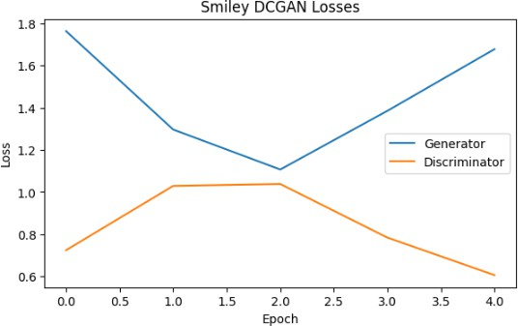

Figure 3: DCGAN generator and discriminator losses over epochs.
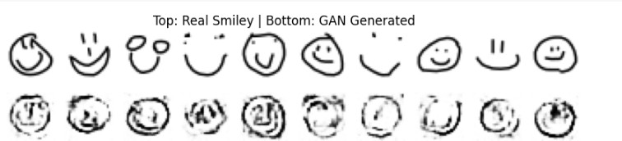

Figure 4: Top: Real; Bottom: DCGAN-generated smiley faces.

Results
The generator quickly learned to produce circular shapes and facial features. Some outputs looked almost human, while others remained abstract or blurry. The loss curves stabilized, which is a good sign of adversarial balance.

Reflections and Evaluation
    - Quality: The best fakes were hard to distinguish from real sketches. Some, however, lacked clear facial features.
    - Challenges: Occasional mode collapse (generator outputs nearly identical faces).
    - Possible Improvements: More training data, longer training.

Part 3: DCGAN for QuickDraw Horses (Extension)

Motivation
To push the limits of my GAN, I chose the ’horse’ category—a far more complex class than smiley faces. Horses in QuickDraw come in many poses and levels of abstraction, making this a tough test for standard DCGANs.

Data Exploration
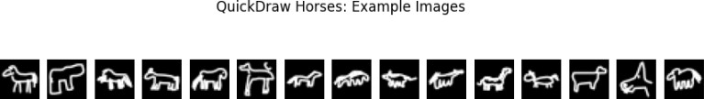

Figure 5: Example real horse sketches from QuickDraw.

As seen above, the sketches are extremely diverse—from stick figures to full-body horses with details.

Network Architecture Choices
Why this network? I adapted the DCGAN structure to cope with the increased complexity: more feature maps, deeper generator, and ELU activations for smoother gradients. I also tuned the learning rate and batch size based on visual feedback during training.

Training and Results
The DCGAN learned to generate the rough outline and pose of horses, but struggled with details (legs, heads, etc.) and sometimes produced surreal, abstract outputs. This isn’t surprising, as horses are much more complicated than faces for a DCGAN to learn.

Analysis and Inferences
    - Visual Quality: Some generated horses are surprisingly recognizable, while others are clearly synthetic.
    - Complexity: The jump in difficulty from smiley faces to horses is dramatic; DCGANs may need more data, time, or even architectural changes to do better.

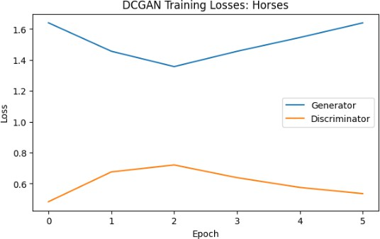

Figure 6: DCGAN loss curves for horses.
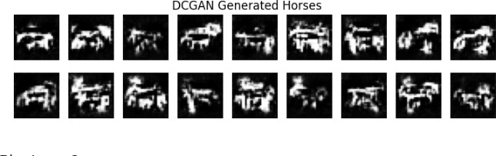
Figure 7: Top: Real; Bottom: DCGAN-generated horses.

    - Evaluation Metrics: While qualitative analysis is informative, quantitative metrics like FID or Inception Score (not included here due to time/complexity) would be valuable for larger projects.
    - Lessons Learned: GANs are not one-size-fits-all; complexity of the data must inform the model and training strategy.

References
- Radford, A., Metz, L., & Chintala, S. (2016). “Unsupervised Representation Learning
with Deep Convolutional Generative Adversarial Networks.” arXiv preprint arXiv:1511.06434.
https://arxiv.org/abs/1511.06434
- Goodfellow, I., Pouget-Abadie, J., Mirza, M., Xu, B., Warde-Farley, D., Ozair, S., Courville, A., & Bengio, Y. (2014). “Generative Adversarial Nets.” Advances in

Neural Information Processing Systems, 27.
- Google QuickDraw Dataset, https://github.com/googlecreativelab/quickdraw-dataset
- Other references as appropriate for background or extra metrics.

