**6 Tools to Change or Spoof Hard Disk Hardware Serial Number and Volume ID**

Some multiplayer games that implement the PunkBuster anti cheat system get cheaters off the server using hardware bans. It used to ban the hard disk serial number but no longer does that since there are ways to spoof and temporarily change the so-called hardcoded serial number. So now they’ve started to ban the CD-Key. Other than that, some licensing system also uses the hard disk serial number to generate a unique hardware ID which is then used to generate an external license file to activate the software.

A simple way to find your current hard disk volume serial number is to open a command prompt (Win key+R and type cmd) and then type **dir**. The second line shows your volume serial number for the system C partition. Type dir [driveletter:] and it will show a different serial number even if the volume is on the same physical hard drive. The volume serial number changes every time you format the partition and Windows also uses this value during activation so you can’t simply move your install from one partition to another. If your Windows has been activated using a product key from a sticker it will probably ask for the key again after a reboot and will need reactivating if you change the volume serial number on the system drive.  
Read More: <https://www.raymond.cc/blog/changing-or-spoofing-hard-disk-hardware-serial-number-and-volume-id/>

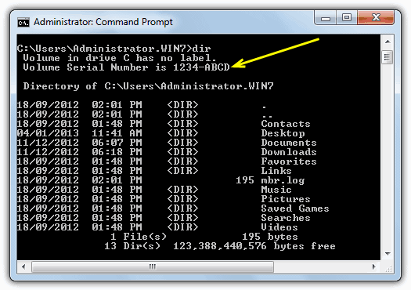

If you do a simple search in Google, you’ll find tons of information about to change your hard disk volume serial number, but not the real hard disk serial number that is hard coded into the hardware. Some people said that it is impossible to change it, but we will show you that there are ways to change both volume and hard coded serial numbers for your hard disk.

1. **Hard Disk Serial Number Changer**

There are a few free tools around capable of changing the volume serial number and one of them is called **Hard Disk Serial Number Changer**. The name is a bit misleading though as it doesn’t actually change the hard disk serial number but the volume serial number which is different. It works on just about any Windows operating system from 98 onward and is a standalone portable executable but does need to be run as administrator on Vista and 7.

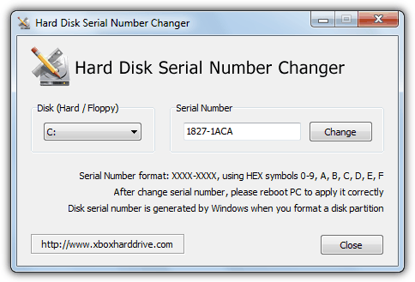

Usage is pretty straightforward and you simply choose your drive from the drop down box, enter the new serial number and click the Change button. Do note the serial number format as mentioned in the window is made up of 8 hex characters from 0-9 and A-F split by a “-” into two groups of 4. You will then need to reboot to commit the changes.

[**Download Hard Disk Serial Number Changer**](https://www.raymond.cc/blog/download/did/1095/)

2. **VolumeID**

Another useful tool to change the volume serial number is by Sysinternals called **VolumeID**. This tool is only usable from the command line so won’t be as quick and easy to use for some people as Hard Disk Serial Number Changer. The command line usage to change the ID of a drive volume/partition is:

**volumeid [driveletter:] xxxx-xxxx**

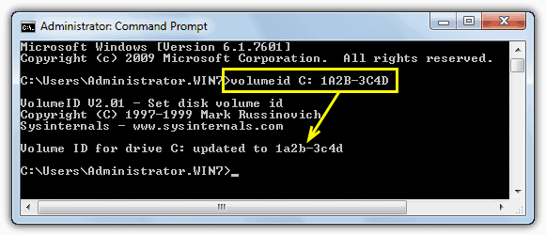

The format is again 4 hex characters, a “-” followed by another 4 hex characters. You should shut down all your running applications before using this tool and will need to reboot immediately after the changes if they are being made on an NTFS partition.

[**Download Sysinternals VolumeID**](https://www.raymond.cc/blog/download/did/1096/)

The tools above are fine for changing the serial number of a volume/partition but trying to change the serial number of the actual hard drive itself is a whole different story. These are hard coded into the hard drive itself and cannot simply be edited or altered using a piece of software. There are however, several tools around that can spoof the hard drive’s built in serial number temporarily which can hopefully fool whatever software you are trying to get round. Unfortunately a lot of these tools aren’t free and some are even approaching $100 to buy.

3. **PB DownForce**

There is a free tool that’s been around for quite a while called PB DownForce which is able to temporarily spoof your hard drive’s static serial number into a different random or seeded number. There is also an option to set your own predefined serial number although we were unable to get that function to work during testing. To use the program in it’s simplest form, all you have to do is start it up and click on the Start spoofing button. Make sure to run PB DownForce as administrator.

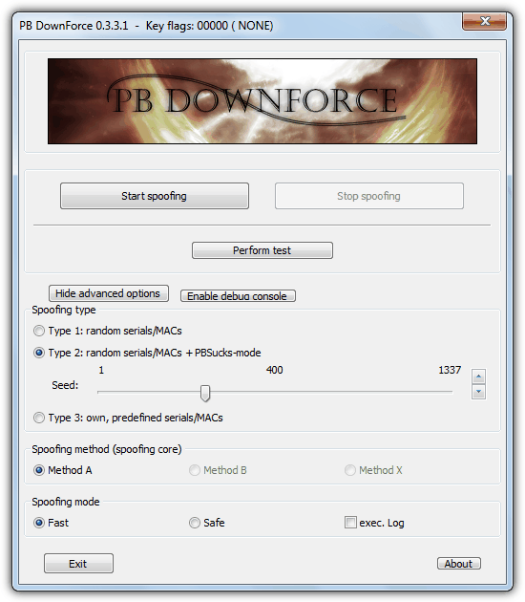

The Advanced options button shows the 3 different types of spoofing to choose, although as mentioned we couldn’t get method 3 to work as intended and it just showed a serial full of a single number. You can easily use the Stop Spoofing button and try another random number. Perform test will quickly tell what drive model name and serial has been given. The image below shows a new serial after using PB DownForce to change a hard disk serial number in the [PC Wizard](https://www.raymond.cc/blog/download/did/434/) hardware information tool. Do note that some tools such as [Speccy](https://www.raymond.cc/blog/download/did/413/) will still show the original serial number for the drive because they gather their data in another way, [HWInfo](https://www.raymond.cc/blog/download/did/433/) does something different again and will show the spoofed drive as another completely new hard drive in its list.

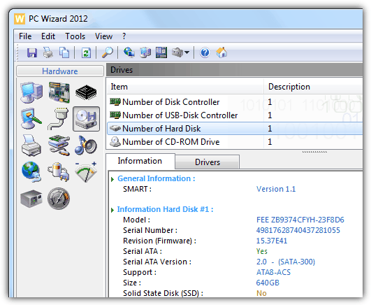

PB DownForce was tested and worked on Windows XP and Windows 7 32-bit although it still was quite random to which machines worked and which showed no change or produced an error. 64-bit Windows is not supported in any free hard drive spoofing tools we came across. The spoofed serial will return to normal after a reboot.

[**Download PB DownForce**](https://www.raymond.cc/blog/download/did/1092/)

There are several more hard disk serial number Spoofing tools on page 2.  
Read More: <https://www.raymond.cc/blog/changing-or-spoofing-hard-disk-hardware-serial-number-and-volume-id/>

4. **Hardware Spoofer**

HWSpoofer was tested and is only compatible with Windows 2000/XP but works along the same lines as PB DownForce in spoofing the hard disk’s serial number. The program has no interface and you simply execute it to patch the system, an ini file will be created in the same folder with the spoofing details.

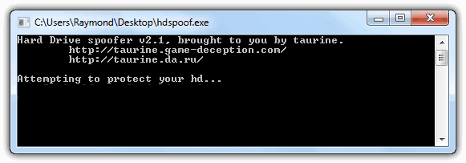

If you want to change the spoofed serial number, simply delete the ini file to generate another set of numbers. To run HWSpoofer again you will need to reboot the the system as blue screens or crashes are likely to follow if you try to run it again. Like PB Downforce, HWSpoofer will also try to spoof your network adapters MAC address.

[**Download Hardware Spoofer**](https://www.raymond.cc/blog/download/did/1093/)

5. **Object Tree**

This tool does something a little bit different and actually hides your drives and optionally network adapters completely instead of trying to spoof the serial number. Open the program and Expand [ROOT] -> GLOBAL??, select PhysicalDrive0 and then click Hide. Alternatively, you can click on the File menu -> “Hide all PB related symbolic links”. To get the drives back again, select Unhide all entries from the File menu.

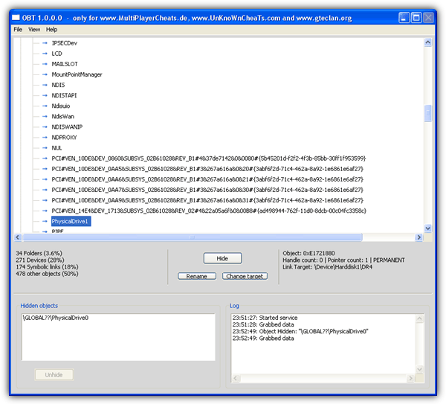

[**Download Object Tree**](https://www.raymond.cc/blog/download/did/1094/)

6. **Chameleon**

As most of the tools mentioned above are not really made for newer Windows operating systems, Chameleon is probably the only hardware ID spoofing tool that can run on Windows 7 and Windows 8. Chameleon runs in kernel mode (Ring 0) to change the hard-coded serial number on hard drives and also the MAC address on network adapters. Currently it is limited to 32-bit version of Windows but 64-bit support will be released later this year.

The process of getting Chameleon to run can be a bit long. After purchase, you need to create a forum account and upgrade it to VIP from the provided web control panel. Then download the software, extract and run the Loader as administrator which will automatically generate a hardware information text file. Go back to the control panel, go to Update HardwareID and enter all 5 information from the hardware information text file. You will instantly receive a license.dat file to be placed at the same folder as the Loader file. Now you’ll need to rename the Loader.exe to any other file name, such as raymond.exe and then run it as admin.

A Setup.ini file will be generated and saved in the program’s folder. Open Setup.ini file with a text editor such as Notepad, and change the NULL to any spoofed serial number that you want with the exact same length as the originals.

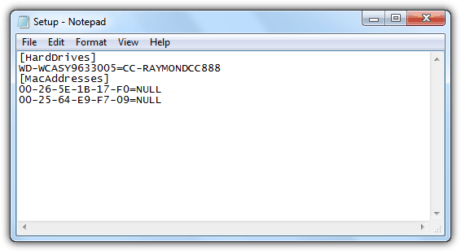

Save the changes made in Setup.ini and run the software again. You will need to wait for a while until you see a window telling you that “Chameleon has been loaded successfully”, which means that your hard drive serial number has been successfully changed.

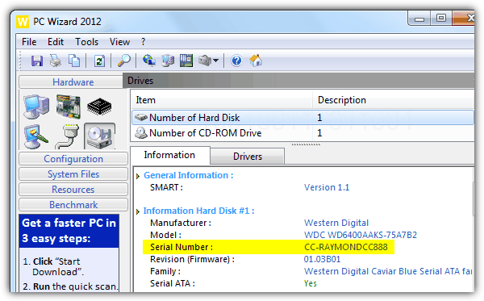

ORGANNER, the company that develops Chameleon promises that the upcoming version 2 will be easier to manage from the web panel. Chameleon cost €69.95 for a lifetime license with 2 hardware ID changes.

[**Download Chameleon**](https://www.raymond.cc/blog/download/did/1097/)

***Special Note:*** Do be aware that because of the nature of these tools they hook Windows functions at a very low level (ring0) and do [behave rather like rootkits](https://www.raymond.cc/blog/10-antirootkits-tested-to-detect-and-remove-a-hidden-rootkit/) in the eyes of security software. Your Antivirus program will definitely complain that PB Downforce and HWSpoofer are trojans so you will have to either allow them in your Antivirus or turn it off temporarily while using these tools.  
Read More: <https://www.raymond.cc/blog/changing-or-spoofing-hard-disk-hardware-serial-number-and-volume-id/2/>