Hello, today I am going to show you how to crack passwords using a Kali Linux tools.  
Remember, almost all my tutorials are based on Kali Linux so be sure to install it.  
I am going to show you these :  
**1. Cracking Linux User Password**  
**2.Cracking Password Protected ZIP/RAR Files**  
**3.Decrypting MD5 Hash**  
**4.Using Wordlists To Crack Passwords**  
Lets begin.

Cracking Linux User Password

The linux user password is saved in /etc/shadow folder.  
So to crack it, we simply type :

john /etc/shadow

It will take a while depending on your system.

[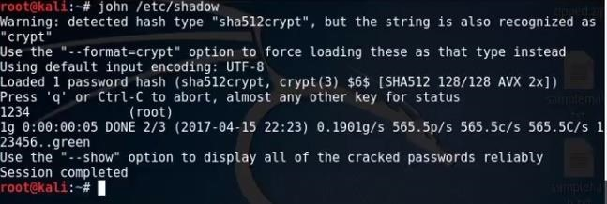](https://img.wonderhowto.com/img/original/13/66/63647565251018/0/636475652510181366.jpg)

Cracking Password Protected ZIP/RAR Files

First, go to the directory of the file.  
I will assume that everyone here can do that.  
After, use this command :

zip2john zipfile > output.txt

(If it is a RAR file, replace the zip in the front to rar.)

Replace the "zipfile" with the name of the zip file you are trying to crack and replace the "output.txt" with any name that is a .txt format.

After that command, you will see that it would have maked a text file.  
The hashes are stored in that file.  
To crack the hash, type :

john --format=zip hashfilepath

Again, replace the "hashfilepath" to yours. Mine is just an example.  
Now, wait, and you can see it is cracked.

[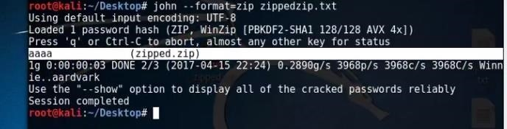](https://img.wonderhowto.com/img/original/83/85/63647566200084/0/636475662000848385.jpg)

Now go in the zip file and put the password.

Decrypting MD5 Hash

I have my Hash over here :

[](https://img.wonderhowto.com/img/original/03/14/63647566548288/0/636475665482880314.jpg)

Now, lets use john to decrypt it.  
To decrypt it, use this :

john --format=raw-md5 hashfilepath

Again, repl......  
I won't say it.  
And now enter, and should take a while and it will decrypt it.

[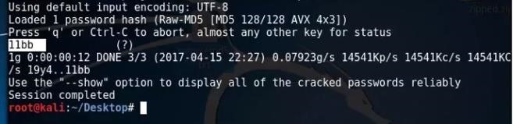](https://img.wonderhowto.com/img/original/75/47/63647566751928/0/636475667519287547.jpg)

And boom.

Using Wordlists to Crack Passwords

I don't really recommend this one, but there are some peoples out there using this to crack...  
I will crack a hash that is inside a text file.  
I have a wordlist here, and I named it password.txt.  
To use the wordlist and crack the file, do :

john --format=raw-shal --wordlist password.txt THEHASHFILE.txt

You know what you gotta do.

Any Errors?

If you got any errors, comment down and I will try to help you out.  
Remember that you need john the ripper to do this.