This is a very frequently asked question, and the complete answer is following steps

1- Open "**Windows Defender Firewall with Advanced Security**" , To open just type Windows Firewall in Search or control panel. [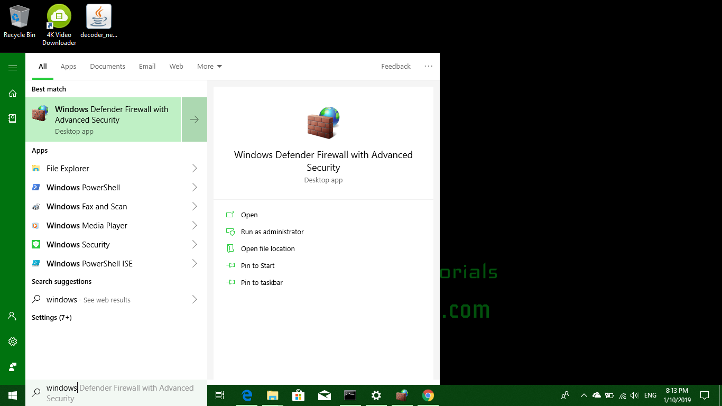](https://i.stack.imgur.com/6j0N3.png)

2- Now in the Left Pane the Top Option says - "**Windows Defender Firewall with Advanced Security on Local Computer**" Right click on that and go to **Properties**. [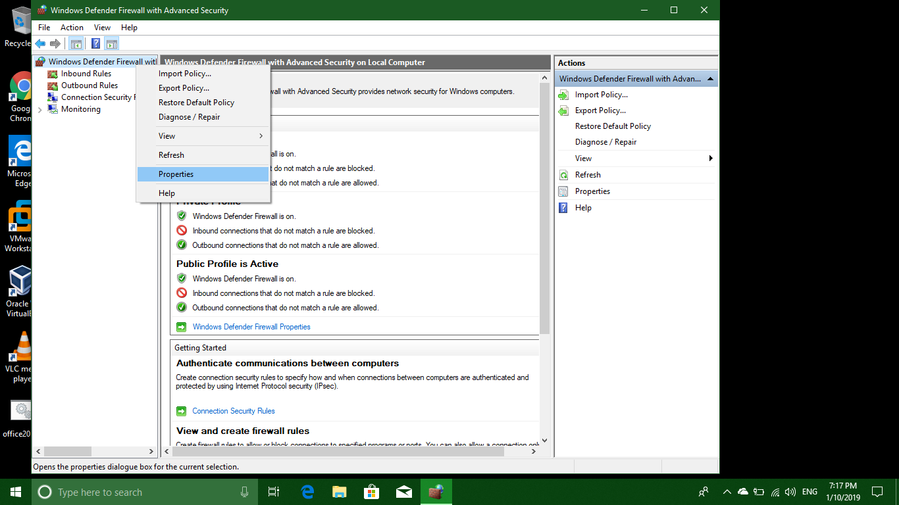](https://i.stack.imgur.com/fsgrw.png)

3- Now in Properties "**Block Outbound Connections**" for Each Profile - **Domain Profile, Public Profile, Private Profile** or if any other you have, Click Apply/OK. [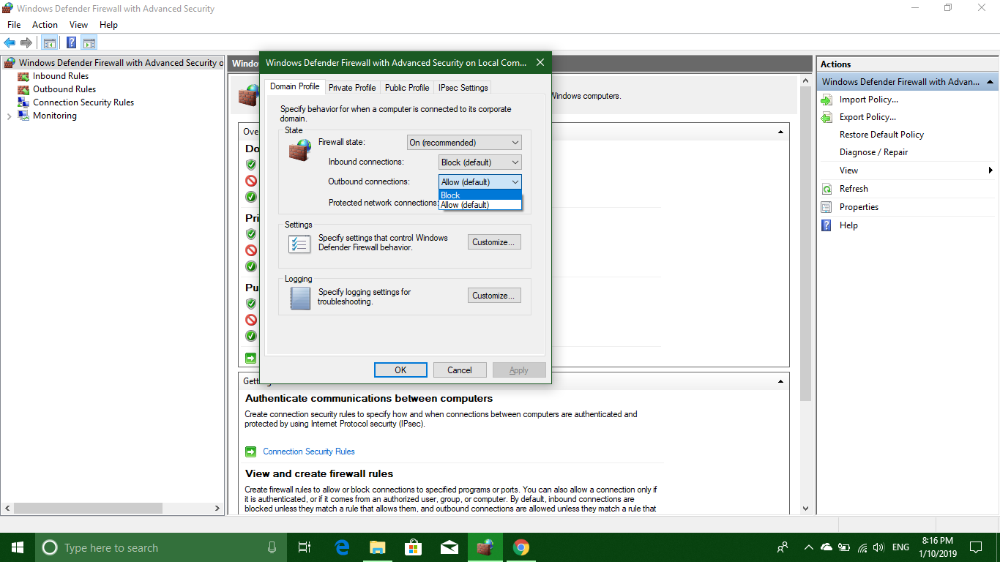](https://i.stack.imgur.com/N1lDg.png)

4- Now go To **Inbound Rules and Outbound Rules Both** one by one, click on any rule and now Press **CTRL+A to select All rules**, from the extreme right Pane somewhere in the lower section click **Disable Rule**. This will **Disable all rules**. [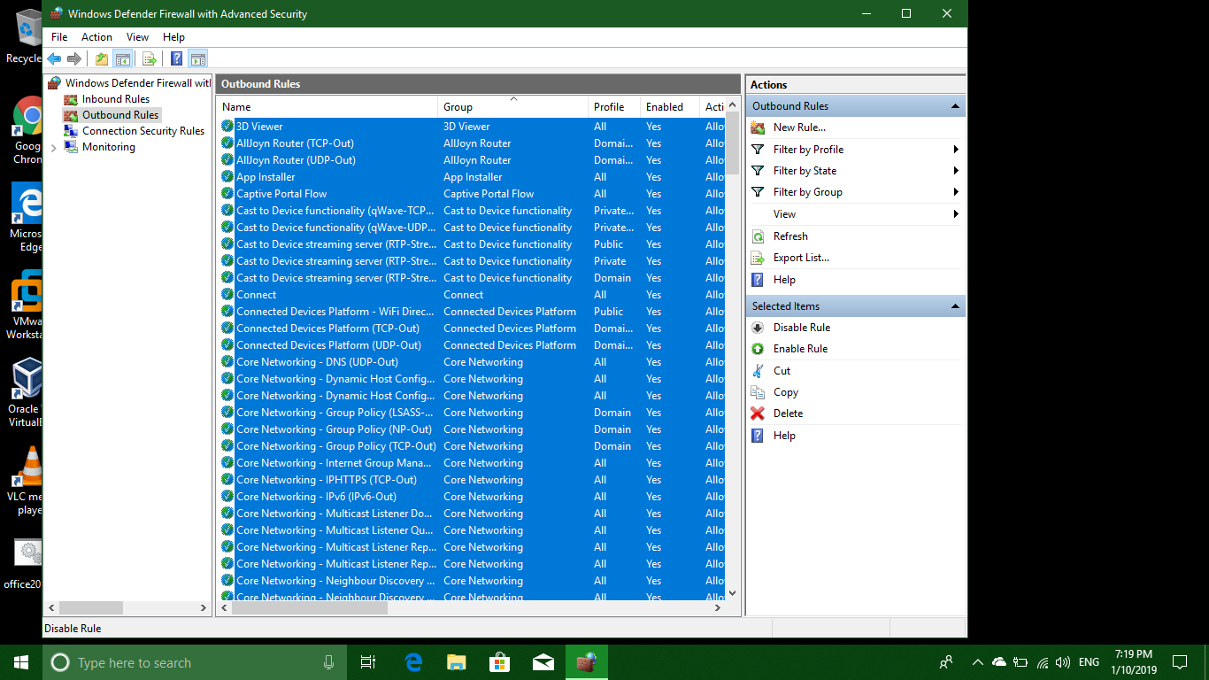](https://i.stack.imgur.com/tZPDT.png)

5- Add a rule in **Outbound Rules, Create New Rule** from Right Pane, Select a Program, which will be your browser [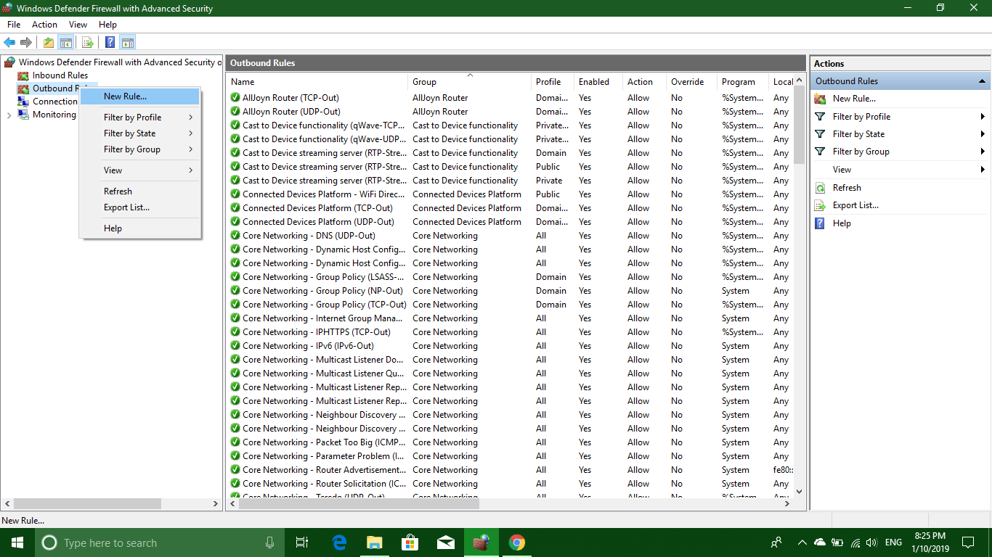](https://i.stack.imgur.com/df1pm.png) [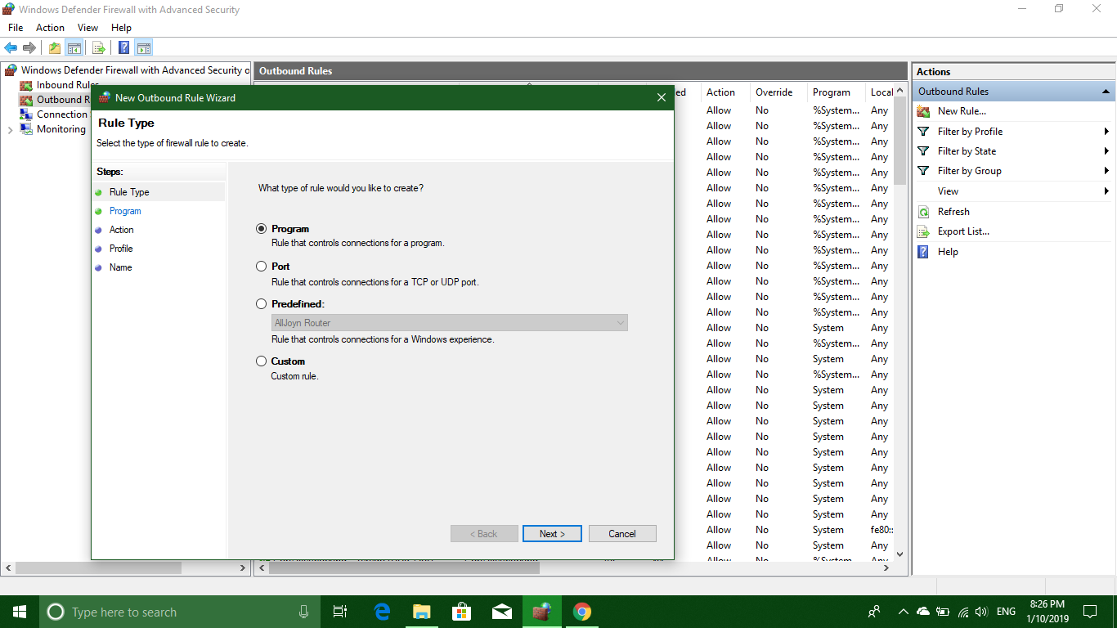](https://i.stack.imgur.com/GfmMQ.png) [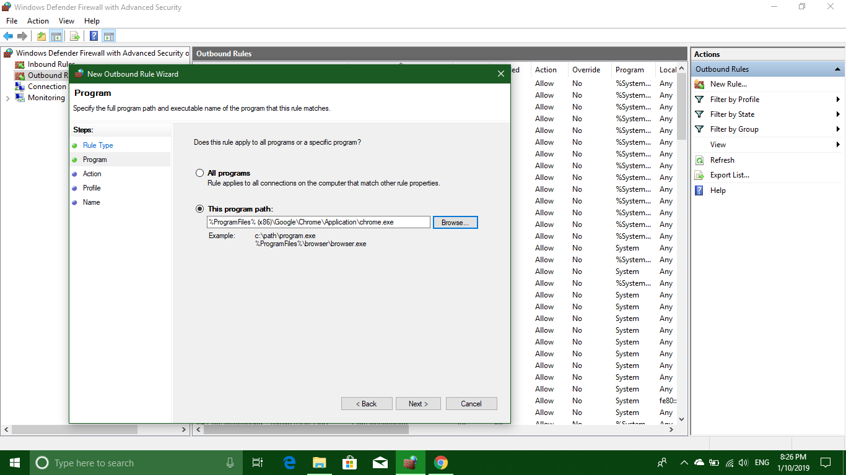](https://i.stack.imgur.com/MNama.png) [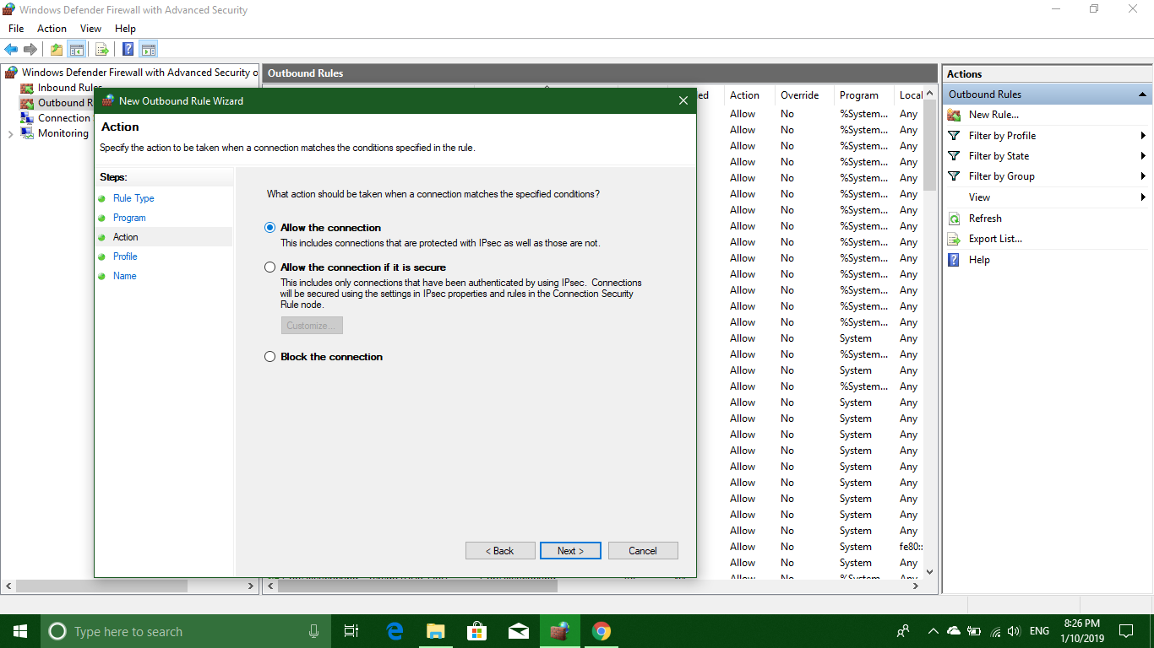](https://i.stack.imgur.com/R7zyl.png)

In many case you can also block it in inbound to stop a program to connect itself ( usually used for patches /activators) [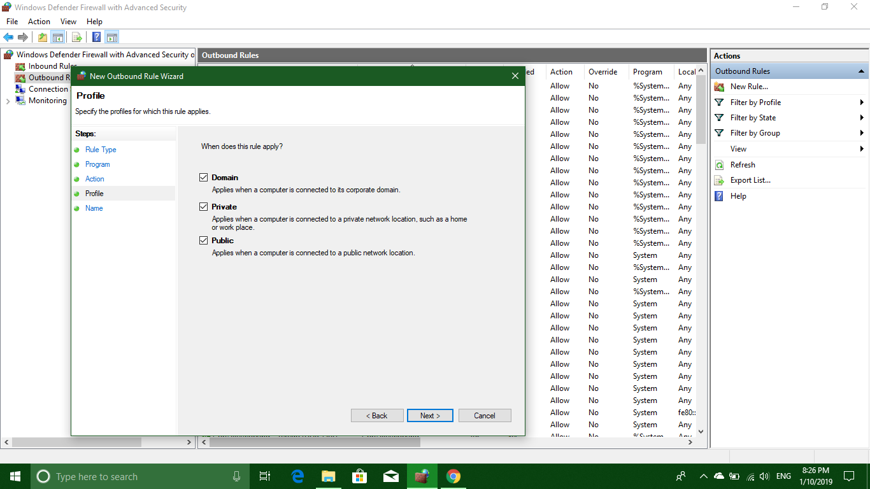](https://i.stack.imgur.com/dntZo.png) [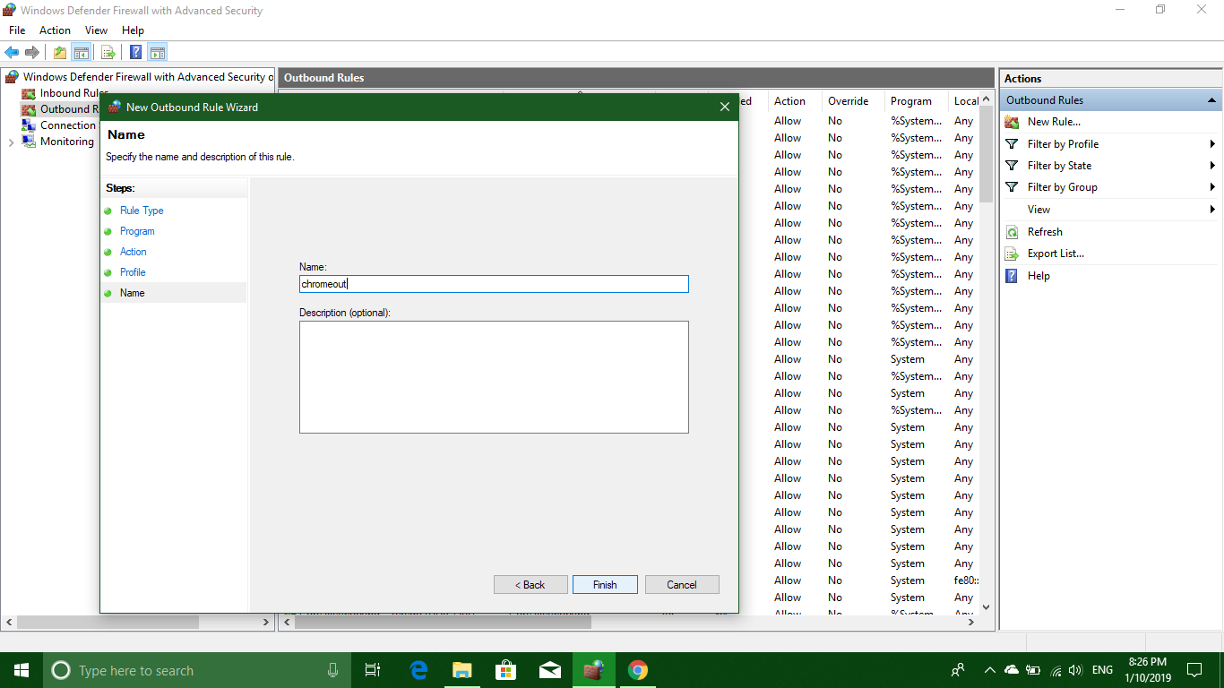](https://i.stack.imgur.com/z80vB.png)

6- Now your computer is almost blocking every connection which means even chrome cannot connect at this point because even networking services are blocked.

7- So in final step, again right click on Outbound rules and Inbound Rule one by one both, in Left Pane, and **Select "Filter by Group" --> "Filter by Core Networking"**[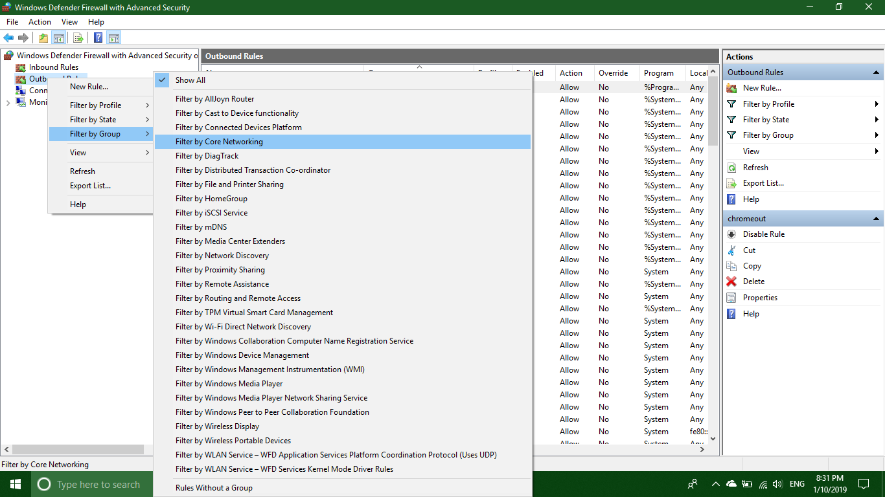](https://i.stack.imgur.com/BXmUB.png)

8- Now in Right Pane for both rule type Filters, **Enable All the Rules** like step 3, select all and from right pane enable rule.

DONE - Now only program of you choice can communicate, even the chrome cannot update itself as inbound for chrome is disabled. TWEAK the RULES accordingly.