**Intro**

The BeagleBone Black (AKA BBB) is a small, 1GHz ARM Cortex-A8 computer with a powerful NEON accelerator, many pin-outs (65!) and great power handling. In this HOWTO we’re going to use it as the core of a cellular base-station that can interact with mobile phones/handsets; manage calls between handsets, interface between handsets and SIP, sending SMSs, etc.

Why the BBB and not a Raspberry Pi? While lacking the graphical processing power of the R-Pi, the BBB is significantly faster and as such better suited to high-I/O applications like (small-footprint) cellular infrastructure. More so, unlike the R-Pi, the BBB has 4Gb of on-board storage, doing away with the need for an SD Card to boot. This makes the cost of getting setup with a BBB more or less the same as that of a R-Pi but with notably better overall performance (for most applications).

A BBB can be powered from standard 5v DC or with Mini-USB. The advantage of the latter is that during development a USB Ethernet interface can also be created, allowing command-line users a convenient way of working with the board - you get both power and network connectivity over a single USB cable.

[[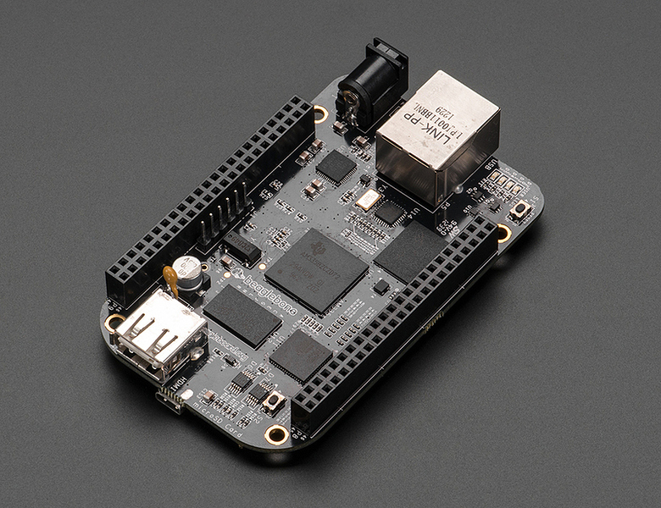](https://discourse.criticalengineering.org/uploads/default/44/4161d77013d161d0.jpg)](https://discourse.criticalengineering.org/uploads/default/44/4161d77013d161d0.jpg" \o "BeagleBone_Black_800.jpg)

**[BeagleBone\_Black\_800.jpg800×615 419 KB](https://discourse.criticalengineering.org/uploads/default/44/4161d77013d161d0.jpg" \o "BeagleBone_Black_800.jpg)**

For an example of using a DIY BTS in a Critical Engineering context, see [PRISM: The Beacon Frame 429](http://criticalengineering.org/projects/prism-the-beacon-frame/).  
For code relating to that project, see [Documentation of GSM spoofing strategy used at Transmediale, 2014 477](http://julianoliver.com/output/log_2014-02-13_17-17).

**Pre-requisites**

This HOWTO assumes certain pre-requisites are taken care of.

* Linux or OS X laptop (this HOWTO assumes the former)
* [BeagleBone black 729](http://beagleboard.org/Products/BeagleBone+Black)
* 4Gb (or more) MicroSD card (for installation only)
* Micro-SDcard sleeve and SDCard reader
* UHD capable Ettus [USRP 2.5k](http://ettus.com/) or [RTL SDR 1.9k](http://rtlsdr.org/) solution (this HOWTO assumes the former - yes they’re expensive)
* GSM antenna fitted to TRX mount of USRP
* Wired Internet connection (for BeagleBone)
* Basic knowledge of the UNIX command line (we’ll work headless).
* More than a little patience

**Flash Debian Wheezy 7 on eMMC**

First you need a 4Gb or more MicroSD card. Stick it into your laptop, open up a terminal and type *dmesg*. Look for “mmcblk” in the output and note it down.

In my case I see:

[25633.985447] mmc0: new SDHC card at address b368  
[25633.985738] mmcblk0: mmc0:b368 USD 3.75 GiB  
[25633.987178] mmcblk0: p1 p2

For this reason I will choose ***mmcblk0*** as the device representing the MicroSD card.

Now download the Debian image that we’ll use to flash onto the card. Now *cd* into a familiar place on your operating system (like /home/you/Desktop) and:

wget -c [https://rcn-ee.net/rootfs/2015-02-19/flasher/BBB-eMMC-flasher-debian-7.8-console-armhf-2015-02-19-2gb.img.xz 148](https://rcn-ee.net/rootfs/2015-02-19/flasher/BBB-eMMC-flasher-debian-7.8-console-armhf-2015-02-19-2gb.img.xz)

Verify the image:

md5sum BBB-eMMC-flasher-debian-7.8-console-armhf-2015-02-19-2gb.img.xz  
adbfa79c6748f47e81dd233f06d98b49 BBB-eMMC-flasher-debian-7.8-console-armhf-2015-02-19-2gb.img.xz

Now we can *dd* it onto the MicroSD (note that I use ***mmcblk0*** **- yours may differ!**):

unxz BBB-eMMC-flasher-debian-7.8-console-armhf-2015-02-19-2gb.img.xz  
sudo dd if=./BBB-eMMC-flasher-debian-7.8-console-armhf-2015-02-19-2gb.img of=/dev/mmcblk0

When done take it out of the laptop and plug it into the **unpowered** BBB. Plug in an ethernet cable connected to your Internet gateway. I like to have both laptop and ethernet cable on a switch for this next part.

Find a mini-USB to USB cable. Plug the USB end into your laptop.

Now hold down the “Power” button and plug in the mini-USB end of the cable into the BBB, supplying power. Wait for the LEDs to start flashing and release. After a short while you’ll see a LED pulse go from left to right and back again. This indicate the Debian image is being flashed to the eMMC. It will take around 10 minutes and then stop flashing, with all 4 LEDs on and static. This indicates success.

Now remove the Mini-USB cable from the BBB, **take out the MicoSD card** and plug the Mini-USB jack back into the BBB.

Above information resourced from [here 89](http://elinux.org/Beagleboard:Debian_On_BeagleBone_Black#Main_Process).

**Configure network between BBB and laptop**

Type *ifconfig -a* on your laptop and you should note a new Ethernet device. In my case it’s labelled ***eth5***. This is an Ethernet over USB device that you can use to connect directly with your BBB.

Ask for a lease from the BBB:

sudo dhcilent eth5 # change “eth5” to whatever you have on your system

Type:

ifconfig eth5

Note the IP you were given. In my case it is always ***192.168.7.1***. Now test to see if you can ping the BBB:

ping 192.168.7.2

Now *ssh* into the BBB:

ssh [debian@192.168.7.2](mailto:debian@192.168.7.2)

Use debian:temppwd for username and password.

You should now be logged into the BBB and able to start updating.

First, check you are online with the BBB with a simple *ping*[*criticalengineering.org 2*](http://criticalengineering.org/). It should’ve been granted an IP by your DHCP server on boot. If not, ask for a new lease.

**Change password**

passwd

**Upgrade Linux kernel on BBB**

Click on [this link on your laptop 143](https://rcn-ee.net/deb/wheezy-armhf/) and find the latest stable (non-rc) kernel for the BBB. In my case it is ***v3.15.2-bone2***. Right-click on the link for the file “install-me.sh” and copy it to the buffer.

Now **on the BBB** (not on the laptop) download the file using *wget*, pasting the link you saved above into your terminal (note my URL may differ from yours):

wget -c [https://rcn-ee.net/deb/wheezy-armhf/v3.15.2-bone2/install-me.sh 101](https://rcn-ee.net/deb/wheezy-armhf/v3.15.2-bone2/install-me.sh)

Make it executable:

chmod +x install.sh

Run it:

sudo ./install.sh

When done, you’ll be asked to reboot the board. Once it’s booted, log in again and type *uname -r*. It should report you have a new kernel version.

**Install software**

Update software database:

sudo apt-get update

Install software:

sudo apt-get install vim bash-completion libboost-date-time-dev libboost-filesystem-dev libboost-program-options-dev libboost-regex-dev libboost-system-dev libboost-thread-dev libboost-test-dev subversion git build-essential cmake python-dev autoconf libtool libosip2-dev libusb-dev sqlite3 libsqlite3-dev libreadline6-dev libncurses5-dev localepurge python-cheetah php5 php5-cgi libapache2-mod-php5 libusb-1.0.0-dev libortp-dev

Once installed, type the following to clear out all the downloaded packages from the cache, recovering precious disk space:

sudo apt-get clean

**Add extra storage**

Now plug in a blank USB stick (or another blank MicroSD card) with more than 2Gb of storage into the BBB. This we’ll use to host the *OpenBTS*, *OSMO-TRX* and *UHD* code repositories.

Type *dmesg* and note the device in the output. In my case, an 8Gb USB stick appears as ***/dev/sda1***:

As the user ***debian***, create a mount point called ***src*** in the home directory of the BBB:

mkdir ~/src

Now we mount it, in such a way that our user, ***debian***, can write to the mount point:

sudo mount /dev/sda1 ~/src -o uid=1000,gid=1000 # note that it may not be ***/dev/sda1*** on your system!

**Compile and install *UHD*, our interface between the BBB and USRP**

UHD is the driver from Ettus Research that we need to talk to our USRP

git clone git://github.com/EttusResearch/uhd.git

*cd* in and create a ***build*** directory:

cd ~/src/uhd/host  
mkdir build  
cd build

I have the B200 USRP. If you have an E100 or other USRP, note that you’ll need to change the value for ***-DENABLE\_B200*** (below) to match your setup there. Available options are: *USRP1, USRP2, B100, X300, B200*.

The below command will build UHD for a USRP B200 (and thus B210), omitting documentation and manpages to preserve eMMC storage space.

cmake …/ -DENABLE\_MANUAL=OFF -DENABLE\_DOXYGEN=OFF -DENABLE\_MAN\_PAGES=OFF -DENABLE\_B200=ON -DENABLE\_USB=ON

Assume all went well, start compiling:

make && sudo make install

Now go and do something entirely unrelated and come back in an hour. Hopefully you’re greeted by sudo asking you for a password needed for install.

Now let’s download the latest firmware using a Python script installed in the last step.

sudo /usr/local/lib/uhd/utils/uhd\_images\_downloader.py

**Compile and install *osmo-trx*, an ARM-friendly GSM transceiver**

The Transceiver52M that ships with OpenBTS is unusable on the BBB. For this reason we’ll install an alternative transceiver called [osmo-trx 260](http://openbsc.osmocom.org/trac/wiki/OsmoTRX), written by the fine folks at [OSMO-COM 123](http://osmocom.org/).  
Fetch and build osmo-trx

cd ~/src  
git clone git://git.osmocom.org/osmo-trx

It’s very important we compile osmo-trx using the **–with-neon** option.

cd osmo-trx  
autoreconf -i  
./configure --with-neon  
make  
sudo make install

**Check out OpenBTS and compile**

OpenBTS is the software that provides us with the software part of a cellular station. It allows us to control the transceiver, manipulate our cell station, interface with SIP (for calls and SMS) and all sorts of other things. Importantly we won’t install the OpenBTS applications that are built in the process, rather choosing to place them in a folder in ***/home/debian/bin***.

Ensure you’re in the ***/home/debian/src*** directory.

Check out OpenBTS with *subversion*:

svn co [http://wush.net/svn/range/software/public 200](http://wush.net/svn/range/software/public) openbts #save as openbts

We need to compile and install a53 first:

cd openbts/a53/trunk  
sudo make install

We need to edit a Makefile to represent the correct architecture. While the rest of OpenBTS is fine, the Transceiver component (which we actually replace with *osmo-trx*) is not. I didn’t find a convenient way or disable the ***Transceiver52M*** component. It was easier/faster just to make this one small change to finish the compile:

In the file ***~/src/openbts/openbts/trunk/Transceiver52M/Makefile.in***, change the line that reads:

AM\_CFLAGS = $(STD\_DEFINES\_AND\_INCLUDES) -std=gnu99 -march=native

To:

AM\_CFLAGS = $(STD\_DEFINES\_AND\_INCLUDES) -std=gnu99 -march=armv7-a

Now move into the OpenBTS trunk and get building:

cd ~/src/openbts/openbts/trunk  
autoreconf -i  
./configure --with-uhd  
make

Now go and learn an endangered natural language, take up horse-back archery or go to Micronesia in search of a rare, carnivorous and aquatic snail. On your return OpenBTS may have compiled.

Original OpenBTS installation notes are [here 91](http://wush.net/trac/rangepublic/wiki/BuildInstallRun).

**Setup the OpenBTS sqlite3 database**

This db holds the runtime configuration of OpenBTS:

sudo mkdir /etc/OpenBTS  
sudo sqlite3 -init ./apps/OpenBTS.example.sql /etc/OpenBTS/OpenBTS.db “.quit”

**Compile *sipauthserve*, for cellular subscriber registration**

sudo mkdir -p /var/lib/asterisk/sqlite3dir  
cd ~/src/openbts/subscriberRegistry/trunk  
make

Copy over a database for sipauthserve to work with:

sudo sqlite3 -init subscriberRegistry.example.sql /etc/OpenBTS/sipauthserve.db “.quit”

**Compile *smqueue*, our message manager**

Smqueue stores and forwards messages received and sent by OpenBTS in a delay-tolerant way

cd ~/src/openbts/smqueue/trunk/  
autoreconf -i  
./configure  
make

Smqueue needs a database for messages in and out of the system:

sudo sqlite3 -init smqueue/smqueue.example.sql /etc/OpenBTS/smqueue.db “.quit”

**Copy compiled binaries to ~/bin folder**

Now we’ll now put our freshly compiled OpenBTS applications into a convenient folder:

mkdir ~/bin # probably already exists  
cp ~/src/openbts/smqueue/trunk/smqueue ~/bin/  
cp ~/src/openbts/subscriberRegistry/trunk/sipauthserve ~/bin  
cp ~/src/openbts/openbts/trunk/apps/{OpenBTS,OpenBTSCLI} ~/bin/

You can now unmount the storage device you used to hold the source code we compiled and remove it from the BBB. We don’t need it anymore.

**Test the BTS**

Now plug in your USRP. You may need to power the BBB from DC as USB power will likely not be enough to drive something like a B200!

Start *osmo-trx* with the *filler table* option “Enable C0 filler table”. This enables OpenBTS style idle bursts and retransmissions.

sudo osmo-trx -f

Wait for it to report that the transceiver is up and running. Once it is, SSH in with another terminal and type the following:

cd ~/bin  
sudo ./smqueue &  
sudo ./sipauthserve &  
sudo ./OpenBTS &

Wait for *OpenBTS* to report that it’s running. You should see something like:

system ready  
use the OpenBTSCLI utility to access CLI

Take out your phone and search for networks. You should see a ***00101*** network. Now start the *OpenBTSCLI*:

sudo ./OpenBTSCLI

Type ‘help’ to see available commands. Interesting commands to immediately familiarise yourself with are:

config <-- dump or set the configuration of your BTS  
tmsis <-- list IMSIs attached to your BTS  
rxgain <-- list or set the gain, in dBm, of your BTS  
sendsms <-- send an SMS to an IMSI

For instance, to allow for automatic registration, use the following command (warning, your neighbours may connect automatically!):

config Control.LUR.OpenRegistration .\*

To set the MNC of the BTS to 07 and the MCC to 262 (Germany) on channel 85, you would:

config GSM.Identity.MNC 07  
config GSM.Identity.MCC 262  
config GSM.Radio.C0 85

**Next steps**

A natural next step would be to install [Asterisk 291](http://www.asterisk.org/), turning your BTS into a fully functional PBX or communications server. That way people can make calls through your BTS and onto other SIP addresses on the Internet from their phone.

Another would be to write shell-scripts to automate the start up process. I like to write scripts that are started in ***/etc/rc.local*** and poll *ps* intermittently to ensure *OpenBTS* and/or *osmo-trx* are still running.

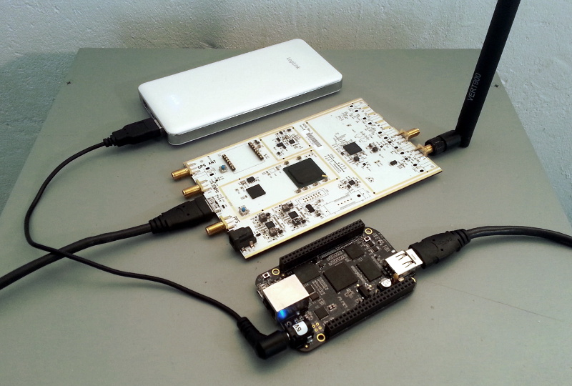

Our finished ‘BoneTS’: BeagleBone Black with 12000mAh 5V Battery, USRP B200 and Vert900 Antenna.