In this tutorial, we will learn about how to create an Entity Class, or in simple terms, we can say that how to generate Java Entity Class from the existing database tables.

[**Generate**](https://docs.oracle.com/javaee/6/tutorial/doc/bnbqa.html)**Entity Class**

This is very useful when developers or [programmers](https://codezup.com/top-ways-habits-steps-to-become-a-good-programmer/)want to finish their tasks early and they have urgent deliveries and they want to meet deadlines.

So, in this tutorial, we can see step by step how to generate Javaentities if the database design is ready.

We are using the MySQL database in this tutorial but you can use another database as well as per your requirement.

First, we go to the MySQL database and create a new database and inside that database, we have to create a new table.

Below is the database scripts for creating a new database and a new table:

create database tablerelationship;

show databases;

create table author (author_id int not null auto_increment,name varchar(20) not null, email varchar(50) not null,primary key (author_id));

create table book (book_id int,title varchar(20),book_description varchar(30),author_id int,primary key (book_id), constraint foreign key (author_id) references author (author_id));

show tables;

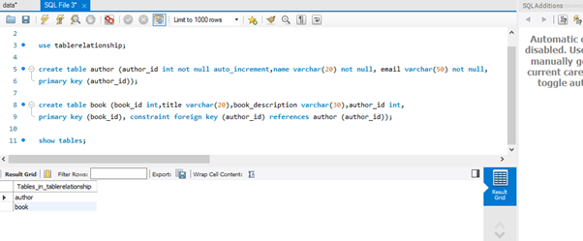

Now we are going to insert data into these tables. So below is the script for the same.

insert into author values (1,'James Gosling','james@java.com');

insert into author values(2,'Guido van Rossum','van@python.com');

insert into book values (101,'Java Book','OOPS CONCEPT',1);insert into book values (102,'Python Book','Dictionary In Python',2);

select * from author;

select * from book;

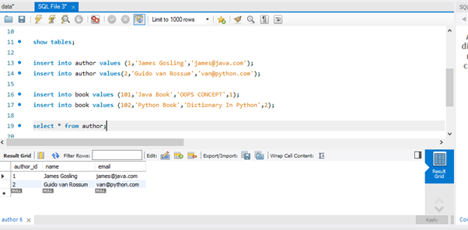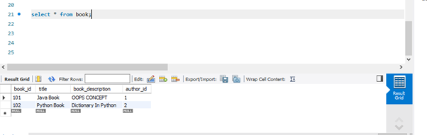

Now we are done with all the steps that are necessary to do at the database level. Now we see what to do at the Java level for generating entities from these two tables or existing tables.

Below is the step steps which you have to follow at the Java level for generating entities from the existing table:

**Step 1: Create a new JPA Project**

For creating a new JPA project first of all you have to go to [Eclipse](https://www.eclipse.org/). Then click on New and then choose the JPA project. Below is the screenshot for the same.

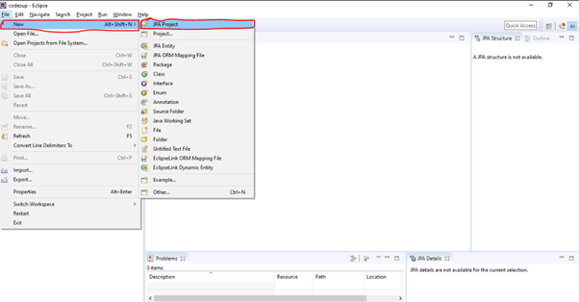

After clicking on the JPA project below screen is appear in front of you and you have to enter details on this screen such as project name etc.

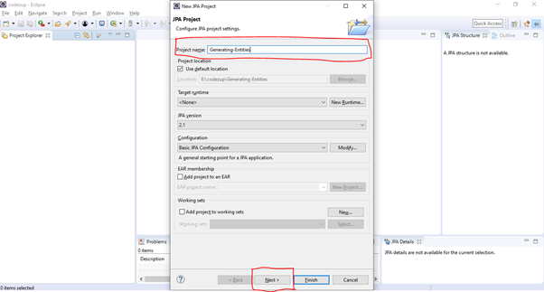

After entering the project name all other required details you have to click on next.

After clicking on the next below given screen comes and, on this screen, again you have to click on next.

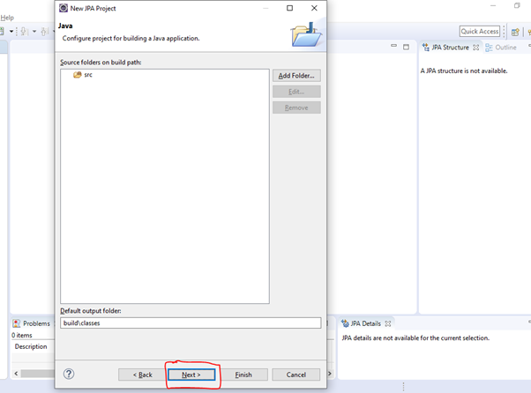

So, when you click on next then the below screen comes, and, on this screen, you have to choose JPA implementation and here we choose this as a “Disable Library Configuration” but you can choose it according to your requirement.

One of the important things present in the below screen is that you have to choose Connection configuration such as which database you have to connect and what its name and its driver.

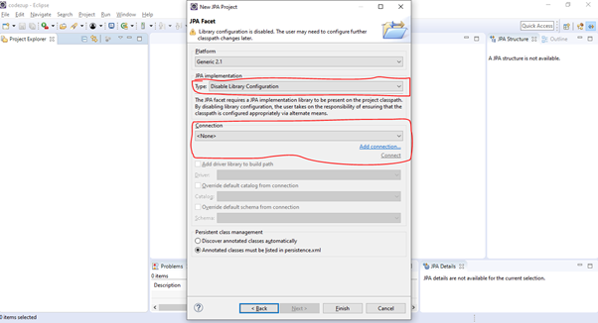

So, click on Add Connection option and it opens the below screen for you.

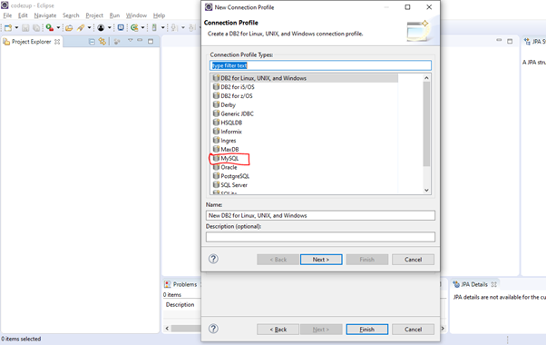

Since we are using MySQL in this example so we choose MySQL and also provide Name and Description according to your requirement.

After entering all details, you have to click on the **Next**button.

After clicking on the next screen below screen opens for you where you have to enter database details such as database name, username, and password.

Also, one of the important steps here is that you have to choose the appropriate driver and its JAR according to the database you used.

If a particular version of JAR is not worked then try to upgrade or degrade the JAR version.

e.g.: here we use the MYSQL 8.0 but we use the **mysql-connector-java-5.1.44.jar** file.

The below screenshot helps you to understand how to add jar and database details.

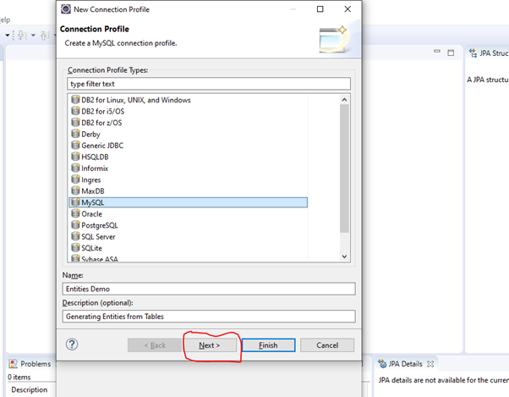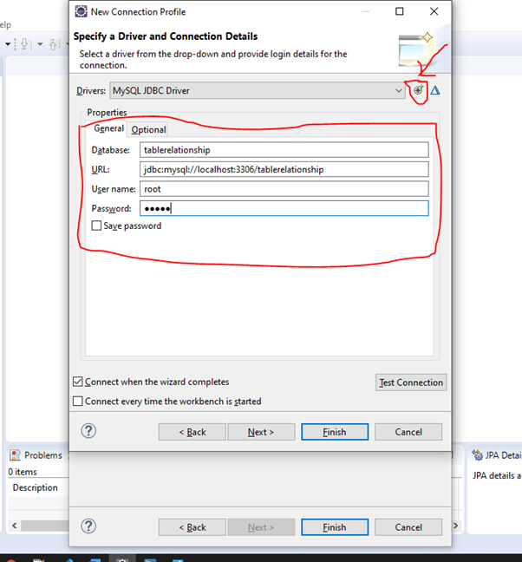

In the above screen, you have to provide database details such as database name, username, and password, etc.

Also, you have to choose a driver. When you click on the **+** icon which exists at the right side of the Drivers input filed then it will open a below screen for you.

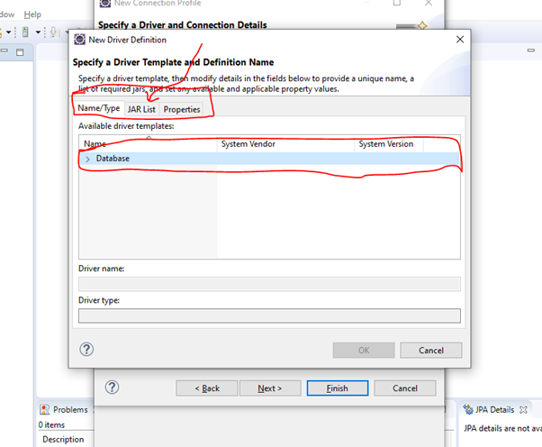

So, in the above screen when you click on the Database field then there is a driver name such as MySQL JDBC Driver.

So, you have to choose a driver from there according to the version and then click on JAR and add jar for that.

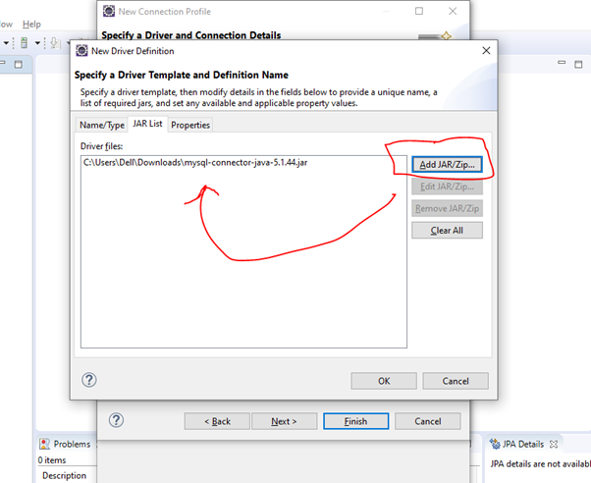

So, after adding JAR you have to click on Ok.

Please make sure that if the particular version is not matched then try to degrade or upgrade the version of JAR.

The below screen comes when clicking on the Ok button. Please cross-verify the database name and other details on this screen.

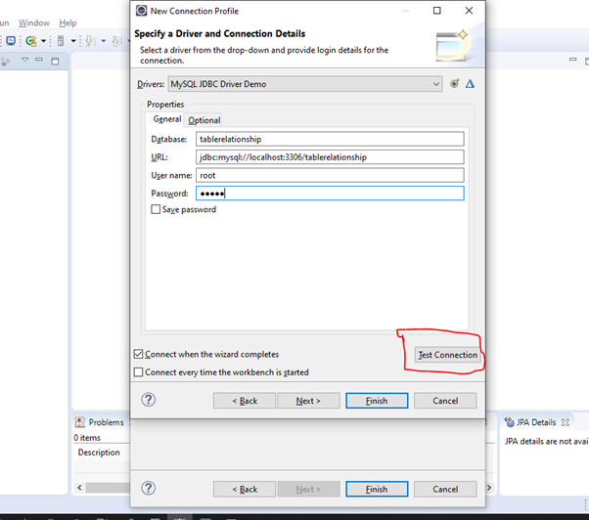

After verifying all the details click on Test Connection.

If the below screen comes then it means the connection is established successfully and now you can click on finish.

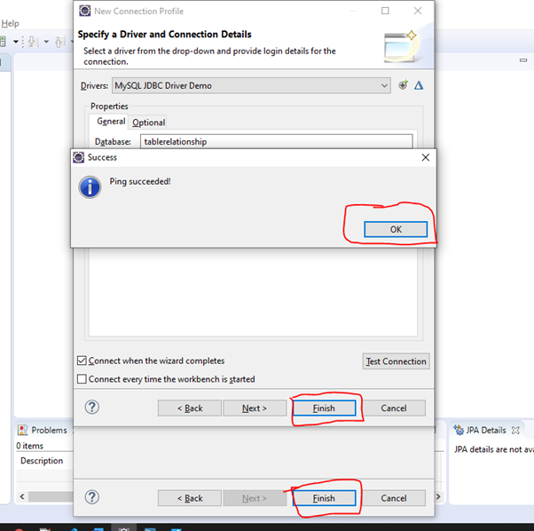

So, it will generate a project for you, and below is the screenshot of the eclipse.

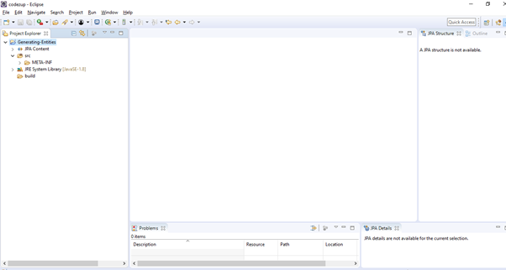

Now right click on the project and then choose New and then click on JPA entities from the Tables option.

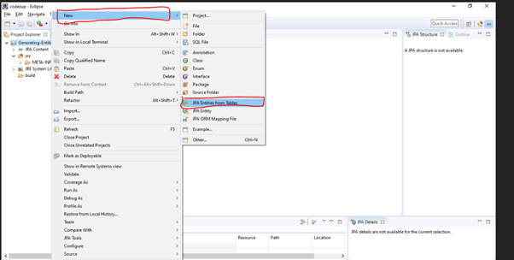

After clicking on **“JPA entities from Tables”**below screen comes:

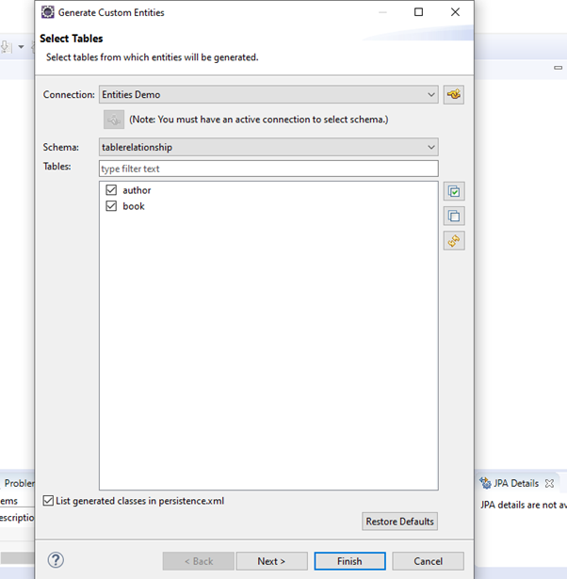

In the above screen, you have to check the checkbox for the tables for which you are generating an entity class.

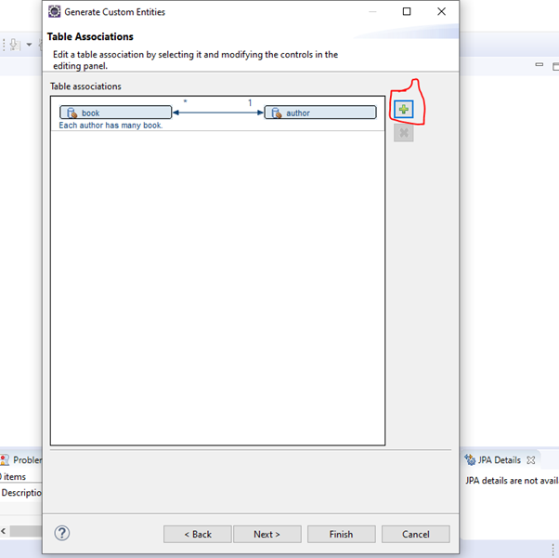

In the above screen, you can choose table relationships such as one to one, one to many, etc.

By default, it is many to one here but you can choose by clicking on the + icon according to the requirement.

After choosing it click on next. After clicking on next:

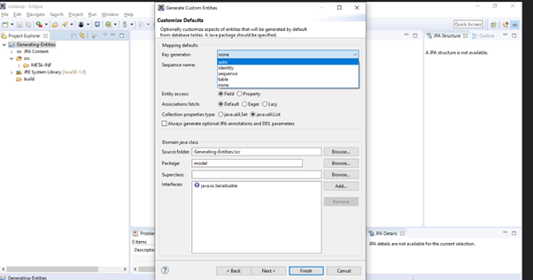

In the above screen, you have to choose a key generator and other options and then click on next. After clicking on the next screen comes and in the below screen, you have to choose the option according to the requirement and then click on finish.

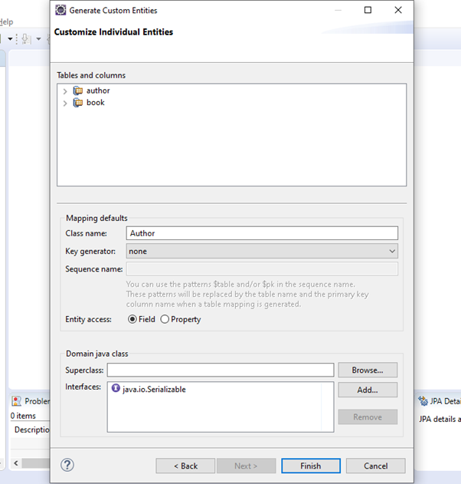

Then click on Finish. After clicking on the finish, it will successfully generate the entities for you. Below is the screenshot of Eclipse in which you can see the entity class Author for you.

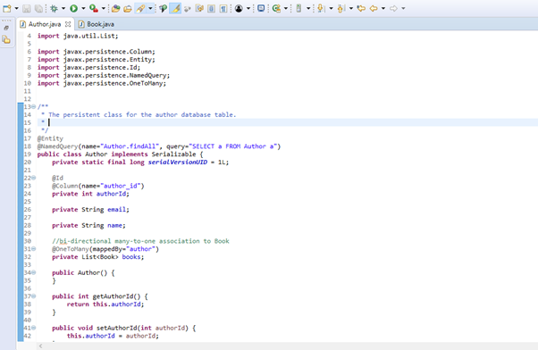

That’s all for this tutorial.

Please write comments if you like the tutorial or if you find anything incorrect. Share this tutorial with others if you find it informative.

Also if you want to share more information about the same topic then contact us via the contact us section.

Happy Learning!