You are correct, starting from IIS 7, it creates new profile for each application pool, this can be disabled in "Advanced settings" / "Load User Profile".

The easiest and safest way to delete unused user profiles with their folder on drive with helps Microsoft control panel "User profiles":

* Right click on "Computer", and select "Properties", then click on "Advanced system settings" (alternative way - just run "sysdm.cpl").
* Go to tab "Advanced" and click button "Setting" in "User profiles" group.
* Unused profiles that created by IIS pool will have name "Account Unknown", select it and click "Delete" button.

[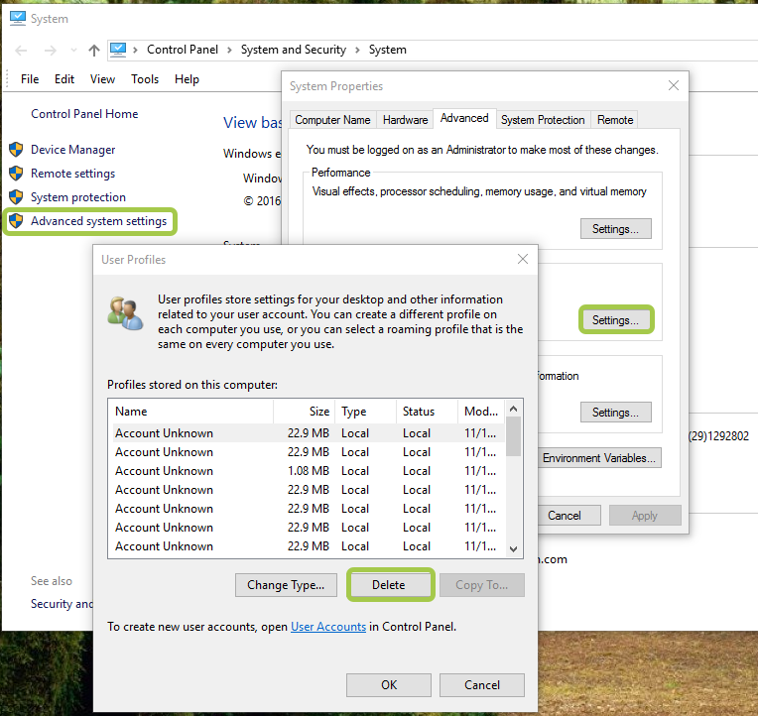](https://i.stack.imgur.com/rW7w8.png)

Profiles, which have references, cannot be deleted, them will have disabled "Delete" button.  
Some reasons why profile is locked:

* IIS application pool, which uses this profile, still exists.
* SQL Server has "Logins" related to this profile (SQL management studio / Security / Logins).

After remove all references to profile need to reboot machine.