How to Create Valid SSL in localhost for XAMPP

[David](https://shellcreeper.com/author/scdave/)[174](https://shellcreeper.com/how-to-create-valid-ssl-in-localhost-for-xampp/#comments) Mar 21, 2018



Chrome browser updates has become a burden for local development. Not only they decided to disable .dev domain for local development, they also really have specific configuration in SSL Cert to show the site as secure.

In this step by step tutorial I will try to explain  the walk-through to create SSL cert locally to be used in XAMPP in Windows.

In my XAMPP install I basically  have a clone to all the site that I managed.  And All of them (of course) use SSL/HTTPS.

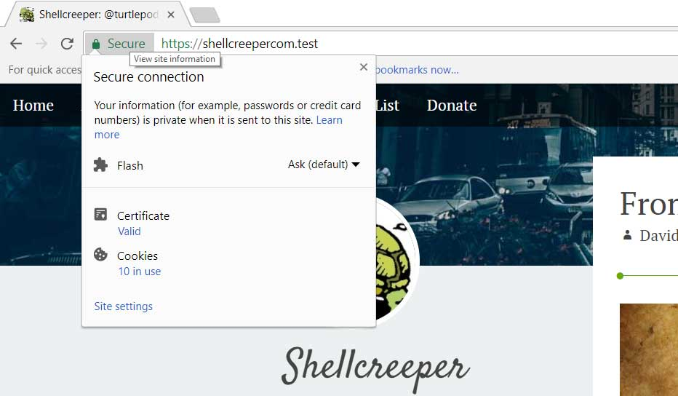

Here’s the step by  step guide:

In this step we are going to crate SSL and setup “site.test” website.

1. Navigate to Apache directory in XAMPP.

In regular install it’s in **C:\xampp\apache**.

2. Create a folder in that page.

This is where we will store our cert. In this example I will create “crt” folder. So we will have **C:\xampp\apache\crt**

3. Add this files.

* [cert.conf](https://gist.github.com/turtlepod/3b8d8d0eef29de019951aa9d9dcba546)
* [make-cert.bat](https://gist.github.com/turtlepod/e94928cddbfc46cfbaf8c3e5856577d0)

4. Edit cert.conf and Run make-cert.bat

Change {{DOMAIN}} text using the domain we want to use, in this case **site.test** and save.

Double click the make-cert.bat and input the domain **site.test** when prompted. And just do enter in other question since we already set the default from cert.conf.

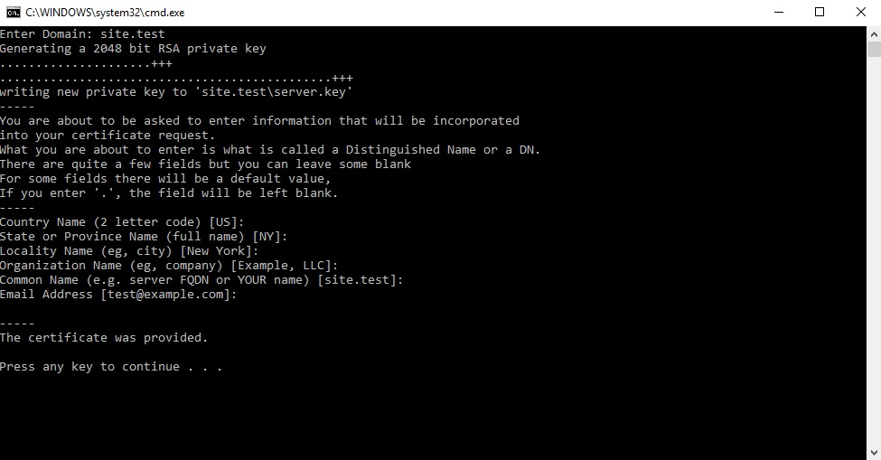

**Note**: I don’t know how to do text replace in .bat script, if you do, let me know in the comment how to do it and I will update make-cert.bat to automatically replace the {{DOMAIN}} with the domain input.

5. Install the cert in windows.

After that, you will see site.test folder created. In that folder we will have **server.crt** and **server.key**. This is our SSL certificate.

Double click on the server.crt to install it on Windows so Windows can trust it.

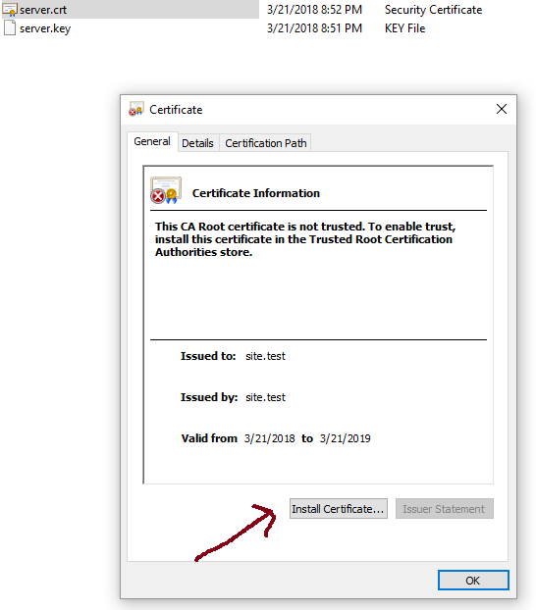

And then select **Local Machine** as Store Location.

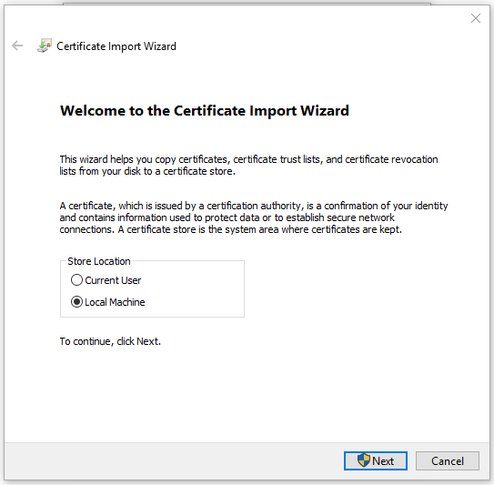

And then Select “**Place all certificate in the following store**” and click **browse** and select Trusted Root Certification Authorities.

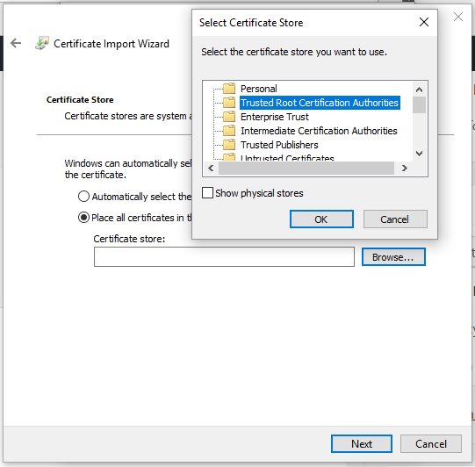

Click **Next** and **Finish**.

And now this cert is installed and trusted in Windows. Next is how how to use this cert in XAMPP.

6. Add the site in Windows hosts

1. Open notepad as administrator.
2. Edit C:\Windows\System32\drivers\etc\hosts (the file have no ext)
3. Add this in a new line:

127.0.0.1 site.test

This will tell windows to load XAMPP when we visit http://site.test You can try and it will show XAMPP dashboard page.

7. Add the site in XAMPP conf.

We need to enable SSL for this domain and let XAMPP know where we store the SSL Cert. So we need to edit **C:\xampp\apache\conf\extra\httpd-xampp.conf**

And add this code at the bottom:

## site.test

<VirtualHost *:80>

DocumentRoot "C:/xampp/htdocs"

ServerName site.test

ServerAlias *.site.test

</VirtualHost>

<VirtualHost *:443>

DocumentRoot "C:/xampp/htdocs"

ServerName site.test

ServerAlias *.site.test

SSLEngine on

SSLCertificateFile "crt/site.test/server.crt"

SSLCertificateKeyFile "crt/site.test/server.key"

</VirtualHost>

After that, you will need to restart Apache in XAMPP.  It’s very simple, simply open XAMPP Control Panel and **Stop** and re-**Start** Apache Module.

**Tips**: In XAMPP conf, as you can see you can change the domain root directory if needed. Eg. as sub-dir in htdocs.

8. Restart your browser and Done!

This is required to load the certificate. And visit the domain on your browser, and you will see green lock!

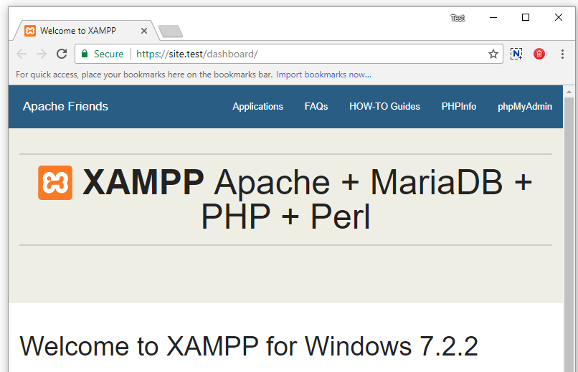

I hope this tutorial is useful!

If you already use other method, let me know in the comment 🙂