**variable-length subnet mask (VLSM)**



**Posted by:**[**Margaret Rouse**](https://www.techtarget.com/contributor/Margaret-Rouse)

[WhatIs.com](https://whatis.techtarget.com/)

Variable-Length Subnet Masking (VLSM) amounts to "subnetting [subnets](https://searchnetworking.techtarget.com/definition/subnet)," which means that VLSM allows [network engineers](https://searchnetworking.techtarget.com/definition/network-engineer) to divide an [IP address](https://searchunifiedcommunications.techtarget.com/definition/Internet-Protocol) space into a hierarchy of subnets of different sizes, making it possible to create subnets with very different host counts without wasting large numbers of addresses.

A [subnet mask](https://searchnetworking.techtarget.com/definition/subnet) defines the size of the subnet (the number of host [addresses](https://searchnetworking.techtarget.com/definition/address) in the subnet).  [Fixed-Length Subnet Masking](https://searchnetworking.techtarget.com/definition/fixed-length-subnet-mask) (FLSM) creates subnets all the same size.  But where some subnets will have many hosts and some have few, FLSM results in some subnets having many orphaned addresses, or some sets of hosts being too big to fit into a subnet.  Where VLSM is enabled, a large subnet can be divided into a set of smaller sub-subnets, which can be used to handle smaller sets of hosts.

For example, consider a traditional Class C address space like 192.168.1.0 and an organization with four groups of computers: the data center with 75 hosts; the call center with 50; the operations floor with 25; and the executive floor with 20.  Under fixed subnetting, dividing the 255 host addresses available into four subnets would support only 62 hosts each, not meeting the needs of the data center and vastly oversupplying addresses for operations and the execs.  Using VLSM, the space is first split in 2, with each subnet able to address 126 hosts.  One subnet covers the data center. The other is split in two, supplying two sub-subnets of 62 hosts.  One covers the contact center, the other is split in two once more, creating two 30-host sub-sub-subnets, to cover operations and executives.

In order to use VLSM, a network administrator must use a [routing](https://searchnetworking.techtarget.com/definition/router) [protocol](https://searchnetworking.techtarget.com/definition/protocol) that supports it, such as [Routing Information Protocol v2](https://searchnetworking.techtarget.com/definition/Routing-Information-Protocol) (RIPv2), [Open Shortest Path First](https://searchnetworking.techtarget.com/definition/OSPF-Open-Shortest-Path-First) (OSPF), [Intermediate System-to-Intermediate System](https://searchnetworking.techtarget.com/definition/IS-IS) (IS-IS), [Enhanced Interior Gateway Routing Protocol](https://searchnetworking.techtarget.com/definition/EIGRP) (EIGRP) and [Border Gateway Protocol](https://searchnetworking.techtarget.com/definition/BGP-Border-Gateway-Protocol) (BGP).

VLSM is similar in concept and intent to [Classless Inter Domain Routing](https://searchnetworking.techtarget.com/definition/CIDR) (CIDR), which allows a single Internet domain to have an address space that does not fit into traditional address classes. VLSM was originally defined in [IETF](https://whatis.techtarget.com/definition/IETF-Internet-Engineering-Task-Force) [RFC](https://whatis.techtarget.com/definition/Request-for-Comments-RFC) 1812.

VLSM Subnetting Explained with Examples

This tutorial explains VLSM Subnetting in detail with practical examples. Learn what VLSM (Variable Length Subnet Masks) Subnetting is and how it is done step by step including the advantages of VLSM Subnetting and the differences between FLSM Subnetting and VLSM Subnetting.

Subnetting is the process of dividing a single large network in multiple small networks known as subnets. There are two types of Subnetting; FLSM Subnetting and VLSM Subnetting.

Differences between FLSM Subnetting and VLSM Subnetting

|  |  |
| --- | --- |
| FLSM (Fixed Length Subnet Masks) Subnetting | VLSM (Variable Length Subnet Masks) Subnetting |
| All subnets are equal in size. | Subnets are variable in size. |
| All subnets have equal number of hosts. | Subnets have variable number of hosts. |
| All subnets use same subnet mask. | Subnets use different subnet masks. |
| It is easy in configuration and administration. | It is complex in configuration and administration. |
| It wastes a lot of IP addresses. | It wastes minimum IP addresses. |
| It is also known as classfull Subnetting. | It is also known as classless Subnetting. |
| It supports both classfull and classless routing protocols. | It supports only classless routing protocols. |

Which Subnetting should be used is depend on objectives and type of addresses used in network. FLSM provides easier Subnetting at the cost of IP addresses while VLSM best utilizes IP addresses at the cost of simplicity. For private IP addresses, FLSM is the best choice. For public IP addresses, VLSM is the best option.

This tutorial is the fifth part of the article “**IP Subnetting in Computer Network Step by Step Explained with Examples**”. Other parts of this article are following.

[Network Address Broadcast Address and IP Address Explained](https://www.computernetworkingnotes.com/ccna-study-guide/network-address-basic-concepts-explained-with-examples.html)

*This tutorial is the first part of the article. It explains IP addressing and network addressing such as IP address, subnet mask, IP address types and IP classes in detail.*

[Basic Subnetting in Computer Networks Explained](https://www.computernetworkingnotes.com/ccna-study-guide/basic-subnetting-in-computer-networks-explained.html)

*This tutorial is the second part of the article. It explains what Subnetting is and why it is necessary in computer network along with the advantages of Subnetting.*

[Subnetting Tutorial - Subnetting Explained with Examples](https://www.computernetworkingnotes.com/ccna-study-guide/subnetting-tutorial-subnetting-explained-with-examples.html)

*This tutorial is the third part of the article. It explains the Subnetting concepts and terms such as network id, broadcast id, total hosts, valid hosts, power of 2, block size and CIDR in detail.*

[Subnetting Tricks Subnetting Made Easy with Examples](https://www.computernetworkingnotes.com/ccna-study-guide/subnetting-tricks-subnetting-made-easy-with-examples.html)

*This tutorial is the fourth part of the article. It explains how to solve or answer any Subnetting related question in less than a minute with 50+ Subnetting examples.*

[VLSM Subnetting Examples and Calculation Explained](https://www.computernetworkingnotes.com/ccna-study-guide/vlsm-subnetting-examples-and-calculation-explained.html)

*This tutorial is the sixth part of the article. It explains VLSM Subnetting examples for Cisco exams and interviews.*

[Supernetting Tutorial: - Supernetting Explained with Examples](https://www.computernetworkingnotes.com/ccna-study-guide/supernetting-tutorial-supernetting-explained-with-examples.html)

*This tutorial is the last part of the article. It explains Supernetting in detail with examples.*

Since I have already explained FLSM Subnetting with examples in previous parts of this tutorial, instead of repeating it again, in this part I will focus on VLSM Subnetting.

If you don’t know what FLSM is and how it is done, I highly recommend you take a pause here and learn FLSM Subnetting from the previous parts of this tutorial. For this part I assume that you have sound knowledge of FLSM Subnetting.

VLSM Subnetting

The biggest advantage of VLSM Subnetting is that, instead of forcing us to use a fixed size for all segments, it allows us to choose the individual size for each segment. This flexibility reduces the IP wastage. We can choose the size of subnet which closely matches with our requirement. Let’s understand it with an example.

VLSM Example

Do the VLSM Subnetting of following network.

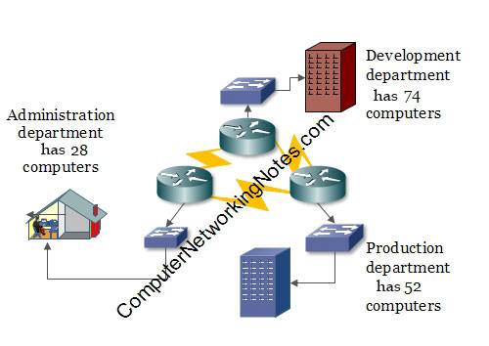

In this network: -

* Development department has 74 computers.
* Production department has 52 computers.
* Administration department has 28 computers.
* All departments are connected with each other via wan links.
* Each wan link requires two IP addresses.
* The given address space is 192.168.1.0/24.

Before we perform VLSM Subnetting for this network, let’s understand how VLSM Subnetting actually works.

Basic concepts of VLSM Subnetting

VLSM Subnetting is the extended version of FLSM Subnetting. If you know how FLSM Subnetting works and how it is done, you already know the 90% of VLSM Subnetting. In FLSM, all subnets use same block size, thus Subnetting is required only one time. In VLSM, subnets use block size based on requirement, thus Subnetting is required multiple times.

The concept of VLSM Subnetting is relatively simple.

* Select block size for each segment. Block size must be greater than or equal to the actual requirement. Actual requirement is the sum of host addresses, network address and broadcast address.
* Based on block size arrange all segments in descending order.
* Do FLSM Subnetting for the block size of the first segment.
* Assign first subnet from subnetted subnets to the first segment.
* If next segment has similar block size, assign next subnet to it.
* If next segment has lower block size, do FLSM Subnetting again for the block size of this segment.
* From subnetted subnets exclude the occupied subnets. Occupied subnets are the subnets which provide the addresses which are already assigned.
* From available subnets, assign the first available subnet to this segment.
* Repeat above steps till the last segment of the network.

Let’s implement above steps in our example network.

Step by step VLSM Subnetting

The first step of VLSM Subnetting is selecting the appropriate block size for each segment. Following table lists all available block sizes.

|  |  |  |  |  |  |  |  |
| --- | --- | --- | --- | --- | --- | --- | --- |
| 2 | 4 | 8 | 16 | 32 | 64 | 128 | 256 |
| 512 | 1024 | 2048 | 4096 | 8192 | 16384 | 32768 | 65536 |
| 131072 | 262144 | 524288 | 1048576 | 2097152 | 4194304 | 8388608 | 16777216 |

*To learn how block size is calculated, please see the third part of this tutorial.*

While selecting appropriate block size for a given segment, always select a size which is adequate for host addresses plus two additional addresses; network address and broadcast address.

Identity of a subnet and certain networking services depend on network address and broadcast address. In each subnet, the first address and the last address are always reserved for network address and broadcast address respectively.

Regardless the information about these two addresses is provided or not in question; always add these addresses in requirement while selecting the block size for a segment.

Actual requirement = Host requirement + Network address + broadcast address

Block Size >= Actual requirement

Following table shows the selection of block size in our example.

|  |  |  |  |
| --- | --- | --- | --- |
| Segment | Host requirement | Actual requirement | Block size |
| Production | 52 | 54 | 64 |
| Wan link 1 | 2 | 4 | 4 |
| Development | 74 | 76 | 128 |
| Wan link 2 | 2 | 4 | 4 |
| Administration | 28 | 30 | 32 |
| Wan link 3 | 2 | 4 | 4 |

The next step of VLSM Subnetting is arranging segments in descending order. Based on block size, following table arranges all segments in descending order.

|  |  |  |
| --- | --- | --- |
| Segment | Block size | Descending order |
| Development | 128 | 1 |
| Production | 64 | 2 |
| Administration | 32 | 3 |
| Wan link 1 | 4 | 4 |
| Wan link 2 | 4 | 5 |
| Wan link 3 | 4 | 6 |

The next step of VLSM Subnetting is doing FLSM Subnetting and selecting appropriate subnets for segments from the subnetted subnets.

A single FLSM Subnetting provides a single block size for all of its subnets. If different block size is required, we have to perform the FLSM Subnetting again for that block size. How many times we have to perform the FLSM Subnetting is depend on how many unique block sizes we need. For instance, our example network requires four unique block sizes 128, 64, 32 and 4. For four block sizes, we have to perform FLSM Subnetting four times.

FLSM Subnetting is always performed in descending order. For ordering, block size is used. In our example, first we have to perform FLSM Subnetting for block size 128 then for block size 64 then for block size 32 and finally for block size 4.

Following figure shows the FLSM Subnetting for all four block sizes and selected subnets for segments from each FLSM Subnetting.

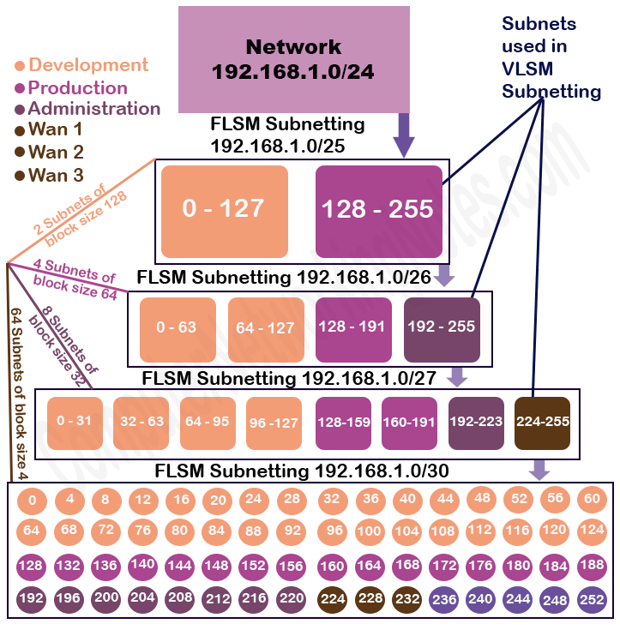

Let’s understand above process in more detail.

First largest segment (Block size 128)

Our first segment needs a block size of 128. The FLSM Subnetting of /25 provides us two subnets with the block size 128.

**FLSM Subnetting of 192.168.1.0/25**

|  |  |  |
| --- | --- | --- |
| Subnet | Subnet1 | Subnet2 |
| Network ID | 192.168.1.0 | 192.168.1.128 |
| First host address | 192.168.1.1 | 192.168.1.129 |
| Last host address | 192.168.1.126 | 192.168.1.254 |
| Broadcast ID | 192.168.1.127 | 192.168.1.255 |

From Subnetted subnets assign first subnet to this segment.

|  |  |
| --- | --- |
| Segment | Development |
| Requirement | 74 |
| CIDR | /25 |
| Subnet mask | 255.255.255.128 |
| Network ID | 192.168.1.0 |
| First hosts | 192.168.1.1 |
| Last hosts | 192.168.1.126 |
| Broadcast ID | 192.168.1.127 |

Since our second segment (Production) needs different block size (64), instead of using second subnet (Subnet2) for it, let’s do Subnetting again.

Second largest segment (Block size 64)

The Subnetting of /26 provide us 4 subnets with block size 64.

**Subnetting of 192.168.1.0/26**

|  |  |  |  |  |
| --- | --- | --- | --- | --- |
| Subnet | Subnet 1 | Subnet 2 | Subnet 3 | Subnet 4 |
| Network ID | 0 | 64 | 128 | 192 |
| First address | 1 | 65 | 129 | 193 |
| Last address | 62 | 126 | 190 | 254 |
| Broadcast ID | 63 | 127 | 191 | 255 |

From this Subnetting, we cannot use subnet 1 and subnet 2 as they are already occupied.

Subnet 1 and Subnet 2 provide addresses from 0 to 127 which are already assigned in the development department.

We can use subnet 3 for this segment (production).

|  |  |
| --- | --- |
| Segment | Production |
| Requirement | 52 |
| CIDR | /26 |
| Subnet mask | 255.255.255.192 |
| Network ID | 192.168.1.128 |
| First hosts | 192.168.1.129 |
| Last hosts | 192.168.1.190 |
| Broadcast ID | 192.168.1.191 |

Third largest segment (block size 32)

The Subnetting of /27 provides us 8 network and 32 hosts.

**Subnetting of 192.168.1.0/27**

|  |  |  |  |  |  |  |  |  |
| --- | --- | --- | --- | --- | --- | --- | --- | --- |
| Subnet | Sub 1 | Sub 2 | Sub 3 | Sub 4 | Sub 5 | Sub 6 | Sub 7 | Sub 8 |
| Net ID | 0 | 32 | 64 | 96 | 128 | 160 | 192 | 224 |
| First Host | 1 | 33 | 65 | 95 | 129 | 161 | 193 | 225 |
| Last Host | 30 | 62 | 94 | 126 | 158 | 190 | 222 | 254 |
| Broadcast ID | 31 | 63 | 95 | 127 | 159 | 191 | 223 | 255 |

Exclude the already occupied subnets (Sub1 to Sub6) and assign the first available subnet (Sub7) to this segment.

|  |  |
| --- | --- |
| Segment | Administration |
| Requirement | 28 |
| CIDR | /27 |
| Subnet mask | 255.255.255.224 |
| Network ID | 192.168.1.192 |
| First hosts | 192.168.1.193 |
| Last hosts | 192.168.1.222 |
| Broadcast ID | 192.168.1.223 |

WAN Links (Block Size 4)

Last three segments require the block size of 4. The Subnetting of /30 gives us 64 subnets of block size 4.

**Subnets of /30 Subnetting:-**

0, 4, 8, 12, 16, 20, 24, 28, 32, 36, 40, 44, 48, 52, 56, 60, 64, 68, 72, 76, 80, 84, 88, 92, 96, 100, 104, 108, 112, 116, 120, 124, 128, 132, 136, 140, 144, 148, 152, 156, 160, 164, 168, 172, 176, 180, 184, 188, 192, 196, 200, 204, 208, 212, 216, 220, 224, 228, 232, 236, 240, 244, 248, 252, 256

Exclude already occupied subnets (0-56) and use first three available subnets 57, 58 and 59 for WAN links.

|  |  |  |  |
| --- | --- | --- | --- |
| Subnet | Subnet 57 | Subnet 58 | Subnet 59 |
| Network ID | 224 | 228 | 232 |
| First host | 225 | 229 | 233 |
| Last host | 226 | 230 | 234 |
| Broadcast ID | 227 | 231 | 235 |

Assign subnet 57 to the WAN link 1.

|  |  |
| --- | --- |
| Subnet | Subnet 57 |
| Segments | Wan Link 1 |
| Requirement | 2 |
| CIDR | /30 |
| Subnet mask | 255.255.255.252 |
| Network ID | 192.168.1.224 |
| First hosts | 192.168.1.225 |
| Last hosts | 192.168.1.226 |
| Broadcast ID | 192.168.1.227 |

Assign subnet 58 to the WAN link 2.

|  |  |
| --- | --- |
| Subnet | Subnet 58 |
| Segments | Wan Link 2 |
| Requirement | 2 |
| CIDR | /30 |
| Subnet mask | 255.255.255.252 |
| Network ID | 192.168.1.228 |
| First hosts | 192.168.1.229 |
| Last hosts | 192.168.1.230 |
| Broadcast ID | 192.168.1.231 |

Assign subnet 59 to the WAN link 3.

|  |  |
| --- | --- |
| Subnet | Subnet 59 |
| Segments | Wan Link 3 |
| Requirement | 2 |
| CIDR | /30 |
| Subnet mask | 255.255.255.252 |
| Network ID | 192.168.1.232 |
| First hosts | 192.168.1.233 |
| Last hosts | 192.168.1.234 |
| Broadcast ID | 192.168.1.235 |

We have assigned IP addresses to all segments. The subnets 60, 61, 62, 63 and 64 are still available for further use.

Following figure shows a summarize allocation of all addresses in given network.

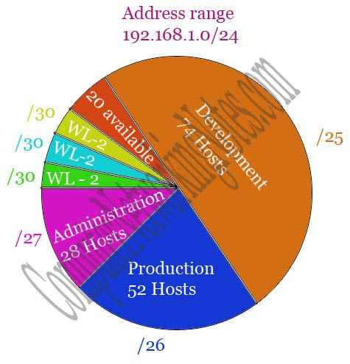

That’s all for this part. In next part, I will explain few more VLSM examples in detail. If you have any feedback or suggestion about this tutorial, mail me. If you like this tutorial, please share it with friends through your favorite social platform.

VLSM Subnetting Examples and Calculation Explained

Looking for VLSM Subnetting examples or want to understand the complex VLSM calculation through the examples, then this tutorial is the prefect resource for you. It provides VLSM Subnetting examples which not only help you in learning the VLSM Subnetting but also assist you in performing the VLSM calculation.

For this tutorial I assume that you know what VLSM Subnetting is and how it is done. Since I have already explained VLSM Subnetting and its procedure in previous parts of this tutorial, in this part I will focus on VLSM examples.

This tutorial is the sixth part of the article “**IP Subnetting in Computer Network Step by Step Explained with Examples**”. Other parts of this article are following.

[Network Address Broadcast Address and IP Address Explained](https://www.computernetworkingnotes.com/ccna-study-guide/network-address-basic-concepts-explained-with-examples.html)

*This tutorial is the first part of the article. It explains IP addressing and network addressing such as IP address, subnet mask, IP address types and IP classes in detail.*

[Basic Subnetting in Computer Networks Explained](https://www.computernetworkingnotes.com/ccna-study-guide/basic-subnetting-in-computer-networks-explained.html)

*This tutorial is the second part of the article. It explains what Subnetting is and why it is necessary in computer network along with the advantages of Subnetting.*

[Subnetting Tutorial - Subnetting Explained with Examples](https://www.computernetworkingnotes.com/ccna-study-guide/subnetting-tutorial-subnetting-explained-with-examples.html)

*This tutorial is the third part of the article. It explains the Subnetting concepts and terms such as network id, broadcast id, total hosts, valid hosts, power of 2, block size and CIDR in detail.*

[Subnetting Tricks Subnetting Made Easy with Examples](https://www.computernetworkingnotes.com/ccna-study-guide/subnetting-tricks-subnetting-made-easy-with-examples.html)

*This tutorial is the fourth part of the article. It explains how to solve or answer any Subnetting related question in less than a minute with 50+ Subnetting examples.*

[VLSM Subnetting Explained with Examples](https://www.computernetworkingnotes.com/ccna-study-guide/vlsm-subnetting-explained-with-examples.html)

*This tutorial is the fifth part of the article. It explains what VLSM Subnetting is and how it is done step by step including differences between FLSM Subnetting and VLSM Subnetting.*

[Supernetting Tutorial: - Supernetting Explained with Examples](https://www.computernetworkingnotes.com/ccna-study-guide/supernetting-tutorial-supernetting-explained-with-examples.html)

*This tutorial is the last part of the article. It explains Supernetting in detail with examples.*

Subnetting charts

Before we take the examples of VLSM Subnetting, let’s build Subnetting chart for each IP class. Subnetting charts summarize all possible combinations of all Subnetting bits in all IP classes.

In VLSM Subnetting, we calculate how many networks and hosts the given Subnetting bits provide. Subnetting charts not only provide this information but also help us in selecting appropriate block sizes and subnet masks for segments.

Class A Subnetting chart

|  |  |  |  |  |  |  |
| --- | --- | --- | --- | --- | --- | --- |
| CIDR | Subnet mask | Network bits | Host bits | Networks | Block Size or Total Hosts | Valid Hosts |
| /8 | 255.0.0.0 | 0 | 24 | 1 | 16777216 | 16777214 |
| /9 | 255.128.0.0 | 1 | 23 | 2 | 8388608 | 8388606 |
| /10 | 255.192.0.0 | 2 | 22 | 4 | 4194304 | 4194302 |
| /11 | 255.224.0.0 | 3 | 21 | 8 | 2097152 | 2097150 |
| /12 | 255.240.0.0 | 4 | 20 | 16 | 1048576 | 1048574 |
| /13 | 255.248.0.0 | 5 | 19 | 32 | 524288 | 524286 |
| /14 | 255.252.0.0 | 6 | 18 | 64 | 262144 | 262142 |
| /15 | 255.254.0.0 | 7 | 17 | 128 | 131072 | 131070 |
| /16 | 255.255.0.0 | 8 | 16 | 256 | 65536 | 65534 |
| /17 | 255.255.128.0 | 9 | 15 | 512 | 32768 | 32766 |
| /18 | 255.255.192.0 | 10 | 14 | 1024 | 16384 | 16382 |
| /19 | 255.255.224.0 | 11 | 13 | 2048 | 8192 | 8190 |
| /20 | 255.255.240.0 | 12 | 12 | 4096 | 4096 | 4094 |
| /21 | 255.255.248.0 | 13 | 11 | 8192 | 2048 | 2046 |
| /22 | 255.255.252.0 | 14 | 10 | 16384 | 1024 | 1022 |
| /23 | 255.255.254.0 | 15 | 9 | 32768 | 512 | 510 |
| /24 | 255.255.255.0 | 16 | 8 | 65536 | 256 | 254 |
| /25 | 255.255.255.128 | 17 | 7 | 131072 | 128 | 126 |
| /26 | 255.255.255.192 | 18 | 6 | 262144 | 64 | 62 |
| /27 | 255.255.255.224 | 19 | 5 | 524288 | 32 | 30 |
| /28 | 255.255.255.240 | 20 | 4 | 1048576 | 16 | 14 |
| /29 | 255.255.255.248 | 21 | 3 | 2097152 | 8 | 6 |
| /30 | 255.255.255.252 | 22 | 2 | 4194304 | 4 | 2 |

Class B Subnetting chart

|  |  |  |  |  |  |  |
| --- | --- | --- | --- | --- | --- | --- |
| CIDR | Subnet mask | Network bits | Host bits | Networks | Block Size /Total Hosts | Valid Hosts |
| /16 | 255.255.0.0 | 0 | 16 | 1 | 65536 | 65534 |
| /17 | 255.255.128.0 | 1 | 15 | 2 | 32768 | 32766 |
| /18 | 255.255.192.0 | 2 | 14 | 4 | 16384 | 16382 |
| /19 | 255.255.224.0 | 3 | 13 | 8 | 8192 | 8190 |
| /20 | 255.255.240.0 | 4 | 12 | 16 | 4096 | 4094 |
| /21 | 255.255.248.0 | 5 | 11 | 32 | 2048 | 2046 |
| /22 | 255.255.252.0 | 6 | 10 | 64 | 1024 | 1022 |
| /23 | 255.255.254.0 | 7 | 9 | 128 | 512 | 510 |
| /24 | 255.255.255.0 | 8 | 8 | 256 | 256 | 254 |
| /25 | 255.255.255.128 | 9 | 7 | 512 | 128 | 126 |
| /26 | 255.255.255.192 | 10 | 6 | 1024 | 64 | 62 |
| /27 | 255.255.255.224 | 11 | 5 | 2048 | 32 | 30 |
| /28 | 255.255.255.240 | 12 | 4 | 4096 | 16 | 14 |
| /29 | 255.255.255.248 | 13 | 3 | 8192 | 8 | 6 |
| /30 | 255.255.255.252 | 14 | 2 | 16384 | 4 | 2 |

Class C Subnetting chart

|  |  |  |  |  |  |  |
| --- | --- | --- | --- | --- | --- | --- |
| CIDR | Subnet mask | Network bits | Host bits | Networks | Block Size /Total Hosts | Valid Hosts |
| /24 | 255.255.255.0 | 0 | 8 | 1 | 256 | 254 |
| /25 | 255.255.255.128 | 1 | 7 | 2 | 128 | 126 |
| /26 | 255.255.255.192 | 2 | 6 | 4 | 64 | 62 |
| /27 | 255.255.255.224 | 3 | 5 | 8 | 32 | 30 |
| /28 | 255.255.255.240 | 4 | 4 | 16 | 16 | 14 |
| /29 | 255.255.255.248 | 5 | 3 | 32 | 8 | 6 |
| /30 | 255.255.255.252 | 6 | 2 | 64 | 4 | 2 |

*To learn how to build the Subnetting charts, please see the previous parts of this tutorial.*

Examples of VLSM Subnetting

There are five IP classes; A, B, C, D and E. From there classes Subnetting can be done only in first three classes; A, B and C. To understand VLSM Subnetting in detail, let’s take one example from each class.

**VLSM Example 1 (Class C Network)**

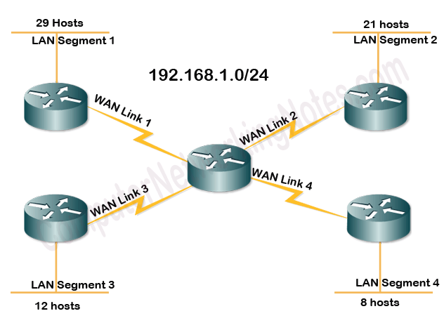

**VLSM Example 2 (Class B Network)**

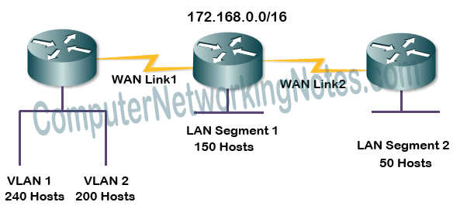

**VLSM Example 3 (Class A Network)**

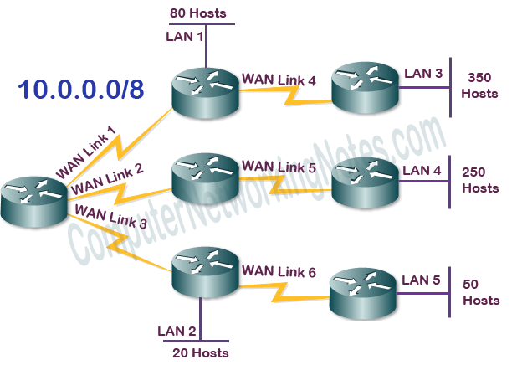

Step by step VLSM calculation

Based on hosts’ requirement, arrange all segments in descending order and select appropriate block size for each segment.

VLSM Example 1

|  |  |  |  |  |
| --- | --- | --- | --- | --- |
| No. | Segment | Host requirement | Nearest block size | Valid hosts in block |
| 1 | LAN Segment1 | 29 | 32 | 30 (32 -2) |
| 2 | LAN Segment 2 | 21 | 32 | 30 (32 -2) |
| 3 | LAN Segment 3 | 12 | 16 | 14 (16-2) |
| 4 | LAN Segment 4 | 8 | 16 | 14 (16-2) |
| 5 | WAN Link 1 | 2 | 4 | 2 (4-2) |
| 6 | WAN Link 2 | 2 | 4 | 2 (4-2) |
| 7 | WAN Link 3 | 2 | 4 | 2 (4-2) |
| 8 | WAN Link 4 | 2 | 4 | 2 (4-2) |

*While selecting the nearest block size, compare the host requirement with valid host instead of the block size itself. For example, LAN segment 4 needs 8 hosts, but we can’t use the block size 8 for it. As block size 8 offers only 6 valid hosts (8 -2) while we need 8 valid hosts for this segment. For this segment, we have to use the block size which provides 8 or more valid hosts such as block size 16. Same way for WAN links which need 2 hosts, we have to use the block size 4.*

VLSM Example 2

|  |  |  |  |  |
| --- | --- | --- | --- | --- |
| No. | Segment | Host requirement | Nearest block size | Valid hosts in block |
| 1 | VLAN1 | 240 | 256 | 254 |
| 2 | VLAN2 | 200 | 256 | 254 |
| 3 | LAN Segment 1 | 150 | 256 | 254 |
| 4 | LAN Segment 2 | 50 | 64 | 62 |
| 5 | WAN Link 1 | 2 | 4 | 2 |
| 6 | WAN Link 2 | 2 | 4 | 2 |

VLSM Example 3

|  |  |  |  |  |
| --- | --- | --- | --- | --- |
| No. | Segment | Host requirement | Nearest block size | Valid hosts |
| 1 | LAN Segment 3 | 350 | 512 | 510 |
| 2 | LAN Segment 4 | 250 | 256 | 254 |
| 3 | LAN Segment 1 | 80 | 128 | 126 |
| 4 | LAN Segment 5 | 50 | 64 | 62 |
| 5 | LAN Segment 2 | 20 | 32 | 30 |
| 6 | WAN Link1 | 2 | 4 | 2 |
| 7 | WAN Link2 | 2 | 4 | 2 |
| 8 | WAN Link3 | 2 | 4 | 2 |
| 9 | WAN Link4 | 2 | 4 | 2 |
| 10 | WAN Link5 | 2 | 4 | 2 |
| 11 | WAN Link6 | 2 | 4 | 2 |

Once segments are arranged based on hosts’ requirement and host requirements are converted in nearest block size, use following steps.

* Do Subnetting for the largest segment. From subnetted subnets, assign first subnet to it.
* If next segment has similar block size, assign next subnet to it.
* Repeat this process till the requirements are same.
* If next segment requires different block size, do Subnetting again for the block size of that segment and pick the subnet which comes after the occupied subnets. Occupied subnets are the subnets which provide the IP addresses which are already used.
* Just like above step, if next segment requires similar block size, use next subnet for it otherwise do Subnetting again.
* Repeat same steps till the last segment of the network.

Let’s implement above steps in our examples.

VLSM Example 1

The first largest segment (LAN Segment1) requires the block size 32. For 32 block size, we use the Subnetting of /27.

In class C, Subnetting of /27 provides us 8 networks (subnets) of block size 32.

0-31, 32-63, 64-95, 96-127, 128-159, 160-191, 192-223, 224-255

Let’s use the first subnet **0-31** for it.

Since second segment (LAN Segment2) also has the similar requirement, use the second subnet **32-63** for it.

Third segment (LAN Segment3) requires the block size 16 which is different from the second segment, so instead of using the subnet which provides block size 32, we will do the Subnetting again and use the subnet which provides block size 16.

In class C, Subnetting of /28 provides 16 networks of block size 16.

0-15, 16-31, 32-47, 48-63, 64-79, 80-95, 96-111, 112-127, 128-143, 144-159, 160-175, 176-191, 192-207, 208-223, 224-239, 240-255

If we exclude the occupied subnets, we will get the available subnets for this segment and next segments.

*The subnets which provide the addresses which are already assigned are known as occupied subnets. In this Subnetting the occupied subnets are 0-15, 16-31, 32-47 and 48-63. These subnets provide the addresses (0 to 63) which are already assigned in previous segments.*

Let’s use the first available subnet **64-79** from this Subnetting for the third segment (LAN Segment3).

Forth segment (LAN Segment4) also has the similar requirement. Let’s assign next available subnet **80-95** to it.

Next segments are WAN links. WAN links require only 2 addresses. For 2 valid addresses we need the block size of 4.

In class C, Subnetting of /30 provides us 64 networks of block size 4.

0-3, 4-7, 8-11, 12-15, 16-19, 20-23, 24-27, 28-31, 32-35, 36-39, 40-43, 44-47, 48-51, 52-55, 56-59, 60-63, 64-67, 68-71, 72-75, 76-79, 80-83, 84-87, 88-91, 92-95, 96-99, 100-103, 104-107, 108-111, 112-115, 116-119, 120-123, 124-127, 128-131, 132-135, 136-139, 140-143, 144-147, 148-151, 152-155, 156-159, 160-163, 164-167, 168-171, 172-175, 176-179, 180-183, 184-187, 188-191, 192-195, 196-199, 200-203, 204-207, 208-211, 212-215, 216-219, 220-223, 224-227, 228-231, 232-235, 236-239, 240-243, 244-247, 248-251, 252-255

Exclude the occupied subnets and use first four available subnets 96-99, 100-103, 104-107 and 108-111 for WAN links.

Following figure explains above steps and Subnetting.

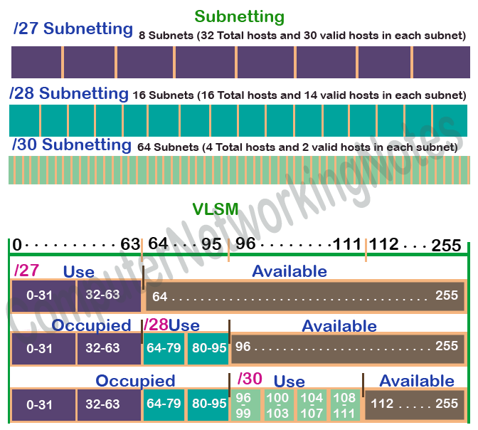

Subnetting table for first example of VLSM

|  |  |  |  |  |  |
| --- | --- | --- | --- | --- | --- |
| Segment | CIDR | Subnet Mask | Network Address | Broad cast Address | Valid host addresses |
| LAN Segment1 | /27 | 255.255.255.224 | 192.168.1.0 | 192.168.1.31 | 192.168.1.1 to 192.168.1.30 |
| LAN Segment 2 | /27 | 255.255.255.224 | 192.168.1.32 | 192.168.1.63 | 192.168.1.33 to 192.168.1.62 |
| LAN Segment 3 | /28 | 255.255.255.240 | 192.168.1.64 | 192.168.1.79 | 192.168.1.65 to 192.168.1.78 |
| LAN Segment 4 | /28 | 255.255.255.240 | 192.168.1.80 | 192.168.1.95 | 192.168.1.81 to 192.168.1.94 |
| WAN Link 1 | /30 | 255.255.255.252 | 192.168.1.96 | 192.168.1.99 | 192.168.1.97 to 192.168.1.98 |
| WAN Link 2 | /30 | 255.255.255.252 | 192.168.1.100 | 192.168.1.103 | 192.168.1.101 to 192.168.1.102 |
| WAN Link 3 | /30 | 255.255.255.252 | 192.168.1.104 | 192.168.1.107 | 192.168.1.105 to 192.168.1.106 |
| WAN Link 4 | /30 | 255.255.255.252 | 192.168.1.108 | 192.168.1.111 | 192.168.1.107 to 192.168.1.108 |

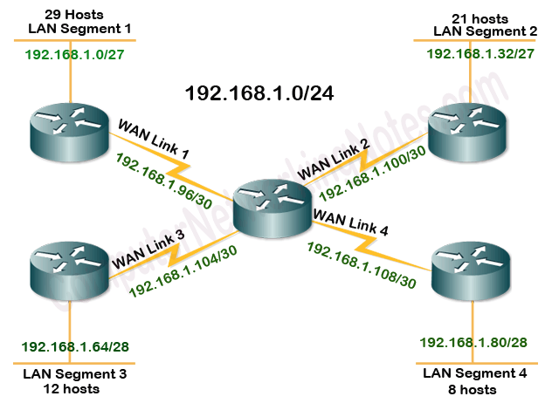

VLSM Example 2

In this example, first segment (VLAN1) requires the block size of 256.

In class B, Subnetting of /24 provides us 256 subnets and 256 hosts in each subnet.

0.0, 1.0, 2.0, 3.0, 4.0, 5.0 ……………………………….. 252.0, 253.0, 254.0, 255.0

Let’s assign first subnet **0.0** to this segment.

Since second segment (VLAN2) and third segment (LAN Segment1) also have the similar requirement, instead of doing Subnetting again, let’s use the next available subnets from already subnetted subnets for these segments.

Assign second subnet **1.0** and third subnet **2.0** to the second segment (VLAN2) and third segment (LAN Segment1) respectively.

Fourth segment (LAN Segment2) requires the block size of 64 which is different and lower from current block size. Instead of using current subnets, let’s do Subnetting again for this segment.

In class B, Subnetting of /26 provides 1024 subnets with block size of 64.

0.0, 0.64, 0.128, 0.192, 1.0, 1.64, 1.128, 1.192, 2.0, 2.64, 2.128, 2.192, 3.0, 3.64, 3.128, 3.192, 4.0, 4.64, 4.128, 4.192………………………………….. 254.0, 254.64, 254.128, 254.192, 254.0, 254.64, 254.128, 254.192

Exclude already occupied subnets and use first available subnet **3.0** for this segment (LAN segment2).

Next two segments are WAN links. For WAN links we use the Subnetting of /30.

In class B, Subnetting of /30 provides 16384 networks with the block size of 4.

0.4, 0.8, 0.12, ….…… 3.0, 3.4, …………. 3.56, 3.60, .64, 3.68, 3.72, 3.78, …………………………… 255.248, 255.252

Just like we did above, exclude occupied subnets and assign first two available subnets **3.64** and **3.68** to the WAN Link1 and WAN Link2 respectively.

Subnetting table for second example of VLSM

|  |  |  |  |  |  |
| --- | --- | --- | --- | --- | --- |
| Segment | CIDR | Subnet Mask | Network Address | Broad cast Address | Valid host addresses |
| VLAN1 | /24 | 255.255.255.0 | 172.168.0.0 | 172.168.0.255 | 172.168.0.1 to 172.168.0.254 |
| VLAN2 | /24 | 255.255.255.0 | 172.168.1.0 | 172.168.1.255 | 172.168.1.1 to 172.168.1.254 |
| LAN Segment 1 | /24 | 255.255.255.0 | 172.168.2.0 | 172.168.2.255 | 172.168.2.1 to 172.168.2.254 |
| LAN Segment 2 | /26 | 255.255.255.192 | 172.168.3.0 | 172.168.3.63 | 172.168.3.1 to 172.168.3.62 |
| WAN Link 1 | /30 | 255.255.255.252 | 172.168.3.64 | 172.168.3.67 | 172.168.3.65 to 172.168.3.66 |
| WAN Link 2 | /30 | 255.255.255.252 | 172.168.3.68 | 172.168.3.71 | 172.168.3.69 to 172.168.3.70 |

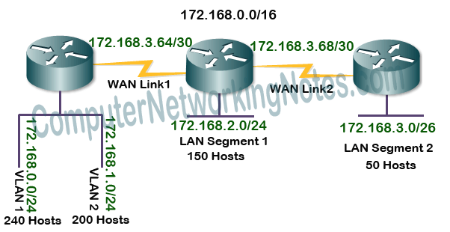

VLSM Example 3

The largest segment (LAN Segment 3) requires the block size 512.

In class A, Subnetting of /23 provides 32768 networks with the block size of 512.

0.0.0, 0.2.0, 0.4.0, …………………………………. 0.252.0, 0.254.0

Assign first subnet **0.0.0** to this segment.

The second largest segment (LAN Segment 4) requires the block size of 256.

In class A, Subnetting of /24 provides 65536 networks with the block size of 256.

0.0.0, 0.1.0, 0.2.0, 0.3.0, 0.4.0, 0.5.0, ……………………… 0.252.0, 0.253.0, 0.254.0

Exclude the occupied subnets and assign first available subnet **0.2.0** to it.

The third largest segment (LAN Segment 1) requires the block size of 128.

In class A, Subnetting of /25 provides 131072 networks with the block size of 128.

0.0.0, 0.0.128, 0.1.0, 0.1.128, 0.2.0, 0.2.128, 0.3.0, 0.3.128, 0.4.0, 0.4.128 ………………… 0.254.0, 0.254.128 , 0.255.0 , 0.255.128

Assign first available subnet **0.3.0** to this segment.

The fourth largest segment (LAN Segment 5) requires the block size of 64.

In class A, Subnetting of /26 provides 262144 networks with the block size of 64.

0.0.64, 0.0.128, 0.0.192, 0.0.255, 0.1.64, …………………. 0.2.192, 0.2.255, 0.3.64, 0.3.128, 0.3.192, 0.3.255, 0.4.64 …………………. , 0.254.0 , 0.254.64 , 0.254.128 , 0.254.255

In this Subnetting, the first subnet with available addresses is **0.3.128**. Assign it to this segment.

The fifth largest segment (LAN Segment2) requires the block size of 32.

In class A, Subnetting of /27 provides 524288 networks with the block size of 32.

0.0.32, 0.0.64, 0.0.96, 0.0.128 ………. 0.3.0, 0.3.32, 0.3.64, 0.3.96, 0.3.128, 0.3.160, 0.3.192, 0.3.224, 0.3.255, …………………. , 0.255.0, 0.255.32, 0.255.64, 0.255.92, 0.255.128, 0.255.224, 0.255.255

The first available subnet of this Subnetting is **0.3.192**. Let’s assign it to this segment.

Next six segments are WAN links. For WAN links use the Subnetting of /30.

In class A, Subnetting of /30 provides 4194304 networks with the block size of 4.

0.0.0, 0.0.4, 0.0.8 …………………….…………….. 0.3.208, 0.3.212, 0.3.216, 0.3.220, 0.3.224, 0.3.228, 0.3.232, 0.3.236, 0.3.240, 0.3.248, 0.3.252, 0.4.0, 0.4.8, …………….. 0.255.240, 0.255.244, 0.255.248, 0.255.252

Assign subnets 0.3.224, 0.3.228, 0.3.232, 0.3.236, 0.3.240 and 0.3.248 to WAN links respectively.

Subnetting table for third example of VLSM

|  |  |  |  |  |  |
| --- | --- | --- | --- | --- | --- |
| Segment | CIDR | Subnet Mask | Network Address | Broad cast Address | Valid host addresses |
| LAN Segment 3 | /23 | 255.255.254.0 | 10.0.0.0 | 10.0.1.255 | 10.0.0.1 to 10.0.1.254 |
| LAN Segment 4 | /24 | 255.255.255.0 | 10.0.2.0 | 10.0.2.255 | 10.0.2.1 to 10.0.2.254 |
| LAN Segment 1 | /25 | 255.255.255.128 | 10.0.3.0 | 10.0.3.127 | 10.0.3.1 to 10.0.3.126 |
| LAN Segment 5 | /26 | 255.255.255.192 | 10.0.3.128 | 10.0.3.191 | 10.0.3.129 to 10.0.3.190 |
| LAN Segment 2 | /27 | 255.255.255.224 | 10.0.3.192 | 10.0.3.223 | 10.0.3.193 to 10.0.3.222 |
| WAN Link1 | /30 | 255.255.255.252 | 10.0.3.224 | 10.0.3.227 | 10.0.3.225 to 10.0.3.226 |
| WAN Link2 | /30 | 255.255.255.252 | 10.0.3.228 | 10.0.3.231 | 10.0.3.229 to 10.0.3.230 |
| WAN Link3 | /30 | 255.255.255.252 | 10.0.3.232 | 10.0.3.235 | 10.0.3.233 to 10.0.3.234 |
| WAN Link4 | /30 | 255.255.255.252 | 10.0.3.236 | 10.0.3.239 | 10.0.3.237 to 10.0.3.238 |
| WAN Link5 | /30 | 255.255.255.252 | 10.0.3.240 | 10.0.3.243 | 10.0.3.241 to 10.0.3.242 |
| WAN Link6 | /30 | 255.255.255.252 | 10.0.3.244 | 10.0.3.247 | 10.0.3.245 to 10.0.3.246 |

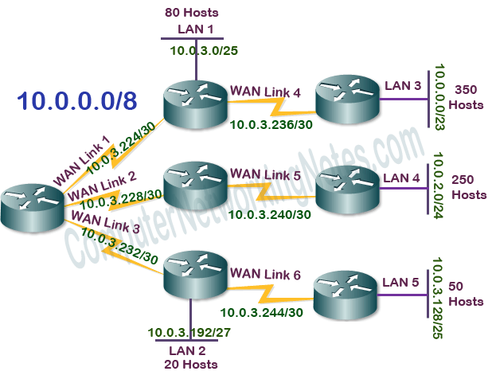

That’s all for this tutorial. If you have any comment or suggestion about this tutorial or need any assistance in VLSM Subnetting, mail me. If like this tutorial, please don’t forget to share it through your favorite social network.