How to use bandwidth control on TP-Link wireless router?

User Application Requirement

Updated 09-06-2019 07:08:04 AM*791882*

This Article Applies to:

**Why we need Bandwidth Control?**

Within a normal home network, the bandwidth is shared by all computers. This means any computer using high-bandwidth applications, for example torrent programs or other P2P software, will affect the other computers. This may also include negative influence on the performance of the entire network. How can we avoid this?

The answer is **Bandwidth Control**, which is designed to minimize the impact caused when the connection is under heavy load.  Using Bandwidth Control, we can assign a specific minimum or maximum bandwidth for each computer, which means they have less interference on each other. Please follow the steps below to configure this feature.

**How to configure** **Bandwidth Control?**

**The scenario below will take 3 computers sharing 512Kbps Egress Bandwidth and 4Mbps Ingress Bandwidth as an example, and explain how to use Bandwidth Control to optimize the load respectively.**

Scenario:

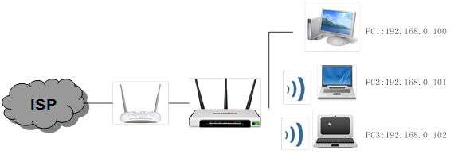

Example:①PC1 often plays online game and downloads files which uses the most part of bandwidth.

            ②PC2 is used for watching movies on the Internet which also needs much bandwidth.

            ③PC3 is used for browsing websites usually, so it only needs a few bandwidth.

**Please log in to the web management interface to setup bandwidth control.**

**Step 1**

Open the web browser and in the address bar type in the default access like::  [http://tplinkwifi.net](http://tplinklogin.net/)

**Note:**

Please find the default access on the bottom label of the product.

**Step 2**

Type the username and password in the login page. The default username and password are both admin in lower case.

**Step 3**

Click on **Bandwidth Control-Control Settings**on the left menu.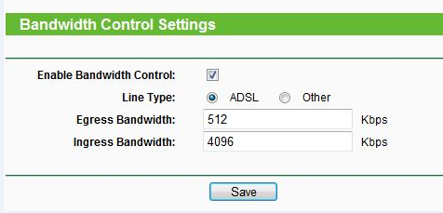

**Note:**

For example, if you have a ADSL Modem, please choose “ADSL” on the line type. If you don’t know how to choose the **Line Type**, please contact your ISP which line type you have access.

The **Egress Bandwidth**and **Ingress Bandwidth** should be the real bandwidth given by your ISP. (**1Mbps=1024Kbps**)

**Step 4**

Click **Save**to save the Settings.

**Step 5**

Click **Bandwidth Control -> Rules List**on the left page, you can view and configure the rules. 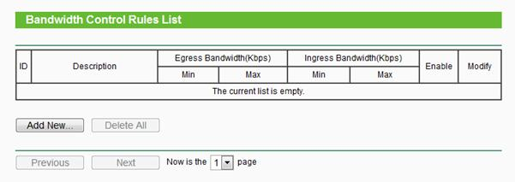

**Step 6**

Click**Add New** to add a new rule. 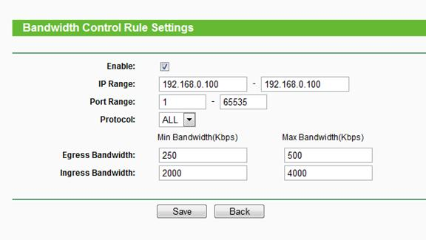

**IP Range-**Single IP address or IP address Range. When you configure the single IP address, the computer with this IP address will get**independent** given bandwidth. When you configure the IP address range, all computers in the range will **share** the given bandwidth.

**Port Range-**The port arrange of TCP protocol or UDP protocol.

**Protocol-**You can choose the TCP protocol or UDP protocol or both of them.

**Egress Bandwidth** - The max and the min upload speed which through the WAN port, default number is 0.

**Ingress Bandwidth**- The max and the min download speed through the WAN port, default number is 0.

NOTE:

You’d better set static IP Address on your local computers or configure Address reservation on the wireless router in order to manage easily.

About how to configure TCP/IP properties on your computer, please refer to[FAQ 14](https://www.tp-link.com/support/faq/14/)

About how to configure Address Reservation, please refer to [FAQ 182](https://www.tp-link.com/support/faq/182/)

**Step 7**

According to the demand of clients, the bandwidth could be allocated as following.

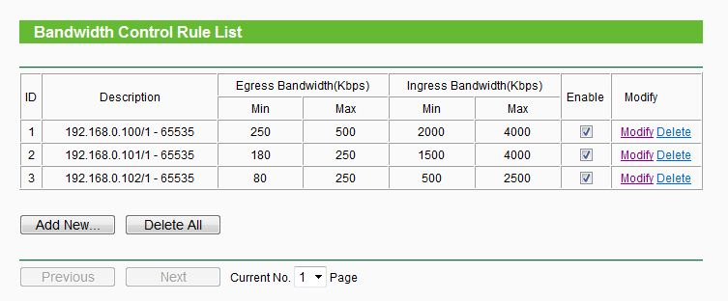

From the rules, the **max Bandwidth** can ensure that  PC1 and PC2 can take up all bandwidth when it’s alone to access the Internet and the**min Bandwidth** can ensure that they have the necessary bandwidth when more than one PC work at the same time.

**Note:**The amount of **Min Egress Bandwidth** and Min**Ingress Bandwidth** you configure should be less than **Egress Bandwidth** and **Ingress Bandwidth** you configure on **Bandwidth Control settings** page previously.

**Step 8**

Enable the **Bandwidth Control** and click the Save button on **Bandwidth Control Settings**to take effect.

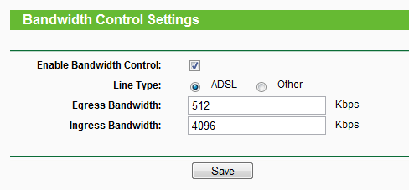

**Get to know more details of each function and configuration please go to** [Download Center](https://www.tp-link.com/support/download/)**to download the manual of your product.**