ANALYSIS OF OSPF LINK STATE UPDATE (LSU) - LINK STATE ADVERTISEMENT (LSA) PACKET STRUCTURE. COMMON LSA TYPES

WRITTEN BY ADMINISTRATOR. POSTED IN [OSPF ROUTING PROTOCOL](http://www.firewall.cx/networking-topics/routing/ospf-routing-protocol.html)

4.7692307692308[11111](javascript:void(null)) Rating 4.77 (13 Votes)

[**fShare**](javascript:void(0))

Share

**Save**

Part 4 of our [OSPF Routing Protocol Series](http://www.firewall.cx/networking-topics/routing/ospf-routing-protocol.html) covers how OSPF uses **Link State Advertisement** (**LSA**) to **exchange information** about the network topology between routers. When a router receives an **LSA**, it is stored in the **Link-State DataBase**(**LSDB**). Once the **LSDBs** between routers are in sync, **OSPF** uses the **Shortest Path First** (**SPF**) algorithm to calculate the **best routes** for **each network**. It is important to understand that **LSAs** are information about a route that is transported inside **Link State Update** (**LSU**) packets.

Each single **Link State Update** (**LSU**) packet can contain one or more **LSAs** inside it and when an **LSU** is sent between OSPF routers, it floods the **LSA information** through the network.

It is very important for any network engineer to understand how **LSAs** are contained within an **LSU**. We’ll use the example below, where an OSPF router sends an **LSU** to the **OSPF Designated Router** (**DR**) containing **LSA information** about a new network:

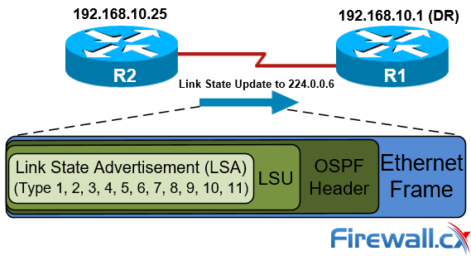

Figure 1. OSPF Link State Multicast Update (LSU) packet containing a Link State Advertisement (LSA)

As shown above, **LSAs** are **contained within LSUs**, which are all part of an **OSPF packet** encapsulated within an Ethernet frame (assuming an Ethernet network).

Our diagram of the LSU/LSA packet structure is confirmed by capturing an **OSPF Ethernet frame** below. We’ve highlighted each section (LSA, LSU, OSPF Header) using the same colors:

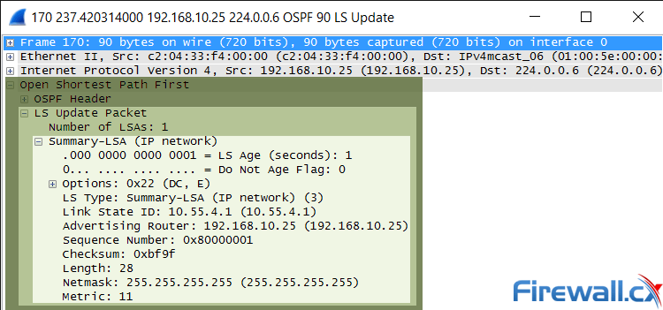

Figure 2. OSPF Link State Update and List State Advertisement within an Ethernet frame

Notice that the destination IP address is [**multicast address 224.0.0.6**](http://www.firewall.cx/networking-topics/general-networking/107-network-multicast.html), as expected since routers send updates to the **Designated Router** (**DR**) using this multicast address. This is also analyzed under the **Working Inside a Single Area** section in our article [How OSPF Protocol Works & Basic Concepts: OSPF Neighbor, Topology & Routing Table, OSPF Areas & Router Roles, Theory & Overview](http://www.firewall.cx/networking-topics/routing/ospf-routing-protocol/1110-ospf-operation-basic-advanced-concepts-ospf-areas-roles-theory-overview.html)

MOST POPULAR OSPF LSA TYPES

OSPF currently defines 11 different LSA types, however, despite the large variety of LSAs only around half of them are commonly found in OSPF networks. **Table 1** below shows the most popular LSA types, the [type of OSPF routers](http://www.firewall.cx/networking-topics/routing/ospf-routing-protocol/1110-ospf-operation-basic-advanced-concepts-ospf-areas-roles-theory-overview.html) (DR, ABR, ASBR etc) that generate them along with their function and the OSPF areas they affect:

|  |  |  |  |
| --- | --- | --- | --- |
| **LSA** | **Generated by** | **Function** | **Flooding Map** |
| **Type 1** | Normal Area Routers | Advertising router's interface and status to neighbors | Intra-Area (Area of origin) |
| **Type 2** | DR | Advertising DRs direct connected neighbors | Intra-Area (Area of origin) |
| **Type 3** | ABR | Advertising ABRs areas summary | Inter-Area (Multiple Areas) |
| **Type 4** | ABR | Advertising the presence of ASBRs | Inter-Area (Multiple Areas) |
| **Type 5** | ASBR | Advertising external routes to internet | Inter-Area (Multiple Areas) |
| **Type 7** | ASBR | Advertising external routes to internet to NSSA areas | Inter-Area (Multiple Areas) |

Table 1. Most often used LSA Types, router origin type, their function and Areas affected

Looking at the OSPF packet captured with our network analyzer, we can now understand that the specific **LSA** was a **Type-3 LSA** (**LS Type**: Summary-LSA IP network **3**) which means it was generated by an **ABR OSPF router**.

LINK STATE ADVERTISEMENT (LSA) PACKET STRUCTURE (WITHIN A LINK STATE UPDATE - LSU)

Each **LSA** packet consists of a header and a body that contains all the information needed to exchange network information within an OSPF network. The diagram below shows the structure of an **OSPF LSA packet**:

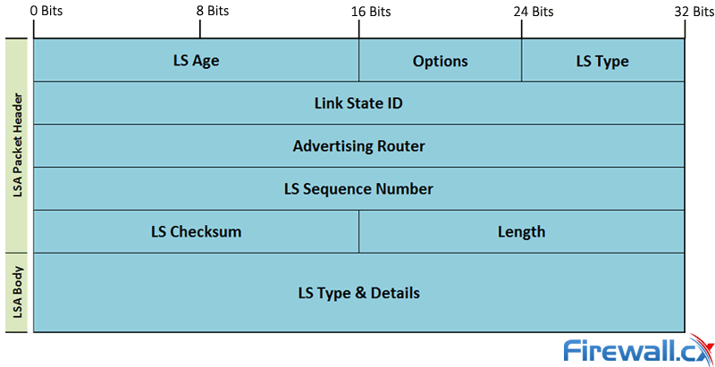

Figure 3. OSPF LSA Packet structure and fields

The **LSA header** is a **20 byte** (**32x5 = 160 bits**) section that consists of the following fields:

* **LS Age** (2 Bytes): Time passed since the LSA was generated (in seconds).
* **Options** (1 Byte): Indicates the OSPF features and options the origin can support.
* **LS Type** (1 Byte): Defines the LSA type (all types will be explained later).
* **Link State ID** (4 Bytes): Identifies the network link between OSPF routers (usually IP address).
* **Advertising Router** (4 Bytes): Indicates the origin router’s ID.
* **LS Sequence Number** (4 Bytes): A specific digit on each LSA packet to filter old and repeated
* **LS Checksum** (2 Bytes): A certain digit given to LS to compare and detect errors.
* **Length** (2 Bytes): Represents LSA packet length.

The **LSA body** varies in size according to the **LS type** and the details it identifies, LSA types are explained in great detail in our upcoming article.

This article explained **OSPF Link State Update**(**LSA**)**packets** and showed how they contain **Link State Advertisements**(**LSAs**). We also **analyzed OSPF LSU & LSAs packet structure** and explained each field in an **OSPF LSA packet**. Finally, we spoke about the most common **LSA Types**, **router origin type** (**ABR**, **ASBR**, **DR** etc), their function and Areas affected. Read more on OSPF by visiting our [OSPF Section](http://www.firewall.cx/networking-topics/routing/ospf-routing-protocol.html).

Link state packet

From Wikipedia, the free encyclopedia

[Jump to navigation](https://en.wikipedia.org/wiki/Link_state_packet#mw-head)[Jump to search](https://en.wikipedia.org/wiki/Link_state_packet#searchInput)

**Link State Packet** (**LSP**) is a packet of information generated by a [network router](https://en.wikipedia.org/wiki/Network_router) in a [link state](https://en.wikipedia.org/wiki/Link_state) [routing protocol](https://en.wikipedia.org/wiki/Routing_protocol) that lists the router's neighbors. Link state packet can also be further defined as special datagrams that determine the names of and the cost or distance to any neighboring [routers](https://en.wikipedia.org/wiki/Router_(computing)) and associated [networks](https://en.wikipedia.org/wiki/Computer_network). They are used to efficiently determine what the new neighbor is, if a link failure occurs, and the cost of changing a link if the need arises. LSPs are queued for transmission, and must time out at about the same time. They must be acknowledged, and can be distributed throughout the network, but cannot use the routing database.



**Contents**

* [1Developing Link State Packets](https://en.wikipedia.org/wiki/Link_state_packet#Developing_Link_State_Packets)
* [2Types of Link State packets](https://en.wikipedia.org/wiki/Link_state_packet#Types_of_Link_State_packets)
  + [2.1Link state update packet](https://en.wikipedia.org/wiki/Link_state_packet#Link_state_update_packet)
  + [2.2Link state acknowledgment packet](https://en.wikipedia.org/wiki/Link_state_packet#Link_state_acknowledgment_packet)
* [3See also](https://en.wikipedia.org/wiki/Link_state_packet#See_also)
* [4References](https://en.wikipedia.org/wiki/Link_state_packet#References)

Developing Link State Packets[[edit](https://en.wikipedia.org/w/index.php?title=Link_state_packet&action=edit&section=1)]

When Information needed for exchange is collected, a [router](https://en.wikipedia.org/wiki/Router_(computing)) then builds a [packet](https://en.wikipedia.org/wiki/Packet_(information_technology)) containing all the data. The [packet](https://en.wikipedia.org/wiki/Packet_(information_technology)) starts with the identity of the sender, followed by a [sequence number](https://en.wikipedia.org/wiki/Sequence_number) and age, and a list of neighbors. For each neighbor, the delay to that neighbor is given. Building a link state packet is usually easy, the complex part is determining when to build them. One way to reduce this problem is to build them periodically, that is, at regular intervals, or when some significant event occurs, such as a line or neighbor going down or coming back up again, or changing its properties appreciatively.

A major procedure called [flooding](https://en.wikipedia.org/wiki/Flooding_(computer_networking)) which is used for distributing link state algorithms throughout the routing domain can be implemented with link state packets. However, ordinary flooding may result in problems, because it generates exponential behavior. Smart flooding, on the other hand, recognizes link state packets appropriately.

Types of Link State packets[[edit](https://en.wikipedia.org/w/index.php?title=Link_state_packet&action=edit&section=2)]

Link state packets are usually implemented with [Open Shortest Path First](https://en.wikipedia.org/wiki/Open_Shortest_Path_First) (OSPF) protocol. OSPF's reliable flooding mechanism is implemented by Link State Update and Link State Acknowledgment packets.

**Link state update packet**[[edit](https://en.wikipedia.org/w/index.php?title=Link_state_packet&action=edit&section=3)]

Link State Update packets are [OSPF](https://en.wikipedia.org/wiki/OSPF) packet type 4.[[1]](https://en.wikipedia.org/wiki/Link_state_packet#cite_note-1) These packets implement the flooding of link state advertisements. Each Link State Update packet carries a collection of link state advertisements one hop further from its origin. Several [link-state advertisement](https://en.wikipedia.org/wiki/Link-state_advertisement) may be included in a single packet.

Link State Update packets are [multicast](https://en.wikipedia.org/wiki/Multicast) on those physical networks that support multicast/broadcast. In order to make the flooding procedure reliable, flooded advertisements are acknowledged in Link State Acknowledgment packets. If retransmission of certain advertisements is necessary, the retransmitted advertisements are always carried by [unicast](https://en.wikipedia.org/wiki/Unicast) Link State Update packets.

**Link state acknowledgment packet**[[edit](https://en.wikipedia.org/w/index.php?title=Link_state_packet&action=edit&section=4)]

Link State Acknowledgment Packets are [OSPF](https://en.wikipedia.org/wiki/OSPF) packet type 5.[[2]](https://en.wikipedia.org/wiki/Link_state_packet#cite_note-2) To make the flooding of link state advertisements reliable, flooded advertisements are explicitly acknowledged. This acknowledgment is accomplished through the sending and receiving of Link State Acknowledgment packets. Multiple link state advertisements can be acknowledged in a single Link State Acknowledgment packet.

Depending on the state of the sending interface and the source of the advertisements being acknowledged, a Link State Acknowledgment packet is sent either to the [multicast](https://en.wikipedia.org/wiki/Multicast) address AllSPFRouters, to the [multicast](https://en.wikipedia.org/wiki/Multicast) address AllDRouters, or as a [unicast](https://en.wikipedia.org/wiki/Unicast).

See also[[edit](https://en.wikipedia.org/w/index.php?title=Link_state_packet&action=edit&section=5)]

* [Link-state routing protocol](https://en.wikipedia.org/wiki/Link-state_routing_protocol)
* [Flooding algorithm](https://en.wikipedia.org/wiki/Flooding_algorithm)
* [Computer network](https://en.wikipedia.org/wiki/Computer_network)
* [Open Shortest Path First](https://en.wikipedia.org/wiki/Open_Shortest_Path_First)

References[[edit](https://en.wikipedia.org/w/index.php?title=Link_state_packet&action=edit&section=6)]

* 1. [**^**](https://en.wikipedia.org/wiki/Link_state_packet#cite_ref-1) *Moy, John.*[*"RFC 2328 OSPF Version 2"*](https://tools.ietf.org/html/rfc2328)*. IETF Request for Comments. IETF. Retrieved 13 April 2015.*
  2. [**^**](https://en.wikipedia.org/wiki/Link_state_packet#cite_ref-2) *Moy, John.*[*"RFC 2328 OSPF Version 2"*](https://tools.ietf.org/html/rfc2328)*. IETF Request for Comments. IETF. Retrieved 13 April 2015.*
* FireWire system architecture : IEEE 1394a / MindShare, Inc. ; Don Anderson Anderson, Don, 1953-

Reading, Mass. : Addison-Wesley, c1999

* Routing in communications networks / editor, Martha Steenstrup Englewood Cliffs, NJ : Prentice Hall, 1995
* Radia Perlman “Rbridges: Transparent Routing”, Infocom 2004.

[Categories](https://en.wikipedia.org/wiki/Help:Category):

* [Packets (information technology)](https://en.wikipedia.org/wiki/Category:Packets_(information_technology))