An SDN controller is the application that acts as a strategic control point in a software-defined network. Essentially, it is the “brains” of the network.

[Software-defined networking (SDN)](https://www.sdxcentral.com/networking/sdn/definitions/what-the-definition-of-software-defined-networking-sdn/) is the separation of a network’s control functions from its forwarding functions. When SDN is used in conjunction with [network functions virtualization (NFV)](https://www.sdxcentral.com/networking/nfv/definitions/whats-network-functions-virtualization-nfv/), the two create virtual network overlays that exist on top of the physical network infrastructure. [SDN architecture](https://www.sdxcentral.com/networking/sdn/definitions/inside-sdn-architecture/) relies on controllers to allow network administrators to manage the network.

An SDN controller manages flow control to the switches/routers “below” (via southbound APIs) and the applications and business logic “above” (via northbound APIs) to deploy intelligent networks. They consolidate and mediate between different controller domains using common application interfaces.

Two of the most well-known protocols used by SDN controllers to communicate with the switches/routers are[OpenFlow](https://en.wikipedia.org/wiki/OpenFlow) and open virtual switch database ([OVSDB](https://www.sdxcentral.com/open-source/definitions/what-is-ovsdb/)). Other controller protocols are being currently developed, many of them open-standard and collaborative. For example, the Internet Engineering Task Force (IETF) working group — the[Interface to the Routing System (i2rs)](https://datatracker.ietf.org/wg/i2rs/documents/) — developed an SDN standard that enables a controller to leverage proven, traditional protocols, such as OSPF, [MPLS](https://www.sdxcentral.com/networking/sd-wan/definitions/sd-wan-vs-mpls-pros-cons-technologies/), BGP, and IS-IS, across a variety of SDN platforms.

The type of protocols supported can influence the overall architecture of the network — for example, while OpenFlow attempts to completely centralize packet-forwarding decisions, i2rs splits the decision making by leveraging traditional routing protocols to execute distributed routing and allowing applications to modify routing decisions.

**Featured Definitional Guide**

New: 2020 Technology Hot Topics: What You Need to Know Placeholder Image



New: 2020 Technology Hot Topics: What You Need to Know

Get everything you need to know about 2020’s biggest tech innovations, from 5G to IoT to machine learning. Download today.

[DOWNLOAD](https://www.sdxcentral.com/5g/definitions/2020-tech-guide/)

*By clicking the link, I consent to share my contact information with the sponsor(s) of this content, who may reach out to you as part of their marketing campaigns, and register for SDxCentral email communications. See how we use your data:*[*Privacy Policy*](https://www.sdxcentral.com/legal/privacy/)*.*

SDN Controller Platforms

An SDN controller platform typically contains a collection of “pluggable” modules that can perform different network tasks. Some of the basic tasks including inventorying what devices are within the network and the capabilities of each, gathering network statistics, and other monitoring functions, etc. Extensions can be inserted that enhance the functionality and support more advanced capabilities, such as running algorithms to perform analytics and orchestrating new rules throughout the network.

A controller platform can be from a different company than the application is from, allowing for interoperability and flexibility.[Cisco](https://www.cisco.com/c/en/us/products/collateral/cloud-systems-management/open-sdn-controller/datasheet-c78-733458.html), for example, offers a controller platform built by OpenDaylight. This open-source controller is interoperable with several different proprietary applications.

open daylight sdn controller Placeholder Image

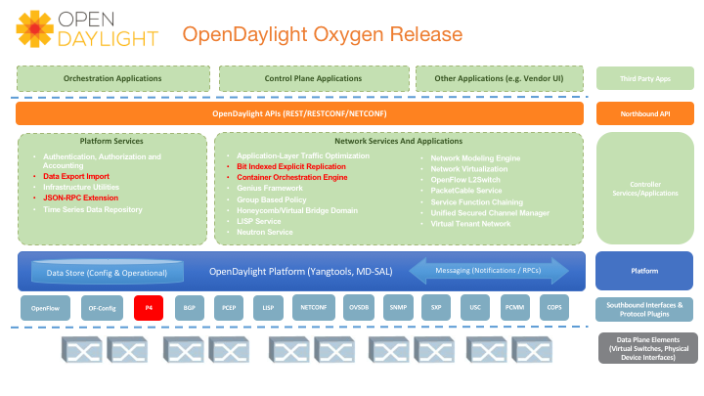

OpenDaylight Oxygen Release, which is the eighth release of the OpenDaylight SDN controller. The project is open source, and uses a plugin, which was developed by the [Open Networking Foundation](https://www.sdxcentral.com/networking/sdn/definitions/who-is-open-networking-foundation-onf/) and Linux. Source: [OpenDaylight](https://www.opendaylight.org/what-we-do/current-release/oxygen)

A Little History

The first SDN controller was[NOX](https://github.com/noxrepo/), which was initially developed by Nicira Networks, alongside OpenFlow. In 2008, Nicira Networks (acquired by VMware) donated NOX to the SDN community, making it open source. It has since become the basis for many SDN controller solutions. Nicira then went on to co-develop ONIX with NTT and Google; ONIX is the base for the Nicira/VMware controller. While ONIX was originally supposed to be opened up, the parties later decided not to make it open source.

There are, however, a variety of open source controllers currently available. The earliest ones include[POX](https://github.com/noxrepo/pox) and[Beacon](https://openflow.stanford.edu/display/Beacon/Home). Started in early 2010, Beacon is a Java-based OpenFlow controller licensed under a combination of the[GPL v2 license and the Stanford University FOSS License Exception v1.0](https://openflow.stanford.edu/display/Beacon/License). Other controllers of note include Trema (Ruby-based from NEC), as well as Ryu (supported by NTT).

Subsequently, vendors such as Cisco, HP, IBM, VMWare, Lumina Networks, and Juniper have jumped into the controller market with their own offerings.

OpenDaylight is another major player in the SDN controller game, as it’s the largest open-source SDN controller and SDN controller platform currently offered on the market.

SD-WAN Controllers

[Software-defined wide area network (SD-WAN)](https://www.sdxcentral.com/networking/sd-wan/definitions/software-defined-sdn-wan/) has seen increased popularity among enterprises. One of the reasons for its popularity is that the centralized application-based policy controller leverages existing hybrid WAN architectures. The controller in conjunction with analytics brings network and application visibility.

SDN Controller: Key Takeaways

1. SDN controllers are the software used to control a software-defined network (SDN).
2. The controller software communicates with applications with northbound APIs.
3. The controller software communicates with the network infrastructure with southbound APIs.
4. [SDN controller platforms](https://www.sdxcentral.com/networking/sdn/definitions/what-the-definition-of-software-defined-networking-sdn/) are software modules that can be assembled to perform all of the tasks a controller must do.