**Understanding Supernetting - How Supernets Work**

Written by Administrator. Posted in [Supernetting & CIDR](http://www.firewall.cx/networking-topics/protocols/supernetting-a-cidr.html)

4.1 [1](javascript:void(null)) [1](javascript:void(null)) [1](javascript:void(null)) [1](javascript:void(null)) [1](javascript:void(null)) Rating 4.10 (10 Votes)

[fShare](javascript:void(0))

[Tweet](https://twitter.com/share)

Save

This article explains **basic concepts of Supernets** - **Supernetting** and shows **how Supernets work** by **combining multiple smaller class networks** to **create one large network**, effectively replacing multiple routes with a single route.

Consider this realistic example: You work for a large ISP with a few hundred networks to which it provides services like Internet access, e-mail etc. These networks, which basically are your ISP's clients, consist of 254 host IPs each (One full Class C network for each client), and they all have a permanent connection to headquarters (represented by the yellow links) and from there the ISP has a direct connection to the Internet Backbone, as shown in the diagram below:

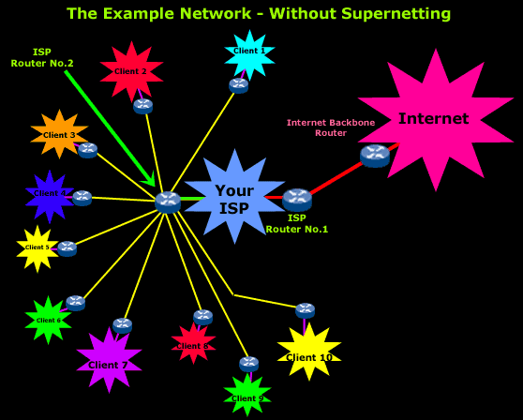

Our main focus are the two routers the ISP has, **Router No.1** and **Router No.2**, because these will be affected when we supernet the smaller networks behind them.

Routers No.1 & No.2 exchange information with each other and update their tables, which contain the networks they know about. Router 2 connects directly to 10 networks and needs to let Router 1 know about each one of them. Router 1 in turn will also advertise these networks to the Internet Backbone Router so it too will know about these networks.

The above setup requires that Router No.1 and the Internet Backbone Router each have more than 13 separate entries in their routing tables to make sure that each network is accessible from them. This is not so bad for this example, but try to imagine the problems and the complexity of a similar setup where you have thousands of networks, where the routing tables would be enormous ! Also, you should keep in mind that the larger the routing table, the more work the router needs to do because it has a huge table of routes to maintain and look through all the time.

By using Supernetting, we could supernet the whole network so it appears to the Internet as follows:

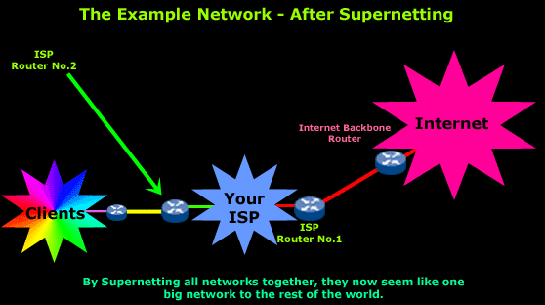

You can clearly see that all the clients' networks have been combined into one big network. Even though Router No.1 and the Internet Backbone router see only one big network, Router No.2 knows all about the smaller Class C networks since it is the one "hiding" them from the rest of the world and makes sure it sends the correct data to each network.

We are going to look at a more detailed example later on so we can understand exactly how supernetting works.

NOTE: There are some limitations with Supernetting - this is why there is a rule which we must follow so we don't bump into big routing problems and upset the network. We will have a closer look at the rule on the next page.

**The Reason for Evolution**

Supernetting has become very popular and there are a lot of reasons why:

* Class B network address space has nearly been exhausted
* A small percentage of class C network addresses have been  
  assigned to networks
* Routing tables in Internet routers have grown to a size beyond   
  the ability of software and people to effectively manage
* The 32-bit IP address space will eventually be exhausted

**How Supernets Work**

If you understand how Subnetting works, then you will surely understand Supernetting.

Supernets are the opposite of Subnets in that they combine multiple Class C networks into blocks rather than dividing them into segments.

When Subnetting, we borrow bits from the Host ID portion, which increases the number of bits used for the Network ID portion. With Supernetting we do exactly the opposite, meaning we take the bits from the Network ID portion and give them to the Host ID portion, as illustrated in the picture below:

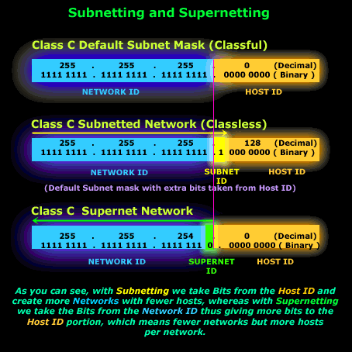

The next [Supernet/CIDR articles](http://www.firewall.cx/networking-topics/protocols/supernetting-a-cidr.html) deal with a detailed example to give you an [in-depth analysis of Supernetting](http://www.firewall.cx/networking-topics/protocols/supernetting-a-cidr/190-supernetting-analysis.html). The main concept you need to understand is that Supernetting is all about combining multiple networks into one or more groups and it does this by taking bits from the **Network ID** portion and, by doing so, the bits assigned to the **Host ID** portion increase.