**Troubleshooting installation**

Below are related errors and suggested fixes. Refer to the [WSL troubleshooting page](https://docs.microsoft.com/en-us/windows/wsl/troubleshooting) for other common errors and their solutions.

* **Installation failed with error 0x80070003**
  + The Windows Subsystem for Linux only runs on your system drive (usually this is your C: drive). Make sure that distributions are stored on your system drive:
  + Open **Settings** -> **System --> **Storage** -> **More Storage Settings: Change where new content is saved** 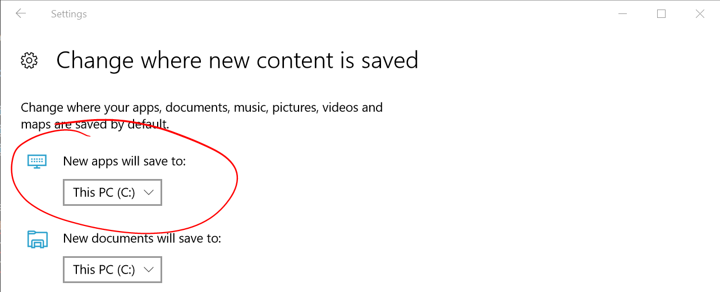
* **WslRegisterDistribution failed with error 0x8007019e**
  + The Windows Subsystem for Linux optional component is not enabled:
  + Open **Control Panel** -> **Programs and Features** -> **Turn Windows Feature on or off** -> Check **Windows Subsystem for Linux** or using the PowerShell cmdlet mentioned at the beginning of this article.
* **Installation failed with error 0x80070003 or error 0x80370102**
  + Please make sure that virtualization is enabled inside of your computer's BIOS. The instructions on how to do this will vary from computer to computer, and will most likely be under CPU related options.
* **Error when trying to upgrade: Invalid command line option: wsl --set-version Ubuntu 2**
  + Enure that you have the Windows Subsystem for Linux enabled, and that you're using Windows Build version 18362 or higher. To enable WSL run this command in a PowerShell prompt with admin privileges: Enable-WindowsOptionalFeature -Online -FeatureName Microsoft-Windows-Subsystem-Linux.
* **The requested operation could not be completed due to a virtual disk system limitation. Virtual hard disk files must be uncompressed and unencrypted and must not be sparse.**
  + Deselect “Compress contents” (as well as “Encrypt contents” if that’s checked) by opening the profile folder for your Linux distribution. It should be located in a folder on your Windows file system, something like: USERPROFILE%\AppData\Local\Packages\CanonicalGroupLimited...
  + In this Linux distro profile, there should be a LocalState folder. Right-click this folder to display a menu of options. Select Properties > Advanced and then ensure that the “Compress contents to save disk space” and “Encrypt contents to secure data” checkboxes are unselected (not checked). If you are asked whether to apply this to just to the current folder or to all subfolders and files, select “just this folder” because you are only clearing the compress flag. After this, the wsl --set-version command should work.

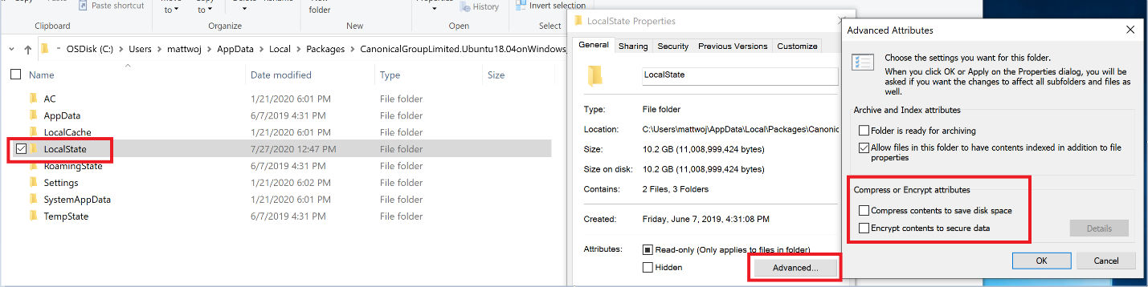

**Note**

In my case, the LocalState folder for my Ubuntu 18.04 distribution was located at C:\Users<my-user-name>\AppData\Local\Packages\CanonicalGroupLimited.Ubuntu18.04onWindows_79rhkp1fndgsc

Check [**WSL Docs GitHub thread #4103**](https://github.com/microsoft/WSL/issues/4103) where this issue is being tracked for updated information.

* **The term 'wsl' is not recognized as the name of a cmdlet, function, script file, or operable program.**
  + Ensure that the [Windows Subsystem for Linux Optional Component is installed](https://docs.microsoft.com/en-us/windows/wsl/install-win10#step-3---enable-virtual-machine-feature). Additionally, if you are using an ARM64 device and running this command from PowerShell, you will receive this error. Instead run wsl.exe from [PowerShell Core](https://docs.microsoft.com/en-us/powershell/scripting/install/installing-powershell-core-on-windows), or Command Prompt.
* **Error: This update only applies to machines with the Windows Subsystem for Linux.**
  + To install the Linux kernel update MSI package, WSL is required and should be enabled first. If it fails, it you will see the message: This update only applies to machines with the Windows Subsystem for Linux.
  + There are three possible reason you see this message:
  + You are still in old version of Windows which doesn't support WSL 2. See step #2 for version requirements and links to update.
  + WSL is not enabled. You will need to return to step #1 and ensure that the optional WSL feature is enabled on your machine.
  + After you enabled WSL, a reboot is required for it to take effect, reboot your machine and try again.
* **Error: WSL 2 requires an update to its kernel component. For information please visit**[**https://aka.ms/wsl2kernel**](https://aka.ms/wsl2kernel)**.**
  + If the Linux kernel package is missing in the %SystemRoot%\system32\lxss\tools folder, you will encounter this error. Resolve it by installing the Linux kernel update MSI package in step #4 of these installation instructions. You may need to uninstall the MSI from ['Add or Remove Programs'](ms-settings:appsfeatures-app), and install it again.