Docker Desktop for Windows user manual

*Estimated reading time: 17 minutes*

Welcome to Docker Desktop! The Docker Desktop for Windows user manual provides information on how to configure and manage your Docker Desktop settings.

For information about Docker Desktop download, system requirements, and installation instructions, see [Install Docker Desktop](https://docs.docker.com/docker-for-windows/install/).

Settings

The **Docker Desktop** menu allows you to configure your Docker settings such as installation, updates, version channels, Docker Hub login, and more.

This section explains the configuration options accessible from the **Settings** dialog.

1. Open the Docker Desktop menu by clicking the Docker icon in the Notifications area (or System tray):

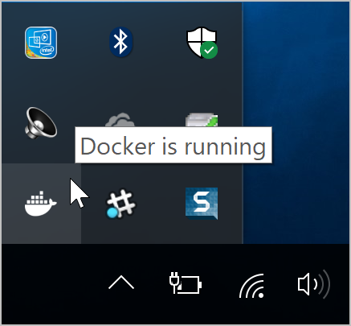

1. Select **Settings** to open the Settings dialog:

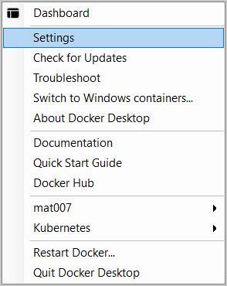

General

On the **General** tab of the Settings dialog, you can configure when to start and update Docker.

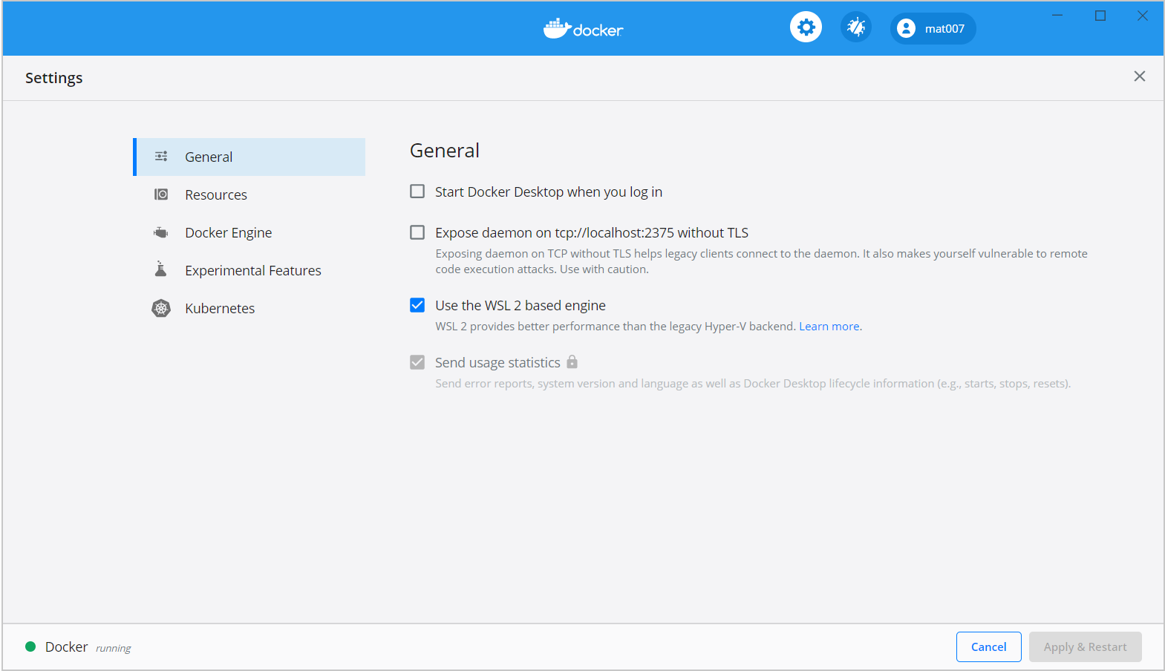

* **Start Docker when you log in** - Automatically start Docker Desktop upon Windows system login.
* **Expose daemon on tcp://localhost:2375 without TLS** - Click this option to enable legacy clients to connect to the Docker daemon. You must use this option with caution as exposing the daemon without TLS can result in remote code execution attacks.
* **Send usage statistics** - By default, Docker Desktop sends diagnostics, crash reports, and usage data. This information helps Docker improve and troubleshoot the application. Clear the check box to opt out. Docker may periodically prompt you for more information.

Resources

The **Resources** tab allows you to configure CPU, memory, disk, proxies, network, and other resources. Different settings are available for configuration depending on whether you are using Linux containers in WSL 2 mode, Linux containers in Hyper-V mode, or Windows containers.

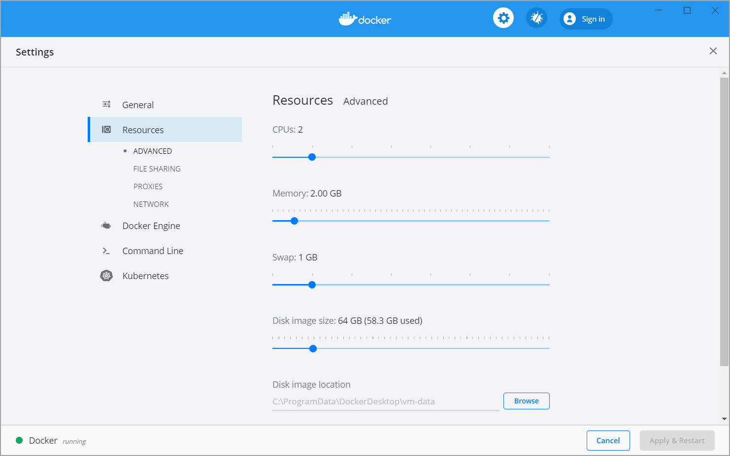

ADVANCED

**Note**

The Advanced tab is only available in Hyper-V mode, because in WSL 2 mode and Windows container mode these resources are managed by Windows. In WSL 2 mode, you can configure limits on the memory, CPU, and swap size allocated to the [WSL 2 utility VM](https://docs.microsoft.com/en-us/windows/wsl/release-notes#build-18945).

Use the **Advanced** tab to limit resources available to Docker.

**CPUs**: By default, Docker Desktop is set to use half the number of processors available on the host machine. To increase processing power, set this to a higher number; to decrease, lower the number.

**Memory**: By default, Docker Desktop is set to use 2 GB runtime memory, allocated from the total available memory on your machine. To increase the RAM, set this to a higher number. To decrease it, lower the number.

**Swap**: Configure swap file size as needed. The default is 1 GB.

**Disk image size**: Specify the size of the disk image.

**Disk image location**: Specify the location of the Linux volume where containers and images are stored.

You can also move the disk image to a different location. If you attempt to move a disk image to a location that already has one, you get a prompt asking if you want to use the existing image or replace it.

FILE SHARING

**Note**

The File sharing tab is only available in Hyper-V mode, because in WSL 2 mode and Windows container mode all files are automatically shared by Windows.

Use File sharing to allow local directories on Windows to be shared with Linux containers. This is especially useful for editing source code in an IDE on the host while running and testing the code in a container. Note that configuring file sharing is not necessary for Windows containers, only [Linux containers](https://docs.docker.com/docker-for-windows/#switch-between-windows-and-linux-containers). If a directory is not shared with a Linux container you may get file not found or cannot start service errors at runtime. See [Volume mounting requires shared folders for Linux containers](https://docs.docker.com/docker-for-windows/troubleshoot/#volume-mounting-requires-shared-folders-for-linux-containers).

File share settings are:

* **Add a Directory**: Click + and navigate to the directory you want to add.
* **Apply & Restart** makes the directory available to containers using Docker’s bind mount (-v) feature.

**Tips on shared folders, permissions, and volume mounts**

* Shared folders are designed to allow application code to be edited on the host while being executed in containers. For non-code items such as cache directories or databases, the performance will be much better if they are stored in the Linux VM, using a [data volume](https://docs.docker.com/storage/volumes/) (named volume) or [data container](https://docs.docker.com/storage/volumes/).
* Docker Desktop sets permissions to read/write/execute for users, groups and others [0777 or a+rwx](http://permissions-calculator.org/decode/0777/). This is not configurable. See [Permissions errors on data directories for shared volumes](https://docs.docker.com/docker-for-windows/troubleshoot/#permissions-errors-on-data-directories-for-shared-volumes).
* Windows presents a case-insensitive view of the filesystem to applications while Linux is case-sensitive. On Linux it is possible to create 2 separate files: test and Test, while on Windows these filenames would actually refer to the same underlying file. This can lead to problems where an app works correctly on a developer Windows machine (where the file contents are shared) but fails when run in Linux in production (where the file contents are distinct). To avoid this, Docker Desktop insists that all shared files are accessed as their original case. Therefore if a file is created called test, it must be opened as test. Attempts to open Test will fail with “No such file or directory”. Similarly once a file called test is created, attempts to create a second file called Test will fail.

SHARED FOLDERS ON DEMAND

You can share a folder “on demand” the first time a particular folder is used by a container.

If you run a Docker command from a shell with a volume mount (as shown in the example below) or kick off a Compose file that includes volume mounts, you get a popup asking if you want to share the specified folder.

You can select to **Share it**, in which case it is added your Docker Desktop Shared Folders list and available to containers. Alternatively, you can opt not to share it by selecting **Cancel**.

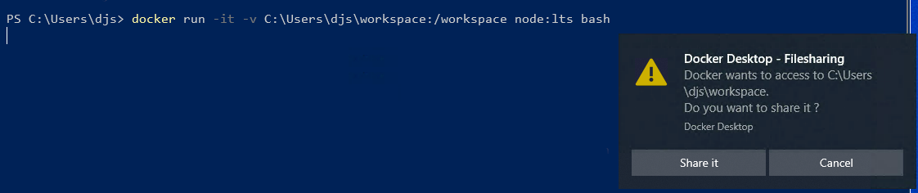

PROXIES

Docker Desktop lets you configure HTTP/HTTPS Proxy Settings and automatically propagates these to Docker. For example, if you set your proxy settings to http://proxy.example.com, Docker uses this proxy when pulling containers.

Your proxy settings, however, will not be propagated into the containers you start. If you wish to set the proxy settings for your containers, you need to define environment variables for them, just like you would do on Linux, for example:

> docker run -e HTTP_PROXY=https://proxy.example.com:3128 alpine env

PATH=/usr/local/sbin:/usr/local/bin:/usr/sbin:/usr/bin:/sbin:/bin

HOSTNAME=b7edf988b2b5

TERM=xterm

HOME=/root

HTTP_PROXY=http://proxy.example.com:3128

For more information on setting environment variables for running containers, see [Set environment variables](https://docs.docker.com/engine/reference/commandline/run/#set-environment-variables--e---env---env-file).

NETWORK

**Note**

The Network tab is not available in Windows container mode because networking is managed by Windows.

You can configure Docker Desktop networking to work on a virtual private network (VPN). Specify a network address translation (NAT) prefix and subnet mask to enable Internet connectivity.

**DNS Server**: You can configure the DNS server to use dynamic or static IP addressing.

**Note**

Some users reported problems connecting to Docker Hub on Docker Desktop. This would manifest as an error when trying to run docker commands that pull images from Docker Hub that are not already downloaded, such as a first time run of docker run hello-world. If you encounter this, reset the DNS server to use the Google DNS fixed address: 8.8.8.8. For more information, see [Networking issues](https://docs.docker.com/docker-for-windows/troubleshoot/#networking-issues) in Troubleshooting.

Updating these settings requires a reconfiguration and reboot of the Linux VM.

WSL INTEGRATION

In WSL 2 mode, you can configure which WSL 2 distributions will have the Docker WSL integration.

By default, the integration will be enabled on your default WSL distribution. To change your default WSL distro, run wsl --set-default <distro name>. (For example, to set Ubuntu as your default WSL distro, run wsl --set-default ubuntu).

You can also select any additional distributions you would like to enable the WSL 2 integration on.

For more details on configuring Docker Desktop to use WSL 2, see [Docker Desktop WSL 2 backend](https://docs.docker.com/docker-for-windows/wsl/).

Docker Engine

The Docker Engine page allows you to configure the Docker daemon to determine how your containers run.

Type a JSON configuration file in the box to configure the daemon settings. For a full list of options, see the Docker Engine [dockerd commandline reference](https://docs.docker.com/engine/reference/commandline/dockerd/).

Click **Apply & Restart** to save your settings and restart Docker Desktop.

Command Line

On the Command Line page, you can specify whether or not to enable experimental features.

You can toggle the experimental features on and off in Docker Desktop. If you toggle the experimental features off, Docker Desktop uses the current generally available release of Docker Engine.

EXPERIMENTAL FEATURES

Experimental features provide early access to future product functionality. These features are intended for testing and feedback only as they may change between releases without warning or can be removed entirely from a future release. Experimental features must not be used in production environments. Docker does not offer support for experimental features.

**To enable experimental features in the Docker CLI, edit the config.json file and set experimental to enabled.**

To enable experimental features from the Docker Desktop menu, click **Settings** (**Preferences** on macOS) > **Command Line** and then turn on the **Enable experimental features** toggle. Click **Apply & Restart**.

For a list of current experimental features in the Docker CLI, see [Docker CLI Experimental features](https://github.com/docker/cli/blob/master/experimental/README.md).

Run docker version to verify whether you have enabled experimental features. Experimental mode is listed under Server data. If Experimental is true, then Docker is running in experimental mode, as shown here:

> docker version

Client: Docker Engine - Community

Version: 19.03.1

API version: 1.40

Go version: go1.12.5

Git commit: 74b1e89

Built: Thu Jul 25 21:17:08 2019

OS/Arch: windows/amd64

Experimental: true

Server: Docker Engine - Community

Engine:

Version: 19.03.1

API version: 1.40 (minimum version 1.12)

Go version: go1.12.5

Git commit: 74b1e89

Built: Thu Jul 25 21:17:52 2019

OS/Arch: linux/amd64

Experimental: true

containerd:

Version: v1.2.6

GitCommit: 894b81a4b802e4eb2a91d1ce216b8817763c29fb

runc:

Version: 1.0.0-rc8

GitCommit: 425e105d5a03fabd737a126ad93d62a9eeede87f

docker-init:

Version: 0.18.0

GitCommit: fec3683

Kubernetes

**Note**

The Kubernetes tab is not available in Windows container mode.

Docker Desktop includes a standalone Kubernetes server that runs on your Windows host, so that you can test deploying your Docker workloads on Kubernetes.

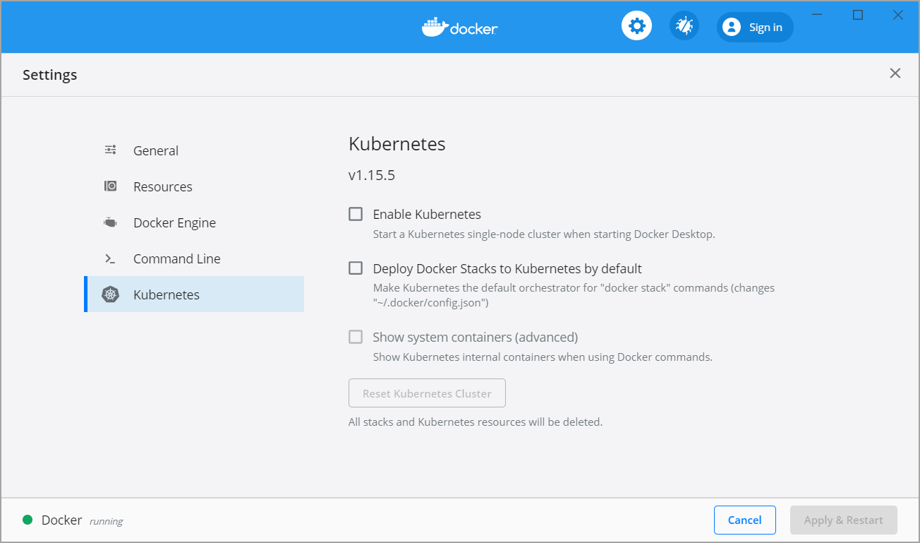

The Kubernetes client command, kubectl, is included and configured to connect to the local Kubernetes server. If you have kubectl already installed and pointing to some other environment, such as minikube or a GKE cluster, be sure to change context so that kubectl is pointing to docker-desktop:

> kubectl config get-contexts

> kubectl config use-context docker-desktop

To enable Kubernetes support and install a standalone instance of Kubernetes running as a Docker container, select **Enable Kubernetes**.

To set Kubernetes as the [default orchestrator](https://docs.docker.com/docker-for-windows/kubernetes/#override-the-default-orchestrator), select **Deploy Docker Stacks to Kubernetes by default**.

By default, Kubernetes containers are hidden from commands like docker service ls, because managing them manually is not supported. To make them visible, select **Show system containers (advanced)**. Most users do not need this option.

Click **Apply & Restart** to save the settings. This instantiates images required to run the Kubernetes server as containers, and installs the kubectl.exe command in the path.

* When Kubernetes is enabled and running, an additional status bar item displays at the bottom right of the Docker Desktop Settings dialog. The status of Kubernetes shows in the Docker menu and the context points to docker-desktop.
* To disable Kubernetes support at any time, clear the **Enable Kubernetes** check box. The Kubernetes containers are stopped and removed, and the /usr/local/bin/kubectl command is removed.
* To delete all stacks and Kubernetes resources, select **Reset Kubernetes Cluster**.
* If you installed kubectl by another method, and experience conflicts, remove it.

For more information on using the Kubernetes integration with Docker Desktop, see [Deploy on Kubernetes](https://docs.docker.com/docker-for-windows/kubernetes/).

Reset

The **Restart Docker Desktop** and **Reset to factory defaults** options are now available on the **Troubleshoot** menu. For information, see [Logs and Troubleshooting](https://docs.docker.com/docker-for-windows/troubleshoot/).

Troubleshoot

Visit our [Logs and Troubleshooting](https://docs.docker.com/docker-for-windows/troubleshoot/) guide for more details.

Log on to our [Docker Desktop for Windows forum](https://forums.docker.com/c/docker-for-windows) to get help from the community, review current user topics, or join a discussion.

Log on to [Docker Desktop for Windows issues on GitHub](https://github.com/docker/for-win/issues) to report bugs or problems and review community reported issues.

For information about providing feedback on the documentation or update it yourself, see [Contribute to documentation](https://docs.docker.com/opensource/).

Switch between Windows and Linux containers

From the Docker Desktop menu, you can toggle which daemon (Linux or Windows) the Docker CLI talks to. Select **Switch to Windows containers** to use Windows containers, or select **Switch to Linux containers** to use Linux containers (the default).

For more information on Windows containers, refer to the following documentation:

* Microsoft documentation on [Windows containers](https://docs.microsoft.com/en-us/virtualization/windowscontainers/about/index).
* [Build and Run Your First Windows Server Container (Blog Post)](https://blog.docker.com/2016/09/build-your-first-docker-windows-server-container/) gives a quick tour of how to build and run native Docker Windows containers on Windows 10 and Windows Server 2016 evaluation releases.
* [Getting Started with Windows Containers (Lab)](https://github.com/docker/labs/blob/master/windows/windows-containers/README.md) shows you how to use the [MusicStore](https://github.com/aspnet/MusicStore/blob/dev/README.md) application with Windows containers. The MusicStore is a standard .NET application and, [forked here to use containers](https://github.com/friism/MusicStore), is a good example of a multi-container application.
* To understand how to connect to Windows containers from the local host, see [Limitations of Windows containers for localhost and published ports](https://docs.docker.com/docker-for-windows/troubleshoot/#limitations-of-windows-containers-for-localhost-and-published-ports)

**Settings dialog changes with Windows containers**

When you switch to Windows containers, the Settings dialog only shows those tabs that are active and apply to your Windows containers:

* [General](https://docs.docker.com/docker-for-windows/#general)
* [Proxies](https://docs.docker.com/docker-for-windows/#proxies)
* [Daemon](https://docs.docker.com/docker-for-windows/#docker-daemon)
* [Reset](https://docs.docker.com/docker-for-windows/#reset)

If you set proxies or daemon configuration in Windows containers mode, these apply only on Windows containers. If you switch back to Linux containers, proxies and daemon configurations return to what you had set for Linux containers. Your Windows container settings are retained and become available again when you switch back.

Dashboard

The Docker Desktop Dashboard enables you to interact with containers and applications and manage the lifecycle of your applications directly from your machine. The Dashboard UI shows all running, stopped, and started containers with their state. It provides an intuitive interface to perform common actions to inspect and manage containers and Docker Compose applications. For more information, see [Docker Desktop Dashboard](https://docs.docker.com/desktop/dashboard/).

Docker Hub

Select **Sign in /Create Docker ID** from the Docker Desktop menu to access your [Docker Hub](https://hub.docker.com/) account. Once logged in, you can access your Docker Hub repositories directly from the Docker Desktop menu.

For more information, refer to the following [Docker Hub topics](https://docs.docker.com/docker-hub/):

* [Organizations and Teams in Docker Hub](https://docs.docker.com/docker-hub/orgs/)
* [Builds and Images](https://docs.docker.com/docker-hub/builds/)

Two-factor authentication

Docker Desktop enables you to sign into Docker Hub using two-factor authentication. Two-factor authentication provides an extra layer of security when accessing your Docker Hub account.

You must enable two-factor authentication in Docker Hub before signing into your Docker Hub account through Docker Desktop. For instructions, see [Enable two-factor authentication for Docker Hub](https://docs.docker.com/docker-hub/2fa/).

After you have enabled two-factor authentication:

1. Go to the Docker Desktop menu and then select **Sign in / Create Docker ID**.
2. Enter your Docker ID and password and click **Sign in**.
3. After you have successfully signed in, Docker Desktop prompts you to enter the authentication code. Enter the six-digit code from your phone and then click **Verify**.

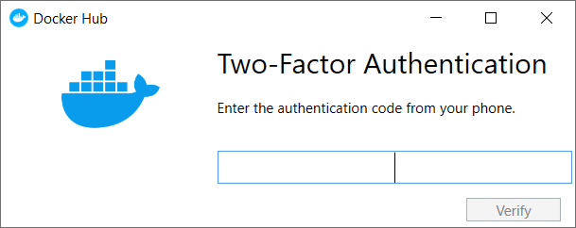

After you have successfully authenticated, you can access your organizations and repositories directly from the Docker Desktop menu.

Adding TLS certificates

You can add trusted **Certificate Authorities (CAs)** to your Docker daemon to verify registry server certificates, and **client certificates**, to authenticate to registries. For more information, see [How do I add custom CA certificates?](https://docs.docker.com/docker-for-windows/faqs/#how-do-i-add-custom-ca-certificates) and [How do I add client certificates?](https://docs.docker.com/docker-for-windows/faqs/#how-do-i-add-client-certificates) in the FAQs.

How do I add custom CA certificates?

Docker Desktop supports all trusted Certificate Authorities (CAs) (root or intermediate). Docker recognizes certs stored under Trust Root Certification Authorities or Intermediate Certification Authorities.

Docker Desktop creates a certificate bundle of all user-trusted CAs based on the Windows certificate store, and appends it to Moby trusted certificates. Therefore, if an enterprise SSL certificate is trusted by the user on the host, it is trusted by Docker Desktop.

To learn more about how to install a CA root certificate for the registry, see [Verify repository client with certificates](https://docs.docker.com/engine/security/certificates/) in the Docker Engine topics.

How do I add client certificates?

You can add your client certificates in ~/.docker/certs.d/<MyRegistry>:<Port>/client.cert and ~/.docker/certs.d/<MyRegistry>:<Port>/client.key. You do not need to push your certificates with git commands.

When the Docker Desktop application starts, it copies the ~/.docker/certs.d folder on your Windows system to the /etc/docker/certs.d directory on Moby (the Docker Desktop virtual machine running on Hyper-V).

You need to restart Docker Desktop after making any changes to the keychain or to the ~/.docker/certs.d directory in order for the changes to take effect.

The registry cannot be listed as an *insecure registry* (see [Docker Daemon](https://docs.docker.com/docker-for-windows/#docker-engine)). Docker Desktop ignores certificates listed under insecure registries, and does not send client certificates. Commands like docker run that attempt to pull from the registry produce error messages on the command line, as well as on the registry.

To learn more about how to set the client TLS certificate for verification, see [Verify repository client with certificates](https://docs.docker.com/engine/security/certificates/) in the Docker Engine topics.

Where to go next[🔗](https://docs.docker.com/docker-for-windows/#where-to-go-next)

* Try out the walkthrough at [Get Started](https://docs.docker.com/get-started/).
* Dig in deeper with [Docker Labs](https://github.com/docker/labs/) example walkthroughs and source code.
* Refer to the [Docker CLI Reference Guide](https://docs.docker.com/engine/reference/commandline/cli/).