VirtualBox has

* full support for
  + VDI
  + VMDK
  + VHD
* partial support for
  + HDD (Parallels version 2 only)
* and [undocumented](https://www.virtualbox.org/svn/vbox/trunk/src/VBox/Storage/) support for
  + QCOW
  + QED

Source:[Oracle® VM VirtualBox® User Manual](https://www.virtualbox.org/manual/)»[Chapter 5. Virtual Storage](https://www.virtualbox.org/manual/ch05.html)»[5.2. Disk Image Files (VDI, VMDK, VHD, HDD)](https://www.virtualbox.org/manual/ch05.html#vdidetails)

[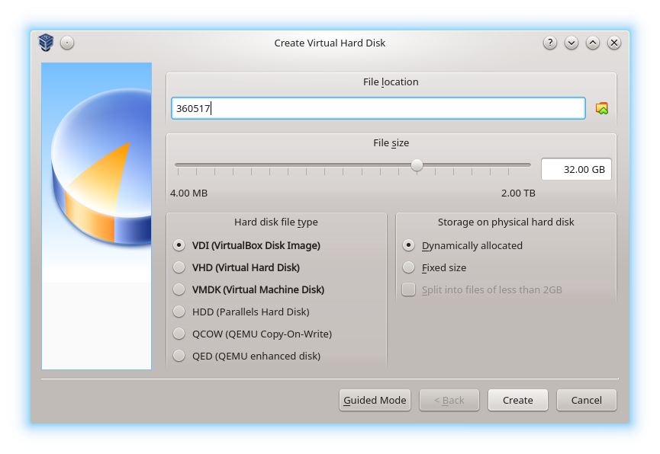](https://i.stack.imgur.com/170Fo.png)

Answering Your Considerations

* be able to use dynamic sizing

**VDI**, **VMDK**, and **VHD** all support dynamically allocated storage. VMDK has an additional capability of splitting the storage file into files less than 2 GB each, which is useful if your file system has a small file size limit.

**HDD**, **QCOW**, and **QED** have to be dynamically allocated if created in VirtualBox.

* be able to have snapshots

VirtualBox supports snapshotting of **all six formats**.

* be able to move my virtual machine to another OS or even another free virtualization solution with minimal effort (probably something that would run fine on Ubuntu).

**VDI** is the native format of VirtualBox. Other virtualization software generally don't support VDI, but it's pretty easy to convert from VDI to another format, especially with [qemu-img convert](https://linux.die.net/man/1/qemu-img).

**VMDK** is developed by and for VMWare, but VirtualBox and QEMU (another common virtualization software) also support it. *This format might be the the best choice for you because you want wide compatibility with other virtualization software.*

**VHD** is the native format of Microsoft Virtual PC. Windows Server 2012 introduced VHDX as the successor to VHD, but VirtualBox does not support VHDX.

**HDD** is a format for [Parallels](https://www.parallels.com/). Parallels specializes in virtualization for macOS. *This probably isn't suitable for you, especially considering that VirtualBox only supports an old version of the HDD format.*

**QCOW** is the old original version of the qcow format. It has been superseded by qcow2, which VirtualBox does not support.

**QED** was an abandoned enhancement of qcow2. [QEMU advises against using QED.](https://wiki.qemu.org/Features/QED)

* performance

Each of the formats may have nuanced performance characteristics due to how the block storage is abstracted by the format, but I haven't found any benchmarks comparing the VirtualBox-supported formats.

There are bigger factors that influence performance, such as:

* your physical device limitations (much more noticeable on a hard disk drive than a [solid-state drive](http://en.wikipedia.org/wiki/Solid-state_drive)… [**Why?**](https://web.archive.org/web/20130430233221/https:/superuser.com/questions/318724/what-are-the-pros-and-cons-of-a-solid-state-drive))
* expanding a dynamically allocated virtual disk drive (write operations are slower as the virtual disk expands, but once it's large enough, expanding should happen less)
* virtualization technology ([hardware vs. software](https://www.virtualbox.org/manual/ch10.html#hwvirt); hardware virtualization helps VirtualBox and improves the speed of virtual operating systems)
* the fact that you are running a virtual operating system. Performance is always slower than running an operating system on the host because of the virtualization overhead.