**Web Services Management Concern**

As Web services become pervasive and critical to business operations, the task of managing Web services and the Web services architecture will be imperative to the success of such operations. Management in this case is defined as a set of capabilities for; discovering the existence, availability, health, and usage, as well the control and configuration of resources, where resources are defined as Web services, components of the Web services architecture, and roles undertaken in the architecture.

**Managed Resources**includes the components of the Web service architecture (Service, Service Environment, Client, Client Environment, Service Description) and roles defined in a Web service architecture (Discovery Agency, Requestor, Providor).

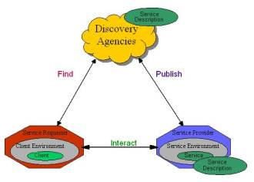

**Management** includes the systems that use information and control mechanisms exposed by the resources to be managed. For example, Management systems may use and correlate information to determine and display topologies, status, events. Mangement systems may also use this information to monitor and compare with policies for automated control or configuration.

**Manageability**includes the information and control semantics that managed resources expose to management systems. Manageability information includes identification, configuration, metrics, operations, and events for the resource. It also includes the means by which manageability is exposed to management applications and mechanisms for control and configuration.

As a result of these definitions it is useful to introduce the role of the **Manager** which uses the manageability information provided by the manageable resources. Since, the manager needs to be able to manage all of the components of the Web services architecture, it needs to be able to ‘discover’ manageable resources and access management information of the resource, as well as utilise the control and configuration mechanisms exposed. The Web service Managemnt Architecture (WSMA) will define the basic set of management information, and control mechanisms supported by each resource identified in the architecture The definition of the ‘Manager’ role, beyond  the information model offered to it and how it interacts with the existing roles of the Web services architecture, is outside the scope of this architecture document, which will neither define how the Manager is implemented or how an implementaion is to use the manageability information.

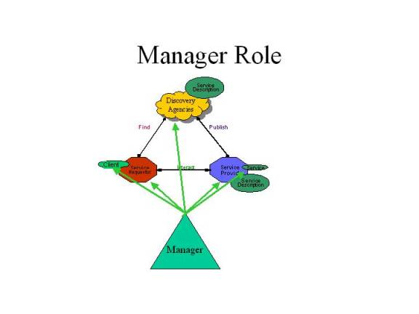

The management concern is satisfied by defining the architecture necessary to make a Web service architecture implementation and a Web service implementation manageable. This architecture must define the minimum, basic information, metrics, configuration, operations, events, and behaviors that a Web services architecture component must implement in order to be called a ‘manageable Web services architecture component’.  Not all components must be manageable.  Not all Web services architecture implementations must be manageable. Support of this manageable Web services architecture by implementations of the Web services architeture is higly recommended, but not required.

To summarize, the Web Services Management Architecture (WSMA) does not specify how management concept should to be implemented and does not prescribe any specific management systems. WSMA defines

* Extensible Management Information Schema that directly correlates with the WS Architecture roles
* Base set of Management Operations/Events (Manageability) that WS Architecture roles need to provide
* Access to Management Information/Operations/Events (Manageability)
* Discovery of Access to Management Information

Essentially, WS MA defines an extensible information set and information flow that enable various interested parties to realize management of implementations of Web Services and Web Services Architectures.

**Manageable Components**

In order for the Web service architecture to be manageable, each of the components of the architeture must be manageable.

Service environment concept is critical to managing Web services. For the components of a web service application, supporting a management environment can add significant complexity to an application. The service environment should simplify this for services by automatically providing metrics, audit logs, start/stop processing, event notification, and other management functions as part of a services execution environment. Since not all information can be gleaned by the infrastructure through observing the behavior of the components it hosts, a web service implementation may need to provide basic health and monitoring information to its hosting environment or directly to the manager.

At this time the components to be managed are:

·        Service Environment

·        Web Service

·        Discovery Agency

Additional managable components may emerge as the architecture definition progresses, including Client Environment, Client, Intermediary, Gateway, Hosted Service, and Service Proxy.

**Manageability Information**

The following management information categories must be defined for each manageable component:

* Identification – read only data that uniquely identifies the component. This data may include information that is not required for unique identification as well.
* Configuration – read only and read/writeable data that represents the configuration of the data component
* Metrics – a value that captures a state at a point in time. Generally these values are numeric, but may be strings as well. A service should allow customization so that metrics can be returned that reflect values accumulated since the service status became ‘Up’, within a sliding window relative to ‘now’ or current time, and within a time interval. A service must declare in its management portType which of these metric interval types are supported.
* Operations – methods that control the component. Operations are distinct from configuration changes in that configuration changes are generally persistent over interations/instances of the component. Operations includes lifecycle control.
* Events – one way messages from the component that indicate a problem, a lifecycle state change, or a state change.

**Access to Manageability Information**

In addition to defining the information to be exposed by a manageable component, this architecture must define a standard means to access this information. Access must be defined for the management information from the  Web Service Execution Environment, Web Service, Discovery Agency, and Web Service client.

**Manageability Discovery**

Finally, it must be possible for the manageability information and access to that information to be discovered. Hence we need to define the discovery of managable components as well as the management information.

**Realization in Web Services Architecture**

Since the Web services architecture defines how to define information, operations, and notifications through WSDL portTypes, access through bindings, and locateability through ports, it is consistent to use the Web services architecture to describe as well as provide access to and discoverability of the manageable components of the Web services architecture itself.

A Web service can define its manageability information in a portType and service that is available to the manager or environment. A manageability service WSDL document can be defined that a web service implements to provide access to a web service’s management information by management systems.  This interface would include the ability to get configuration and metric data, update configurations, and receive events from manageable web service that the manageability service represents.  Other components of the Web services architecture can provide their own manageability portTypes and ports as well.

The management interface, or service port, of a Web Service, Execution Environment, or Discovery Agency is identified by a URI. This URI will be bound directly to a port type described by WSDL.  The WSDL document may contain multiple bindings, including a SOAP over HTTP and an HTTP binding, which allows direct HTTP Get of  manageability data items via a URL. The manageability WSDL should be published or advertised to a discovery agency. This provides for the following variation of the Web services oriented architecture triangle:

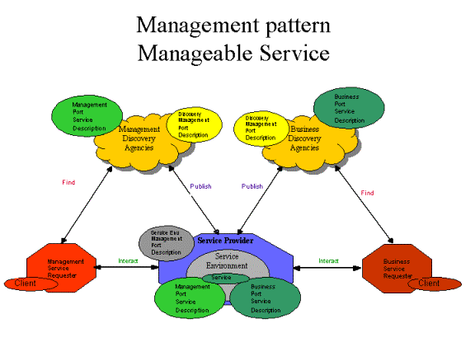

In this scenario we take the Web services architectural triangle, we can decorate it with the artifacts and roles for management activities. In this example we add the following artifacts

1.      An service environment that the service runs in. The service environment is part of the service provider

2.      A management portType for the execution environment which it advertises (grey oval).

3.      Management portTypes for the Discovery Agencies which they advertise (yellow oval).

4.      A management portType for the service which the service provider advertises (green oval)

5.      A business portType and for the service which the service provider advertises

6.      A discovery agency for management portTypes. The management portType is advertised with a different discovery agency than the busines portType. This is for illustration purposes only and certainly the both portTypes could be available from the same discovery agency.

7.      A business service requester (i.e. stockquote requester) which has access to the business operations.

8.      A separate management service requester which has access to the management operations. Certainly, these requesters could be one and the same.

In this scenario, a manageable service is advertised by the service provider in a management discovery agency. The management service requester discovers the existence and interface of a manageable Web service. It then interacts with the management portType to access the management data of the service.

This same scenario works for management requesters who want to interact with the management PortTypes of the discovery agencies and execution environment. The management service requester can discover the managability portType for the discovery agencies, service environment, and service and interace with any of these component just like the example of their interaction with a service.

This scenario is not meant to be exclusive of all other ways to advertise and pass manageability information to managers.

* Management Using Web Services (MUWS) — WSDM MUWS defines how to represent and access the manageability interfaces of resources as Web services. It defines a basic set of manageability capabilities, such as resource identity, metrics, configuration, and relationships, which can be composed to express the capability of the management instrumentation. WSDM MUWS also provides a standard management event format to improve interoperability and correlation.
* Management Of Web Services (MOWS) — WSDM MOWS defines how to manage Web services as resources and how to describe and access that manageability using MUWS. MOWS provides mechanisms and methodologies that enable manageable Web services applications to interoperate across enterprise and organizational boundaries.