Switching from LightDM to the "older" GDM is very easy, and need not even involve opening a terminal.

Note:

* *If you need/want to do this from a terminal (e.g. recovery console), please scroll below the screenshots for a how-to.*
* **Also**, [the "new" GDM](https://askubuntu.com/questions/64797/how-to-get-gnome-3-2-login-manager-installed) is not covered here because it is not officially available for 12.04 and the unofficial packages do not work for most users.

Easily switch to GDM with the Software Centre

1. Open the Software Center, type "gdm" in the search box, and click on *Install* as shown below, or click on this button: [gdm](https://apps.ubuntu.com/cat/applications/gdm)

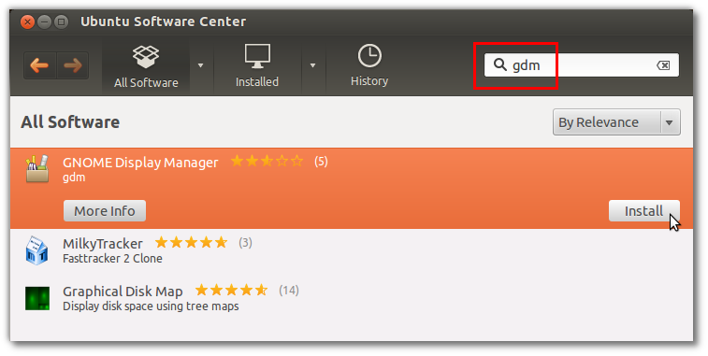

1. After you enter your password, you will get the configuration screen shown below. Change *lightdm* to *gdm* and click on *Forward*:

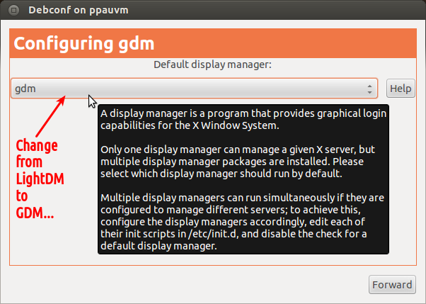

1. Restart your computer, and you should now have the "old" GDM login screen; note that you can still select from any available session, including Ubuntu (3D), Ubuntu 2D, Gnome, Gnome Classic, etc.

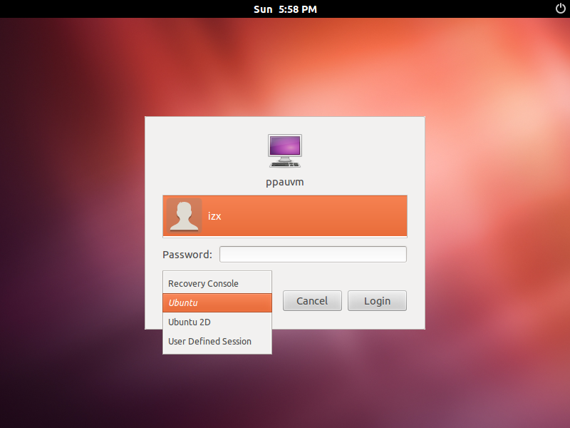

Switch to GDM via the terminal

1. Open a terminal with Ctrl+Alt+T if you are on the desktop and not in the recovery console.
2. Type sudo apt-get install gdm, and then your password when prompted or run sudo dpkg-reconfigure gdm then sudo service lightdm stop, in case gdm is already installed.
3. A "Package Configuration" dialog will be displayed; click OK to proceed to the below screen. Use the arrow-keys to select gdm instead of lightdm, press Tab to move to OK, and press Enter.

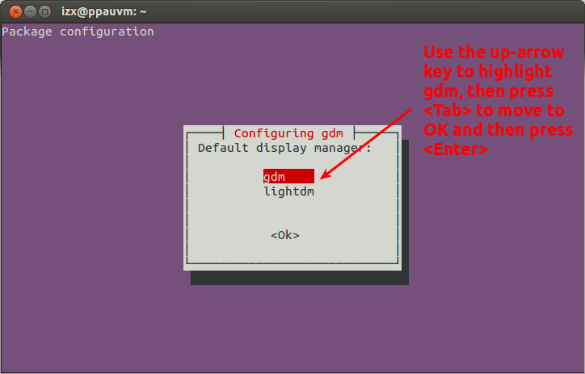

1. Reboot the computer (you can do this with sudo reboot if in the recovery console).

sudo dpkg-reconfigure gdm3

systemctl stop lightdm

systemctl start gdm3