**4 Commands to Find Linux Kernel Version**

**uname Command**

Launch a terminal window, then enter the following:

uname –r

The system will return a numeric code, for example:

3.10.0-957.21.2.

Each number, separated by a dot or hyphen, is part of a code:

* **3** – This is the **main kernel** **version**
* **.10** – This is the **major release** **version**
* **.0 –** This is the **minor revision** **level**
* **-957** – This is the**level of patches and bug fixes**

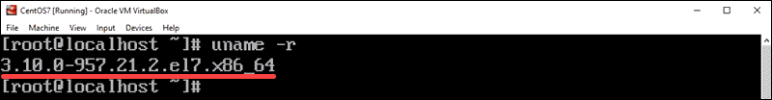

The **uname** command includes additional options that you can use to get more information about your kernel. Simply add an option after the command:

* **-a** – Display **all information**
* **-o** – Display the **operating system** (usually GNU/Linux)
* **-r** – Display **kernel release**
* **-v** – Display **kernel version** (usually includes the base OS and time the kernel was compiled)

For a full list of **uname** commands, enter

uname ––help

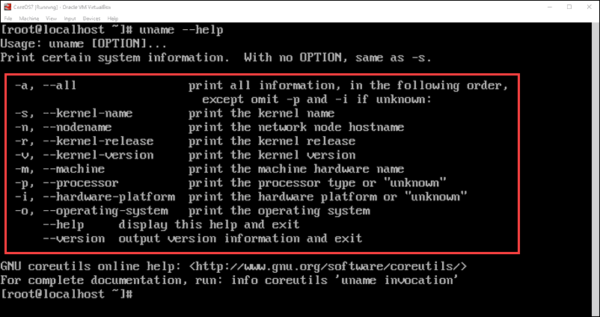

**Note:** Your kernel version will likely be different than this example. At the time of writing this article, the latest version is [Linux kernel 5.0](https://phoenixnap.com/kb/linux-kernel-5-0-released).

**hostnamectl Command**

The **hostnamectl** command is typically used to display information about the system’s network configuration. It also displays the kernel version.

To check the kernel version, enter the following:

hostnamectl

The second-to-last line should read:

Kernel: Linux 3.10.0-957.21.2.el7.x86_64

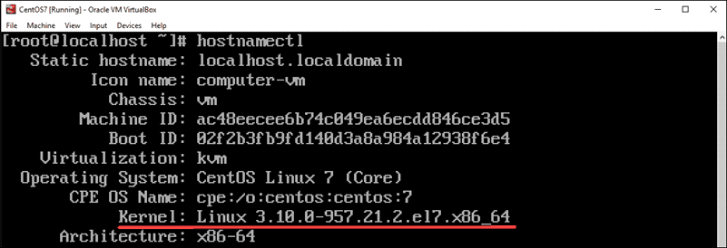

**Display the /proc/version File**

To display the **proc/version** file, enter the command:

cat /proc/version

The **cat** command displays the contents of the **/proc/version** file. This will output the Linux kernel version first, along with additional data about your operating system.

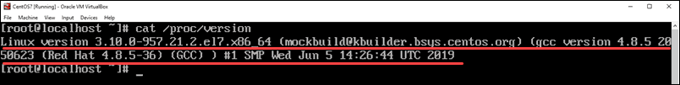

**dmesg Command**

The **dmesg** command is used to print the message buffer of the kernel. This is usually used to read messages from device drivers, but it can also be used to find the kernel version.

Enter the command:

dmesg | grep Linux

The **|** (pipe) symbol is usually on the same key as the **\** symbol, just above the enter key.

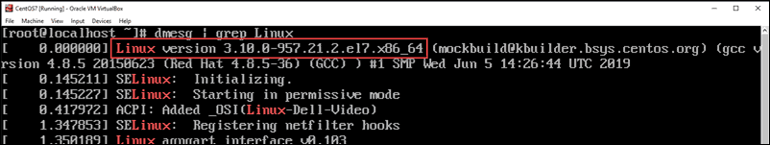

The commands work as follows:

* **dmesg** – read the contents of the kernel buffer
* **|** – pipe the command into the next command
* **grep** – [search for a particular string of characters](https://phoenixnap.com/kb/grep-command-linux-unix-examples#htoc-to-show-only-the-lines-that-exactly-match-search-string), and display lines that contain them
* **Linux** – the exact string of characters that **grep** should search for (capitalization matters)

The first line of output displays the Linux kernel version.

**Note:** When [updating your kernel](https://phoenixnap.com/kb/how-to-update-kernel-ubuntu), it is recommended that you choose a release version that’s compatible with your version of Linux. Your package manager will typically give you kernel versions that are tested and verified.

**Conclusion**

This guide showed you several different ways to check the Linux kernel version. Since you’re only reading the output of a file, you shouldn’t need **sudo** privileges.