How to create a file in Linux using the bash shell terminal

Author: Vivek Gite Last updated: December 2, 2018 [4 comments](https://www.cyberciti.biz/faq/create-a-file-in-linux-using-the-bash-shell-terminal/#comments)

[](https://www.cyberciti.biz/faq/category/linux/)

Iam a new Linux system user. How do I create a file in Linux using the bash shell terminal? What is the fastest and easiest way to create a file in a Linux terminal?  
  
*Introduction* – A file is nothing but a container in a Linux based system for storing information. For example, music stored in a file named foo.mp4. Similarly, my cat’s picture stored in kitten.jpg and so on. This page shows various methods to create a file in Linux using the terminal window.

ADVERTISEMENTS

How to create a file in Linux from terminal window?

1. Create an empty text file named foo.txt:  
   **touch foo.bar**  
   OR  
   **> foo.bar**
2. Make a text file on Linux:  
   **cat > filename.txt**
3. Add data and press CTRL+D to save the filename.txt when using cat on Linux
4. Run shell command:  
   **echo 'This is a test' > data.txt**

Let us see some examples for creating a text files on Linux operating systems.

How to create a text file using the [cat command](https://www.cyberciti.biz/faq/linux-unix-appleosx-bsd-cat-command-examples/)

To create a text file named sales.txt, type the following command and then press [Enter] key:  
cat > sales.txt  
Now type your lines of text. For example:

Month, Profit

01/Apr/2004, $1500

01/May/2004, $1600

01/Jun/2004, $1450

01/Jul/2004, $1950

01/Aug/2004, $3950

01/Sep/2004, $2950

01/Oct/2004, $1750

01/Nov/2004, $1950

01/Dec/2004, $3250

When done and you need to save and exit, press Ctrl+D to return to the bash shell prompt. To view file use cat or more command/less command:  
cat sales.txt  
more sales.txt

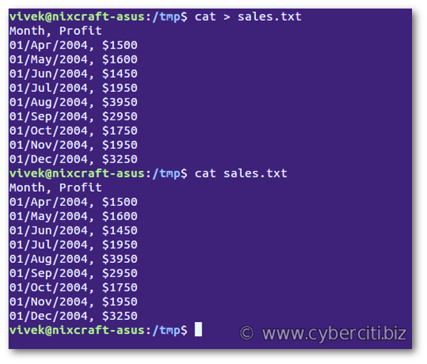

How to create a file in Linux from terminal window

See also: [Redirection of standard output](https://bash.cyberciti.biz/guide/Redirection_of_standard_output)

How to create an empty text file using the touch command

Simply type any one of the following command:  
> data.txt  
OR  
touch test.txt  
Verify that empty files are created with the help of ls command:  
ls -l data.txt test.txt  
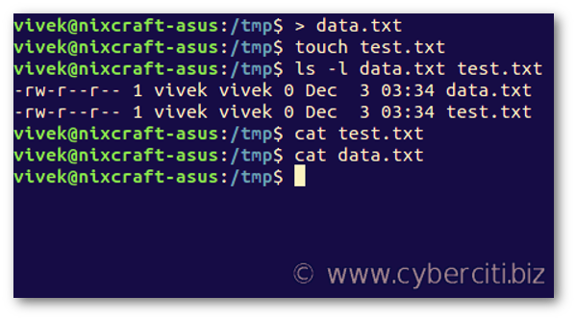

Creating a file in Linux using the echo or printf

Let us create a file called quote1.txt using echo command, enter:  
echo "While I thought that I was learning how to live, I have been learning how to die." > quote1.txt  
OR use the printf commandprintf 'Study nature, love nature, stay close to nature. It will never fail you.\n' > quote2.txt

How to create a file in Linux using joe text editor

JOE is text editor. To create a file called delta.txt, type:  
joe -help delta.txt  
You will see help menu on screen. Next type something. To save the file and leave joe, by typing ^KX (press CTRL+K+X).

How to create a text file in Linux using vi / vim text editor

The vi / vim is another text editor. To create a file called purchase.txt, type:  
vi purchase.txt  
OR  
vim purchase.txt  
Press i to insert new text. To [save the file and leave vi](https://www.cyberciti.biz/faq/save-file-in-vi-vim-linux-apple-macos-unix-bsd/), type ESC+:+x (press ESC key, type : followed by x and [enter] key).

Conclusion

You learned various methods that allow you to create text files in a Linux terminal window quickly.