[UPDATING](https://tb-manual.torproject.org/updating/)

Tor Browser must be kept updated at all times. If you continue to use an outdated version of the software, you may be vulnerable to serious security flaws that compromise your privacy and anonymity.

Tor Browser will prompt you to update the software once a new version has been released: the Torbutton icon will display a yellow triangle, and you may see a written update indicator when Tor Browser opens. You can update either automatically or manually.

UPDATING TOR BROWSER AUTOMATICALLY

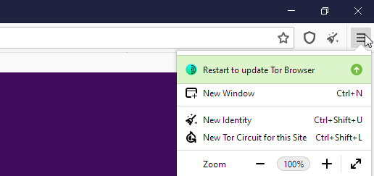

When you are prompted to update Tor Browser, click on hamburger menu (main menu), then select “Restart to update Tor browser”.

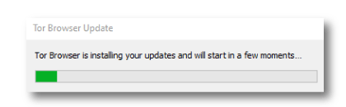

Wait for the update to download and install, then Tor Browser will restart itself. You will now be running the latest version.

UPDATING TOR BROWSER MANUALLY

When you are prompted to update Tor Browser, finish the browsing session and close the program.

Remove Tor Browser from your system by deleting the folder that contains it (see the [Uninstalling](https://tb-manual.torproject.org/uninstalling) section for more information).

Visit <https://www.torproject.org/download/> and download a copy of the latest Tor Browser release, then install it as before.

[TROUBLESHOOTING](https://tb-manual.torproject.org/troubleshooting/)

You should be able to start browsing the web using Tor Browser shortly after running the program, and clicking the “Connect” button if you are using it for the first time.

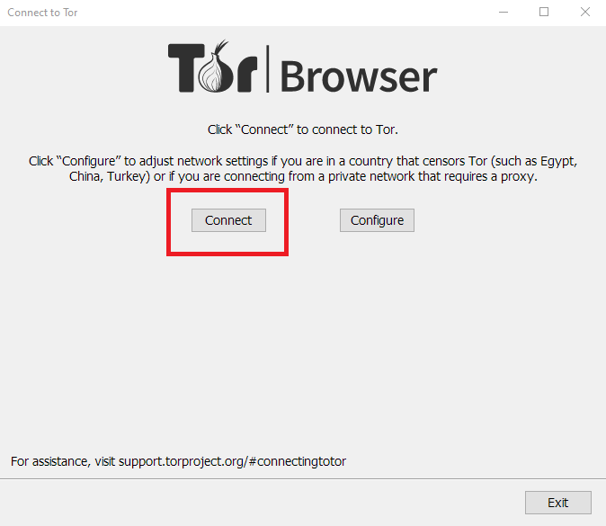

QUICK FIXES

If Tor Browser doesn’t connect, there may be a simple solution. Try each of the following:

* Your computer’s system clock must be set correctly, or Tor will not be able to connect.
* Make sure another Tor Browser is not already running. If you’re not sure if Tor Browser is running, restart your computer.
* Make sure that any antivirus program you have installed is not preventing Tor from running. You may need to consult the documentation for your antivirus software if you do not know how to do this.
* Temporarily disable your firewall.
* Delete Tor Browser and install it again. If updating, do not just overwrite your previous Tor Browser files; ensure they are fully deleted beforehand.

IS YOUR CONNECTION CENSORED?

If you still can’t connect, your Internet Service Provider might be censoring connections to the Tor network. Read the [Circumvention](https://tb-manual.torproject.org/circumvention) section for possible solutions.

KNOWN ISSUES

Tor Browser is under constant development, and some issues are known about but not yet fixed. Please check the [Known Issues](https://tb-manual.torproject.org/known-issues) page to see if the problem you are experiencing is already listed there.

##### [PLUGINS, ADD-ONS AND JAVASCRIPT](https://tb-manual.torproject.org/plugins/)

### FLASH PLAYER

Video websites, such as Vimeo make use of the Flash Player plugin to display video content. Unfortunately, this software operates independently of Tor Browser and cannot easily be made to obey Tor Browser’s proxy settings. It can therefore reveal your real location and IP address to the website operators, or to an outside observer. For this reason, Flash is disabled by default in Tor Browser, and enabling it is not recommended.

Some video websites (such as YouTube) offer alternative video delivery methods that do not use Flash. These methods may be compatible with Tor Browser.

### JAVASCRIPT

JavaScript is a programming language that websites use to offer interactive elements such as video, animation, audio, and status timelines. Unfortunately, JavaScript can also enable attacks on the security of the browser, which might lead to deanonymization.

Tor Browser includes an add-on called NoScript. It's accessible through 'Preferences' on hamburger menu (main menu), then select 'Customize' and drag the “S” icon to the top-right of the window. NoScript allows you to control the JavaScript (and other scripts) that runs on individual web pages, or block it entirely.

Users who require a high degree of security in their web browsing should set Tor Browser’s [Security Level](https://tb-manual.torproject.org/security-settings/) to “Safer” (which disables JavaScript for non-HTTPS websites) or “Safest” (which does so for all websites). However, disabling JavaScript will prevent many websites from displaying correctly, so Tor Browser’s default setting is to allow all websites to run scripts in "Standard" mode.

### BROWSER ADD-ONS

Tor Browser is based on Firefox, and any browser add-ons or themes that are compatible with Firefox can also be installed in Tor Browser.

However, the only add-ons that have been tested for use with Tor Browser are those included by default. Installing any other browser add-ons may break functionality in Tor Browser or cause more serious problems that affect your privacy and security. It is strongly discouraged to install additional add-ons, and the Tor Project will not offer support for these configurations.

[UNINSTALLING](https://tb-manual.torproject.org/uninstalling/)

Removing Tor Browser from your system is simple:

On Windows:

* Locate your Tor Browser folder or application. The default location is the Desktop.
* Delete the Tor Browser folder or application.
* Empty your Trash.

On macOS:

* Locate your Tor Browser application. The default location is the Applications folder.
* Move the Tor Browser application to Trash.
* Go to your ~/Library/Application Support/ folder.
* Note the Library folder is hidden on newer versions of macOS. To navigate to this folder in Finder, select "Go to Folder..." in the "Go" menu.

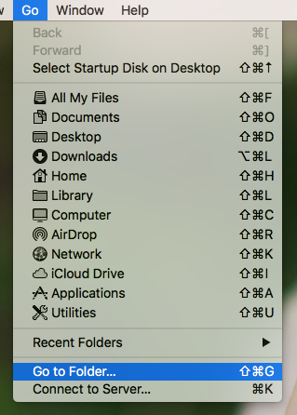

* Then type "~/Library/Application Support/" in the window and click Go.

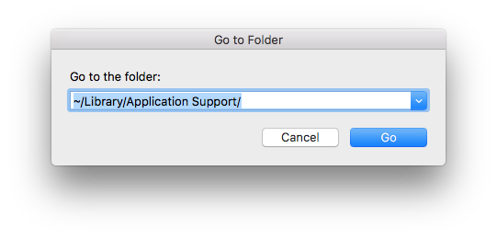

* Locate the TorBrowser-Data folder and move it to Trash.
* Empty your Trash.

Note that if you did not install Tor Browser in the default location (the Applications folder), then the TorBrowser-Data folder is not located in the ~/Library/Application Support/ folder, but in the same folder where you installed Tor Browser.

On Linux:

* Locate your Tor Browser folder. On Linux, there is no default location, however the folder will be named "tor-browser_en-US" if you are running the English Tor Browser.
* Delete the Tor Browser folder.
* Empty your Trash.

Note that your operating system’s standard "Uninstall" utility is not used.

##### [MOBILE TOR](https://tb-manual.torproject.org/mobile-tor/)

### Tor Browser for Android

Tor Browser for Android is the only official mobile browser supported and developed by the Tor Project. It is like the desktop Tor Browser, but for your Android mobile device. Some of the prime features of Tor Browser for Android include: reducing tracking across websites, defending against surveillance, resisting browser fingerprinting, and circumventing censorship.

### DOWNLOADING AND INSTALLATION

There exists Tor Browser for Android and Tor Browser for Android (alpha). Non-technical users should get Tor Browser for Android, as this is stable and less prone to errors. Tor Browser for Android is available on Play Store, F-droid and the Tor Project website. It is very risky to download Tor Browser outside of these three platforms.

#### **Google Play**

You can install Tor Browser for Android from [Google Play Store](https://play.google.com/store/apps/details?id=org.torproject.torbrowser).

#### **F-Droid**

The Guardian Project provides Tor Browser for Android on their F-Droid repository. If you would prefer installing the app from F-Droid, please follow these steps:

1. Install the F-Droid app on your Android device from [the F-droid website.](https://f-droid.org/)
2. After installing F-Droid, open the app.
3. At the lower-right-hand corner, open "Settings".
4. Under the "My Apps" section, open Repositories.
5. Toggle "Guardian Project Official Releases" as enabled.
6. Now F-Droid downloads the list of apps from the Guardian Project's repository (Note: this may take a few minutes).
7. Tap the Back button at the upper-left-hand corner.
8. Open "Latest" at the lower-left-hand corner.
9. Open the search screen by tapping the magnifying glass at the lower-right side.
10. Search for "Tor Browser for Android".
11. Open the query result by "The Tor Project" and install.

#### **The Tor Project website**

You can also get Tor Browser for Android by downloading and installing the apk from the [Tor Project website](https://www.torproject.org/download/#android).

### RUNNING TOR BROWSER FOR ANDROID FOR THE FIRST TIME

When you run Tor Browser for the first time, you will see the option to connect directly to the Tor network, or to configure Tor Browser for your connection with the settings icon.

#### **Connect**

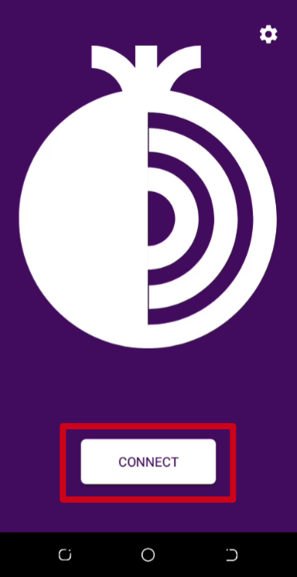

In most cases, choosing "Connect" will allow you to connect to the Tor network without any further configuration. Once clicked, changing sentences will appear at the bottom of the screen, indicating Tor’s connection progress. If you are on a relatively fast connection, but this text seems to get stuck at a certain point, see the [Troubleshooting](https://tb-manual.torproject.org/troubleshooting) page for help solving the problem.

#### **Configure**

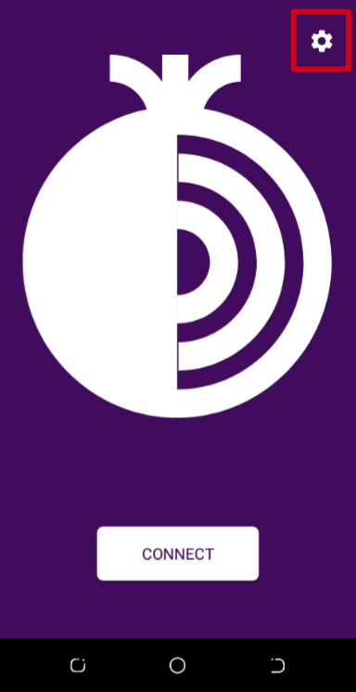

If you know that your connection is censored, you should select the settings icon. Tor Browser will take you through a series of configuration options. The first screen asks if access to the Tor network is blocked or censored on your connection. If you know your connection is censored, or you have tried and failed to connect to the Tor network and no other solutions have worked, click the switch. You will then be taken to the [Circumvention](https://tb-manual.torproject.org/circumvention) screen to configure a pluggable transport.

### CIRCUMVENTION

Bridge relays are Tor relays that are not listed in the public Tor directory. Bridges are useful for Tor users under oppressive regimes, and for people who want an extra layer of security because they're worried somebody will recognize that they are contacting a public Tor relay IP address.

To use a pluggable transport, click on the settings icon when starting Tor Browser for the first time. The first screen asks if access to the Tor network is censored on your connection. Click on the switch to toggle it.

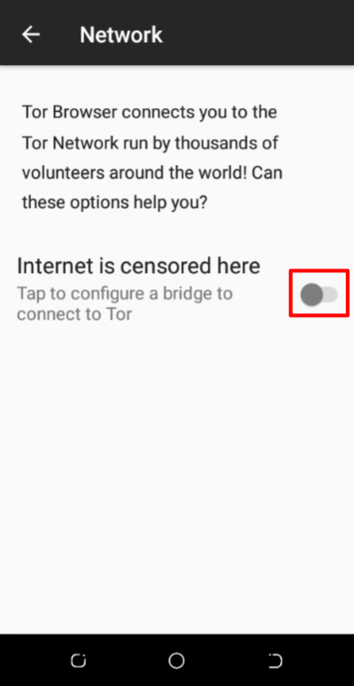

The next screen provides the option to either use a built-in bridge or custom bridge. With the "Select a bridge" option, you will have two options: "obfs4" and "meek-azure".

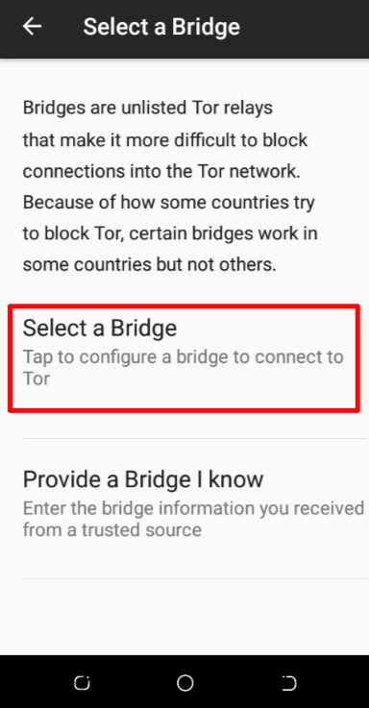

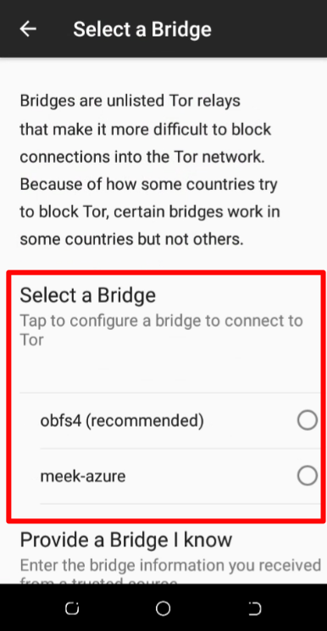

If you choose the "Provide a Bridge I know" option, then you have to enter a [bridge address](https://tb-manual.torproject.org/bridges/).

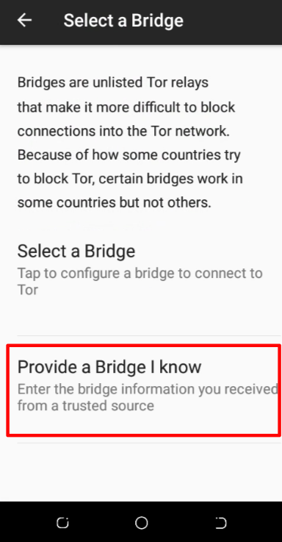

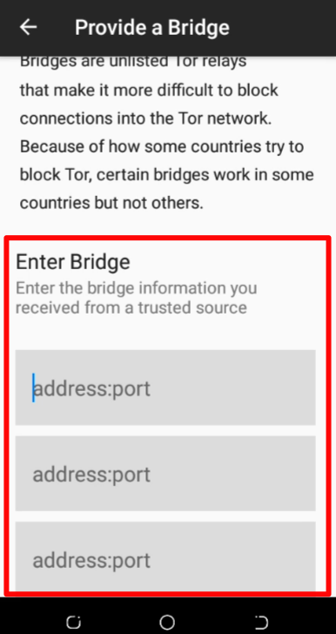

### MANAGING IDENTITIES

#### **New Identity**

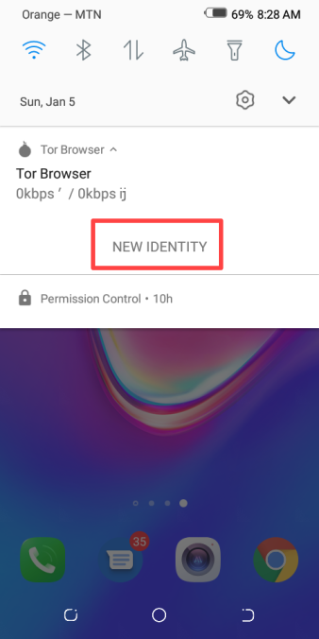

When Tor Browser is running, you would see so in your phone's notification panel along with the button "NEW IDENTITY". Clicking on this button will provide you with a new identity. Unlike in Tor Browser for Desktop, the "NEW IDENTITY" button in Tor Browser for Android does not prevent your subsequent browser activity from being linkable to what you were doing before. Selecting it will only change your Tor circuit.

### SECURITY SETTINGS



[Security settings](https://tb-manual.torproject.org/security-settings/) disable certain web features that can be used to attack your security and anonymity. Tor Browser for Android provides the same three security levels that are available on desktop. You can modify the security level by following given steps:

* Tap on a button of 3 vertical dots in URL bar.
* Scroll down and tap on "Security Settings".
* You can now select an option from the security level slider.

### UPDATING

Tor Browser must be kept updated at all times. If you continue to use an outdated version of the software, you may be vulnerable to serious security flaws that compromise your privacy and anonymity. You can update Tor Browser automatically or manually.

#### **Updating Tor Browser for Android automatically**

This method assumes that you have either Google Play or F-droid installed on your mobile device.

##### Google Play

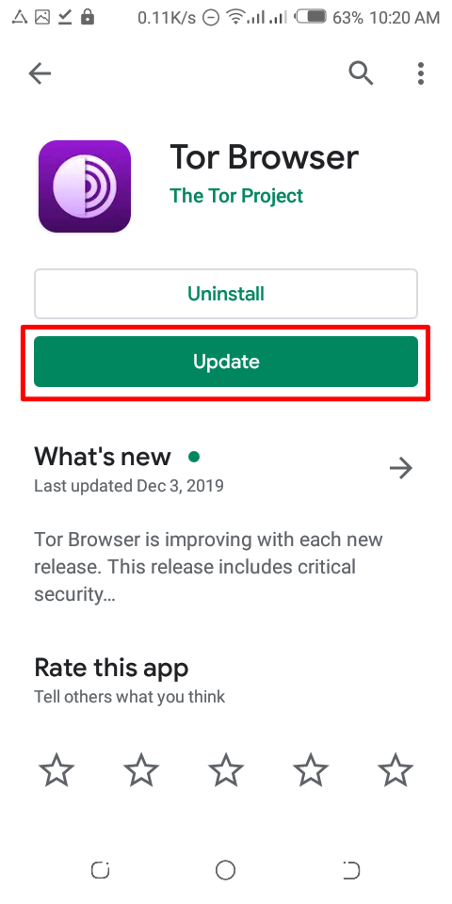

Click on the hamburger menu next to the search bar and navigate to "My apps & games" > "Updates". If you find Tor Browser on the list of apps which need updating, select it and click the "Update" button.

##### F-Droid

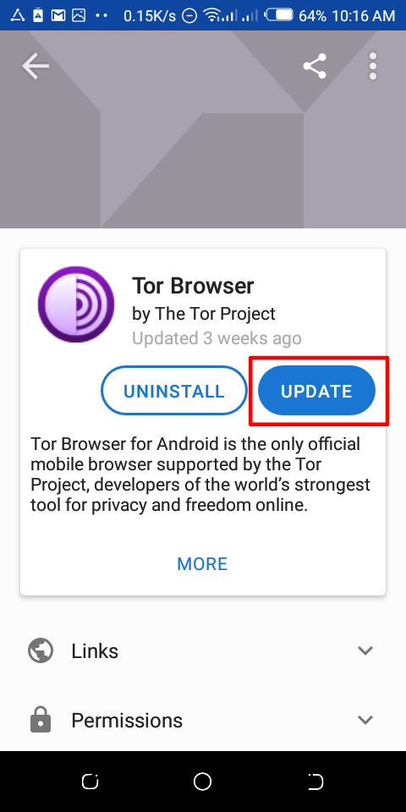

Click on "Settings", then go to "Manage installed apps". On the next screen, select Tor Browser and finally click on the "Update" button.

#### **Updating Tor Browser for Android manually**

Visit the [Tor Project website](https://www.torproject.org/download/#android) and download a copy of the latest Tor Browser release, then [install](https://tb-manual.torproject.org/mobile-tor/#downloading-and-installation) it as before. In most cases, this latest version of Tor Browser will install over the older version, thereby upgrading the browser. If doing this fails to update the browser, you may have to uninstall Tor Browser before reinstalling it. With Tor Browser closed, remove it from your system by uninstalling it using your device's settings. Depending on your mobile device's brand, navigate to Settings > Apps, then select Tor Browser and click on the "Uninstall" button. Afterwards,download the latest Tor Browser release and install it.

### UNINSTALLING

Tor Browser for Android can be uninstalled directly from F-droid, Google Play or from your mobile device's app settings.

#### **Google Play**

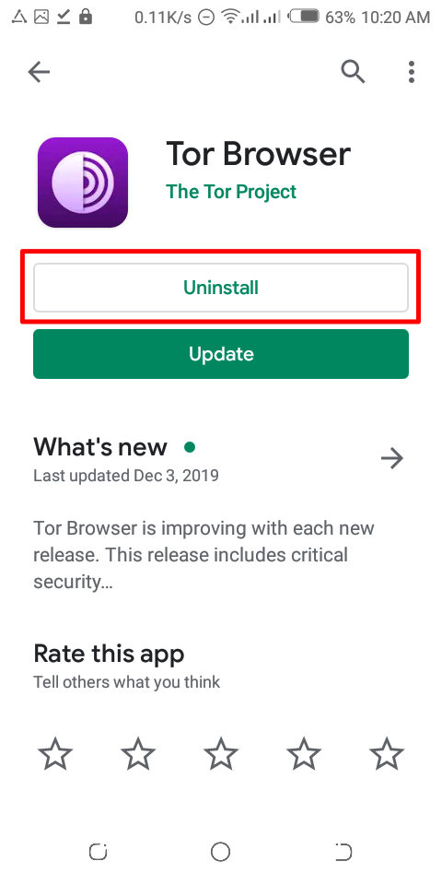

Click on the hamburger menu next to the search bar and navigate to "My apps & games" > "Installed". Select Tor Browser from the list of installed apps, then press the "Uninstall" button.

#### **F-Droid**

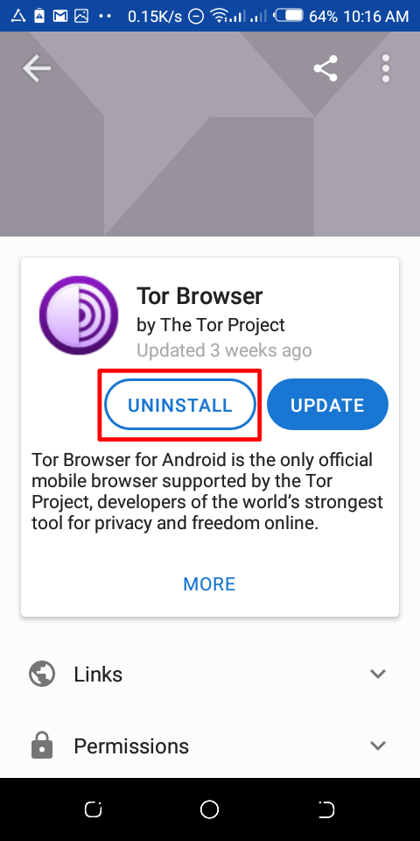

Click on "Settings", then go to "Manage installed apps". On the next screen, select Tor Browser and finally click on the "Uninstall" button.

#### **Mobile device app settings**

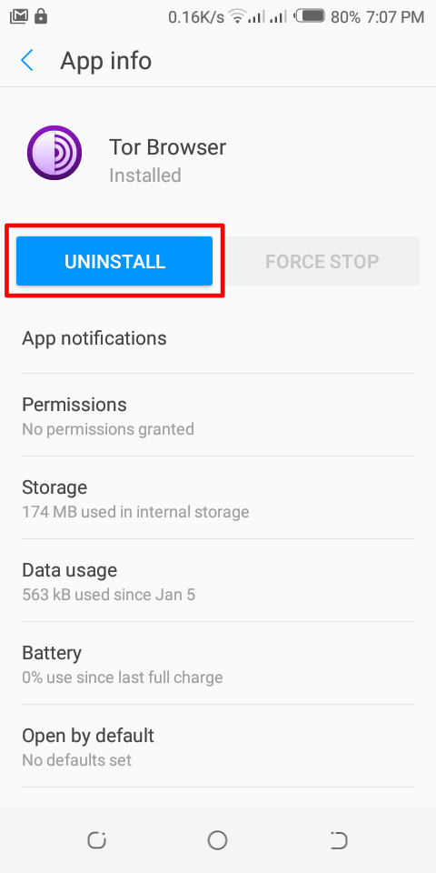

Depending on your mobile device's brand, navigate to Settings > Apps, then select Tor Browser and click on the "Uninstall" button.

### KNOWN ISSUES

At the moment, there are some features which are not available in Tor Browser for Android, but are currently available in Tor Browser for desktop.

* You can't see your Tor circuit. [#25764](https://trac.torproject.org/projects/tor/ticket/25764)
* Custom obfs4 bridges not working. [#30767](https://trac.torproject.org/projects/tor/ticket/30767)
* 'Clear private data' option does not clear browsing history. [#27592](https://trac.torproject.org/projects/tor/ticket/27592)
* Tor Browser for Android does not connect when moved to the SD Card. [#31814](https://trac.torproject.org/projects/tor/ticket/31814)
* You can't take screenshots while using Tor Browser for Android. [#27987](https://trac.torproject.org/projects/tor/ticket/27987)
* You can't save images. [#31013](https://trac.torproject.org/projects/tor/ticket/31013)

### More about Tor on mobile devices

#### **Orfox**

Orfox was first released in 2015 by The Guardian Project, with the aim of giving Android users a way to browse the internet over Tor. Over the next three years, Orfox continously improved and became a popular way for people to browse the internet with more privacy than standard browsers, and Orfox was crucial for helping people circumvent censorship and access blocked sites and critical resources. In 2019, [Orfox was sunsetted](https://blog.torproject.org/orfox-paved-way-tor-browser-android) after the official Tor Browser for Android was released.

#### **Orbot**

Orbot is a free proxy app that empowers other apps to use the Tor network. Orbot uses Tor to encrypt your Internet traffic. Then you can use it with other apps installed on your mobile device to circumvent censorship and protect against surveillance. Orbot can be downloaded and installed from [Google Play](https://play.google.com/store/apps/details?id=org.torproject.android). Check out [our Support portal](https://support.torproject.org/tormobile/tormobile-6/) to know if you need both Tor Browser for Android and Orbot or either one.

### Tor Browser for iOS

There is no Tor Browser for iOS. We recommend an iOS app called Onion Browser, which is open source, uses Tor routing, and is developed by someone who works closely with the Tor Project. However, Apple requires browsers on iOS to use something called Webkit, which prevents Onion Browser from having the same privacy protections as Tor Browser.

[Learn more about Onion Browser](https://blog.torproject.org/tor-heart-onion-browser-and-more-ios-tor). Download Onion Browser from the [App Store](https://itunes.apple.com/us/app/onion-browser/id519296448).

### Tor Browser for Windows Phone

There is currently no supported method for running Tor on Windows Phone.