**Name:** Umar Tariq

**Text Classification / Sentiment Analysis with LSTM:**

**Description:**

Perform Text Classification / Sentiment analysis with LSTM on the data. The tweets have been pulled from Twitter and manual tagging has been done then.

Columns:  
1) Location  
2) Tweet At  
3) Original Tweet  
4) Label

**Steps:**

1. Import Libraries
2. Loading testing and training dataframes
3. Preview of testing and training dataframes

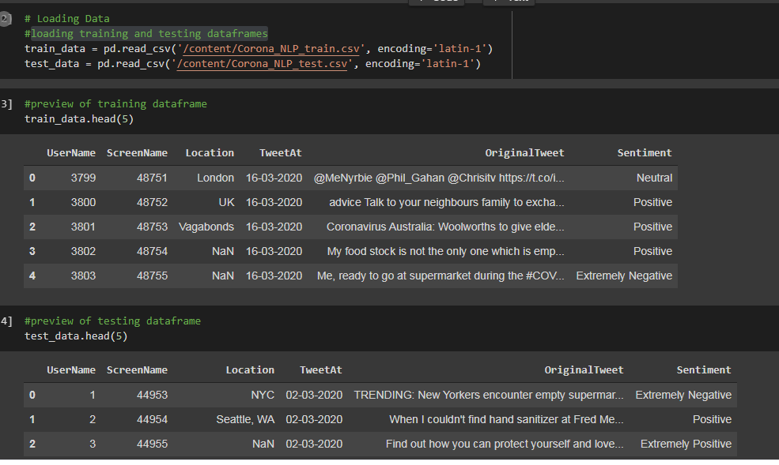

1. Preprocessing training and testing dataftrames
2. Exploratory data analysis

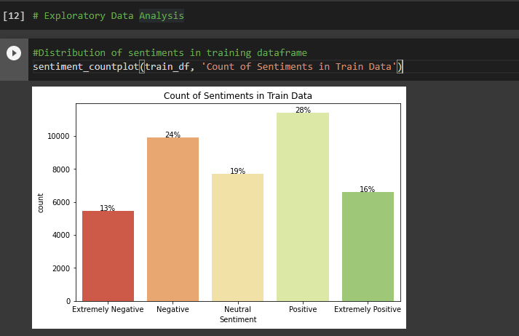

1. Plotting wordcloud for tweetsof all sentiments in training and testin datafreames

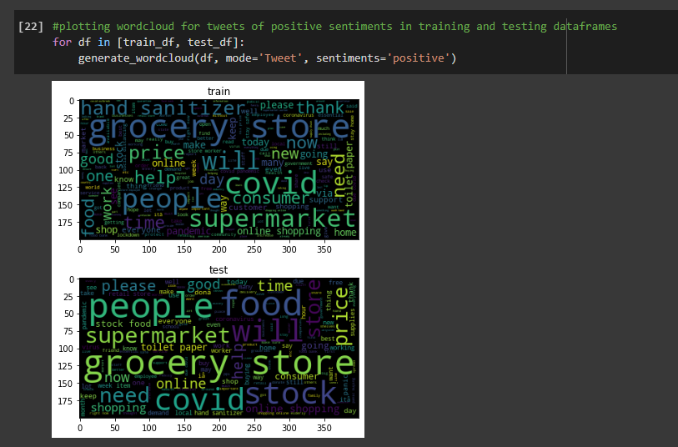

1. Displaying top biggrams for positive and negative tweets in training dataframes
2. Calculating number of unique words

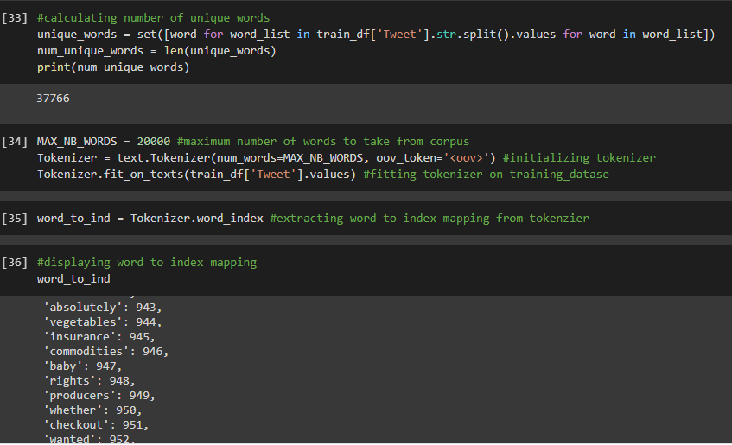

1. Displaying words to index mapping
2. Model Construction

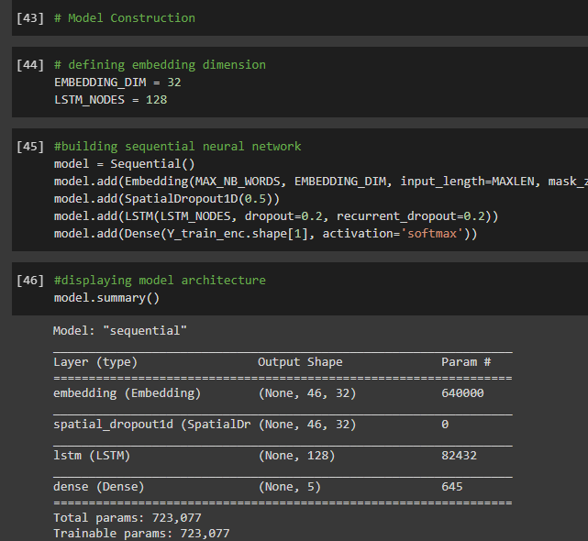

1. Model Training
2. Model Evaluation

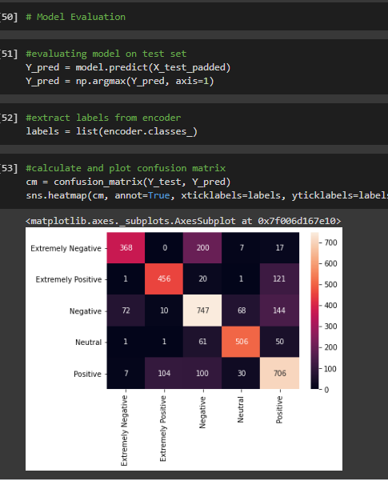

1. Printing Classification report

