**1.Js program to find question and remainder**

<!DOCTYPE html>

<html lang="en">

<head>

<meta charset="UTF-8">

<meta http-equiv="X-UA-Compatible" content="IE=edge">

<meta name="viewport" content="width=device-width, initial-scale=1.0">

<title>Js program to find question and remainder</title>

</head>

<body>

<script>

var a,b,question,remainder;

a=prompt("Enter a nos:")

b=prompt("Enter a nos:")

question=a/b

remainder=a%b

document.write("Question of nos is"+ question+"<br>")

document.write("Question of nos is"+ remainder)

</script>

</body>

</html>

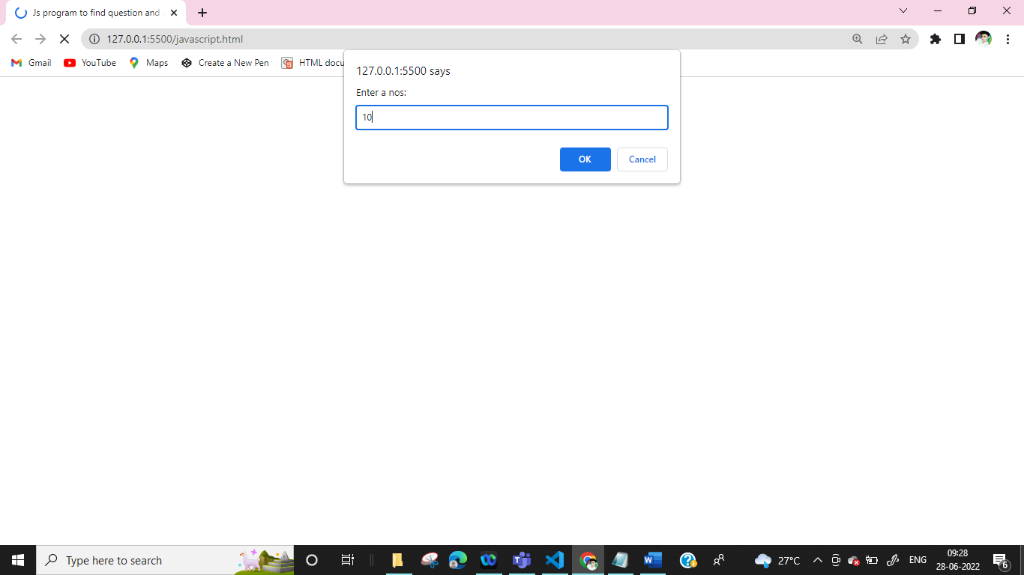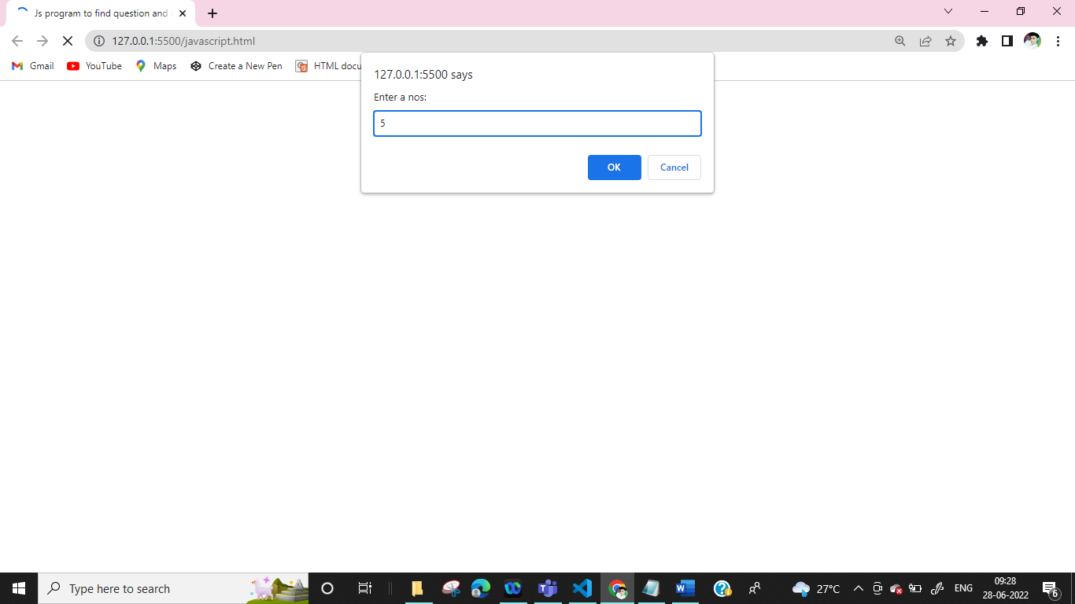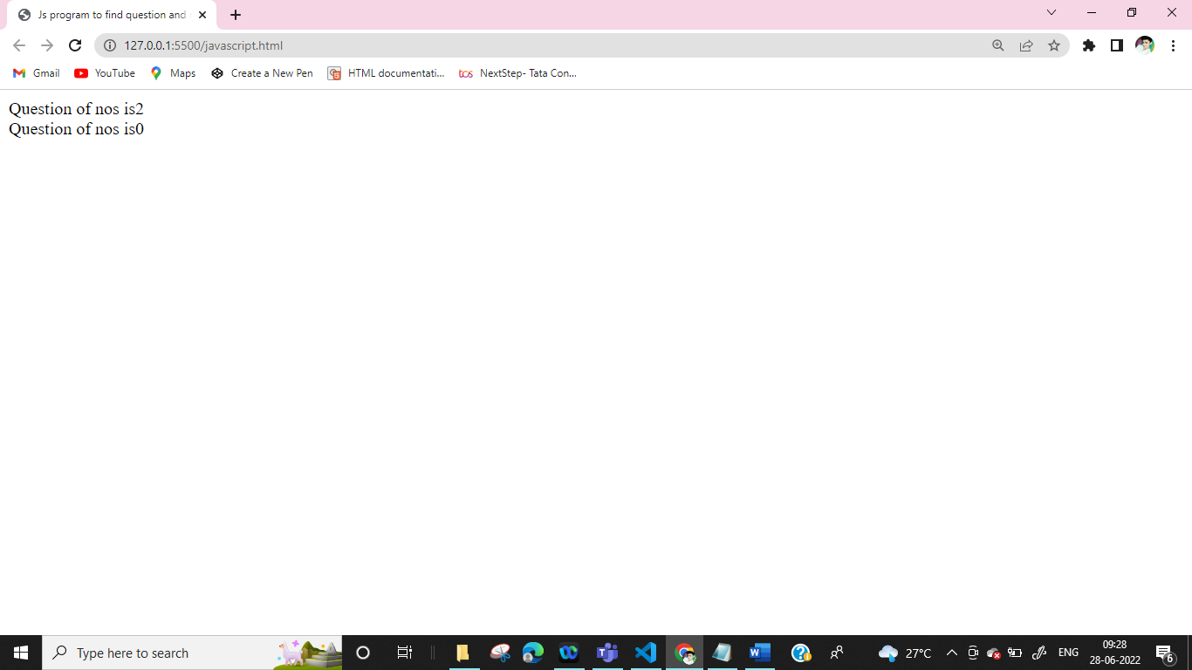

**2.Even or Odd**

<html>

<head><title>

even or odd

</title></head>

<body>

<script type="text/Javascript">

var num;

num=prompt("Enter a Nos")

if(num%2==0)

{

alert(num +" is even")

}

else

{

alert(num +" is odd")

}

</script>

</body>

</html>

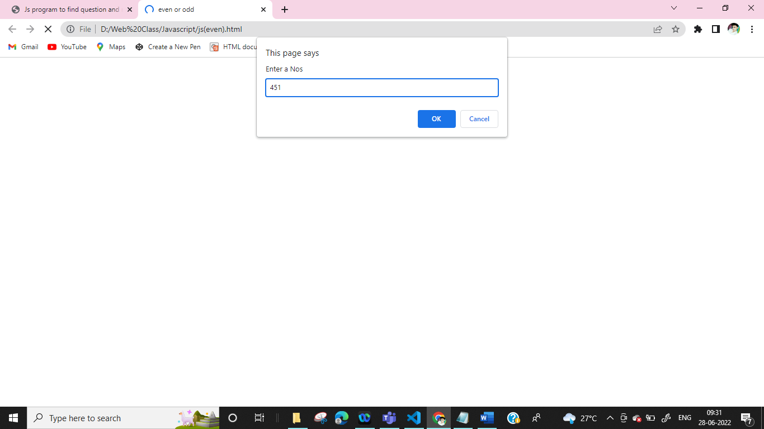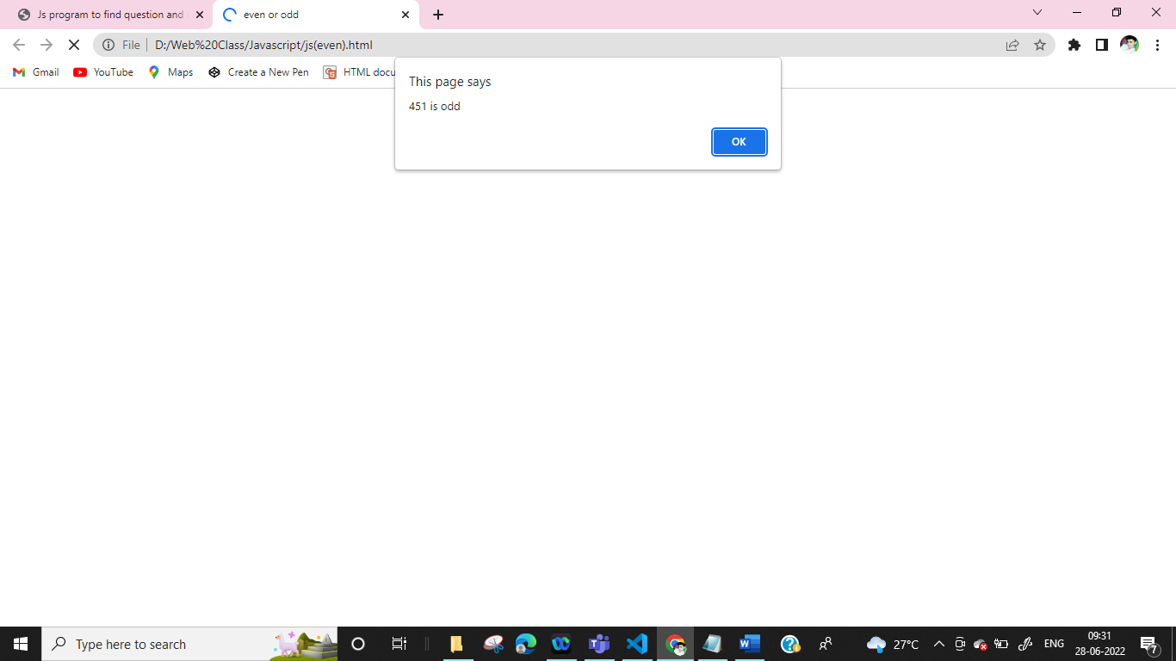

**3. Grade**

<html>

<head></head>

<body>

<script type="text/Javascript">

var m1,m2,m3,Total,Per,Grade;

m1=parseInt(prompt("Enter a marks"))

m2=parseInt(prompt("Enter a marks"))

m3=parseInt(prompt("Enter a marks"))

Total=m1+m2+m3

Per=(Total/3)

if(Per<=100 && Per>=75)

{

Grade="A+"

}

else if(Per<=74 && Per>=60)

{

Grade="A"

}

else if(Per<=59 && Per>=50)

{

Grade="B"

}

else if(Per<=49 && Per>=40)

{

Grade="C"

}

else

{

Grade="FAIL"

}

alert("Total="+Total)

alert("Per="+Per)

alert("Grade="+Grade)

</script>

</body>

</html>

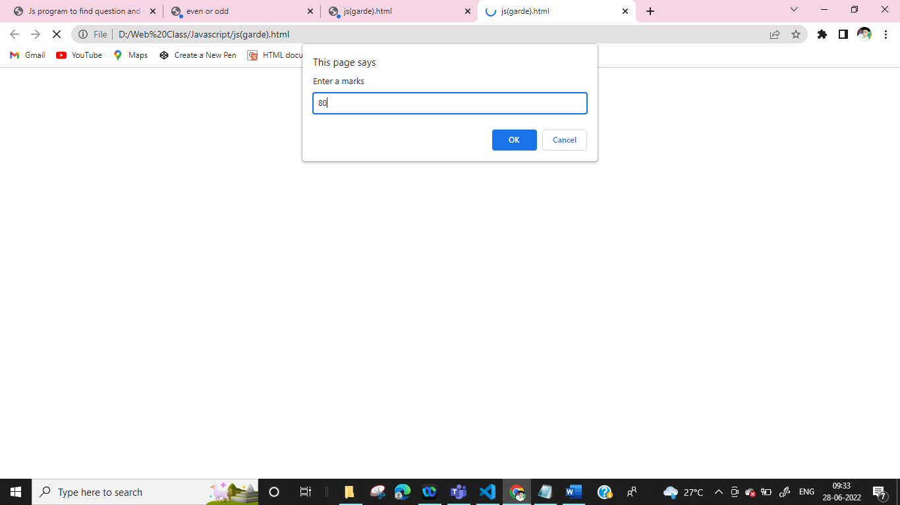

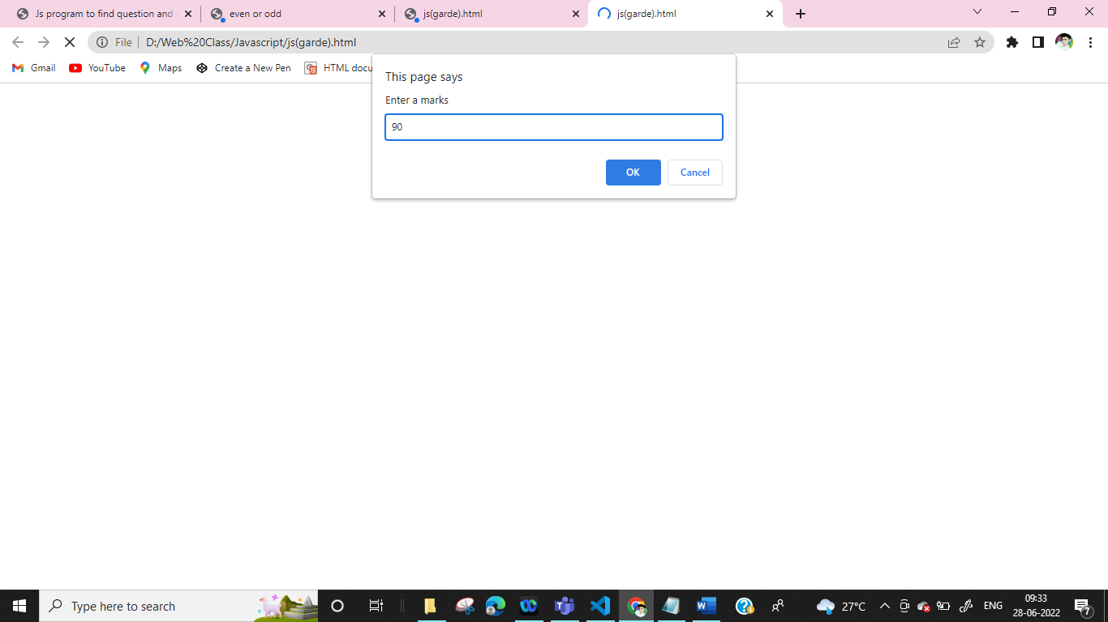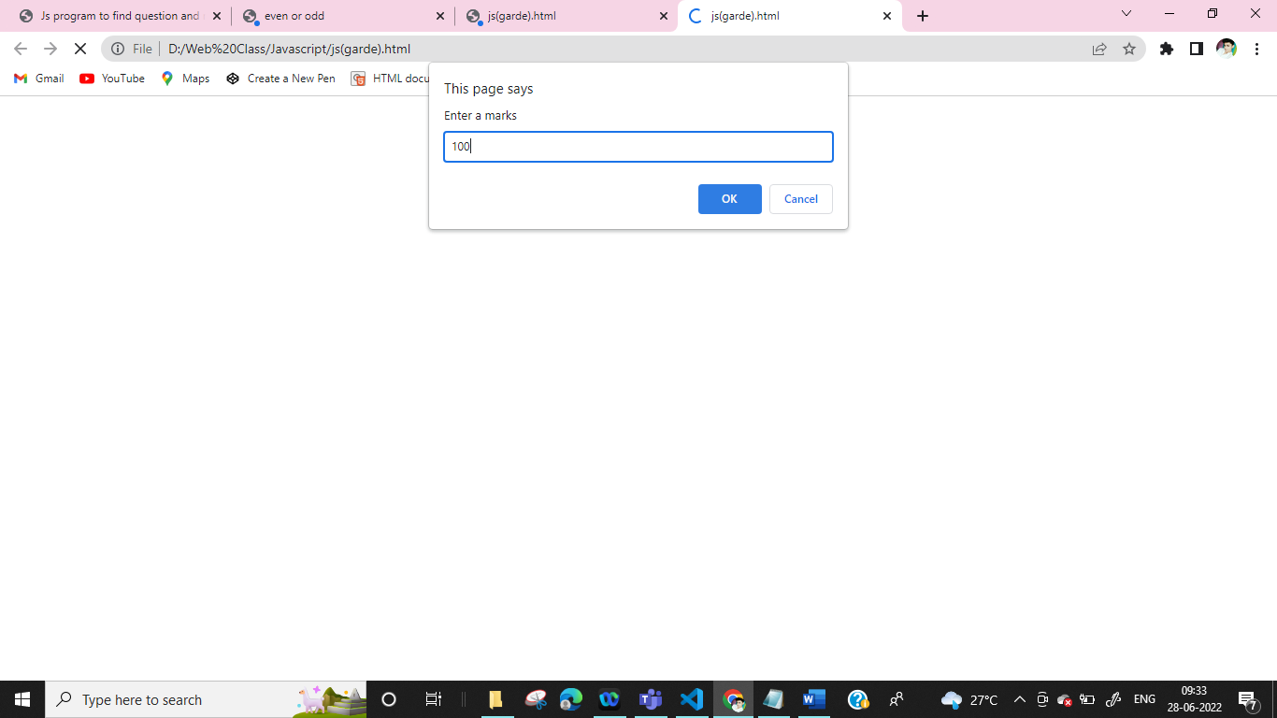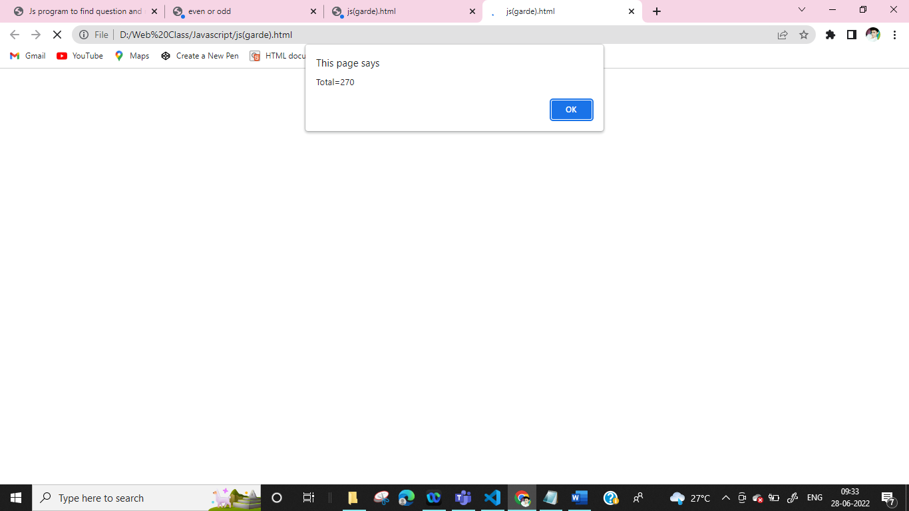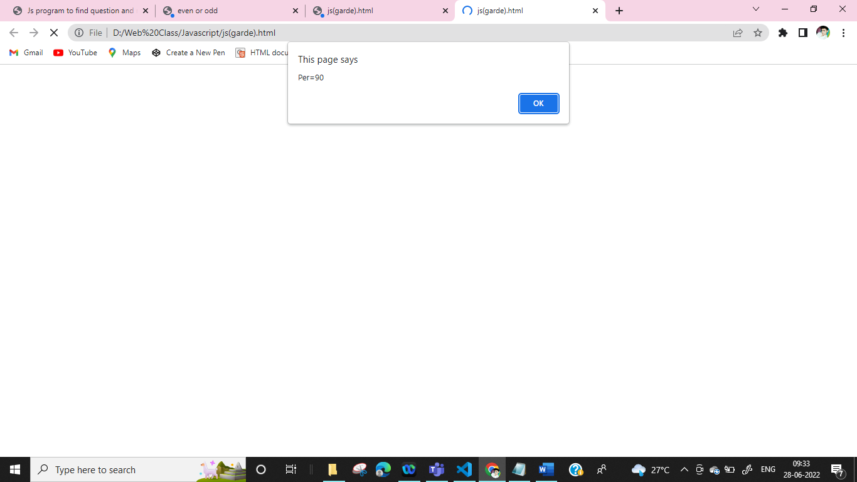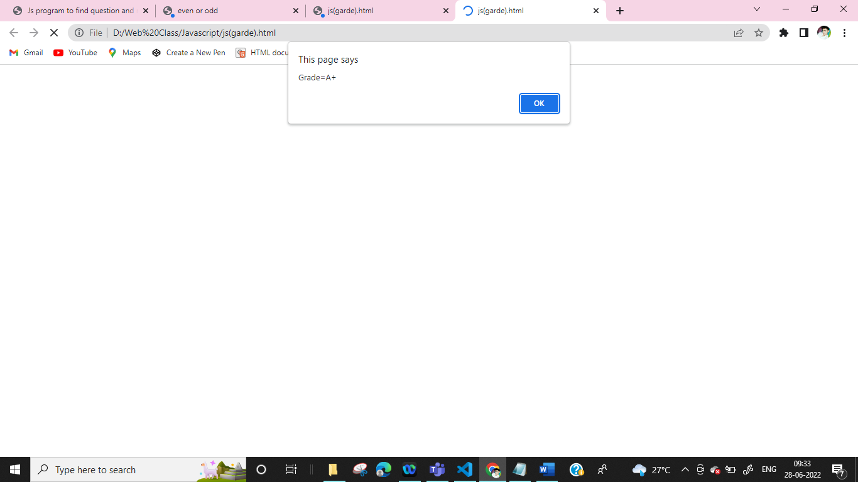

**4.for greater**

<html>

<head></head>

<body>

<script type="text/Javascript">

var a,b

a=prompt("Enter a Nos")

b=prompt("Enter a Nos")

if(a>b)

{

alert("a is Greater")

}

else

{

alert("b is Greater")

}

</script>

</body>

</html>

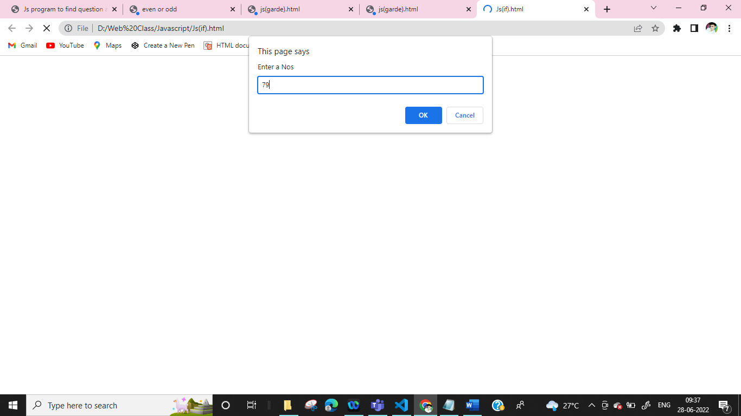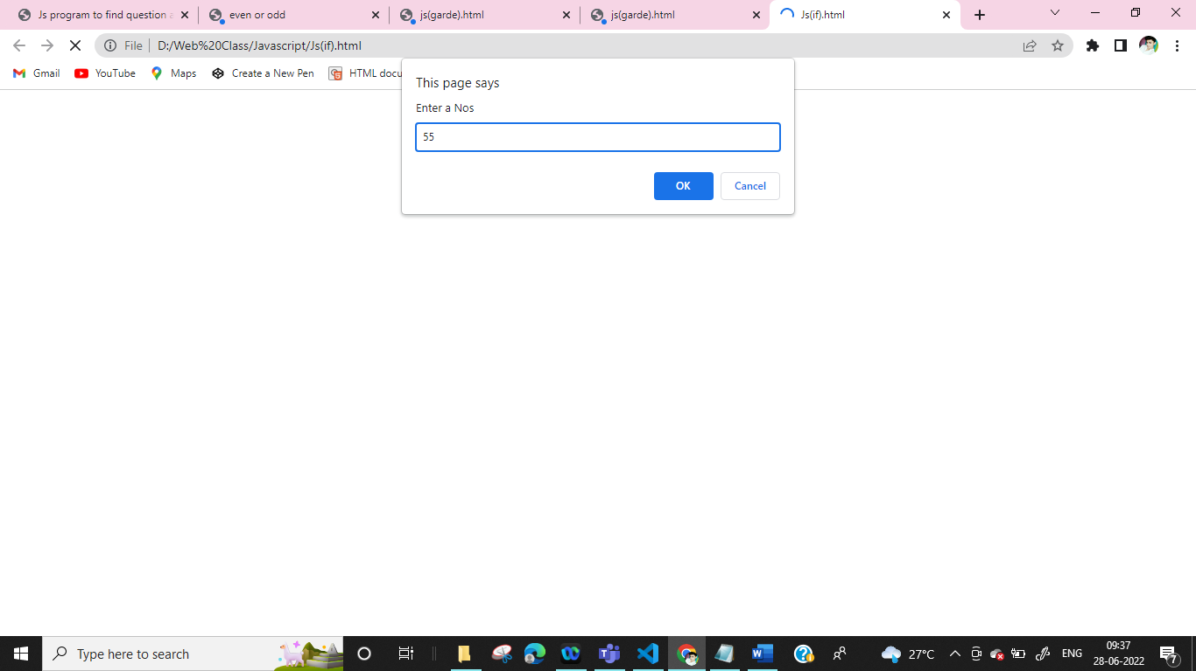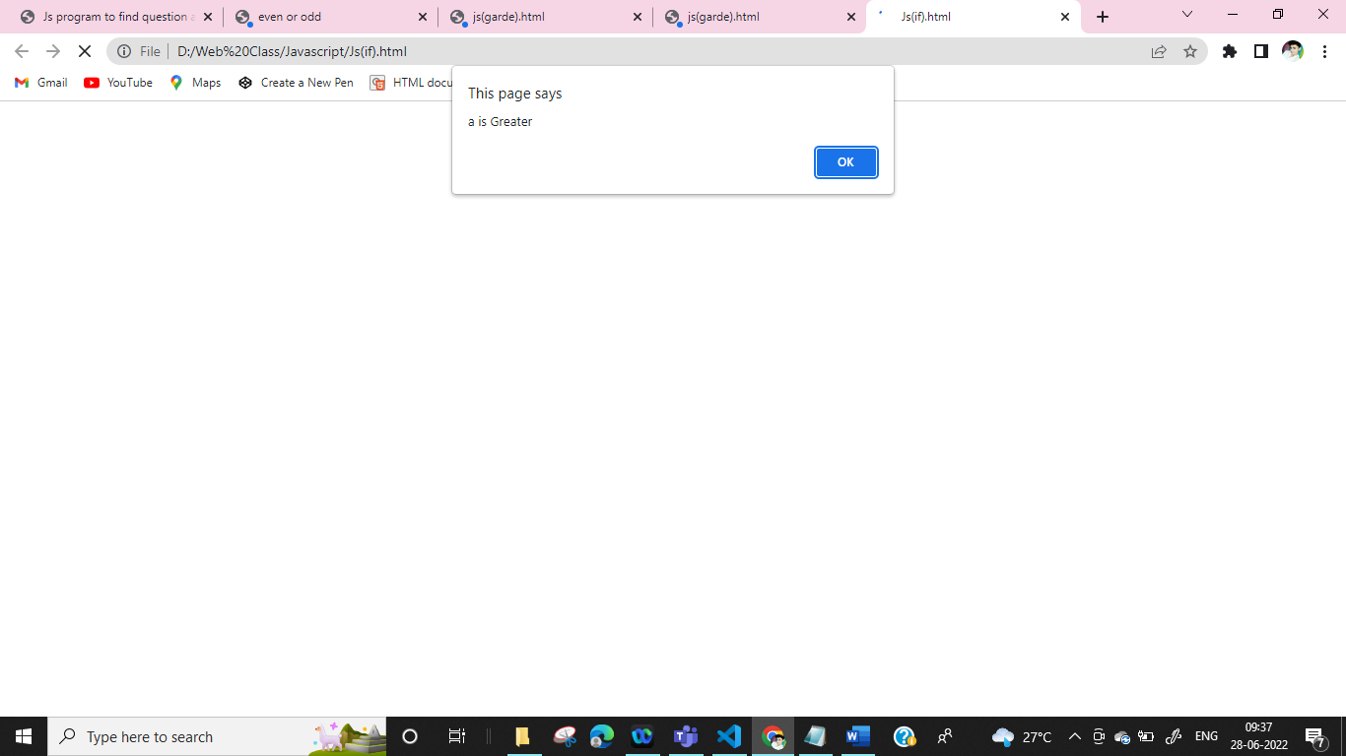

**5.Nested**

<html>

<head></head>

<body>

<script type="text/Javascript">

var a

a=parseInt(prompt("Enter Nos:"))

if(a>0)

{

if(a%2==0)

{

alert(a +" is even")

}

else

{

alert(a +"is odd")

}

}

else

{

alert("Cant Enter negative nos")

}

</script>

</body>

</html>

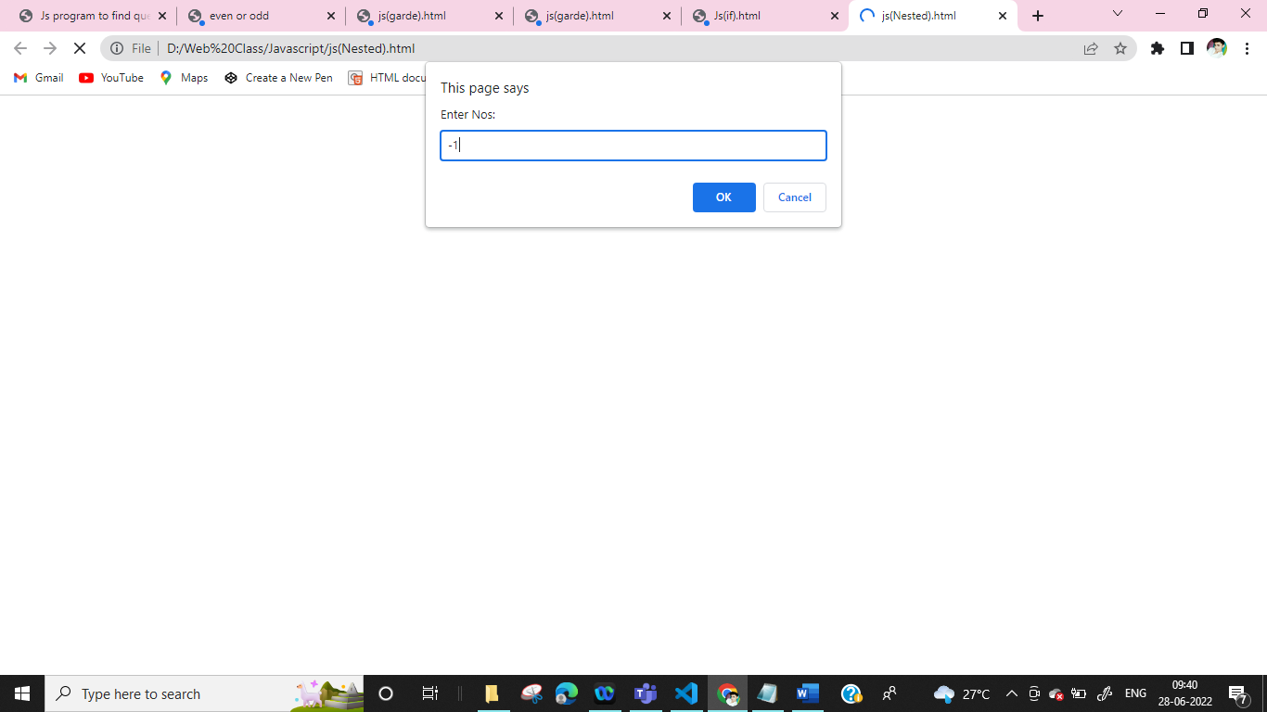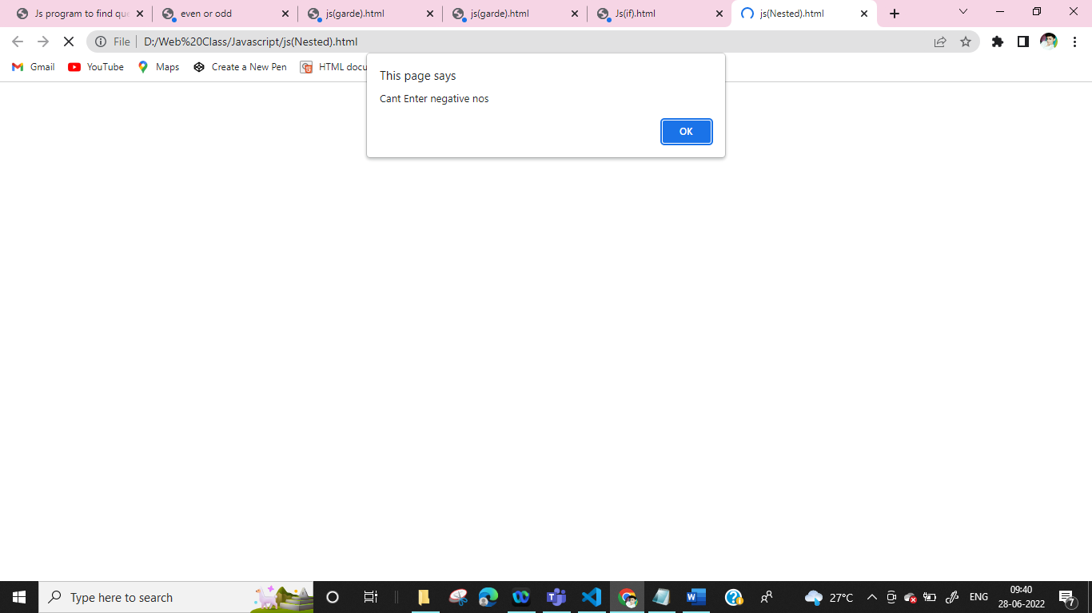

**6.Leap Year**

<html>

<head></head>

<body>

<script type="text/Javascript">

var m,n;

m=prompt("Enter a Nos")

if(m>0)

{

alert(m +" is Greater")

}

else if(m<=0)

{

alert(m +" is Zero ")

}

else if(m<0)

{

alert(m +" is Negative")

}

</script>

</body>

</html>

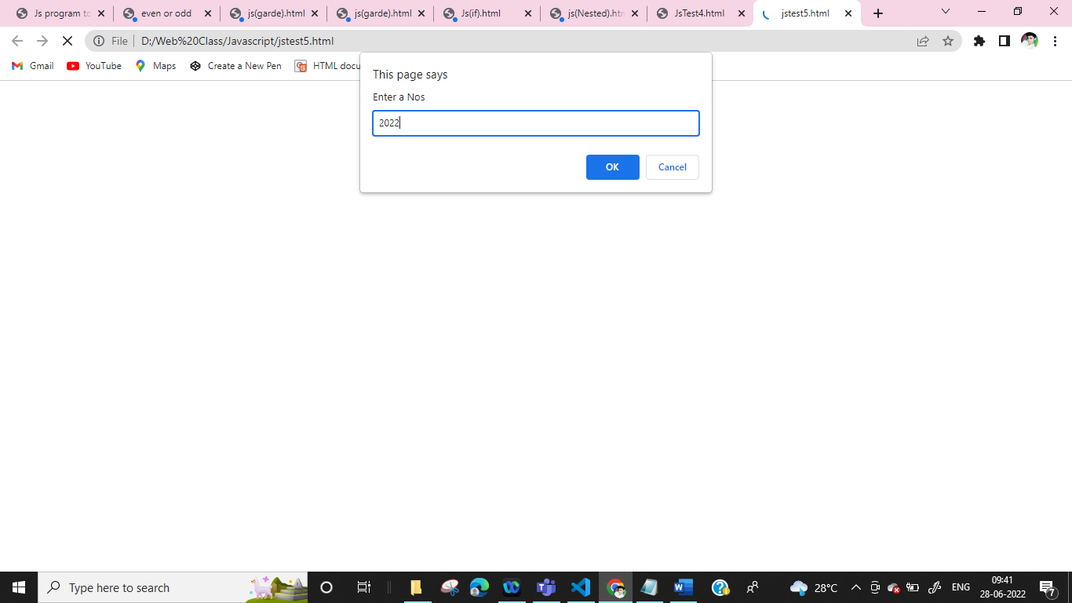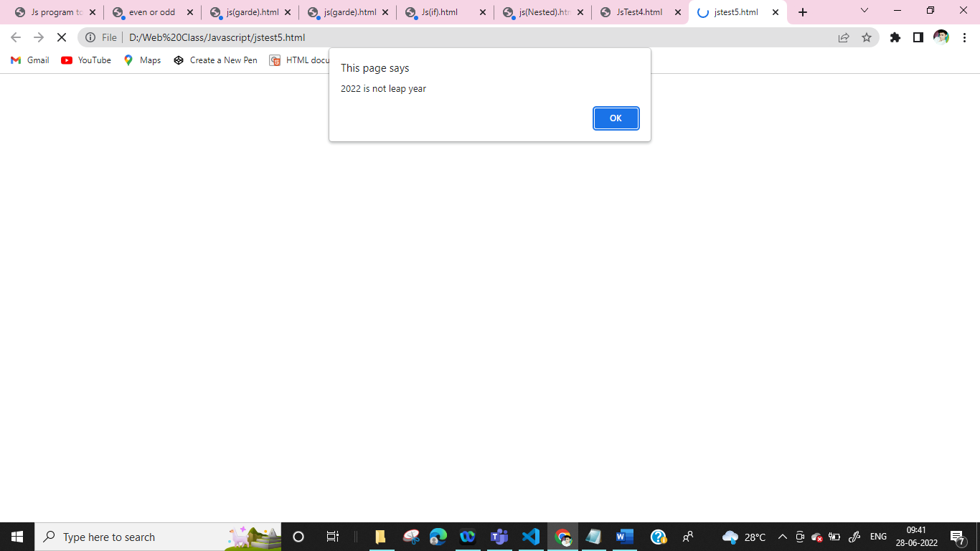

**7.if else to cal income**

<html>

<head></head>

<body>

<script type="text/Javascript">

var unit_price,quantity,income,discount,net_income

unit_price=parseInt(prompt("Enter Unit Price : "))

quantity=parseInt(prompt("Enter Quantity : "))

income=unit_price*quantity

if(quantity>=100 && quantity<=120)

{

discount=income*0.10

}

else if(quantity>120)

{

discount=income*0.15

}

else if(quantity<100)

{

discount=0

}

net_income=income-discount

document.write("Unit Price = "+unit_price+"<br/>")

document.write("Quantity = "+quantity+"<br/>")

document.write("Income = "+income+"<br/>")

document.write("Discount = "+discount+"<br/>")

document.write("Net Income = "+net_income+"<br/>")

</script>

</body>

</html>

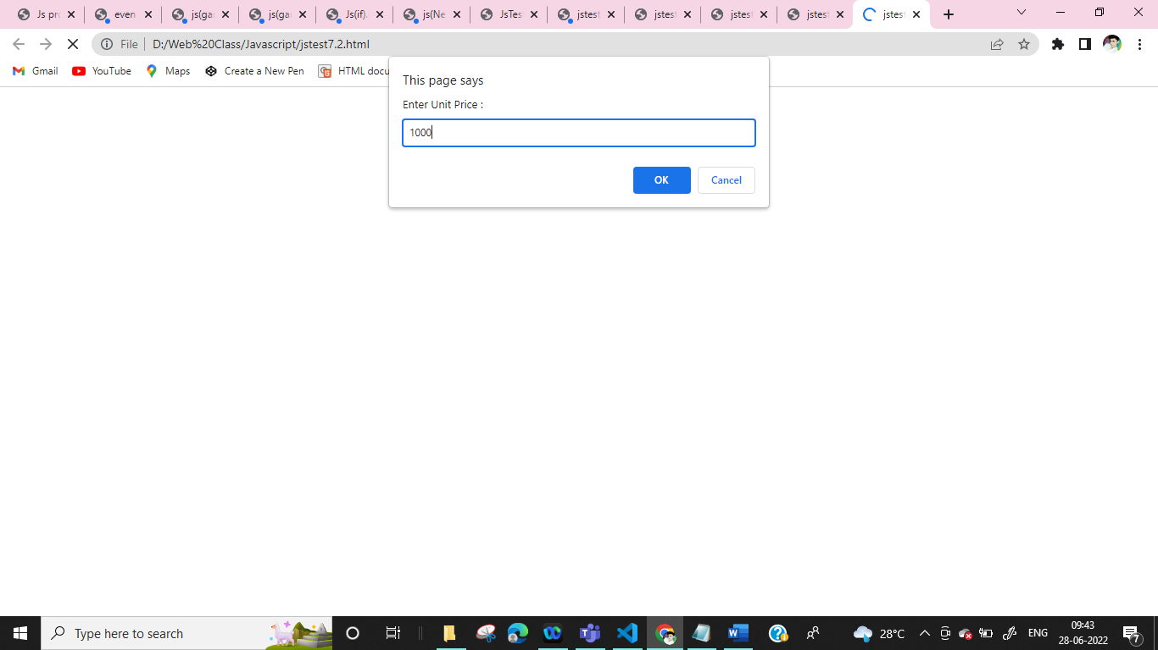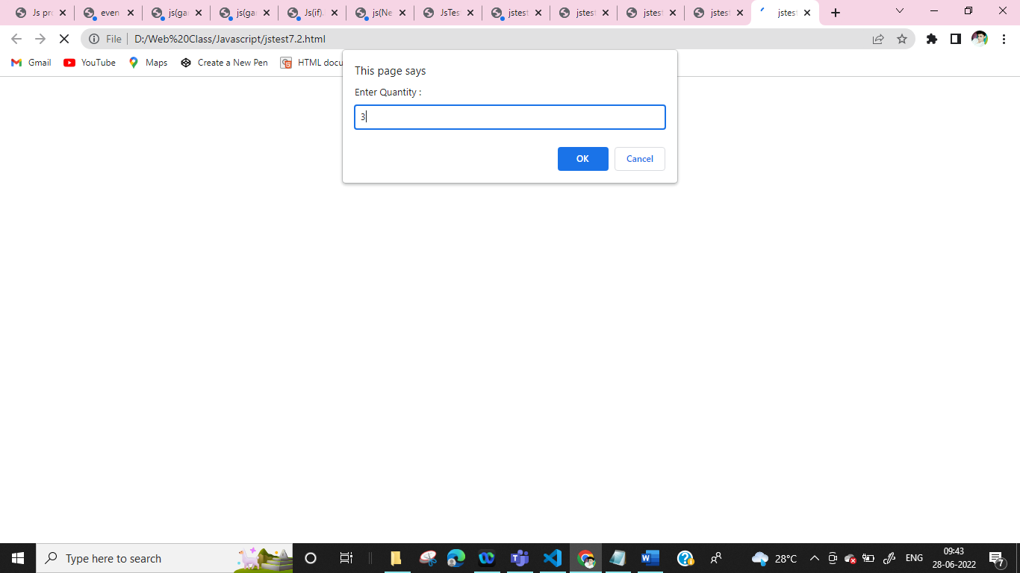

**8.Salary**

<html>

<head></head>

<body>

<script type="text/Javascript">

var basic,gross,HRA,DA

basic=parseInt(prompt("Enter a salary"))

if(basic<=10000)

{

HRA=basic*0.8

DA=basic*0.2

}

else if(basic<=20000)

{

HRA=basic*0.9

DA=basic*0.25

}

else if(basic>20000)

{

HRA=basic*0.95

DA=basic*0.3

}

gross = basic + HRA + DA;

alert("basic is"+ basic)

alert("gross is"+ gross)

alert("HRA is"+ HRA)

alert("DA is"+ DA)

</script>

</body>

</html>

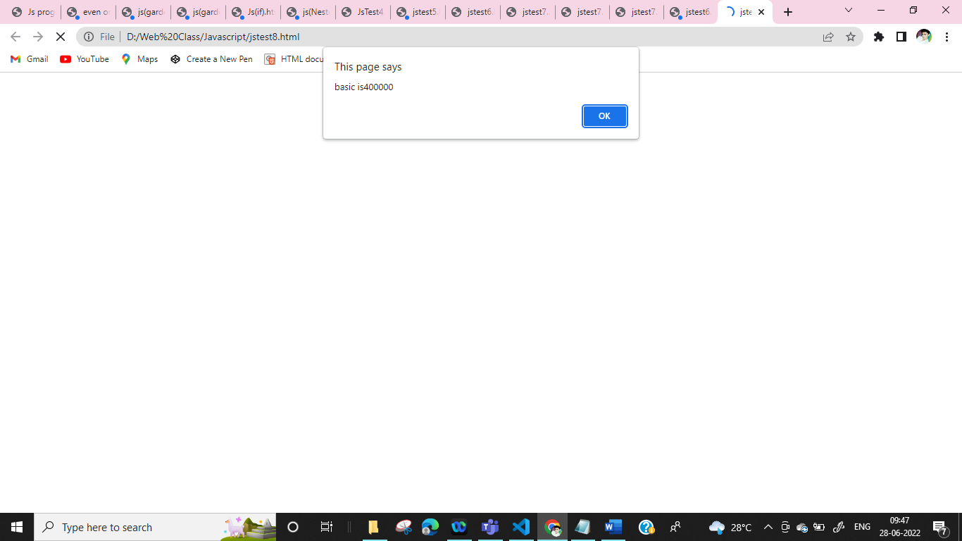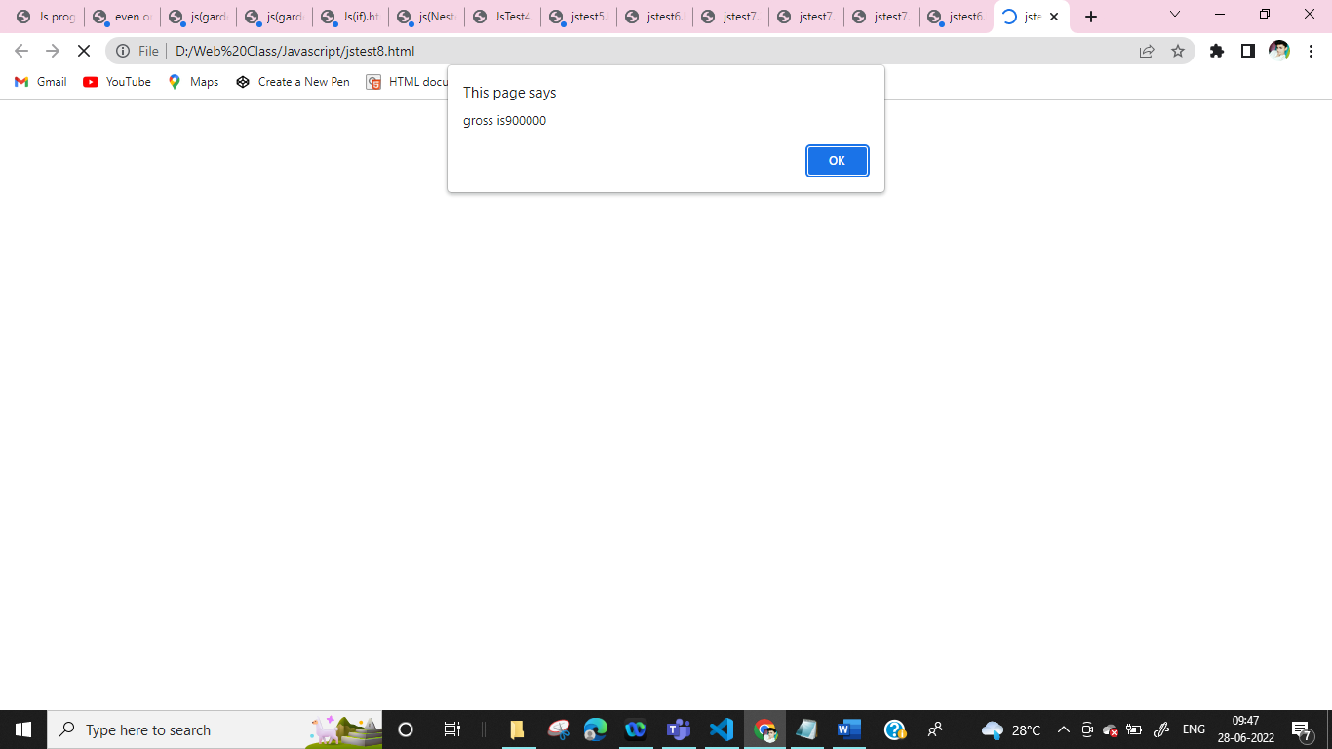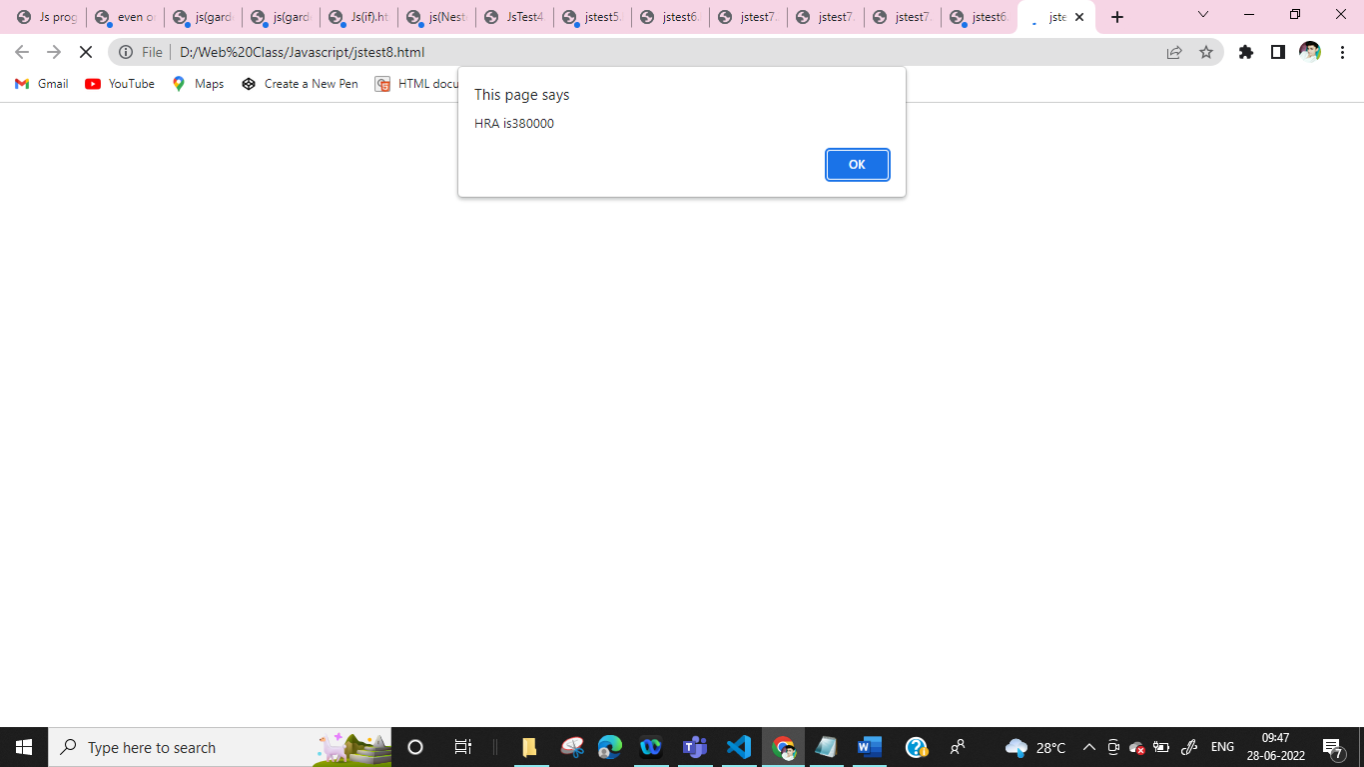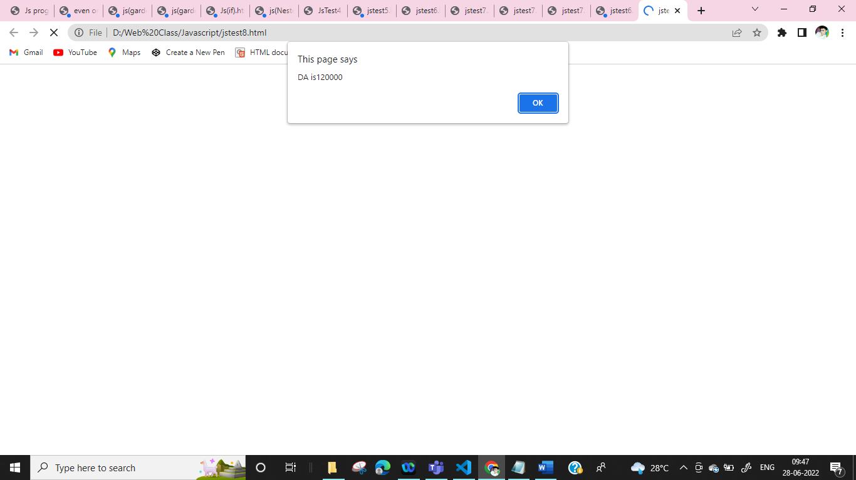

**9.Divisible**

<html >

<head>

<title>Write a program to check whether a number is divisible by 5 and 11 or not</title>

</head>

<body>

<script type="text/Javascript">

var a;

a=parseInt(prompt("Enter nos"));

if(a%5==0 && a%11==0)

{

alert( a + "is divisible by 5 and 11" )

}

else

{

alert( a + "is not divisible by 5 and 11" )

}

</script>

</body>

</html>

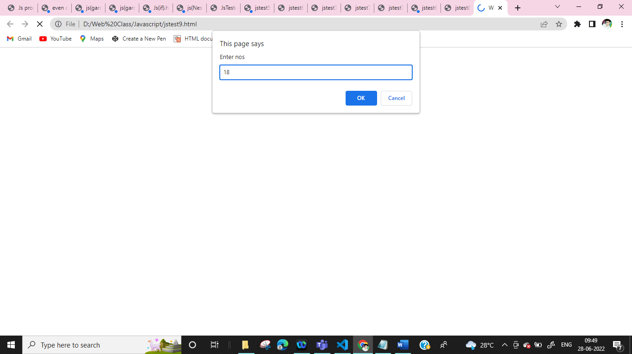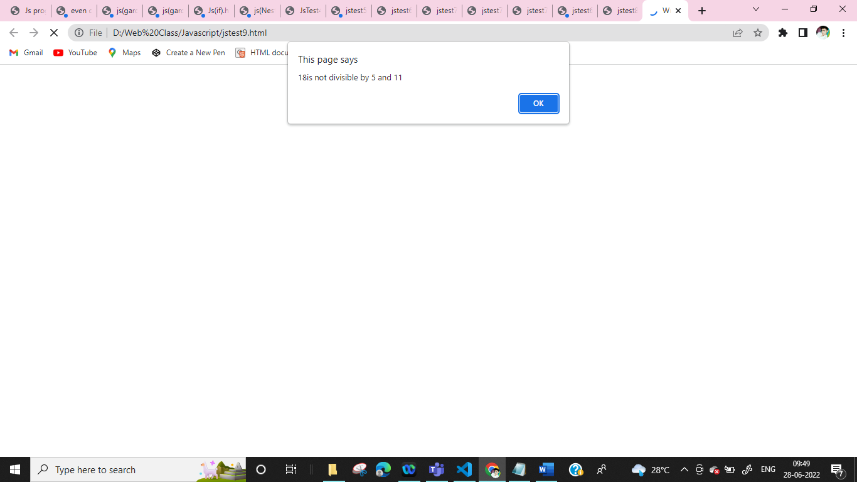

**10.Max btw Third**

<html >

<head>

<title>Program to find maximum between three numbers</title>

</head>

<body>

<script type="text/Javascript">

var a,b,c,max;

a=parseInt(prompt("enter a nos"))

b=parseInt(prompt("enter a nos"))

c=parseInt(prompt("enter a nos"))

if(a>b && a>c)

{

max=a

}

else if (b>a && b>c)

{

max=b

}

else if(c>a && c>b)

{

max=c

}

max;

document.write("The max nos is"+max)

</script>

</body>

</html>

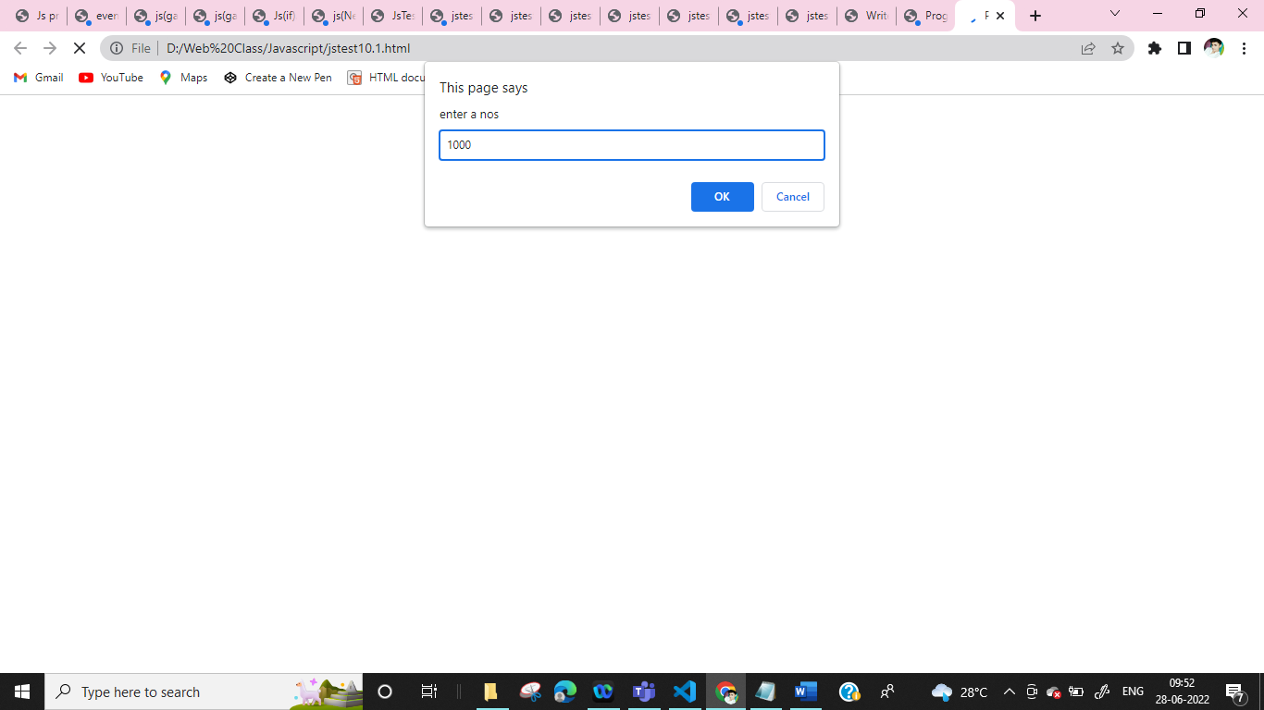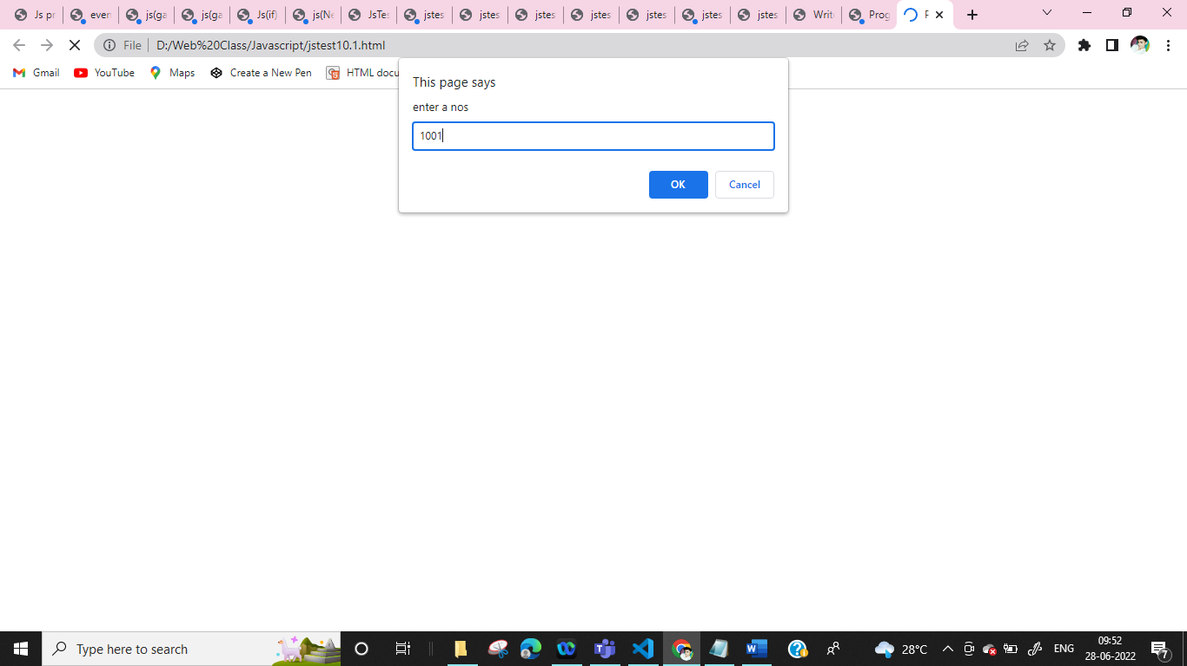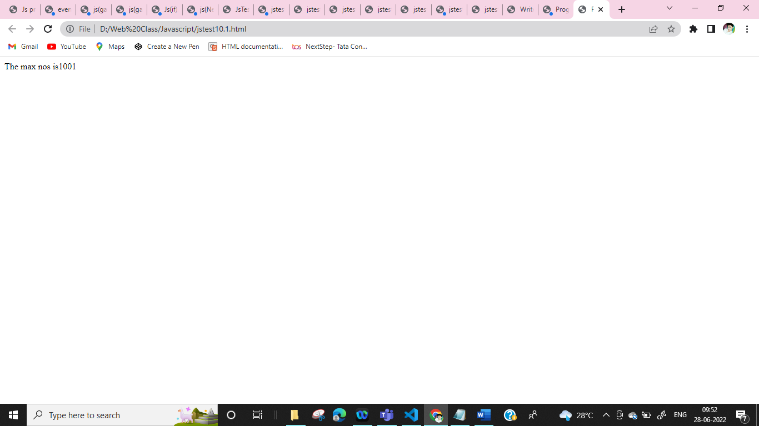

**11.Voting**

<html >

<head>

<title>Program to find maximum between three numbers</title>

</head>

<body>

<script type="text/Javascript">

var a,b,c;

a=parseInt(prompt("enter a nos"))

b=parseInt(prompt("enter a nos"))

c=parseInt(prompt("enter a nos"))

if(a>b)

{

alert(a +"is Greater")

}

else if (b>a)

{

alert(b +"is Greater")

}

else if(c>a,b)

{

alert(c +"is Greater")

}

</script>

</body>

</html>

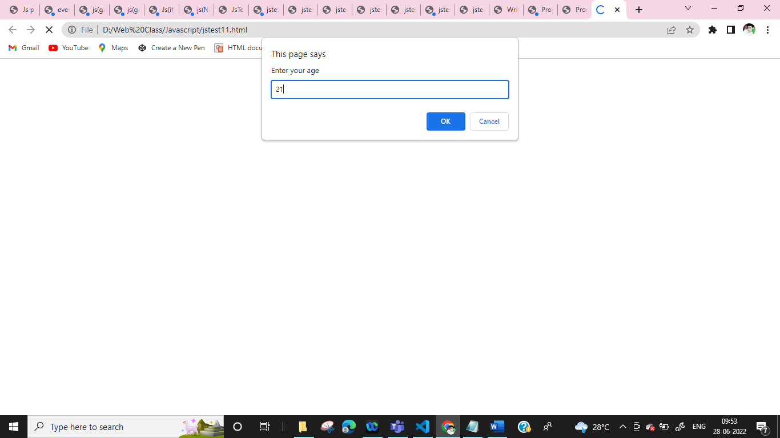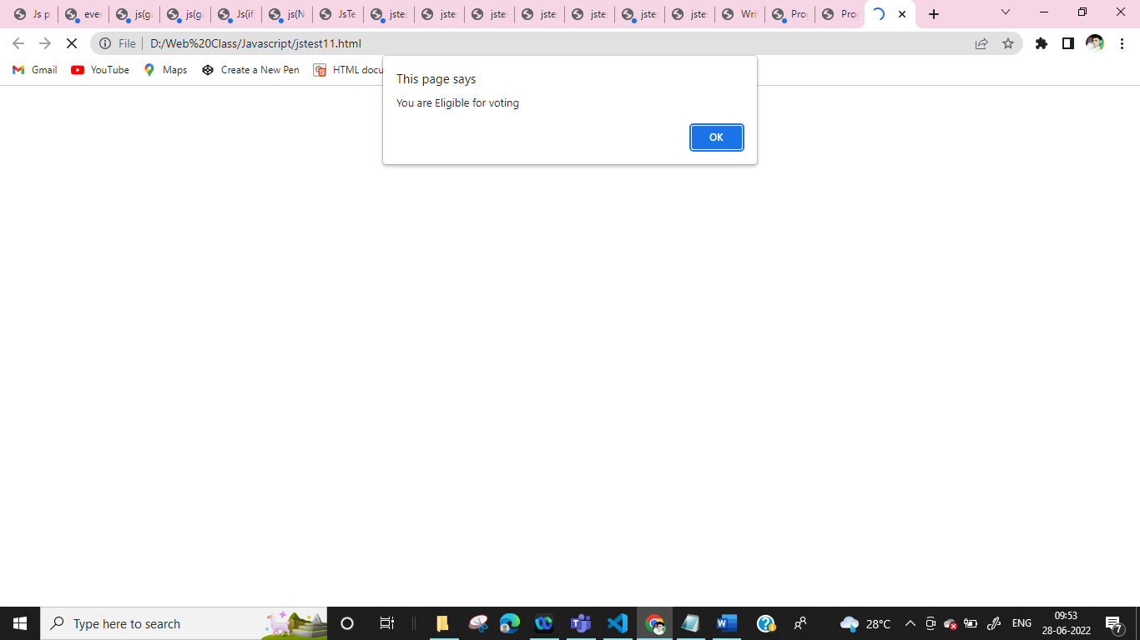

**12.Swap two nos**

<html>

<head>

<title>Js program to swap tow numbers two numbers with using third variabkes</title>

</head>

<body>

<script type="text/Javascript">

var a,b,c

a=prompt("Enter a nos a:")

b=prompt("Enter a nos b:")

c=a

a=b

b=c

document.write("<b>Swap a nos is</b> : "+ a+"<br>")

document.write("<b>Swap b nos is</b> : "+ b+"<br>")

document.write("<b>Swap c nos is</b> : "+ c+"<br>")

</script>

</body>

</html>

