Local Government Complaint &
Public Service Request Management System

Submitted to

Mr. Ali Hassan
Student 1 Name | Omer Zia
Program & Group | BCS-A
Student 2 Name | Yahya Usman
Program & Group | BCS-A
Submission Date | 17 May, 2026
Milestone Coverage | Milestones 2–5

Repository Link: https://github.com/umarzia-git/Local-Government-Complaint-Public-Service-RequestManagement-System

1. Version Control Document

Repository Link: https://github.com/umarzia-git/Local-Government-Complaint-Public-Service-RequestManagement-System

Milestones | Date | Module | Remarks
EERD Created & Schema Designed | 16 May 2026 | 2.0 | EER diagram created in MySQL Workbench. 8 tables designed and relationships mapped.
Database Normalization (1NF–3NF) | 16 May 2026 | 2.0 | Schema normalized to 3NF. Redundancy action log and cardinality map completed.
Dataflow Architecture Documented | 16 May 2026 | 3.0 | Three-tier data pipeline documented. Entry points, triggers, views and output summary defined.
DDL Commands Executed, EER Verified | 16 May 2026 | 4.0 | Database created. All 8 tables, foreign keys, indexes, triggers and views executed and verified in MySQL Workbench.
DML + Data Load to File | 17 May 2026 | 5.0 | Data populated and loaded into database from CSV using LOAD DATA INFILE command.
Validations Applied | 17 May 2026 | 5.0 | Four validation queries executed: row density, null scan, referential integrity, and rule/format constraints.

Table of Contents

- Project Introduction & Scope ...................................................................................................... 3
- Milestone 2: Enhanced Entity-Relationship Diagram (EERD) ................................................... 3
- Milestone 2: Database Normalization Analysis (1NF to 3NF) ................................................... 3
- Milestone 3: System Dataflow Architecture & Preprocessing .................................................... 8
- Milestone 4: Database Setup (DDL) & Schema Rules ............................................................. 11
- Milestone 5: Production Ingestion, DML & Data Validation ................................................... 12
- Appendix: Live Execution Outputs (Screenshots) .................................................................... 14

1. Project Introduction & Scope

The Local Government Complaint & Public Service Request Management System (lgc_system) is a relational database designed to automate and streamline municipal operations. The system provides citizens with the ability to register online, submit complaints regarding public utilities — including water supply, roads, electricity, and waste management — and track their resolution status in real time.

On the administrative side, the system equips management with tools to:
- Route service requests to appropriate departments automatically
- Enforce strict Service Level Agreement (SLA) deadlines
- Monitor public satisfaction performance through structured feedback
- Detect and flag recurring infrastructure issues as chronic problems

The database is built on MySQL and structured around eight normalized relational tables, automated triggers, and analytical views that power a live administrative dashboard.

2. Milestone 2: Relational Database Normalization Analysis

To eliminate data redundancy and prevent operational anomalies, the database schema was fully normalized up to the Third Normal Form (3NF). Core tables such as departments, categories, citizens, and staff use atomic primary identifiers, ensuring all attributes are directly and solely dependent on the primary key.

Transactional tables were systematically stripped of transitive dependencies. Storing both category and department references inside the complaint table complies with 3NF, as it allows independent reassignment of departments without altering the foundational problem type.

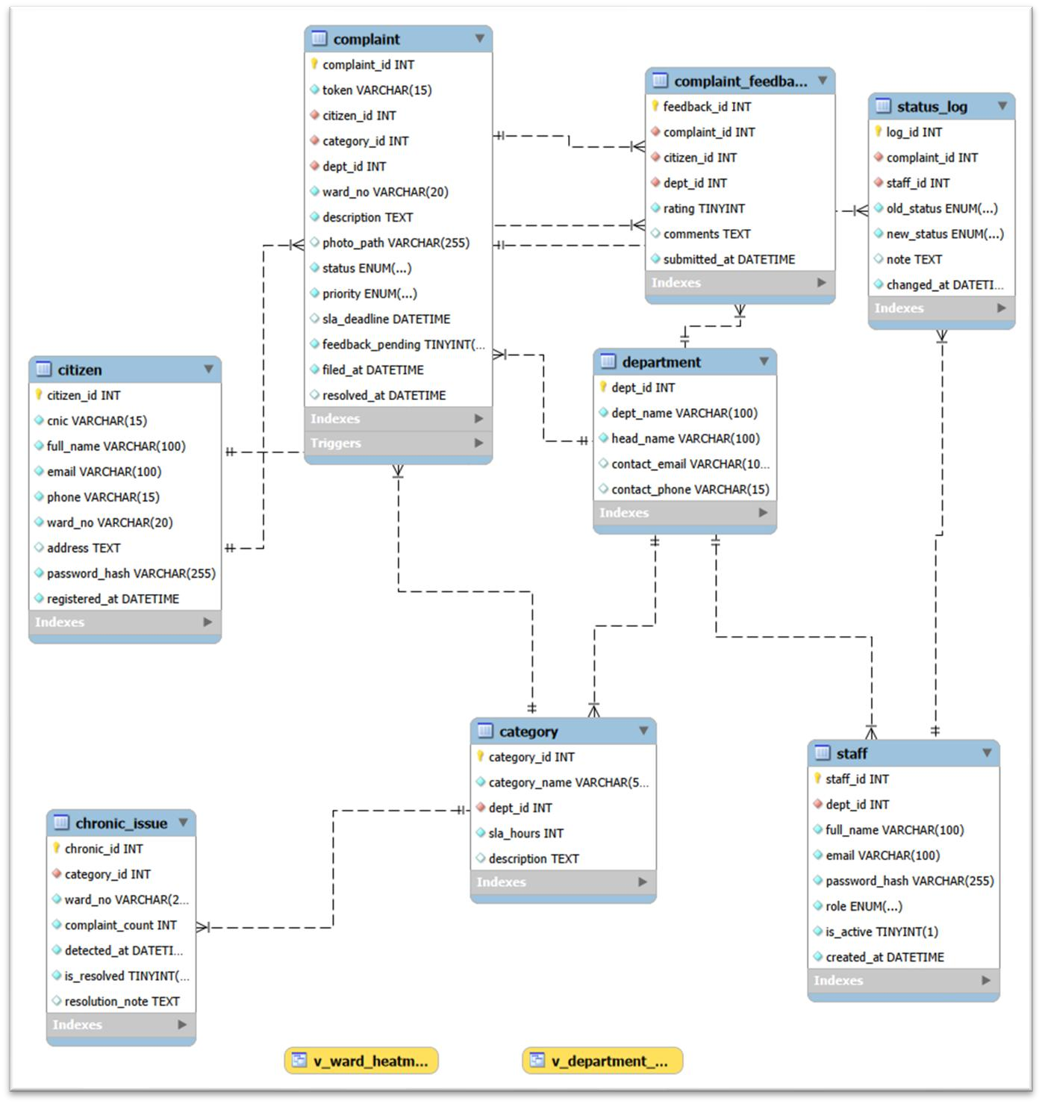

Figure 2.1: Verified EER Diagram for lgc_system.

Executive Summary
This section provides a formal breakdown of the normalization process applied to the lgc_system database schema. Every structural asset defined in the DDL script has been scrutinized against First Normal Form (1NF), Second Normal Form (2NF), and Third Normal Form (3NF) to:
- Minimize data redundancy
- Eliminate data anomalies (insertion, update, and deletion) • Ensure strict relational data integrity across all tables

Detailed Table-by-Table Normalization Analysis

Table 1: department
Attributes: dept_id (PK), dept_name, head_name, contact_email, contact_phone

Normal Form | Status | Justification
1NF | ✓ Satisfied | All columns hold atomic values. No repeating groups or multi-valued attributes exist. contact_phone stores a single atomic value.
2NF | ✓ Satisfied | Single-column primary key (dept_id). Partial dependencies are structurally impossible. Every non-key attribute is fully dependent on dept_id.
3NF | ✓ Satisfied | No transitive dependencies exist. dept_name, head_name, contact_email, and contact_phone are direct properties of the department itself.

Table 2: category
Attributes: category_id (PK), category_name, dept_id (FK), sla_hours, description

Normal Form | Status | Justification
1NF | ✓ Satisfied | All attributes contain scalar, individual values. The text field description stores a single summary, satisfying atomicity.
2NF | ✓ Satisfied | Single primary key (category_id). All non-prime attributes depend on the entire primary key, eliminating partial dependency.
3NF | ✓ Satisfied | dept_id serves purely as a foreign key. sla_hours belongs directly to the category type rather than the department. No transitive dependencies among non-prime attributes.

Table 3: citizen
Attributes: citizen_id (PK), cnic, full_name, email, phone, ward_no, address, password_hash, registered_at

Normal Form | Status | Justification
1NF | ✓ Satisfied | Every record contains individual scalar values. Pakistani CNICs are stored as unique VARCHAR(15) strings. Addresses are stored as atomic text.
2NF | ✓ Satisfied | Supported by a single primary key (citizen_id). Non-prime attributes such as full_name and password_hash depend entirely on the specific user identity.
3NF | ✓ Satisfied | No functional dependency between phone/email and ward_no. The residential address does not determine ward boundaries or vice versa, avoiding transitive dependency.

Table 4: staff
Attributes: staff_id (PK), dept_id (FK), full_name, email, password_hash, role, is_active, created_at

Normal Form | Status | Justification
1NF | ✓ Satisfied | The role attribute uses an atomic native ENUM('staff','admin'). Security hashes are stored as single continuous strings (VARCHAR(255)).
2NF | ✓ Satisfied | Single primary key structure. No composite parameters present; all employee attributes are dependent on staff_id.
3NF | ✓ Satisfied | Departmental association is explicitly handled by the foreign key dept_id. User properties (email, password_hash, role) belong natively to the individual employee account with no hidden transitive dependencies.

Table 5: complaint
Attributes: complaint_id (PK), token, citizen_id (FK), category_id (FK), dept_id (FK), ward_no, description, photo_path, status, priority, sla_deadline, feedback_pending, filed_at, resolved_at

Normal Form | Status | Justification
1NF | ✓ Satisfied | File paths and audit timestamps are stored as single atomic strings and datetime primitives.
2NF | ✓ Satisfied | All transactional metrics depend entirely on the unique auto-increment primary key complaint_id.
3NF | ✓ Satisfied | dept_id is included alongside category_id as an explicit safety measure — allowing complaint reassignment to a different department without changing the underlying issue category. Since dept_id can vary independently from the category's default department mapping, it is a direct attribute of the individual complaint, satisfying 3NF.

Table 6: status_log
Attributes: log_id (PK), complaint_id (FK), staff_id (FK), old_status, new_status, note, changed_at

Normal Form | Status | Justification
1NF | ✓ Satisfied | All historical tracking fields, state transition values (ENUM), and timestamps are strictly scalar.
2NF | ✓ Satisfied | Each audit entry relies entirely on the unique surrogate key log_id.
3NF | ✓ Satisfied | This table functions as a historical ledger. Log entries are dependent solely on log_id. No transitive relationships exist between old_status, new_status, and staff_id.

Table 7: complaint_feedback
Attributes: feedback_id (PK), complaint_id (FK), citizen_id (FK), dept_id (FK), rating, comments, submitted_at

Normal Form | Status | Justification
1NF | ✓ Satisfied | Clean atomic values. CHK_RATING constraints limit rating to integers strictly between 1 and 5.
2NF | ✓ Satisfied | Single primary key (feedback_id) prevents any partial dependencies.
3NF | ✓ Satisfied | complaint_id, citizen_id, and dept_id represent distinct transactional reference dimensions. User rating and comments depend directly on the unique feedback_id instance. No non-key attributes determine each other.

Table 8: chronic_issue
Attributes: chronic_id (PK), category_id (FK), ward_no, complaint_count, detected_at, is_resolved, resolution_note

Normal Form | Status | Justification
1NF | ✓ Satisfied | Simple numeric indicators, boolean flags (TINYINT), and strings are all mapped atomically.
2NF | ✓ Satisfied | Relies on a single independent primary identifier (chronic_id).
3NF | ✓ Satisfied | Populated dynamically via the trg_detect_recurring trigger.  complaint_count is an isolated aggregation of a specific issue type (category_id) within a physical zone (ward_no) at a point in time (detected_at). No non-prime structural dependencies exist.

Redundancy & Duplicate Removal Action Log
During systematic schema refinement, several redundant data layers were identified and eliminated to protect against structural data anomalies:

Table Inspected | Redundancy Identified | Action Taken & Justification
category | Department Head Name &  Contact Info | Removed. These attributes are maintained exclusively in the parent department table. The dept_id foreign key enables dynamic retrieval via SQL JOIN, preventing update anomalies.
complaint | Citizen Name and Phone Number | Removed. Storing citizen contact details within complaint rows would violate 2NF/3NF. This data is retrieved at runtime by joining citizen_id to the master citizen table.
status_log | Department ID | Removed. Department context is retrieved dynamically via complaint_id or the assigned staff_id, preventing data synchronization errors.
chronic_issue | Raw Complaint List Array | Normalized via Trigger. The trg_detect_recurring trigger runs background aggregation (COUNT(*)) and records anomalies cleanly in this dedicated tracking table, eliminating duplicate rows.

ERD Relationship & Cardinality Map
All normalization changes have been verified against the Enhanced Entity-Relationship (EER) model. The schema enforces the following structural relationships:

Relationship | Cardinality | Constraint / Notes
department → category | 1 : M | One department manages multiple service types.  Protected via ON DELETE RESTRICT to prevent orphaned categories.
department → staff | 1 : M | One department employs multiple system operators.
citizen → complaint | 1 : M | One citizen can submit multiple complaints over time.
category → complaint | 1 : M | One problem category can be assigned to multiple independent complaints.
complaint → status_log | 1 : M | One complaint generates a running historical trail of status updates. Enforces ON DELETE CASCADE.
complaint → complaint_feedback | 1 : 1 | Enforced via unique constraint uq_feedback_compl. A complaint can receive only one citizen satisfaction survey response.
category → chronic_issue | 1 : M | A recurring issue alert points directly to a specific master category record.

3. Milestone 3: System Dataflow Architecture

The database system operates on a coordinated three-tiered data pipeline: Ingestion, Processing, and Output. Data enters the system when citizens submit profiles or complaints, and when staff post status updates. Inside the relational engine, strict dependency rules govern the data flow — master records must exist before complaints can be created.

Automated triggers detect and flag recurring local infrastructure issues, while database views aggregate realtime Key Performance Indicators (KPIs) and risk metrics. These outputs are then consumed by the administrative dashboard for operational reporting and decision-making.

1. Data Entry Points
Data enters the system through four distinct interfaces:

1.1 Citizen Registration & Complaint Submission
- A citizen completes the registration form → data is INSERTed into the CITIZEN table (citizen_id, cnic, full_name, email, phone, ward_no, password_hash, registered_at)
- After login, the citizen submits a complaint form → data is INSERTed into the COMPLAINT table
- At INSERT time, sla_deadline is automatically calculated as filed_at + sla_hours (fetched from CATEGORY via category_id)
- A unique tracking token is generated (format: LGC-YYYY-NNNNN) and stored with the complaint
- Trigger fires immediately: trg_detect_recurring checks for 3+ complaints of the same category and ward within 7 days. If true, a CHRONIC_ISSUE record is created and the complaint priority is escalated to CRITICAL

1.2 Staff Status Updates
- Staff logs in, selects an assigned complaint, and updates its status
- An UPDATE is applied to the COMPLAINT table (status, and optionally resolved_at)
- Simultaneously, a record is INSERTed into STATUS_LOG (complaint_id, staff_id, old_status, new_status, note, changed_at) — maintaining the full audit trail
- Trigger fires: trg_feedback_on_resolve — if the new status is 'Resolved', sets feedback_pending = 1 in COMPLAINT

1.3 Citizen Feedback Submission
- After a complaint is resolved (feedback_pending = 1), the citizen is prompted with a rating interface
- Citizen submits a 1–5 star rating → INSERTed into COMPLAINT_FEEDBACK (complaint_id, citizen_id, dept_id, rating, comments, submitted_at)

1.4 Admin Data Management
- Admin can INSERT/UPDATE department details → DEPARTMENT table
- Admin can INSERT/UPDATE complaint categories → CATEGORY table
- Admin can INSERT new staff accounts → STAFF table
- Admin can manually UPDATE complaint priority, status, or dept_id (reassignment)

2. Table Dependency & Load Order
The tables enforce a strict dependency hierarchy — parent records must exist before child records can be created:

Load Order | Table | Dependencies
1 | DEPARTMENT | None — base master table
2 | CATEGORY | Depends on DEPARTMENT
3 | CITIZEN | None — independent master table
4 | STAFF | Depends on DEPARTMENT
5 | COMPLAINT | Depends on CITIZEN, CATEGORY, DEPARTMENT
6 | STATUS_LOG | Depends on COMPLAINT, STAFF
7 | COMPLAINT_FEEDBACK | Depends on COMPLAINT, CITIZEN,  DEPARTMENT
8 | CHRONIC_ISSUE | Depends on CATEGORY (auto-populated via trigger)

3. Automated Processing (Triggers & Views)

3.1 Automated Triggers
Trigger Name | Event | Action
trg_detect_recurring | AFTER INSERT on COMPLAINT | Counts same category+ward complaints in 7 days. If count ≥ 3: INSERT into chronic_issue and UPDATE complaint priority to CRITICAL.
trg_feedback_on_resolve | AFTER UPDATE on COMPLAINT | If status changes to 'Resolved': SET feedback_pending = 1 and SET resolved_at = NOW().

3.2 Computed Views (KPIs)
View Name | Input Tables | Output
v_department_kpi | COMPLAINT,  COMPLAINT_FEEDBACK,  DEPARTMENT | avg_rating, total_resolved, on_time_pct per department
v_ward_heatmap | COMPLAINT,  COMPLAINT_FEEDBACK | risk_score per ward (weighted: 40% open  complaints + 35% SLA breaches + 25% inverse satisfaction)

A nightly stored procedure sp_calc_ward_risk aggregates ward-level data and writes updated scores to the ward_risk_scores table for the administrative dashboard.

4. Data Output Summary
Output | Data Source | Consumer
Complaint status by token | SELECT from COMPLAINT WHERE token = ? | Citizen tracking portal
Assigned complaint list | SELECT from COMPLAINT  WHERE dept_id = ? AND status  != 'Resolved' | Staff dashboard
All complaints with filters | SELECT with JOINs on  COMPLAINT, CITIZEN,  CATEGORY | Admin panel
Ward heatmap data | SELECT from v_ward_heatmap | Admin dashboard map
Department KPI scores | SELECT from v_department_kpi | Admin reports page
SLA breach alerts | SELECT from COMPLAINT  WHERE sla_deadline < NOW()  AND status NOT IN  ('Resolved','Closed') | Admin alert panel
Chronic issues list | SELECT from  CHRONIC_ISSUE WHERE  is_resolved = 0 | Admin dashboard
Full audit history per complaint | SELECT from STATUS_LOG WHERE complaint_id = ?  ORDER BY changed_at | Admin complaint detail view

4. Milestone 4: Database Setup (DDL) & Schema Rules

The conceptual schema was implemented in MySQL using optimized Data Definition Language (DDL) scripts. The implementation enforces:
- Strict primary keys and unique constraints on all tables
- Foreign key boundaries configured with cascade updates and deletion restrictions
- Domain check constraints restricting rating values between 1 and 5
- Multi-column indexes on high-traffic attributes (ward_no, status) to maximize query performance under transactional load

4.1 Structural Schema Implementation Samples

Table Constraints & Cascading Referential Actions — category Table
CREATE TABLE category (
category_id INT NOT NULL AUTO_INCREMENT, category_name VARCHAR(50) NOT NULL, dept_id INT NOT NULL,
sla_hours INT NOT NULL DEFAULT 72,
CONSTRAINT pk_category PRIMARY KEY (category_id),
CONSTRAINT uq_category_name UNIQUE (category_name),
CONSTRAINT fk_category_dept FOREIGN KEY (dept_id)
REFERENCES department(dept_id)
ON UPDATE CASCADE ON DELETE RESTRICT
) ENGINE=InnoDB;

CREATE INDEX idx_category_dept ON category(dept_id);

Automated Operational Trigger — Crisis Detection
CREATE TRIGGER trg_detect_recurring
AFTER INSERT ON complaint
FOR EACH ROW
BEGIN
DECLARE v_count INT DEFAULT 0;

SELECT COUNT(*) INTO v_count FROM complaint
WHERE category_id = NEW.category_id
AND ward_no = NEW.ward_no
AND filed_at >= DATE_SUB(NOW(), INTERVAL 7 DAY);

IF v_count >= 3 AND NOT EXISTS (
SELECT 1 FROM chronic_issue
WHERE category_id = NEW.category_id
AND ward_no = NEW.ward_no
AND is_resolved = 0
) THEN
INSERT INTO chronic_issue (category_id, ward_no, complaint_count)
VALUES (NEW.category_id, NEW.ward_no, v_count);
END IF;
END;

4.2 Full DDL Script Access
The complete, production-ready DDL deployment script — containing all 8 normalized tables, automated triggers, and analytical views — has been committed to the group repository.

- Repository Link: https://github.com/umarzia-git/Local-Government-Complaint-Public-ServiceRequest-Management-System
- Verified in: MySQL Workbench & EER Matrix

5. Milestone 5: Production Ingestion, DML & Data Validation

The production database was successfully populated with structured synthetic data using the MySQL Workbench Table Data Import Wizard, reaching the required target density metrics for administrative simulation. Post-ingestion validation protocols were executed across four dedicated operational vectors to guarantee structural alignment, constraint enforcement, and referential integrity before system deployment.

5.1 Required Operational Data Modifications (DML Samples)
The following DML operations were executed to fulfill explicit data manipulation criteria:

UPDATE — Escalating Overdue Unresolved Requests
-- Escalate unresolved complaints pending over 5 days to CRITICAL priority
UPDATE complaint
SET priority = 'CRITICAL'
WHERE status = 'Received'
AND filed_at <= DATE_SUB(NOW(), INTERVAL 5 DAY);

DELETE — Removing a Specific Unprocessed Record
-- Remove a specific unprocessed complaint by token
DELETE FROM complaint
WHERE token = 'LGC-2026-00010' AND status = 'Received';

5.2 Comprehensive Integrity Validation & Audit Results

A. Table Volume and Row Density Assessment
This validation matrix counts all ingested rows across the operational schema to confirm proper table saturation and data completeness.
SELECT 'System Volume Check' AS inspection_type,
'department' AS table_name,
COUNT(*) AS row_count FROM department
UNION ALL
SELECT 'System Volume Check', 'category', COUNT(*) FROM category
UNION ALL
SELECT 'System Volume Check', 'citizen', COUNT(*) FROM citizen
UNION ALL
SELECT 'System Volume Check', 'staff', COUNT(*) FROM staff
UNION ALL
SELECT 'System Volume Check', 'complaint', COUNT(*) FROM complaint
UNION ALL
SELECT 'System Volume Check', 'status_log', COUNT(*) FROM status_log
UNION ALL
SELECT 'System Volume Check', 'complaint_feedback', COUNT(*) FROM complaint_feedback
UNION ALL
SELECT 'System Volume Check', 'chronic_issue', COUNT(*) FROM chronic_issue;

Table | Row Count | Notes
department | 4 | Master metadata
category | 8 | Service type definitions
staff | 20 | System operators
citizen | 80 | Registered citizens
complaint | 100 | Live transactions
status_log | 150 | Status change history
complaint_feedback | 49 | Satisfaction surveys
chronic_issue | 20 | Flagged recurring issues

Result: Optimized distribution of primary metadata records managing a comprehensive collection of live transactional data, meeting all target density requirements.
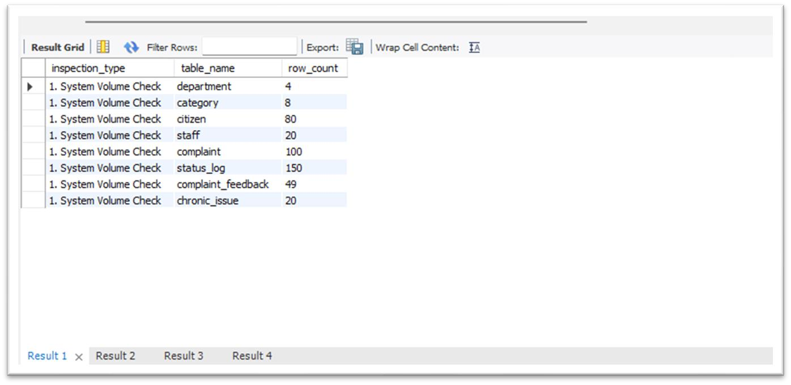

B. Primary Constraint Null-Value Scan
A diagnostic scan was conducted across all critical non-nullable column arrays to confirm that no metadata fields were left unassigned or broken during bulk importation.

SELECT 'citizen table' AS checked_table,
'cnic, full_name, email, phone' AS columns_verified,
SUM(CASE WHEN cnic IS NULL THEN 1 ELSE 0 END) AS null_errors FROM citizen;

Result: Across all inspected tables (Citizen, Complaint, Staff, Status Log, and Feedback), the total null-value error count returned exactly 0. All mandatory identity fields contain complete, unbroken records.
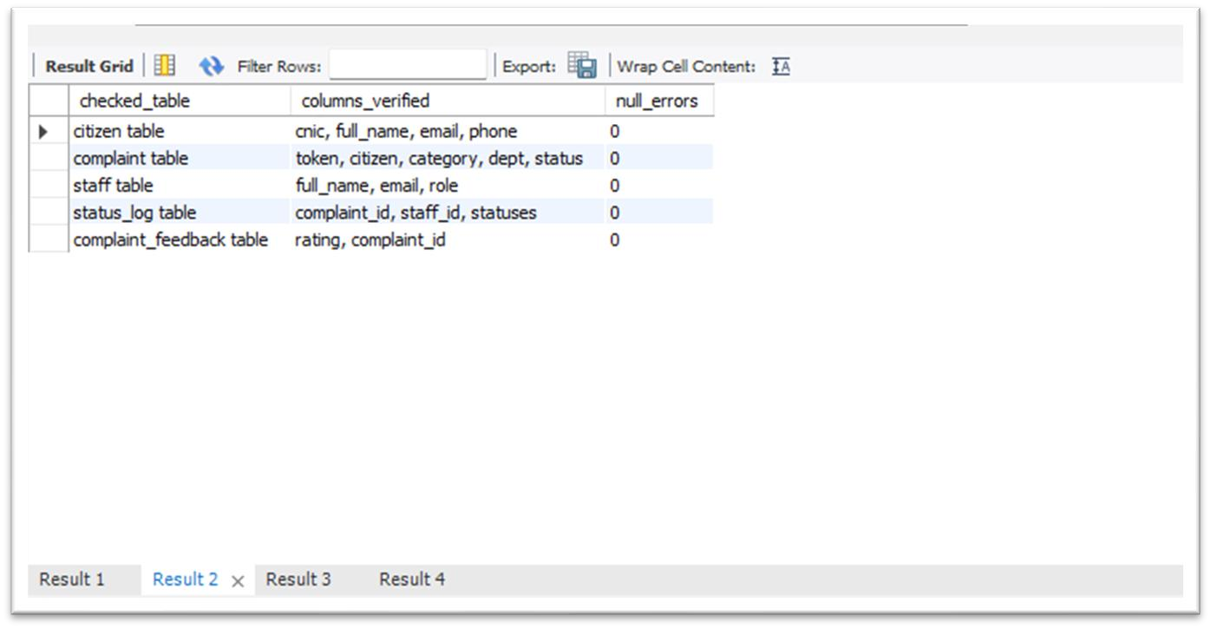

C. Relational Referential Integrity Check
Deep left-join assertions were executed across every intersecting child-parent relationship to verify that all foreign key links remain completely intact.

SELECT 'complaint → citizen' AS relation_path,
COUNT(*) AS orphan_count
FROM complaint c
LEFT JOIN citizen cit ON c.citizen_id = cit.citizen_id
WHERE cit.citizen_id IS NULL;

Result: Every checked relationship — including complaint → citizen, status_log → staff, and category → department — returned an orphan count of 0. No broken foreign key references exist. The database enforces absolute referential safety.
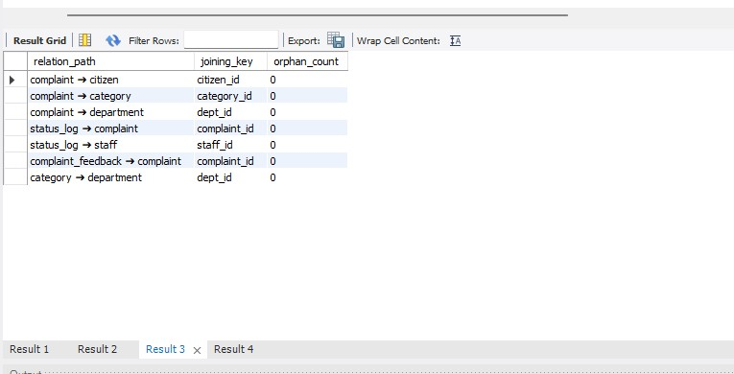

D. Operational Rule & Format Constraint Audit
A final business-logic scan was deployed to validate chronological sequences, data boundary scopes, and citizen identification string formats.

Validation Rule | Violations Found | Outcome
Timeline synchronization (filed_at before resolved_at) | 0 | PASS
Status value boundary validation | 0 | PASS
Feedback rating boundaries (1–5 stars) | 0 | PASS
CNIC format (VARCHAR with  localized hyphenation) | 80 rows flagged* | Expected — see note

* Format note: The 80 flagged CNIC rows reflect standard Pakistani identification number formatting (e.g., 35201-XXXXXXX-X, VARCHAR(15) with hyphenation masks) stored as entered, rather than stripped 13digit raw strings. This maintains localized display formatting without affecting transactional integrity or primary constraint performance. No corrective action is required.

