How to create a HTML page in Servlet application?

Step 1: Right click on Application Name 🡪 New 🡪 HTML file

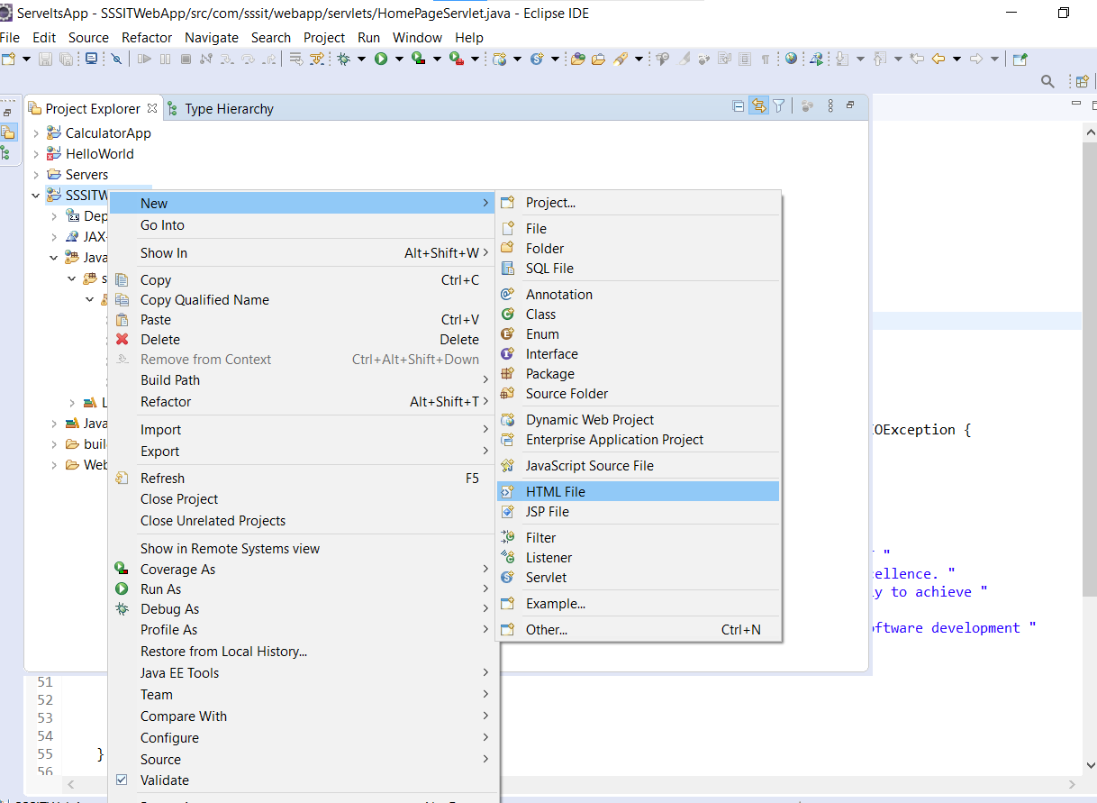

Step 2: provide the name to the HTML file and click on finish button

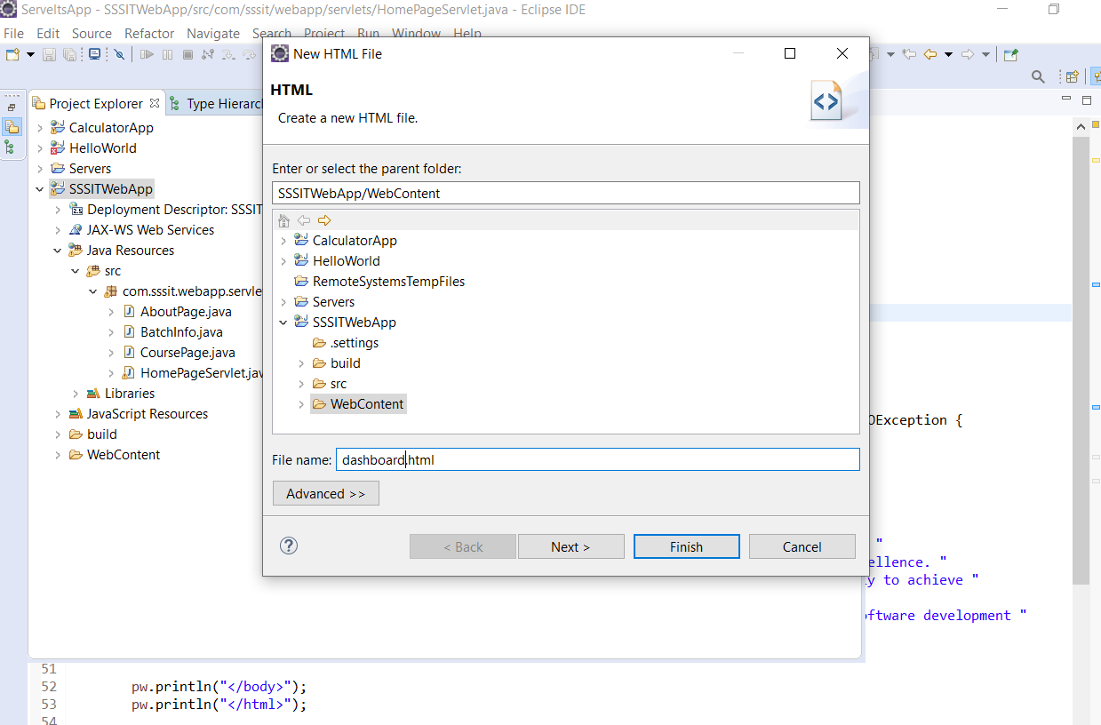

What is the location of HTML file in servlet application?

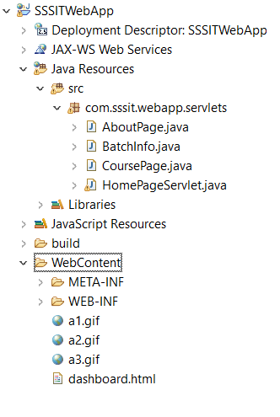

Servlet maintains all HTML, Java script, CSS and Image files inside the WebContent folder

package com.sssit.webapp.servlets;

import java.io.IOException;

import java.io.PrintWriter;

import javax.servlet.ServletException;

import javax.servlet.http.HttpServlet;

import javax.servlet.http.HttpServletRequest;

import javax.servlet.http.HttpServletResponse;

/**

* Servlet implementation class BatchInfo

*/

public class BatchInfo extends HttpServlet {

private static final long serialVersionUID = 1L;

/**

* @see HttpServlet#HttpServlet()

*/

public BatchInfo() {

super();

// TODO Auto-generated constructor stub

}

/**

* @see HttpServlet#service(HttpServletRequest request, HttpServletResponse response)

*/

protected void service(HttpServletRequest request, HttpServletResponse response) throws ServletException, IOException {

PrintWriter pw = response.getWriter();

response.setContentType("text/html");

pw.println("<table border=3>");

pw.println("<tr>");

pw.println("<td> C Language </td>");

pw.println("<td> 7 to 8 </td>");

pw.println("</tr>");

pw.println("<tr>");

pw.println("<td> CPP Language </td>");

pw.println("<td> 8 to 9 </td>");

pw.println("</tr>");

pw.println("<tr>");

pw.println("<td> Core Java</td>");

pw.println("<td> 7 to 8 </td>");

pw.println("</tr>");

pw.println("<tr>");

pw.println("<td> Oracle</td>");

pw.println("<td> 7 to 8 </td>");

pw.println("</tr>");

pw.println("</table>");

pw.println("<a href=/SSSITWebApp/dashboard.html> Clcik Here to go Back </a>");

}

}

package com.sssit.webapp.servlets;

import java.io.IOException;

import java.io.PrintWriter;

import javax.servlet.ServletException;

import javax.servlet.http.HttpServlet;

import javax.servlet.http.HttpServletRequest;

import javax.servlet.http.HttpServletResponse;

/**

* Servlet implementation class AboutPage

*/

public class AboutPage extends HttpServlet {

private static final long serialVersionUID = 1L;

/**

* @see HttpServlet#HttpServlet()

*/

public AboutPage() {

super();

// TODO Auto-generated constructor stub

}

/**

* @see HttpServlet#service(HttpServletRequest request, HttpServletResponse response)

*/

protected void service(HttpServletRequest request, HttpServletResponse response) throws ServletException, IOException {

response.setContentType("text/html");

PrintWriter pw = response.getWriter();

pw.println("<img src=a1.gif alt=NA height=150 width=150/>");

pw.println("<img src=a2.gif alt=NA height=150 width=150/>");

pw.println("<img src=a3.gif alt=NA height=150 width=150/>");

pw.println("<a href=/SSSITWebApp/dashboard.html> Clcik Here to go Back </a>");

}

}

package com.sssit.webapp.servlets;

import java.io.IOException;

import java.io.PrintWriter;

import javax.servlet.ServletException;

import javax.servlet.http.HttpServlet;

import javax.servlet.http.HttpServletRequest;

import javax.servlet.http.HttpServletResponse;

/**

* Servlet implementation class CoursePage

*/

public class CoursePage extends HttpServlet {

private static final long serialVersionUID = 1L;

/**

* @see HttpServlet#HttpServlet()

*/

public CoursePage() {

super();

// TODO Auto-generated constructor stub

}

/**

* @see HttpServlet#service(HttpServletRequest request, HttpServletResponse response)

*/

protected void service(HttpServletRequest request, HttpServletResponse response) throws ServletException, IOException {

PrintWriter pw = response.getWriter();

response.setContentType("text/html");;

pw.println("<ol>");

pw.println("<li> C Language </li>");

pw.println("<li> CPP Language </li>");

pw.println("<li> Core Java </li>");

pw.println("<li> Advanced Java </li>");

pw.println("<li> Oracle </li>");

pw.println("</ol>");

pw.println("<a href=/SSSITWebApp/dashboard.html> Clcik Here to go Back </a>");

}

}

package com.sssit.webapp.servlets;

import java.io.IOException;

import java.io.PrintWriter;

import javax.servlet.GenericServlet;

import javax.servlet.Servlet;

import javax.servlet.ServletConfig;

import javax.servlet.ServletContext;

import javax.servlet.ServletException;

import javax.servlet.ServletRequest;

import javax.servlet.ServletResponse;

/**

* Servlet implementation class HomePageServlet

*/

public class HomePageServlet extends GenericServlet {

private static final long serialVersionUID = 1L;

@Override

public void init(ServletConfig config) throws ServletException {

// TODO Auto-generated method stub

super.init(config);

}

/**

* @see GenericServlet#GenericServlet()

*/

public HomePageServlet() {

super();

// TODO Auto-generated constructor stub

}

/**

* @see Servlet#service(ServletRequest request, ServletResponse response)

*/

public void service(ServletRequest request, ServletResponse response) throws ServletException, IOException {

PrintWriter pw = response.getWriter();

pw.println("<html>");

pw.println("<head></head>");

pw.println("<body>");

pw.println("<p> Welcome to SSSIT A Visionary with more than 16 years of Experience in the IT "

+ "Industry, Mr.V.Ramesh is at the helm of affairs at SSSIT, Steering it towards Excellence. "

+ "SSSIT Founded in 1999 and operating for over of 15 years SSSIT has worked steadily to achieve "

+ "excellence in Computer Education and Training, "

+ "Software Development, Corporative Training and Consultancy. Working on several software development "

+ "projects for both domestic and global markets and Engineering Academic Projects"

+ " SSSIT is today a name to reckon with based in Hyderabad, India.</p>");

pw.println("<a href=/SSSITWebApp/dashboard.html> Clcik Here to go Back </a>");

pw.println("</body>");

pw.println("</html>");

}

}

<?xml version=*"1.0"* encoding=*"UTF-8"*?>

<web-app xmlns:xsi=*"http://www.w3.org/2001/XMLSchema-instance"* xmlns=*"http://java.sun.com/xml/ns/javaee"* xsi:schemaLocation=*"http://java.sun.com/xml/ns/javaee http://java.sun.com/xml/ns/javaee/web-app_2_5.xsd"* id=*"WebApp_ID"* version=*"2.5"*>

<display-name>SSSITWebApp</display-name>

<welcome-file-list>

<welcome-file>index.html</welcome-file>

<welcome-file>index.htm</welcome-file>

<welcome-file>index.jsp</welcome-file>

<welcome-file>default.html</welcome-file>

<welcome-file>default.htm</welcome-file>

<welcome-file>default.jsp</welcome-file>

</welcome-file-list>

<servlet>

<description></description>

<display-name>HomePageServlet</display-name>

<servlet-name>HomePageServlet</servlet-name>

<servlet-class>com.sssit.webapp.servlets.HomePageServlet</servlet-class>

</servlet>

<servlet-mapping>

<servlet-name>HomePageServlet</servlet-name>

<url-pattern>/home</url-pattern>

</servlet-mapping>

<servlet>

<description></description>

<display-name>AboutPage</display-name>

<servlet-name>AboutPage</servlet-name>

<servlet-class>com.sssit.webapp.servlets.AboutPage</servlet-class>

</servlet>

<servlet-mapping>

<servlet-name>AboutPage</servlet-name>

<url-pattern>/about</url-pattern>

</servlet-mapping>

<servlet>

<description></description>

<display-name>CoursePage</display-name>

<servlet-name>CoursePage</servlet-name>

<servlet-class>com.sssit.webapp.servlets.CoursePage</servlet-class>

</servlet>

<servlet-mapping>

<servlet-name>CoursePage</servlet-name>

<url-pattern>/course</url-pattern>

</servlet-mapping>

<servlet>

<description></description>

<display-name>BatchInfo</display-name>

<servlet-name>BatchInfo</servlet-name>

<servlet-class>com.sssit.webapp.servlets.BatchInfo</servlet-class>

</servlet>

<servlet-mapping>

<servlet-name>BatchInfo</servlet-name>

<url-pattern>/batch</url-pattern>

</servlet-mapping>

</web-app>

Dashboard.html

<!DOCTYPE html>

<html>

<head>

<meta charset=*"ISO-8859-1"*>

<title>Insert title here</title>

</head>

<body>

<a href=*"/SSSITWebApp/home"*> Home </a><br>

<a href=*"/SSSITWebApp/about"*> About</a><br>

<a href=*"/SSSITWebApp/batch"*> batch </a><br>

<a href=*"/SSSITWebApp/course"*> Course </a><br>

</body>

</html>

How to run the above application:

Localhost:8080/*SSSITWebApp/dashboard.html*

How to read the values from HTML form or request Object?

FOUR different ways to read the values from request or HTML form

1. getParameter(String) : String
2. getParameterValues(String) : String[]
3. getParameterMap()
4. getParameterNames()

getParameter method is used to read the value associated to the key

getParameterValues is used to read the list of values associated to the key

Develop a servlet application for Login page

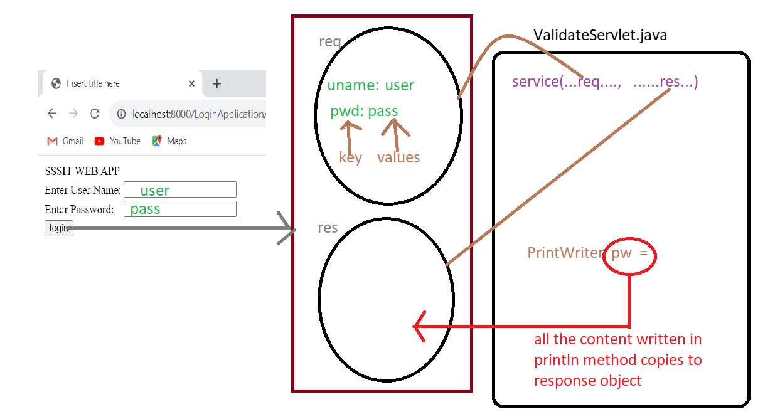

<!DOCTYPE html>

<html>

<head>

<meta charset=*"ISO-8859-1"*>

<title>Insert title here</title>

</head>

<body>

<form action=*"/LoginApplication/validate"* method=*"post"*>

<table>

<tr>

<td colspan=*"2"*> SSSIT WEB APP </td>

</tr>

<tr>

<td> Enter User Name:</td>

<td> <input type=*"text"* name=*"uname"*/> </td>

</tr>

<tr>

<td> Enter Password:</td>

<td> <input type=*"password"* name=*"pwd"*/> </td>

</tr>

<tr>

<td colspan=*"2"*> <input type=*"submit"* value=*"login"*/> </td></tr>

</table>

</form>

</body>

</html>

**package** com.sssit.login.servlets;

**import** java.io.IOException;

**import** java.io.PrintWriter;

**import** javax.servlet.ServletException;

**import** javax.servlet.http.HttpServlet;

**import** javax.servlet.http.HttpServletRequest;

**import** javax.servlet.http.HttpServletResponse;

/**

* Servlet implementation class CredentialsValidateServlet

*/

**public** **class** CredentialsValidateServlet **extends** HttpServlet {

**private** **static** **final** **long** ***serialVersionUID*** = 1L;

/**

* **@see** HttpServlet#HttpServlet()

*/

**public** CredentialsValidateServlet() {

**super**();

// **TODO** Auto-generated constructor stub

}

/**

* **@see** HttpServlet#service(HttpServletRequest request, HttpServletResponse response)

*/

**protected** **void** service(HttpServletRequest request, HttpServletResponse response) **throws** ServletException, IOException {

PrintWriter pw = response.getWriter();

/* How to read the values from Request Object */

String userName = request.getParameter("uname");

String password = request.getParameter("pwd");

**if**("user".equals(userName) && "pass".equals(password))

pw.println("<p> Welcome to SSSIT Mail </p>");

**else**

pw.println("<p> Invalid Credentials </p>");

}

}

<?xml version=*"1.0"* encoding=*"UTF-8"*?>

<web-app xmlns:xsi=*"http://www.w3.org/2001/XMLSchema-instance"* xmlns=*"http://java.sun.com/xml/ns/javaee"* xsi:schemaLocation=*"http://java.sun.com/xml/ns/javaee http://java.sun.com/xml/ns/javaee/web-app_2_5.xsd"* id=*"WebApp_ID"* version=*"2.5"*>

<display-name>LoginApplication</display-name>

<welcome-file-list>

<welcome-file>index.html</welcome-file>

<welcome-file>index.htm</welcome-file>

<welcome-file>index.jsp</welcome-file>

<welcome-file>default.html</welcome-file>

<welcome-file>default.htm</welcome-file>

<welcome-file>default.jsp</welcome-file>

</welcome-file-list>

<servlet>

<description></description>

<display-name>CredentialsValidateServlet</display-name>

<servlet-name>CredentialsValidateServlet</servlet-name>

<servlet-class>com.sssit.login.servlets.CredentialsValidateServlet</servlet-class>

</servlet>

<servlet-mapping>

<servlet-name>CredentialsValidateServlet</servlet-name>

<url-pattern>/validate</url-pattern>

</servlet-mapping>

</web-app>