How to navigate from one resource to another resource?

TWO Ways:

1. Using Request Dispatcher
   1. Include
   2. forward
2. Using SendRedirect

Request dispatcher is used to transfer the request and response objects from one resource to another resource available with in the application

Difference between Include and forward?

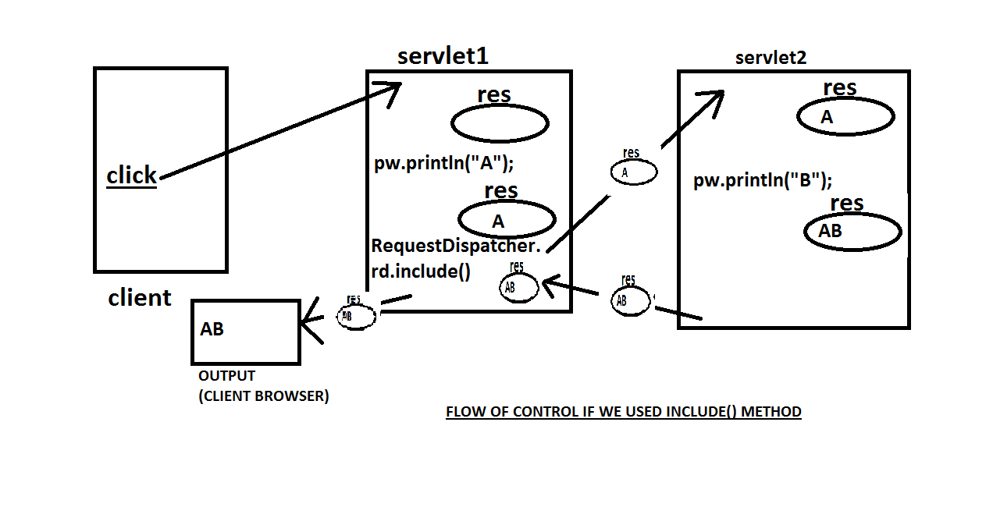

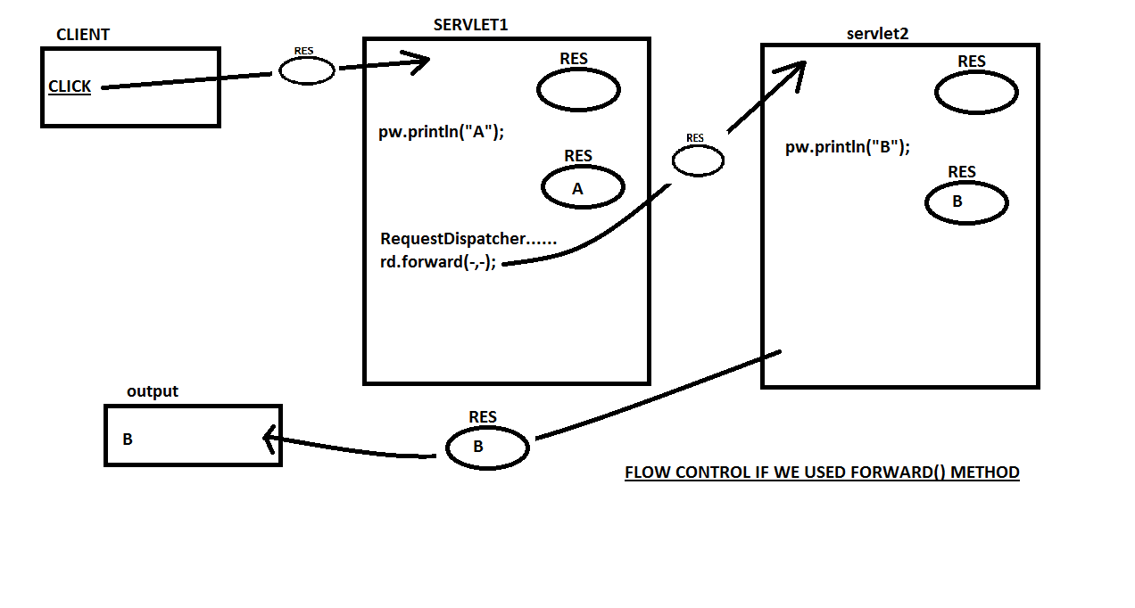

What is the difference between RequestDispatcher and send redirect?

Request dispatcher is used to navigate another resource present with in the web application

EX: In amazon.com, moving from products list page to detailed product view page or moving from detailed product view page to buy product page are the examples from Request dispatcher

sendRedirect is used to navigate to another resource present outside the web application

Ex: In amazon.com, if we select icici bank for making the payment then the request should navigate to the icici bank login page. In this case, we have to use send redirect