JSP Scripting Tags

1. Declaration Tag --

<%!.......%>

instance variables or instance methods or static methods or static variables

2. Expression Tag --- <%=........%>

is used to render the info. on web page

Output statment in JSP

3. Scriplet --- <%........%>

used to write Java code inside JSP page

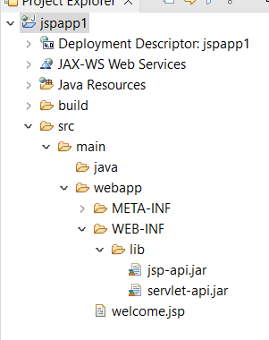

Write a JSP file to display the Welcome Message

Step 1:

Right Click on Project 🡪 New 🡪 JSP

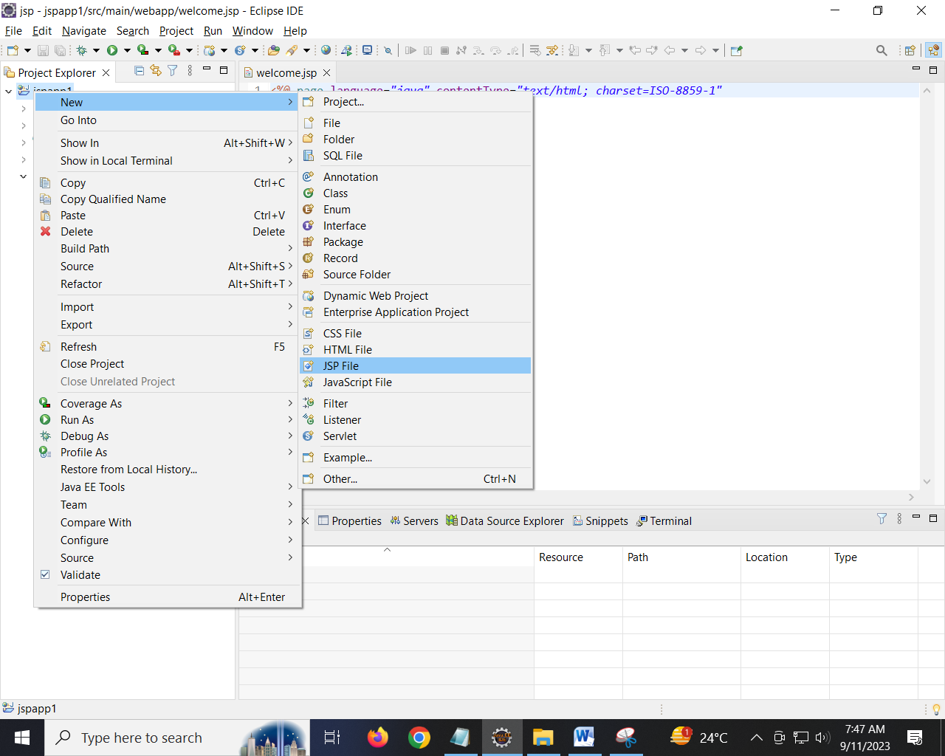

Step 2:

Provide the name of the JSP as “welcome.jsp”

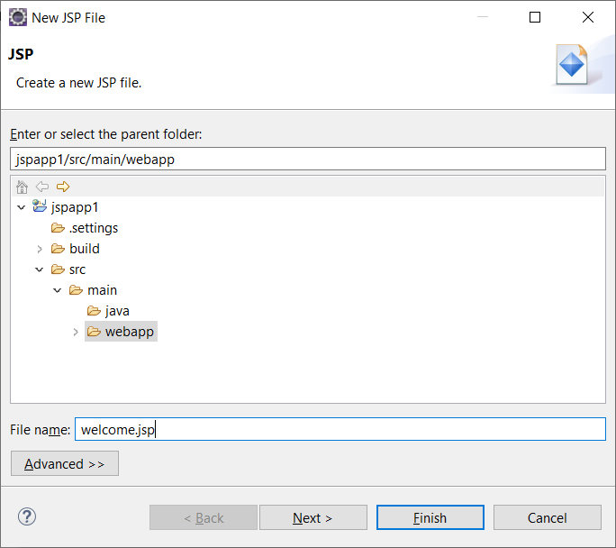

Click on Finish

Step 3: write the JSP program to display Welcome message

<%@ page language=*"java"* contentType=*"text/html; charset=ISO-8859-1"*

pageEncoding=*"ISO-8859-1"*%>

<!DOCTYPE html>

<html>

<head>

<meta charset=*"ISO-8859-1"*>

<title>Insert title here</title>

</head>

<body>

<%!

**public** String messageUsingDeclarationTag(){

**return** "Welcome to JSP from Declaration Tag";

}

%>

<%= "Welcome to JSP using Expression Tag" %> <br>

<%

out.println("Welcome to JSP using Scriplet");

%> <br>

<%=messageUsingDeclarationTag() %> <br>

<%

out.println(messageUsingDeclarationTag());

%>

</body>

</html>

Step 4: Right click on Application 🡪 Run As 🡪 Run on Server

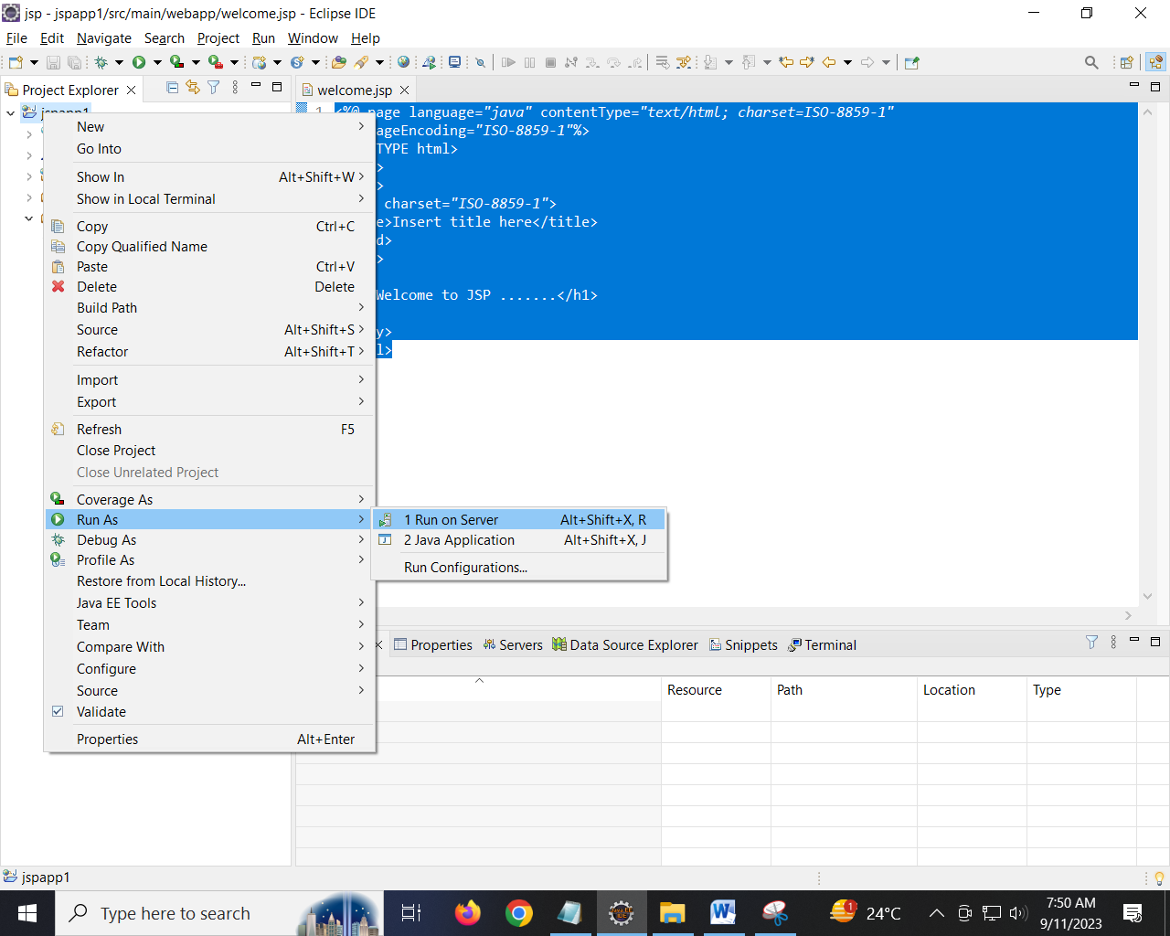

Step 5: Open any browser and type localhost:8081/jspapp1/welcome.jsp

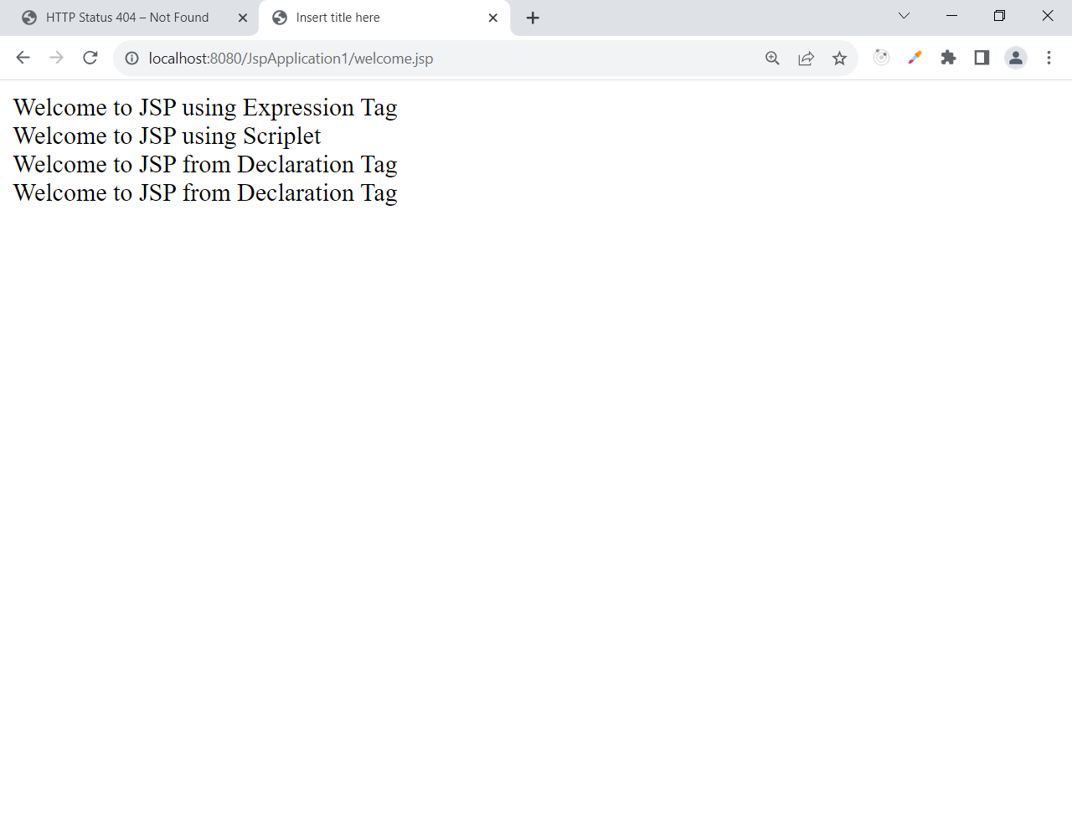

Write a JSP program to display the numbers from 1 to 5

<%@ page language=*"java"* contentType=*"text/html; charset=ISO-8859-1"*

pageEncoding=*"ISO-8859-1"*%>

<!DOCTYPE html>

<html>

<head>

<meta charset=*"ISO-8859-1"*>

<title>Insert title here</title>

</head>

<body>

<%

**for**(**int** i=1;i<5;i++){

%>

<%=i %>

<%

}

%>

Using the Scriplet <br>

<%

**for**(**int** i=1;i<5;i++){

out.println(i);

}

%>

</body>

</html>

Write a JSP file that accepts a number and display whether is the an even or odd

1. Acceptnumber.jsp
2. Checkevenorodd.jsp

acceptnumber.jsp

<%@ page language=*"java"* contentType=*"text/html; charset=ISO-8859-1"*

pageEncoding=*"ISO-8859-1"*%>

<!DOCTYPE html>

<html>

<head>

<meta charset=*"ISO-8859-1"*>

<title>Insert title here</title>

</head>

<body>

<form action=*"checkevenorodd.jsp"* method=*"post"*>

Enter a number: <input type=*"text"* name=*"num"*/>

<input type=*"submit"* value=*"evenorodd"*/>

</form>

</body>

</html>

Checkevenorodd.jsp

<%@ page language=*"java"* contentType=*"text/html; charset=ISO-8859-1"*

pageEncoding=*"ISO-8859-1"*%>

<!DOCTYPE html>

<html>

<head>

<meta charset=*"ISO-8859-1"*>

<title>Insert title here</title>

</head>

<body>

<%

**int** num = Integer.parseInt(request.getParameter("num"));

**if**(num%2==0) {

%>

<%= num + " is even number" %>

<%

} **else** {

%>

<%= num + " is Odd number" %>

<%

}

%>

</body>

</html>

Implicit objects provided by JSP

JSP is providing NINE implicit objects.

1. out
2. request
3. response
4. session
5. application
6. pageContext
7. page
8. exception
9. config

out implicit object is used to render the data on browser

|  |  |
| --- | --- |
| In Servlet | In JSP |
| PrintWriter pw = response.getWriter();  pw.println(“Hi”); | <%  out.println(“Hi”);  %> |

out is the object of jspWriter.

Request Implicit Object

This object is used to read the data from request

It has TWO different methods:

1. request.getParameter(“name”) : String
2. request.getParameterNames() : Enumeration

|  |  |
| --- | --- |
| In Servlet |  |
| …..service(HTTPServletRequest req,……………)  {  req.getParameter(“username”);  ………………  } | <%  out.println( request.getParameter(“username”));  out.println  ( request.getParameter(“password”)); |

