Technologies used to develop Web application:

1. JDK
2. Eclipse IDE
3. Web server – Apache tomcat
4. Any Browser

What is the use of Web server?

* Provides the runtime environment to a web application
* Examples are:
* Tomcat
* Web logic
* Web sphere
* Apache HTTP
* And so on…

Steps to develop the Web application:

Step 1:

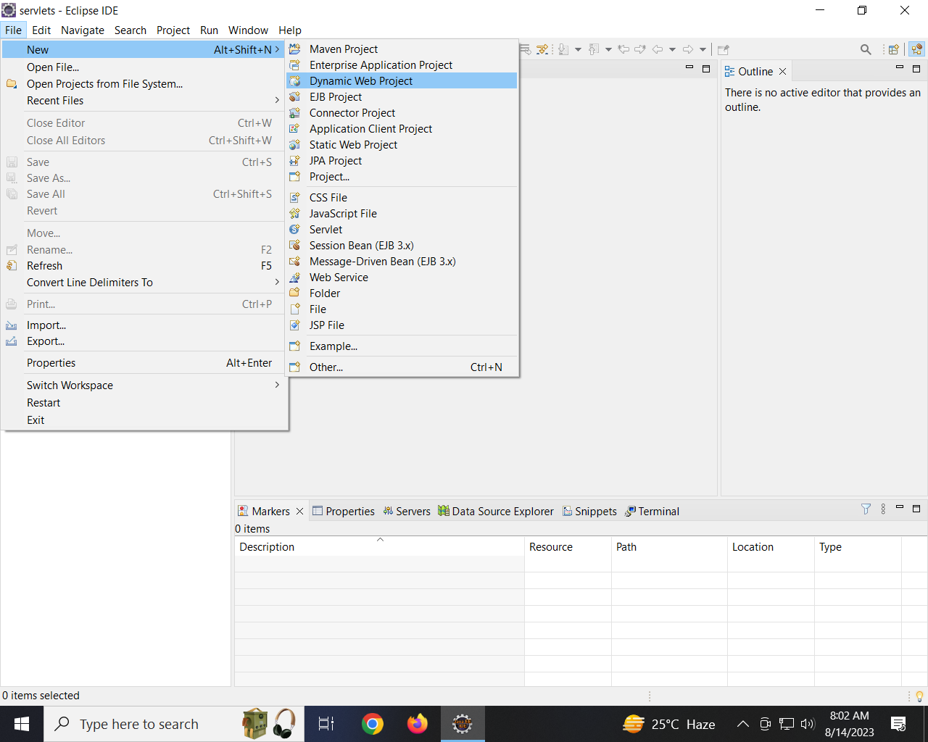

Step 2:

Provide the below information in New Dynamic web module window:

Project Name : HelloWorld

Downgrade the dynamic web module version to 2.5

Click Finish

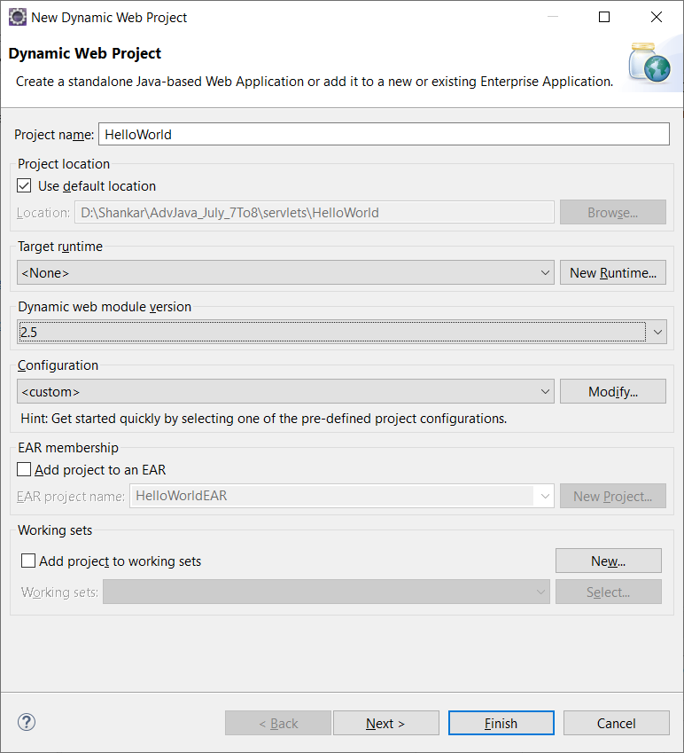

Once we clicked on Finish button, it creates a web application with the below Folder structure

