Technologies used to develop Web application:

1. JDK
2. Eclipse IDE
3. Web server – Apache tomcat
4. Any Browser

What is the use of Web server?

* Provides the runtime environment to a web application
* Examples are:
* Tomcat
* Web logic
* Web sphere
* Apache HTTP
* And so on…

Steps to develop the Web application:

Step 1:

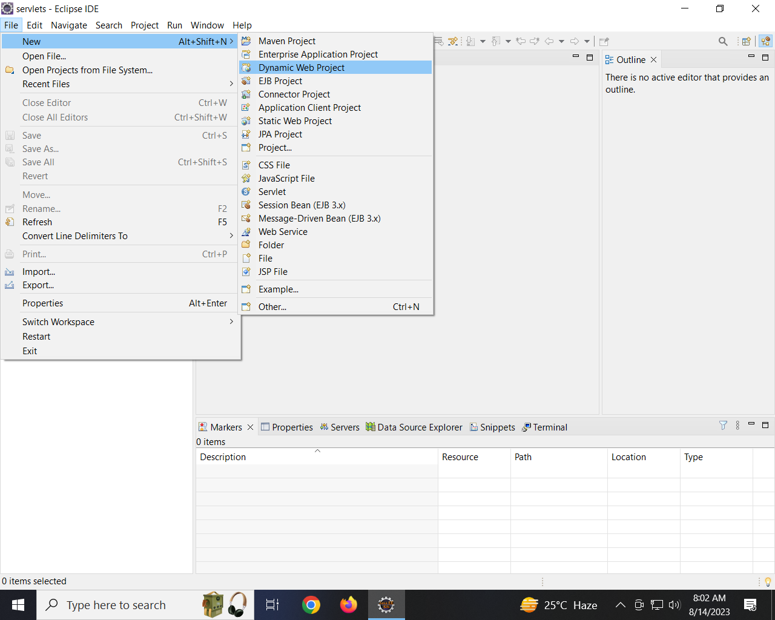

Step 2:

Provide the below information in New Dynamic web module window:

Project Name : HelloWorld

Downgrade the dynamic web module version to 2.5

Click Finish

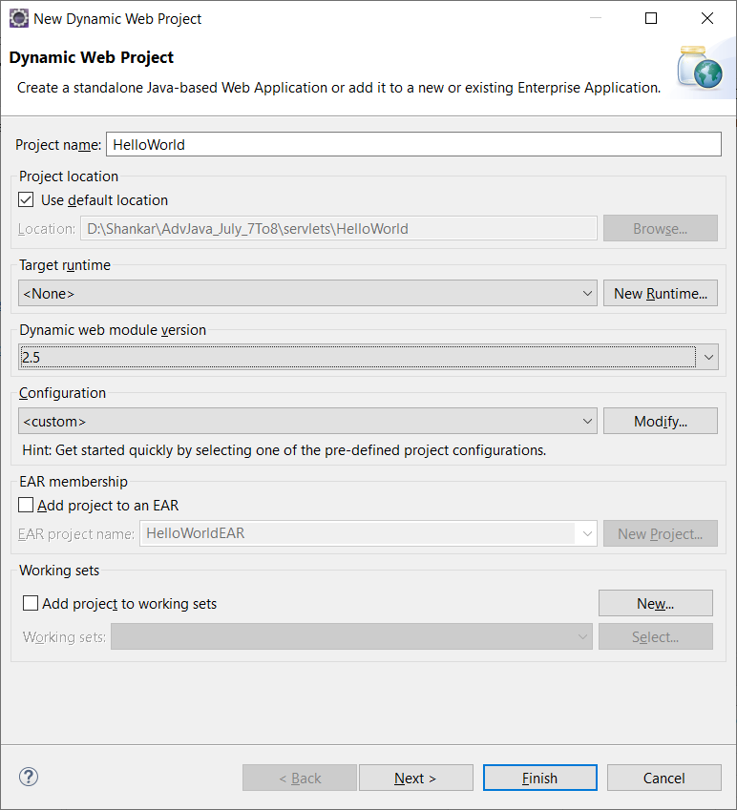

Once we clicked on Finish button, it creates a web application with the below Folder structure

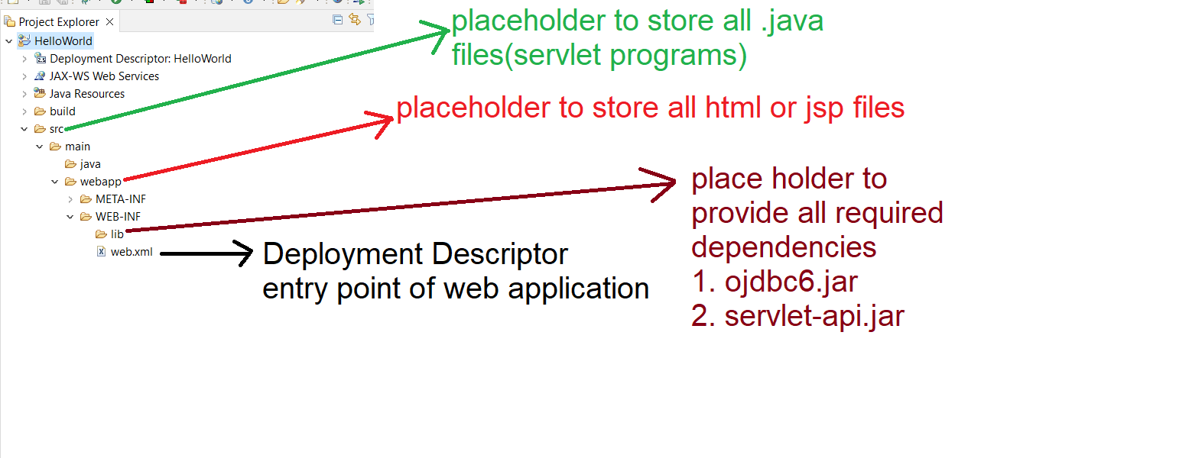

How to Integrate the tomcat server to IDE?

Select Servers tab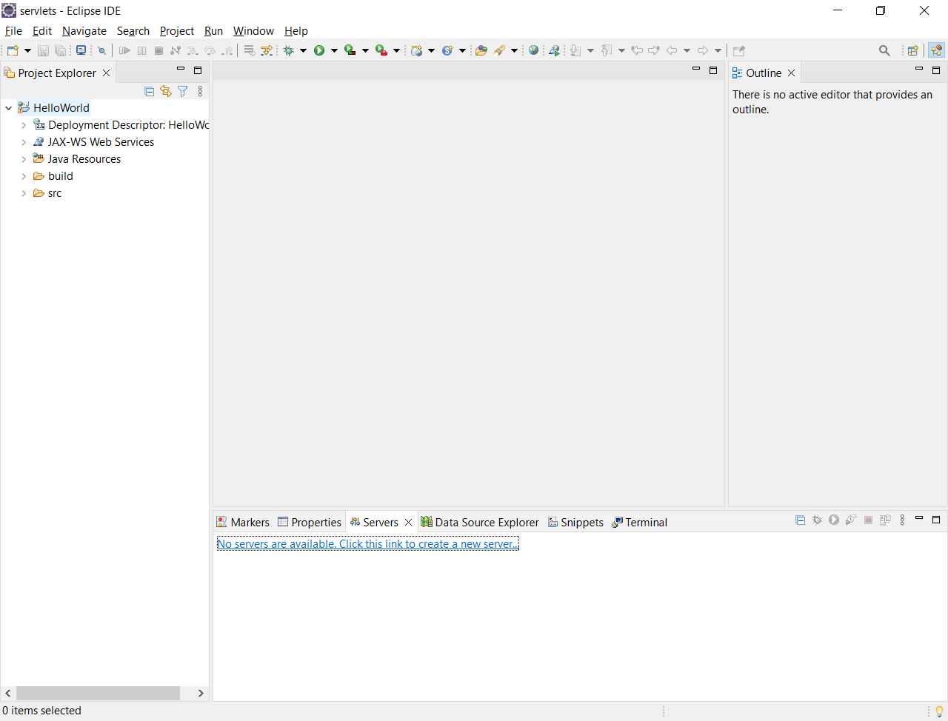

Step 2: Click on the link to add New server

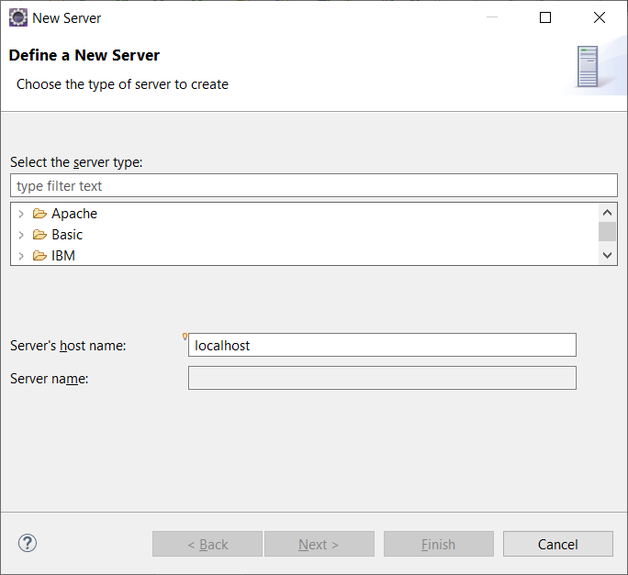

Step 3: select Apache Tomcat 8 from the dropdown Apache.

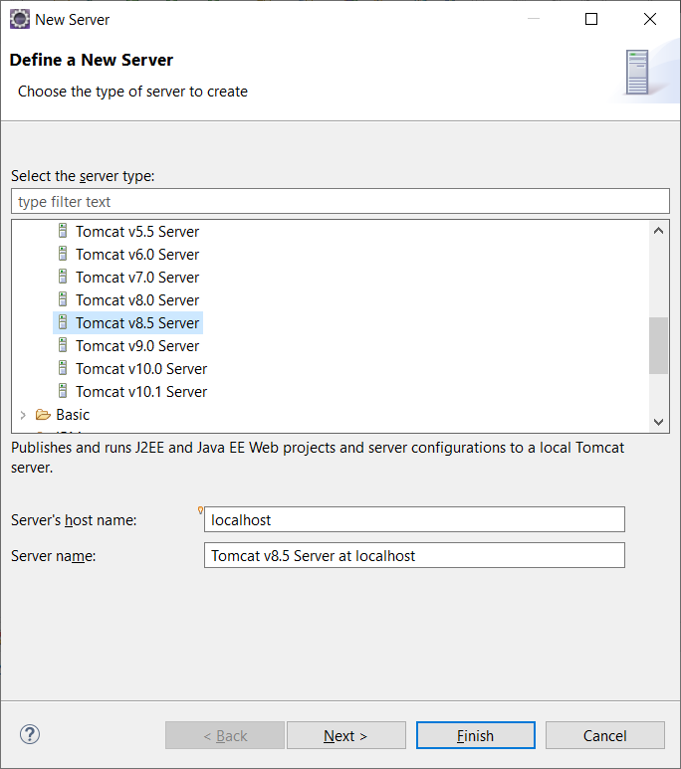

Step 4: Click on Next Button

Step 5: Click on Browse button to navigate to the location where tomcat is available in the computer

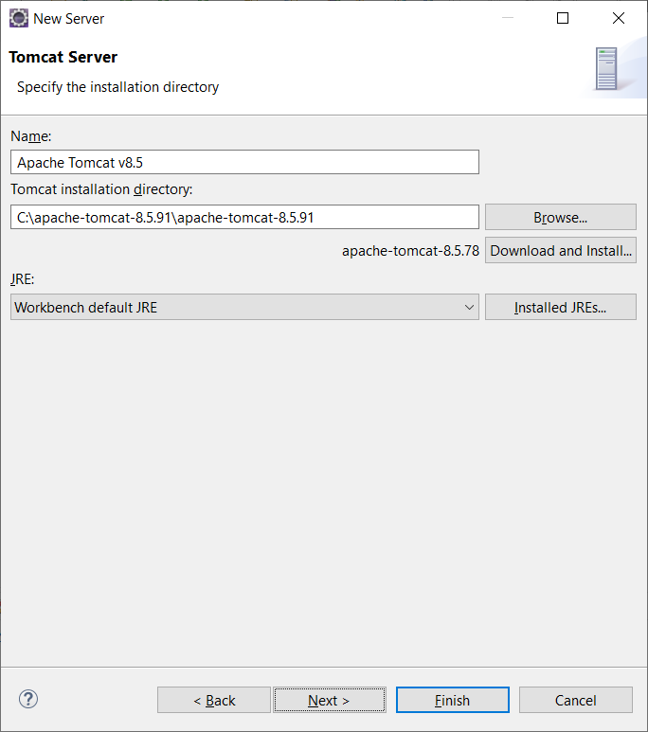

Click on Finish button

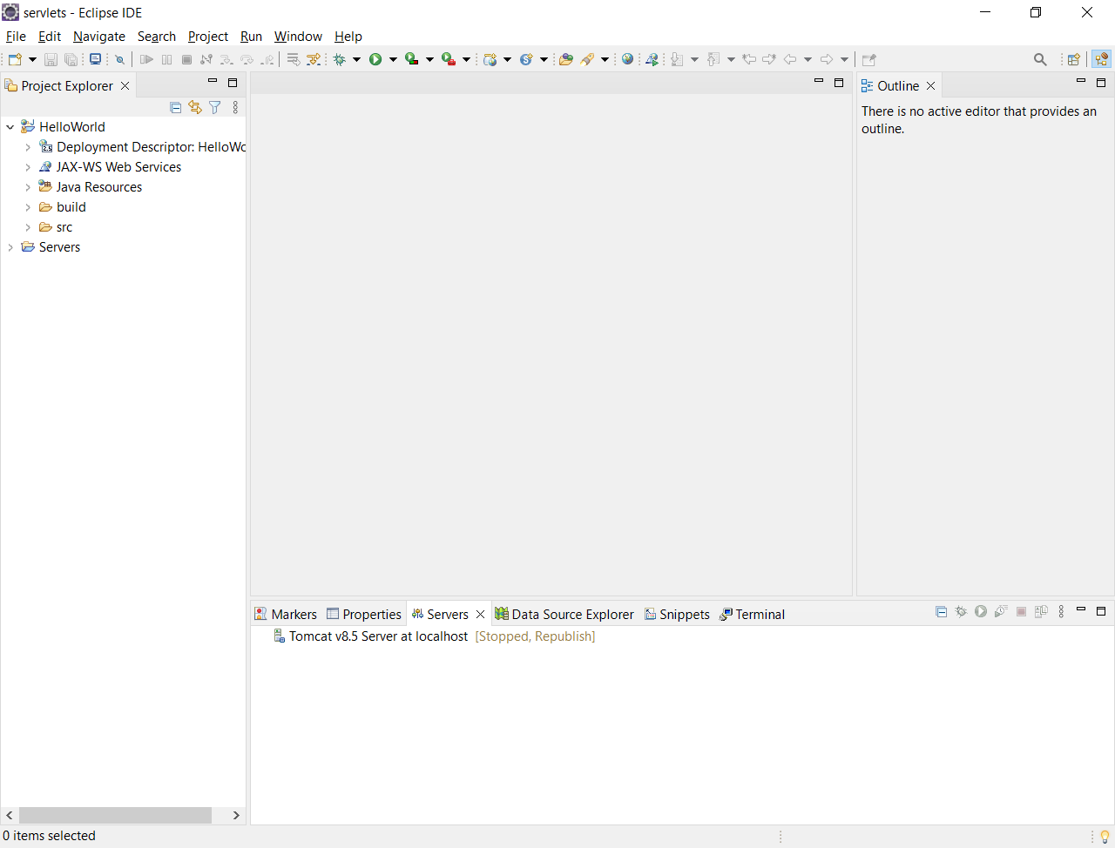

How to create a servlet?

Step 1: Right click on Application 🡪 New 🡪 Servlet

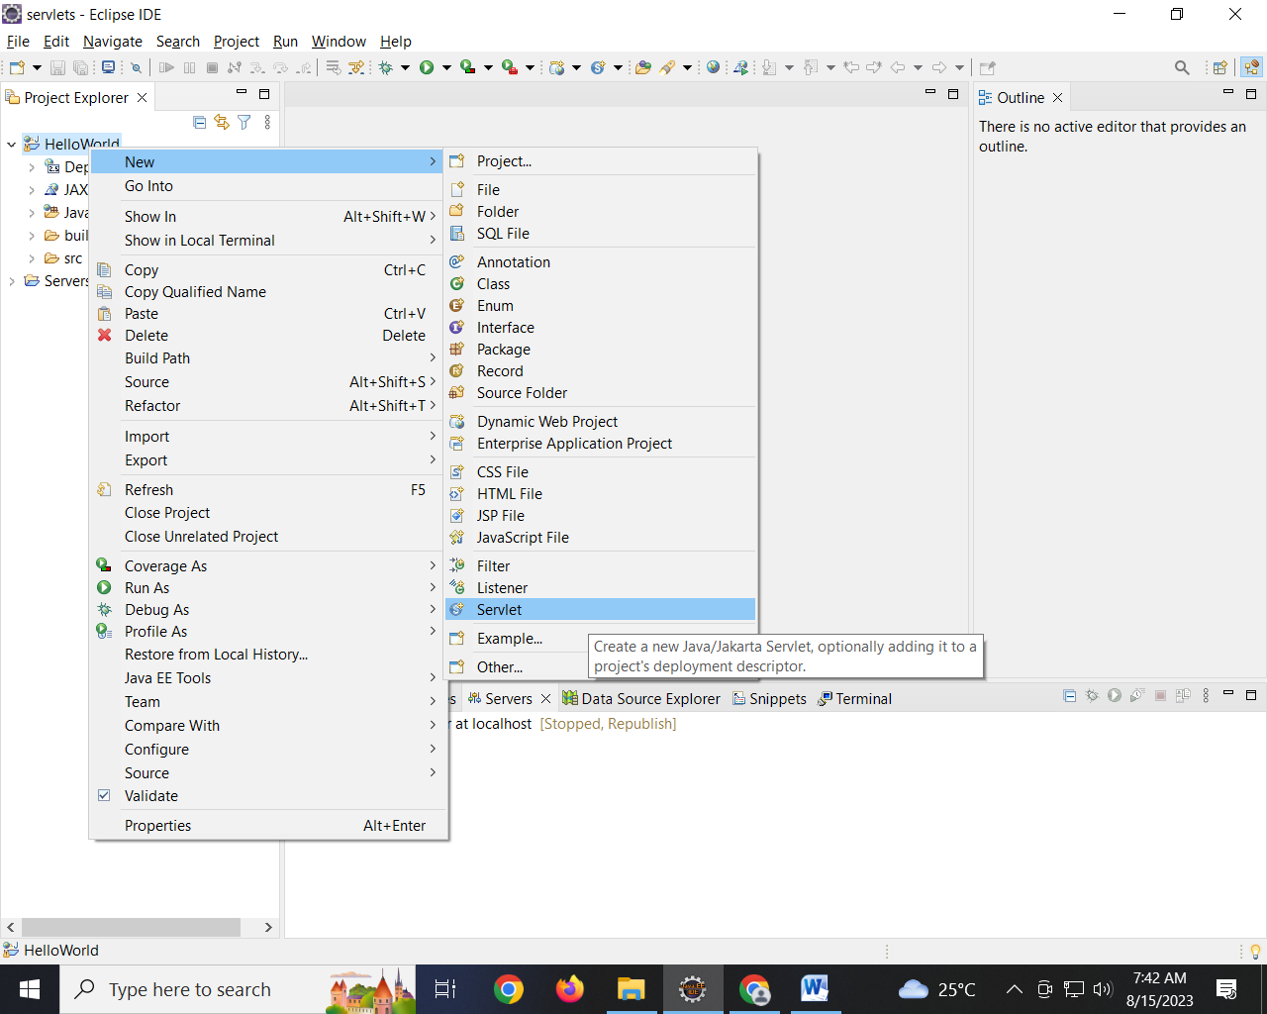

Step 2:

Provide the package name and servlet name click on Next Button

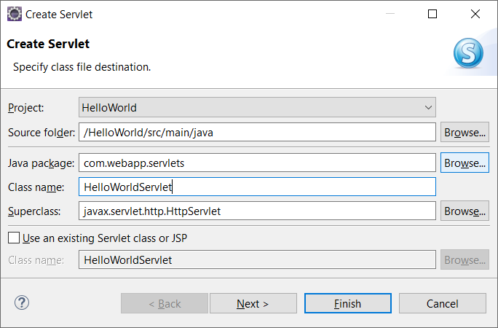

Step 3: change the URL mapping to hello

(Select the URL Mapping 🡪 Click on Edit Button)

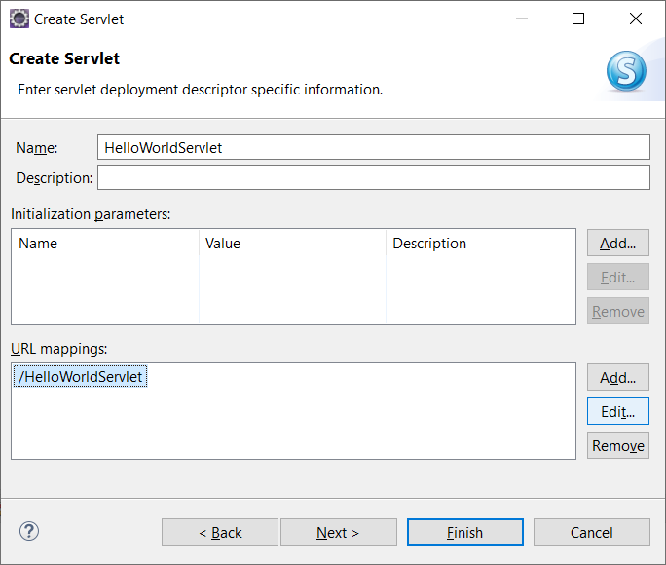

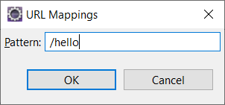

Click on OK Button

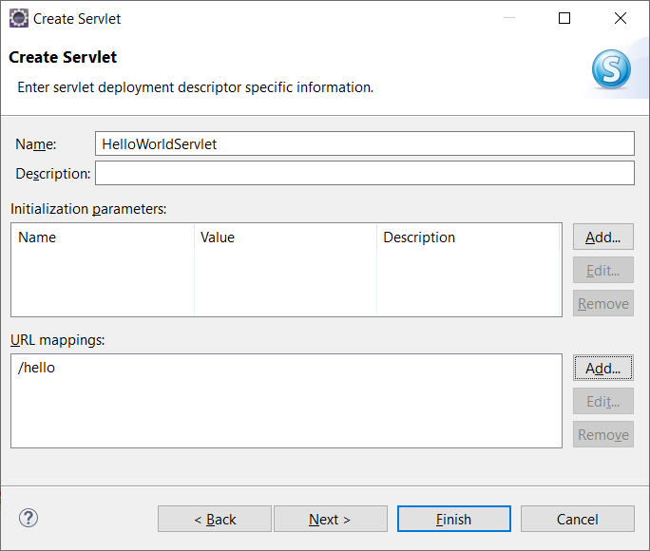

Click On Next Button

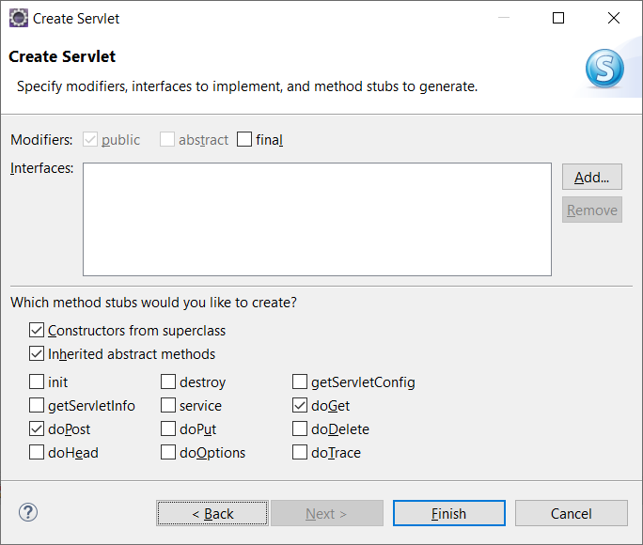

Un Check doPost, doGet options and Check Service Option

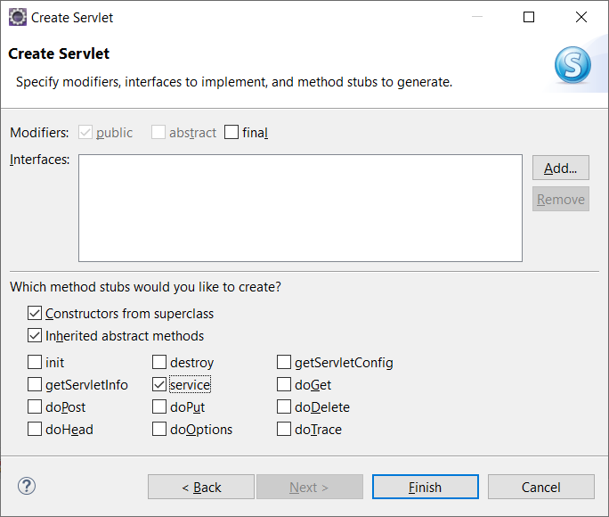

Click On Finish button

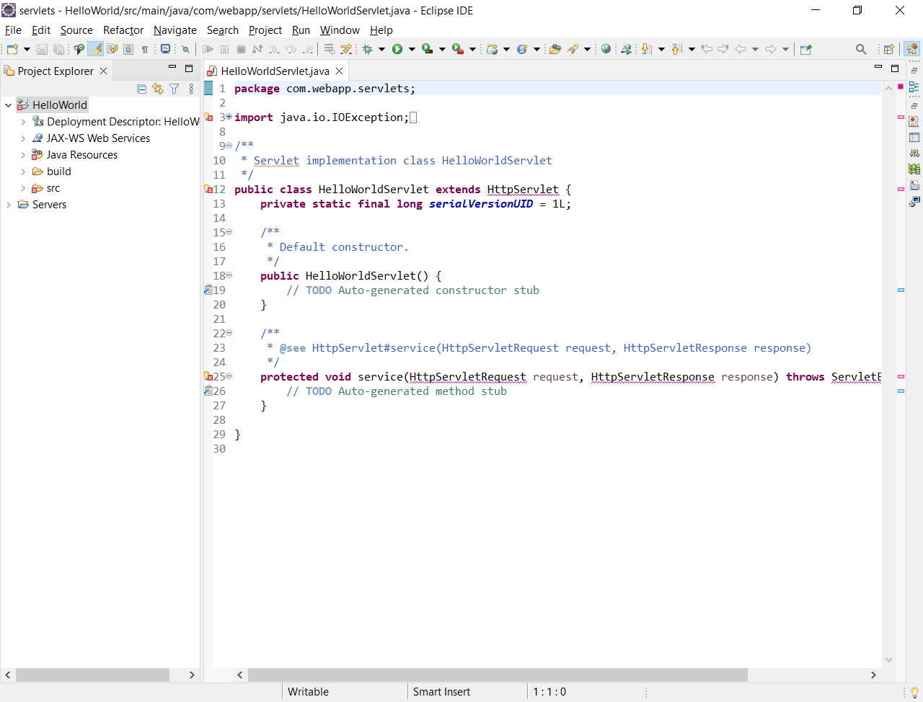

How to resolve the errors in the above program?

Place Servlet-api.jar from Tomcat Installation Directory 🡪 Lib

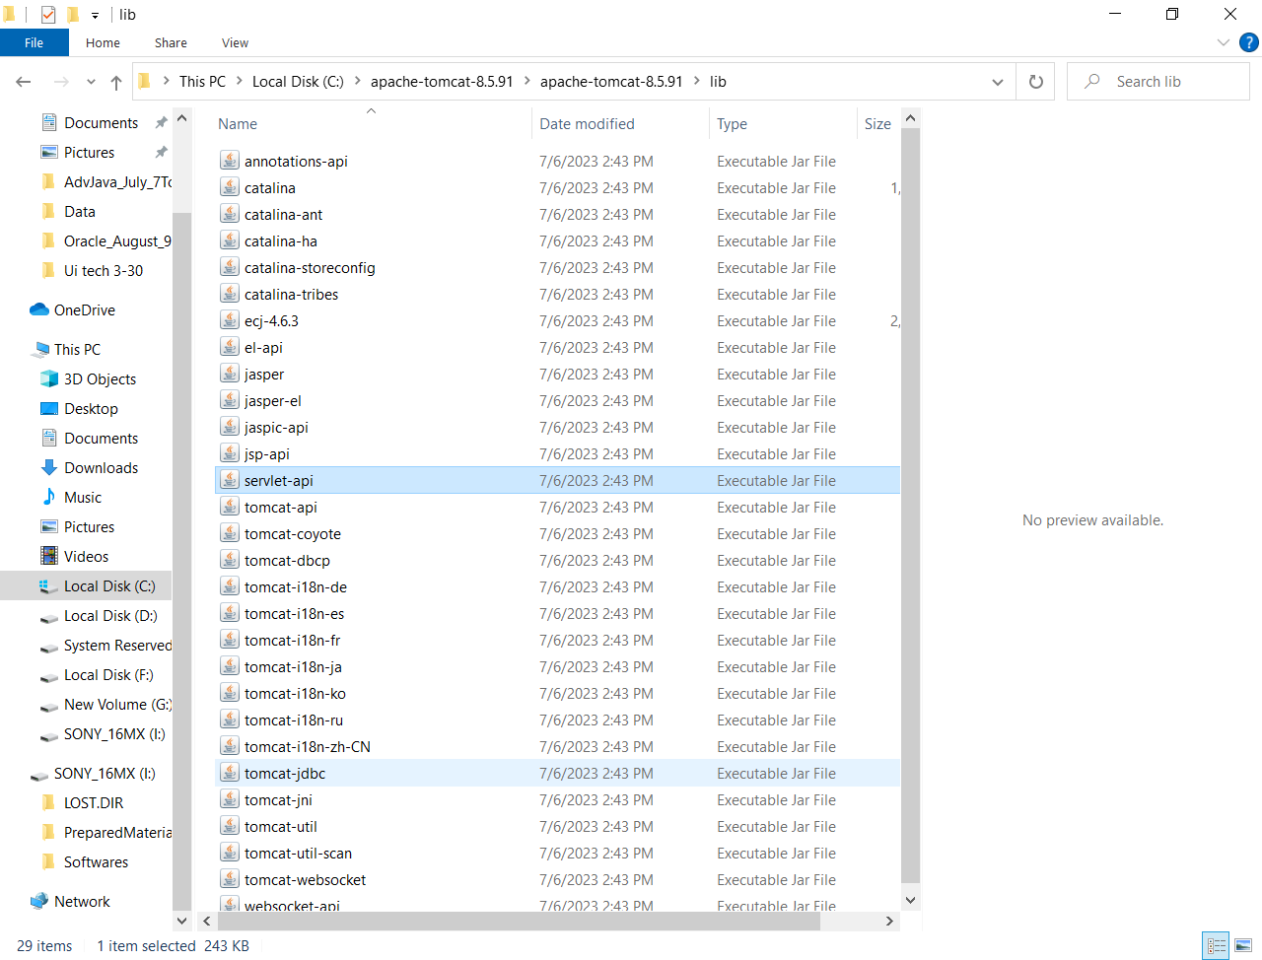

to Application-folder🡪src🡪main🡪webapps🡪WEB-INF 🡪 lib

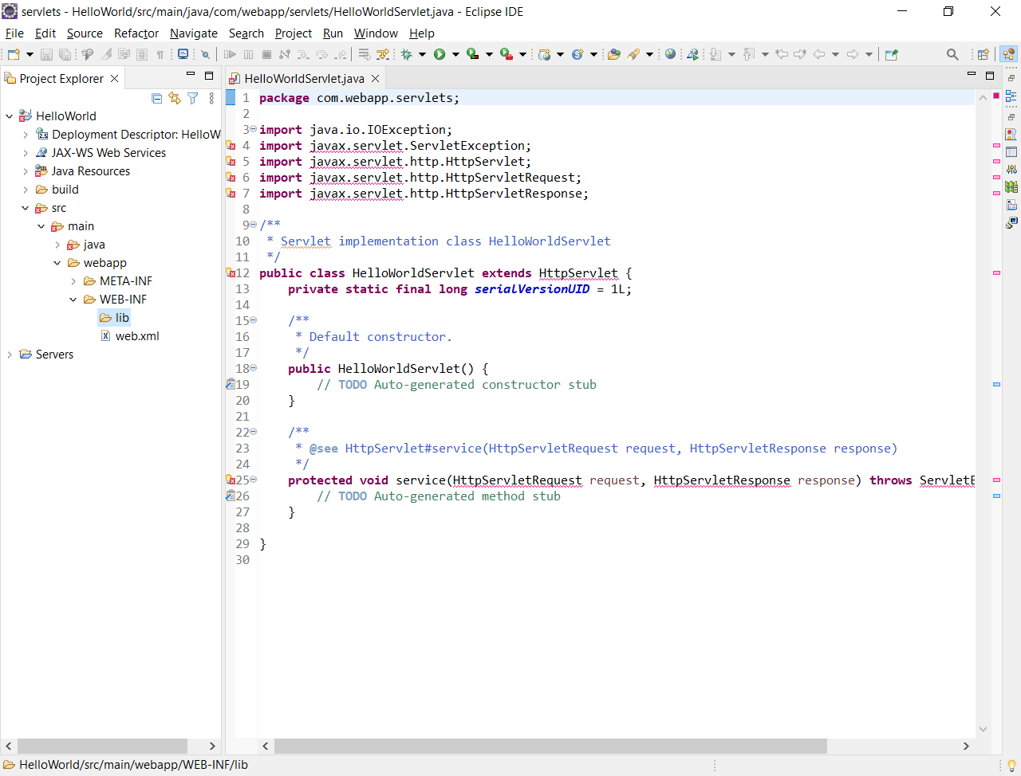

Below is the complete folder structure after the servlet-api.jar is copied

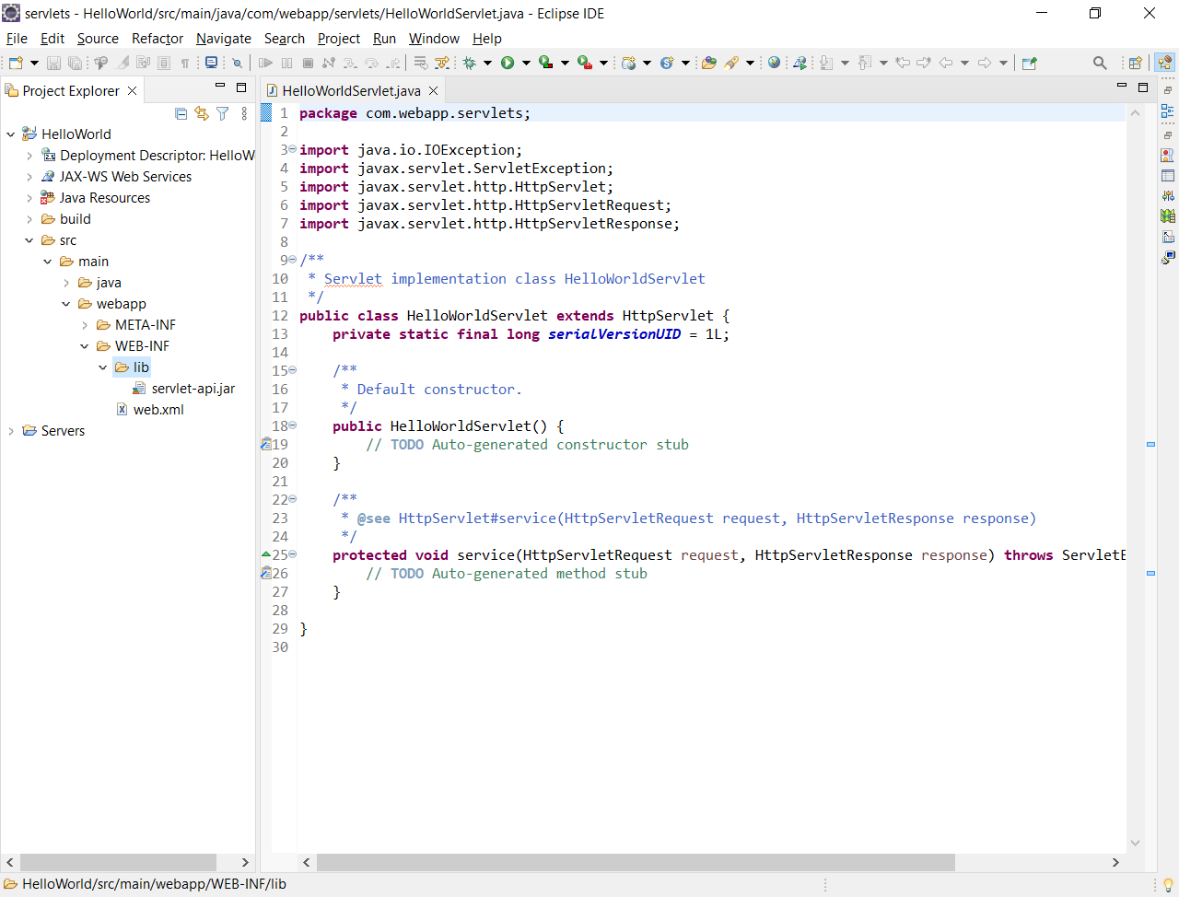

Write a Servlet that displays HelloWorld in the browser?

Inside the service method, write the below code

PrintWriter pw = response.getWriter();

pw.println("<h1>Hello World</h1>");

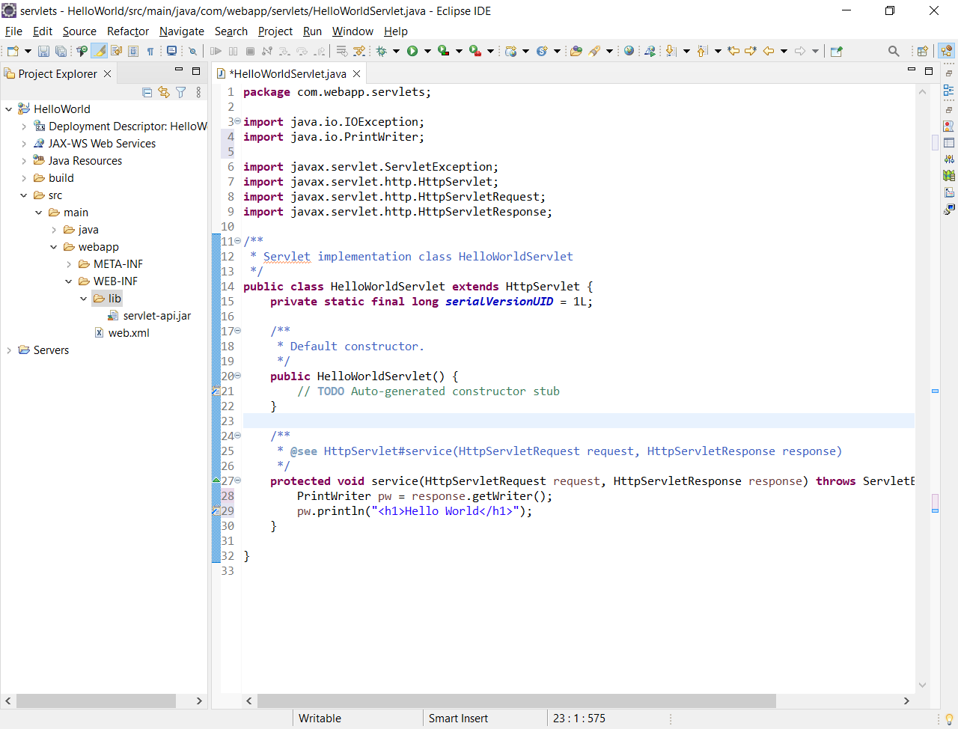

How to run the program?

Right click on Application-name 🡪 Run As 🡪 Run on Server

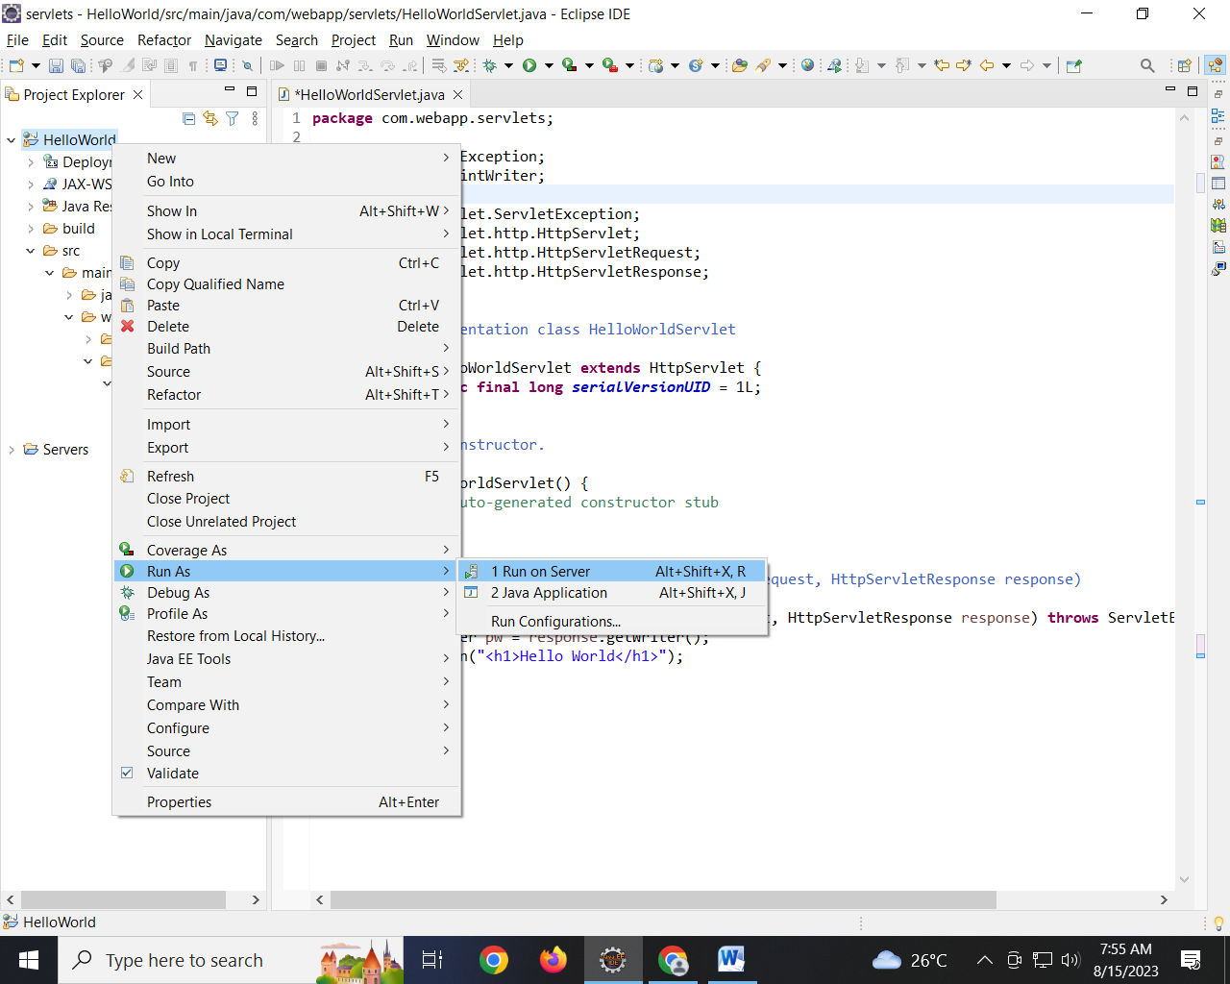

Select the Server as Apache Tomcat 8.5

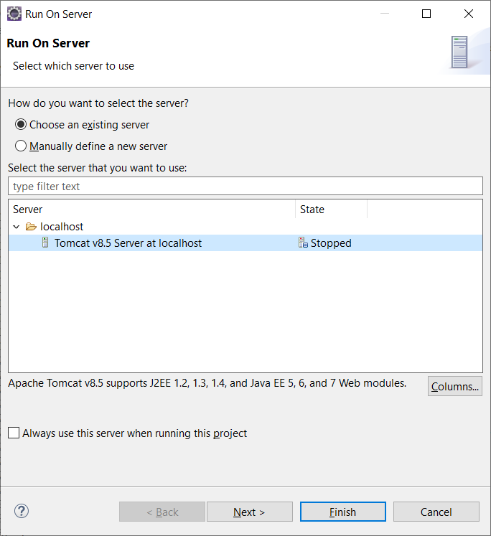

And click on Finish button

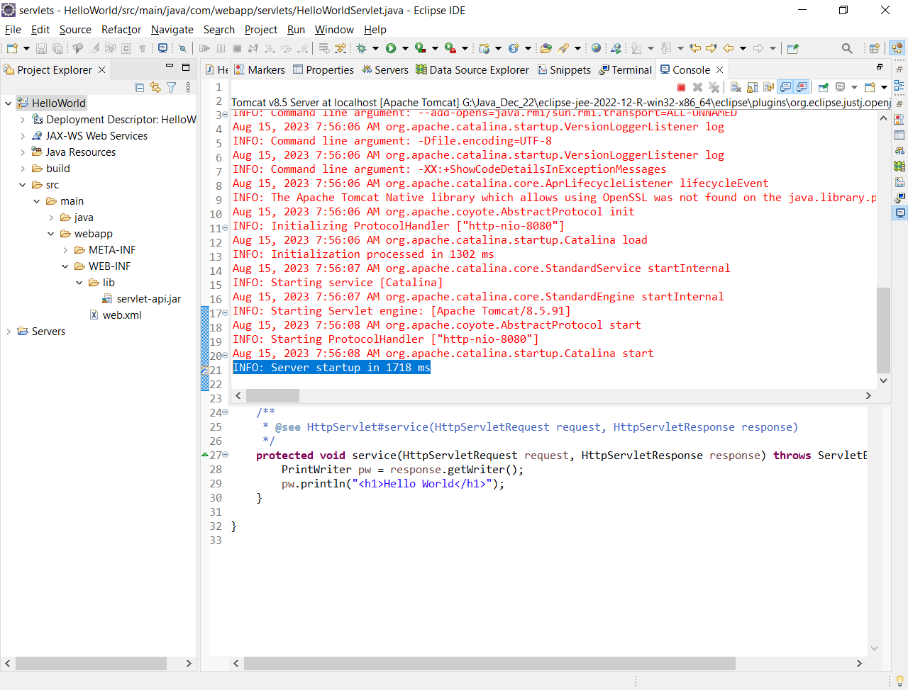

How to render the output in browser?

Step 1: open any browser

Step 2: type the below URL

localhost:8080/HelloWorld/hello

where HelloWorld 🡪 Name of the application

hello🡪 URL Mapping to HelloWorldServlet

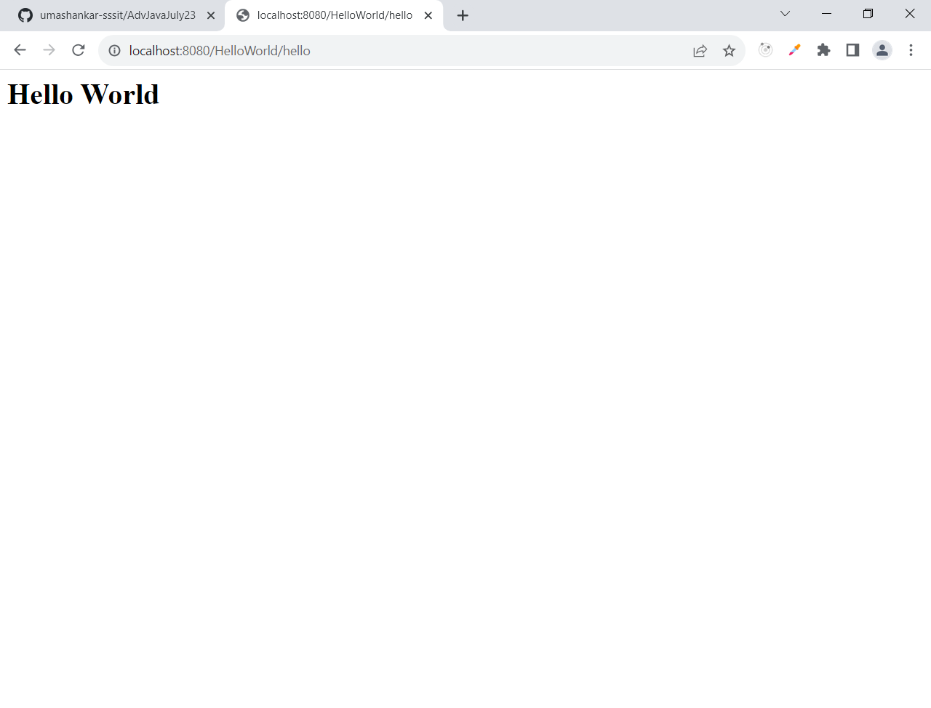

How the Web application executes?

