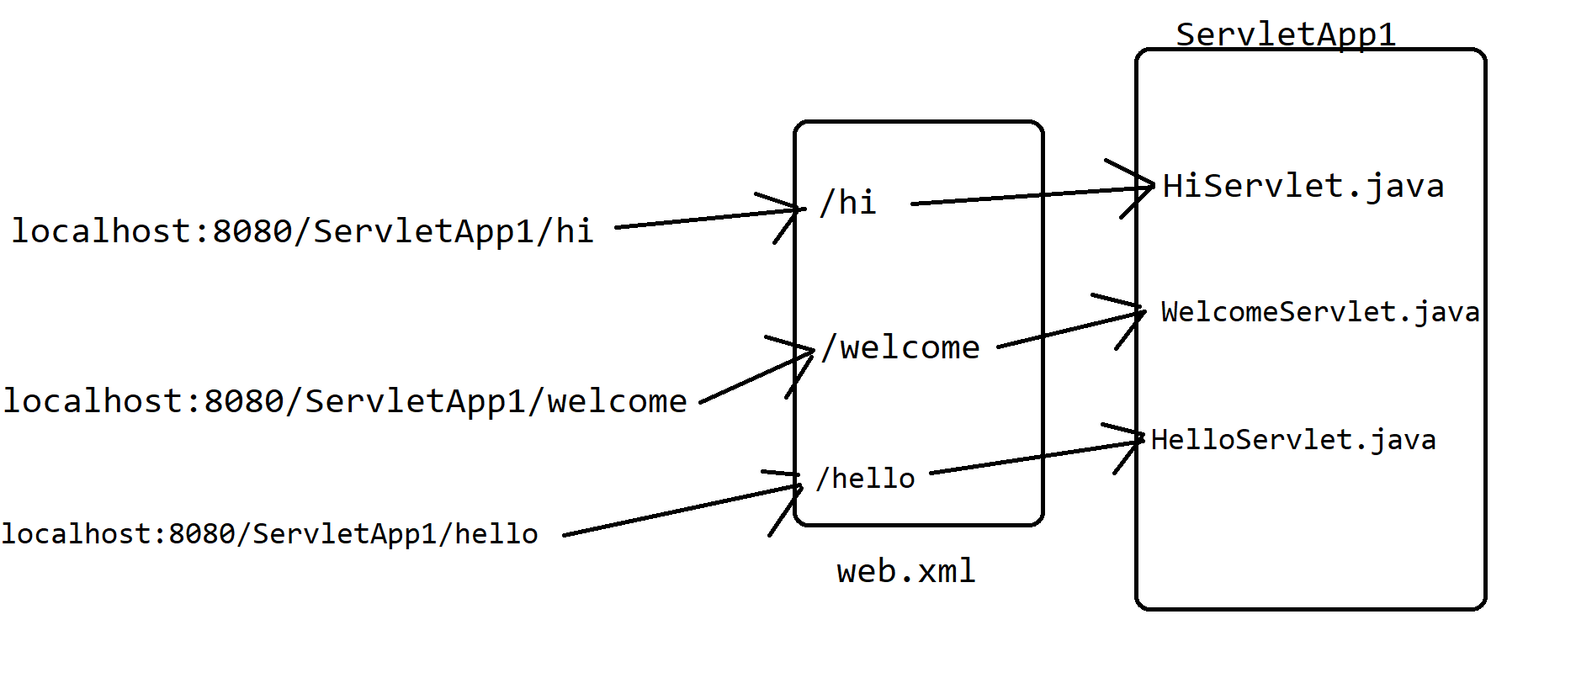

Life cycle of Servlet

Three methods

1. Init()
2. service()
3. destroy()

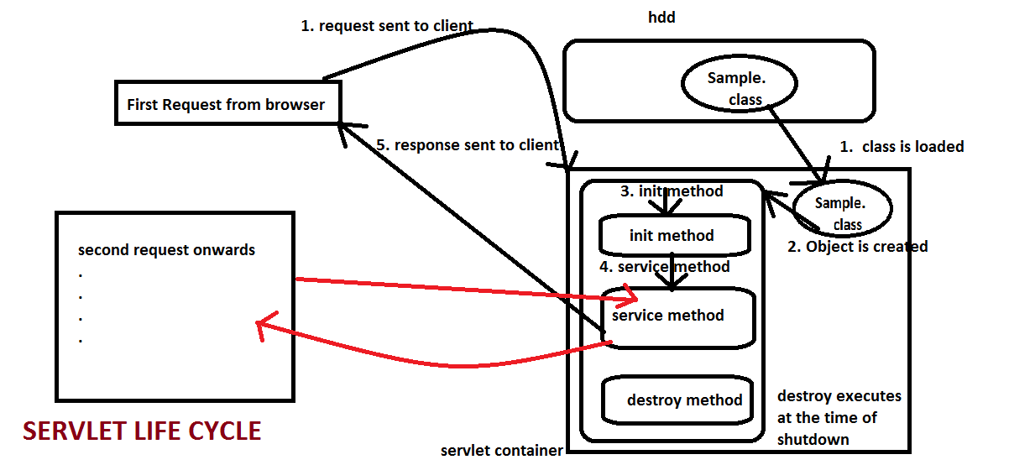

Three different ways to create a servlet