Filters

Once the filter is defined and enabled, every request and response passes thru the filter

How to define the filter in Servlet application?

TWO Steps:

1. Define the filter ( java class extending from Filter)
2. Configure the filter in web.xml

How to create a Filter in Eclipse IDE?

Step 1: Right click on Application 🡪 new 🡪 filter

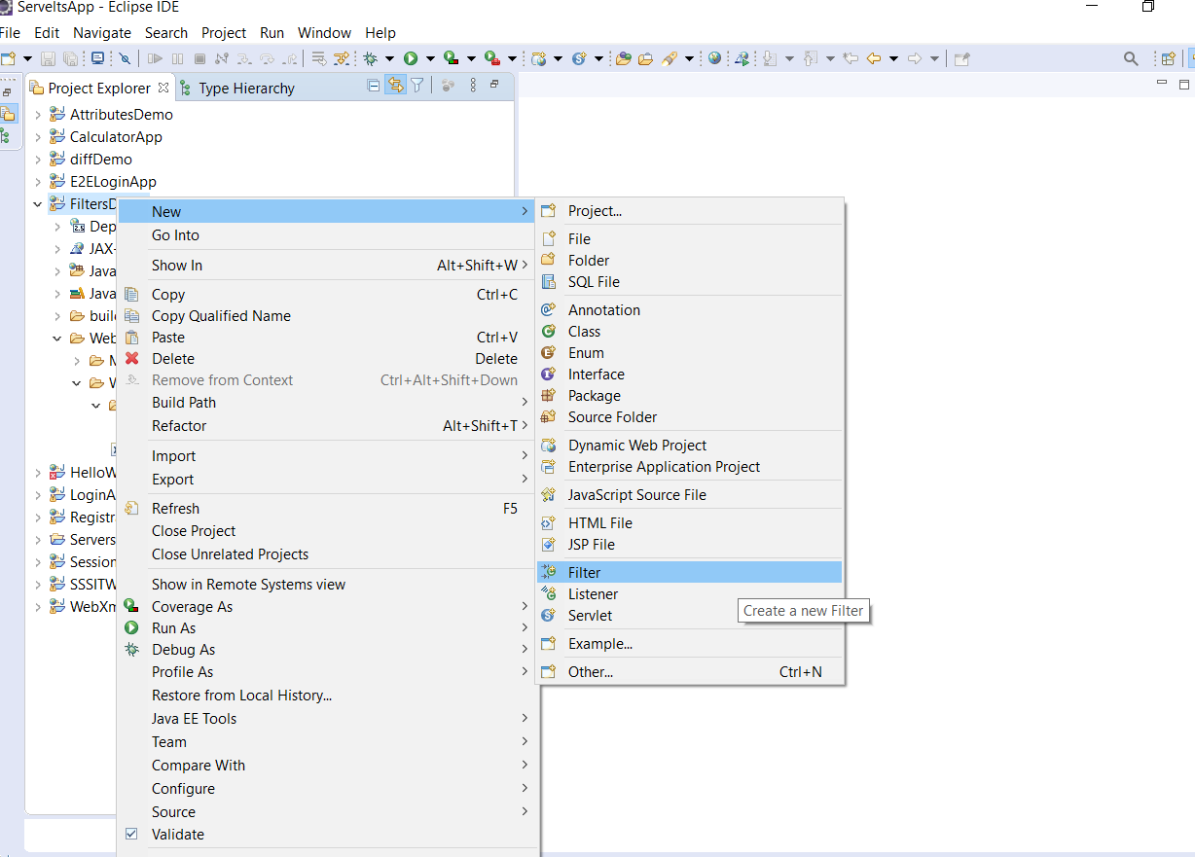

Step 2: provide the details of filter like Package Name and Filter Name then click On Next

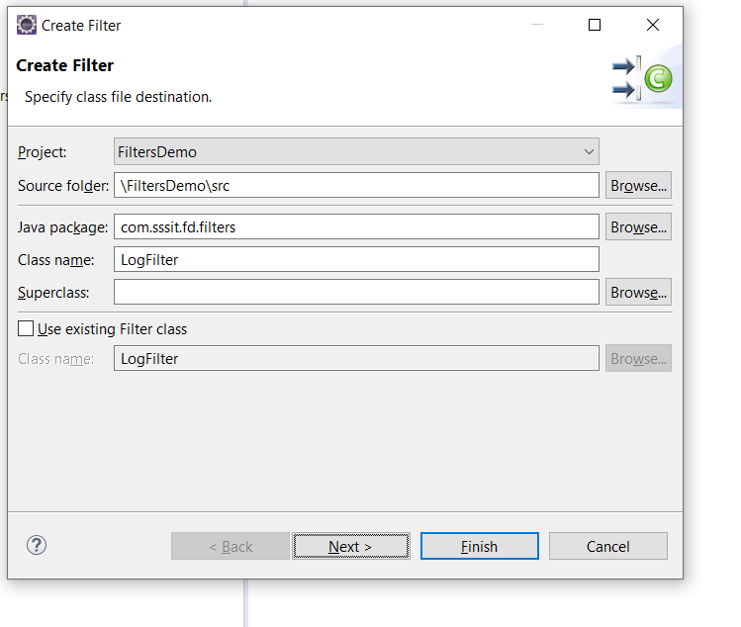

Step 3: in this step, we should provide the information about when this invokes and click on Next button

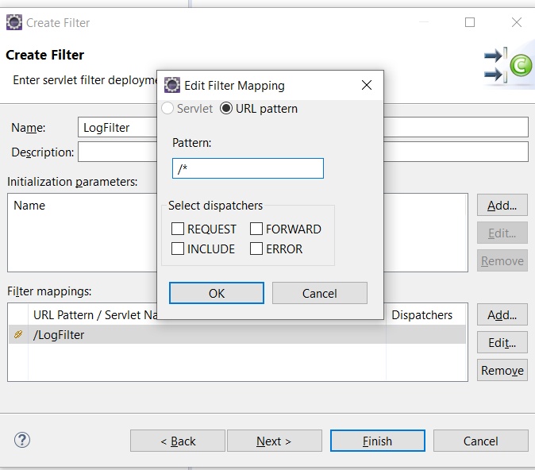

Step 4: make sure that all the filter interface methods are selected and press finish

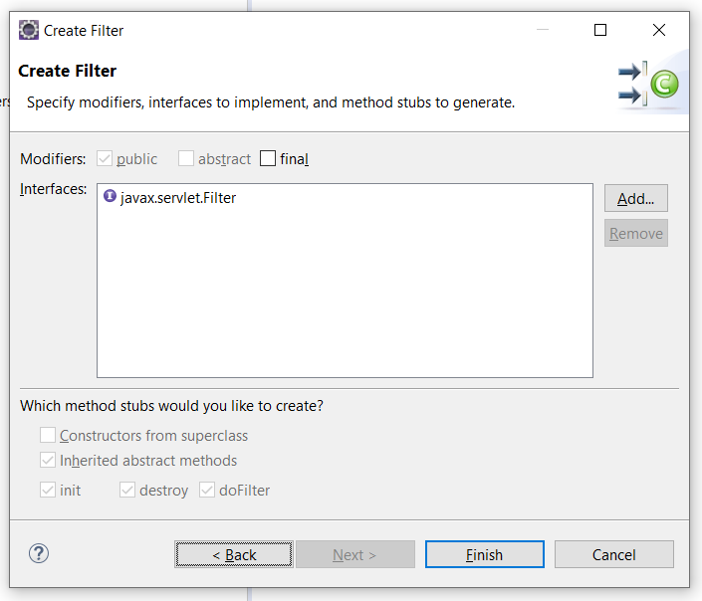

How to define a Servlet?

Right click on Application 🡪 New 🡪 Filter

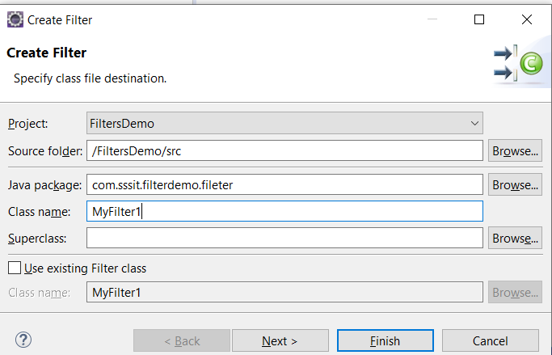

Step 2: provide the servlet application and click Finish

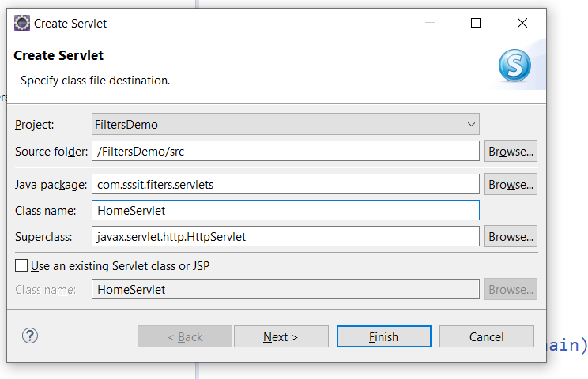

package com.sssit.fd.filters;

import java.io.IOException;

import javax.servlet.Filter;

import javax.servlet.FilterChain;

import javax.servlet.FilterConfig;

import javax.servlet.ServletException;

import javax.servlet.ServletRequest;

import javax.servlet.ServletResponse;

/\*\*

\* Servlet Filter implementation class LogFilter

\*/

public class LogFilter implements Filter {

/\*\*

\* Default constructor.

\*/

public LogFilter() {

// TODO Auto-generated constructor stub

}

/\*\*

\* @see Filter#destroy()

\*/

public void destroy() {

// TODO Auto-generated method stub

}

/\*\*

\* @see Filter#doFilter(ServletRequest, ServletResponse, FilterChain)

\*/

public void doFilter(ServletRequest request, ServletResponse response, FilterChain chain) throws IOException, ServletException {

// TODO Auto-generated method stub

// place your code here

// pass the request along the filter chain

System.out.println("1");

chain.doFilter(request, response);

System.out.println("3");

}

/\*\*

\* @see Filter#init(FilterConfig)

\*/

public void init(FilterConfig fConfig) throws ServletException {

// TODO Auto-generated method stub

}

}