Develop a JSP page to display a welcome message

Step 1: open eclipse

Step 2: create a dynamic web project

Step 3: create a JSP page to display a welcome message

Step 3.1: Right click on project-name 🡪 new 🡪 JSP file

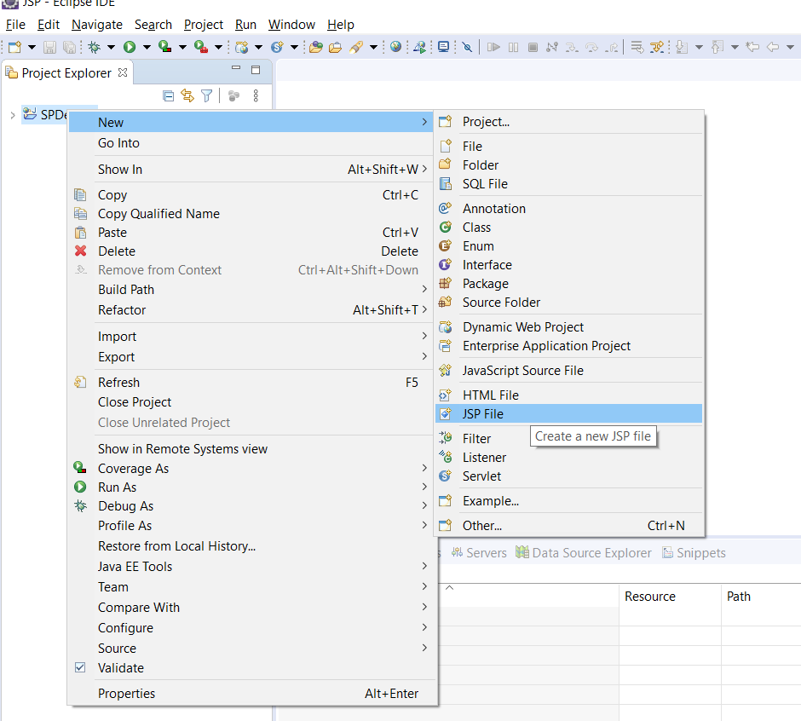

Step 3.2: provide the Name to the JSP file and click on Finish button

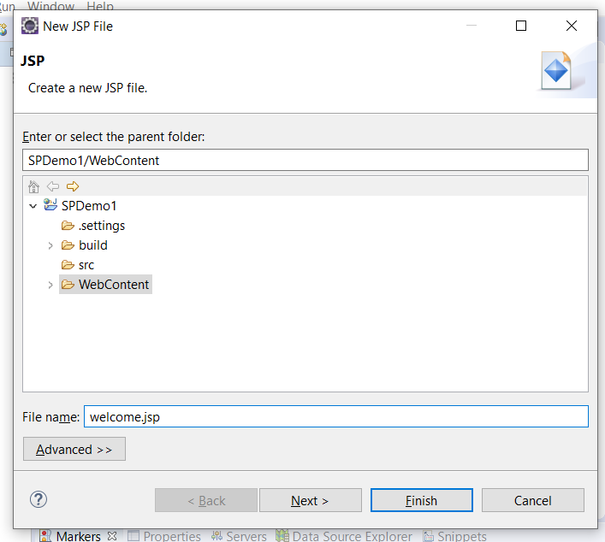

Step 3.3: type the presentation logic in JSP

<%@ page language=*"java"* contentType=*"text/html; charset=ISO-8859-1"*

pageEncoding=*"ISO-8859-1"*%>

<!DOCTYPE html>

<html>

<head>

<meta charset=*"ISO-8859-1"*>

<title>Insert title here</title>

</head>

<body>

<h1> Welcome to JSP </h1>

</body>

</html>

Step 4: deploy and run the web application

Step 4.1: Right click on Project 🡪 Run As 🡪 Run on server

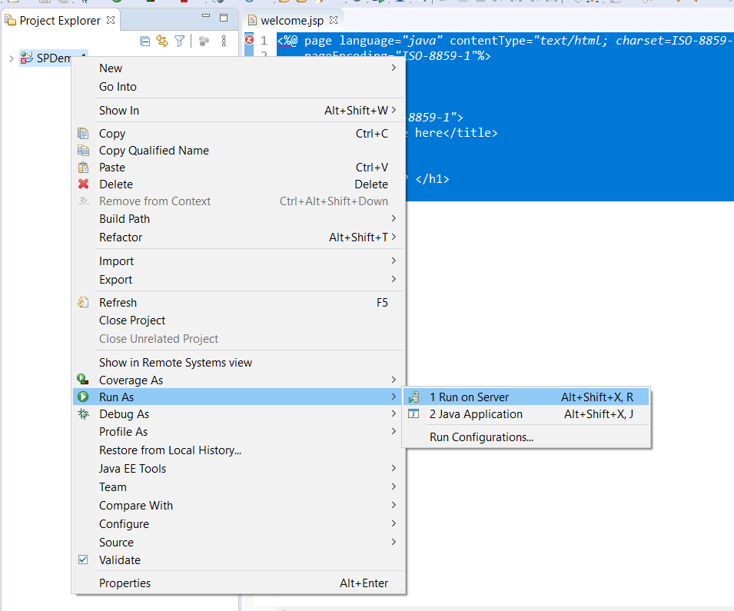

How to run the Java applicarion written in JSP?

Open any browser and provide he below URL:

<http://localhost:8000/SPDemo1/welcome.jsp>