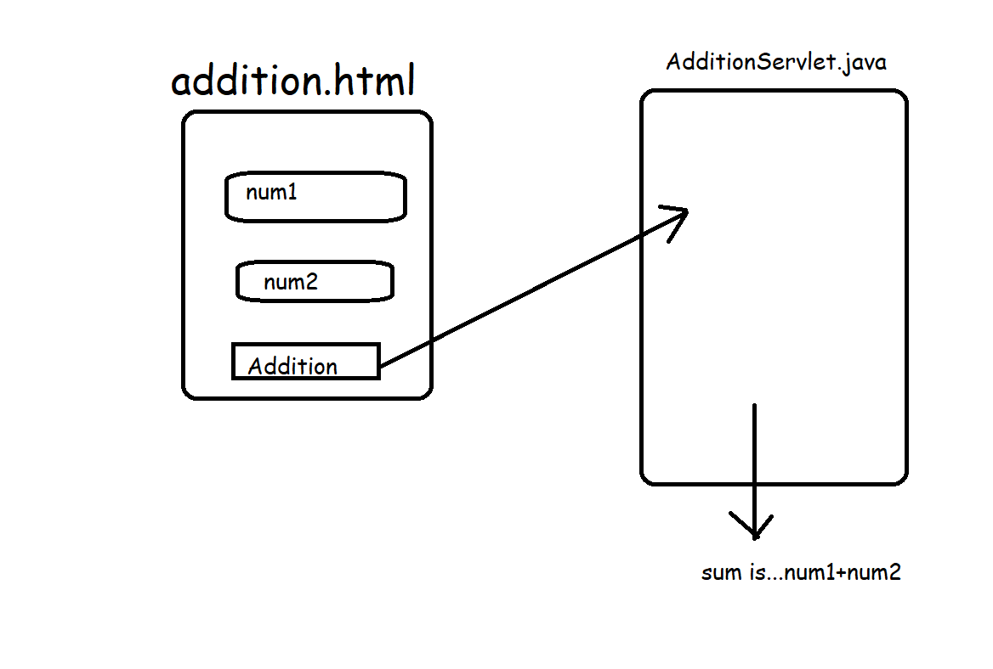

Step1 : design HTML Page

<!DOCTYPE html>

<html>

<head>

<meta charset=*"ISO-8859-1"*>

<title>Insert title here</title>

</head>

<body>

<form action=*"add"* method=*"post"*>

Enter Num1 : <input type=*"text"* name=*"num1"*/> <br/>

Enter Num2 : <input type=*"text"* name=*"num2"*/> <br/>

<input type=*"submit"* value=*"add"*/>

</form>

</body>

</html>

Step 2: develop a servlet that

* reads the values from HTML - request
* Perform the Addition
* Send the result as a response to front end

**package** com.sssit.servlets;

**import** java.io.IOException;

**import** java.io.PrintWriter;

**import** javax.servlet.ServletException;

**import** javax.servlet.http.HttpServlet;

**import** javax.servlet.http.HttpServletRequest;

**import** javax.servlet.http.HttpServletResponse;

/**

* Servlet implementation class AdditionServlet

*/

**public** **class** AdditionServlet **extends** HttpServlet {

**private** **static** **final** **long** ***serialVersionUID*** = 1L;

/**

* **@see** HttpServlet#HttpServlet()

*/

**public** AdditionServlet() {

**super**();

// **TODO** Auto-generated constructor stub

}

/**

* **@see** HttpServlet#service(HttpServletRequest request, HttpServletResponse response)

*/

**protected** **void** service(HttpServletRequest request, HttpServletResponse response) **throws** ServletException, IOException {

// reads the values from HTML - request

**int** num1 = Integer.*parseInt*(request.getParameter("num1"));

**int** num2 = Integer.*parseInt*(request.getParameter("num2"));

// • Perform the Addition

**int** result = num1+num2;

//• Send the result as a response to front end

PrintWriter pw = response.getWriter();

pw.println("<h1> Sum is....." + result + "</h1>");

}

}

Step 3: check whether the defined servlet in configured in web.xml or not

<servlet>

<description></description>

<display-name>AdditionServlet</display-name>

<servlet-name>AdditionServlet</servlet-name>

<servlet-class>com.sssit.servlets.AdditionServlet</servlet-class>

</servlet>

<servlet-mapping>

<servlet-name>AdditionServlet</servlet-name>

<url-pattern>/add</url-pattern>

</servlet-mapping>

Step 4: Run the web application using RunAs 🡪 Run on Server

Step 5: open any browser and provide “localhost:8080/WebApp1/add.html”

Application – 2

Calculator

Step 1 : calculator.html

<!DOCTYPE html>

<html>

<head>

<meta charset=*"ISO-8859-1"*>

<title>Insert title here</title>

</head>

<body>

<form action=*"calculate"* method=*"post"*>

Enter Num1 : <input type=*"text"* name=*"num1"*/> <br/>

Enter Num2 : <input type=*"text"* name=*"num2"*/> <br/>

<input type=*"submit"* value=*"addition"* name=*"operation"*/>

<input type=*"submit"* value=*"subtraction"* name=*"operation"*/>

<input type=*"submit"* value=*"multiplication"* name=*"operation"*/>

</body>

</html>

Step 2:

CalculatorServlet.java

**package** com.sssit.servlets;

**import** java.io.IOException;

**import** java.io.PrintWriter;

**import** javax.servlet.ServletException;

**import** javax.servlet.http.HttpServlet;

**import** javax.servlet.http.HttpServletRequest;

**import** javax.servlet.http.HttpServletResponse;

/**

* Servlet implementation class CalculatorServlet

*/

**public** **class** CalculatorServlet **extends** HttpServlet {

**private** **static** **final** **long** ***serialVersionUID*** = 1L;

/**

* **@see** HttpServlet#HttpServlet()

*/

**public** CalculatorServlet() {

**super**();

// **TODO** Auto-generated constructor stub

}

/**

* **@see** HttpServlet#service(HttpServletRequest request, HttpServletResponse response)

*/

**protected** **void** service(HttpServletRequest request, HttpServletResponse response) **throws** ServletException, IOException {

// reads the values from HTML - request

**int** num1 = Integer.*parseInt*(request.getParameter("num1"));

**int** num2 = Integer.*parseInt*(request.getParameter("num2"));

String operation = request.getParameter("operation");

//• Send the result as a response to front end

PrintWriter pw = response.getWriter();

**if**(operation.equals("addition"))

pw.println("<h1> Sum is....." + (num1+num2) + "</h1>");

**else**

**if**(operation.equals("subtraction"))

pw.println("<h1> Difference is....." + (num1-num2) + "</h1>");

**else**

pw.println("<h1> Multiplication is....." + (num1*num2) + "</h1>");

}

}

Step 3: In Web.xml

<servlet>

<description></description>

<display-name>CalculatorServlet</display-name>

<servlet-name>CalculatorServlet</servlet-name>

<servlet-class>com.sssit.servlets.CalculatorServlet</servlet-class>

</servlet>

<servlet-mapping>

<servlet-name>CalculatorServlet</servlet-name>

<url-pattern>/calculate</url-pattern>

</servlet-mapping>

Step 4: Run As 🡪 Run on Server

Step 5: Open any browser and provide the URL “localhost:8080/WebApp1/calculator.html”

Folder Structure

